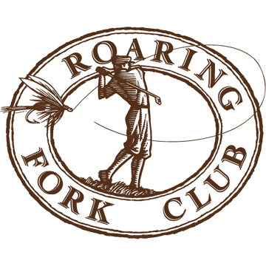
Full Time Employment and Internship Opportunities
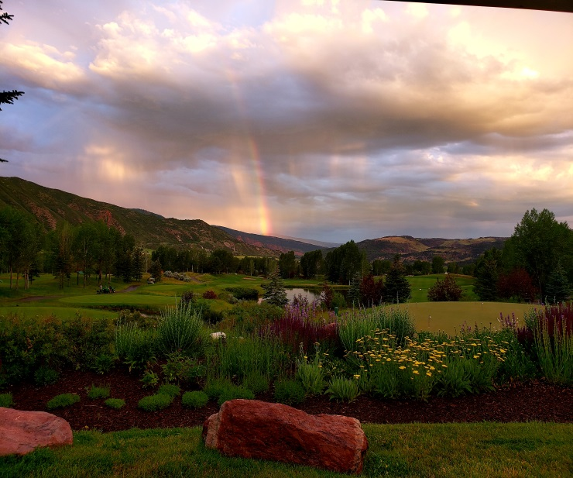
Are you looking for a work environment that subscribes to the “Work Hard, Play Harder” philosophy? Roaring Fork Club, located just minutes outside world famous Aspen, Colorado, is the place for you. While at RFC, employees will participate in all facets of golf course maintenance required to maintain a championship level golf course at 6,800 ft. The course is currently undergoing a Jack Nicklaus bunker renovation as well as a complete irrigation renovation.
What are we looking for?
Turf students and recent graduates dedicated and motivated to learn what is required to maintain a world class golf course. Roaring Fork Club is looking to provide employees with the tools necessary to become successful assistants and superintendents. Our goal is to promote these employees through our organization or other top golf courses in the country. Ideal candidates will work well with a team.
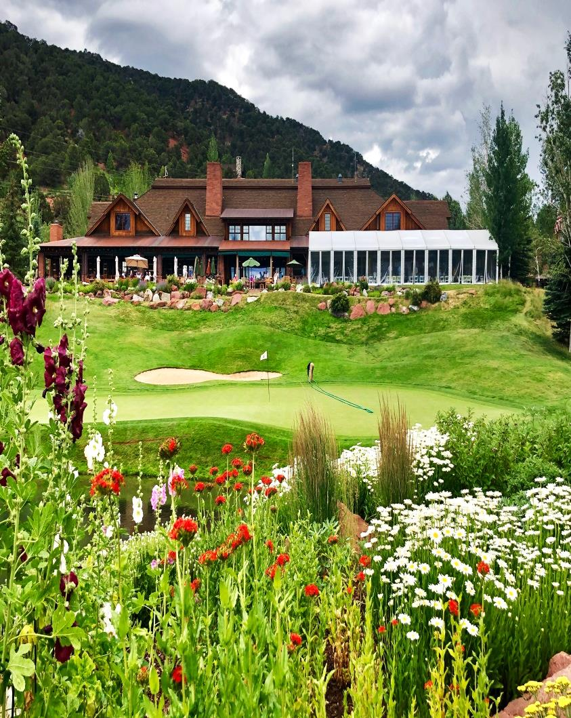
Benefits:
-$18/hr plus overtime
- Brand new employee housing, furnished
-Golfing privileges
-Two “Gold Medal” rated Trout Rivers within 3 minutes
-Sightseeing opportunities including Maroon Bells, Independence Pass, Crystal Mill, and MANY more!
-Discounted ski pass for full time employees
-Work with the best views in the country
-Limited access to private fishing streams and ponds
Send Resume To:
Tim Zevotek, Director of Agronomy
tzevotek@rfclub.com

