The Reserve at Moonlight Basin
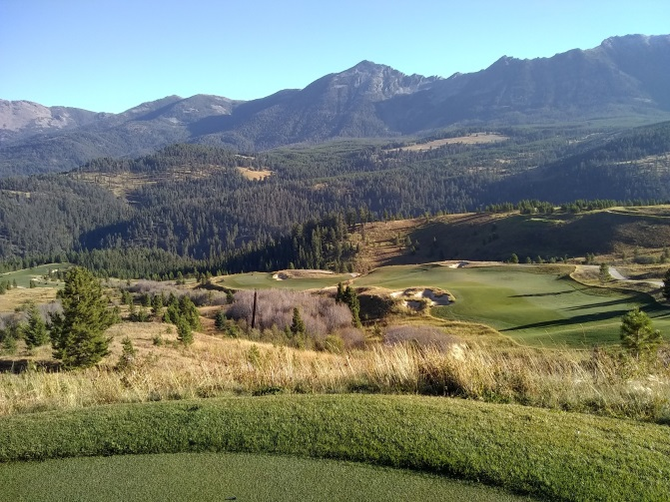
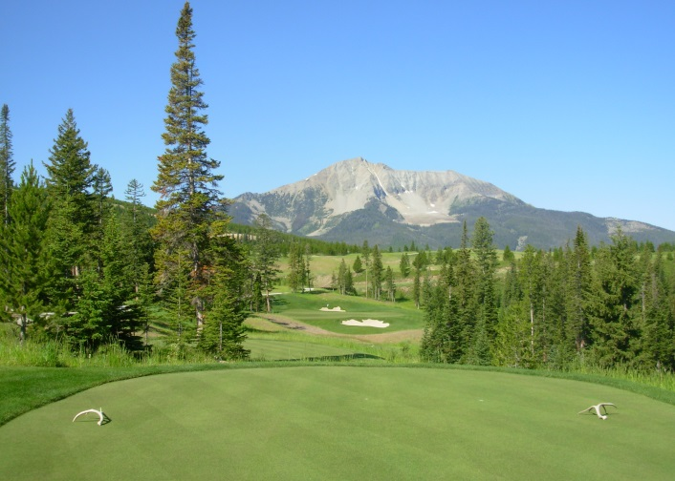
Internship Opportunity

The Reserve at Moonlight Basin is now accepting applications for summer interns for our 2020 season. Moonlight Basin is an 18 private golf course located at 7000 feet of elevation in Big Sky, MT. Moonlight Basin was rated #2 best new private course in 2016 and has climbed to the #2 course in the state according to Golf Digest.
Our internship program will consider the student's goals and involve them in several aspects of golf course management with a strong emphasis on where the student feels he/she needs improvement. Mowing, fertilizer and pesticide applications, course setup, water management, equipment maintenance & mower set up, and budgeting are all topics which will be covered during the summer season.
Benefits
- Competitive wage
- Housing
- Meals
- Uniforms
- Great golfing privileges
- End of the season bonus
- 3 – 6 month positions available
To apply:
Please send cover letter & resume to:
Garrett Turner
Golf Course Superintendent
gturner@moonlightbasin.com
406-209-5498

