Sports Turf Internship at Little League International
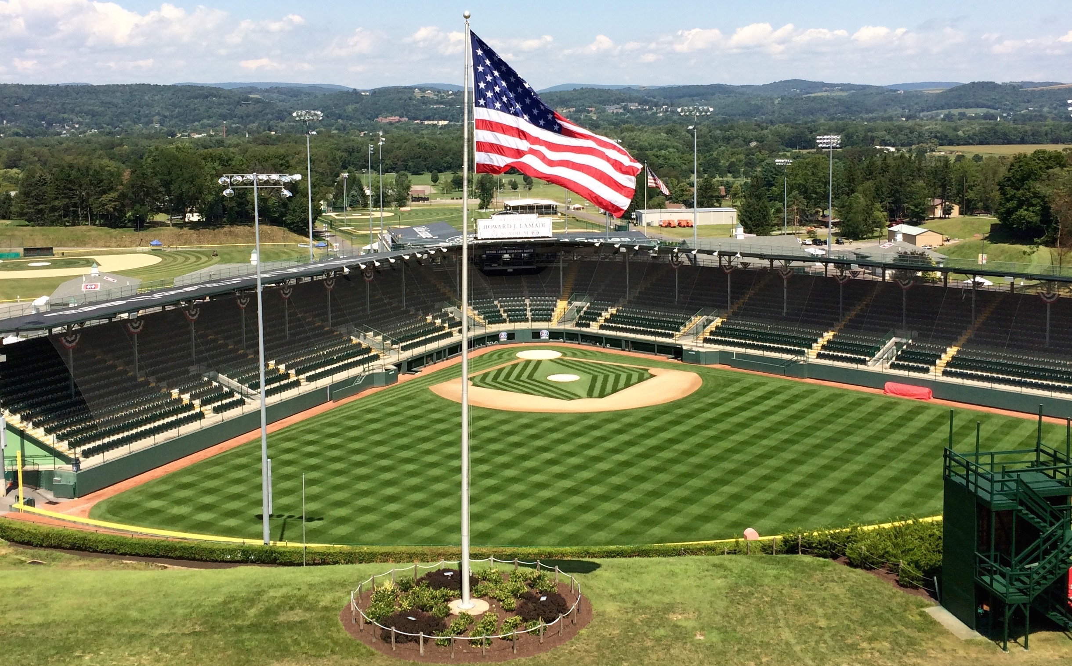

Little League International
P.O. Box 3485
539 US Route 15 Hwy
Williamsport, PA 17701
570-326-1921

Summer 2019 – Little League International is seeking qualified individuals to join the Grounds Maintenance Team for a seasonal Sports Turf Internship.
Little League Baseball and Softball is the world’s largest youth sports organization. Located in scenic South Williamsport, PA, the Little League complex is home to six baseball fields including Howard J. Lamade and Volunteer Stadiums. The stadium field playing surfaces are 100% Kentucky Bluegrass.
The complex in South Williamsport hosts the annual Little League World Series each August and attracts thousands of visitors each year. The complex also hosts six weeks of Little League Baseball Summer Camp and several other events and tournaments throughout the summer.
Sports Turf Interns will be exposed to all aspects of the field maintenance operation including:
- Participate in meetings regarding field use and game day logistics
- Assist in field preparations which include mowing, edging, clay work, dragging and lining
- Assist in fertilization, irrigation maintenance and pesticide program as appropriate
- Maintain and repair infield skin surfaces
- Mound, plate and bullpen clay repairs
- Assist with aeration throughout the season
- Participate in sod work
- Warning track maintenance
- Assist in tarp pulls
- Perform preventative maintenance of grounds equipment
Requirements:
- Applicant must be currently pursuing an undergraduate or graduate degree in Agronomy, Turf Grass Management or related field
- Excellent work ethic
- Knowledge of baseball field dimensions and layout, preferred
- General knowledge of operating and maintaining grounds keeping equipment
- Valid driver’s license
- Ability to lift at least 50 pounds
- Frequent bending, stooping and lifting
- Must pass criminal background check
- Flexible work schedule including holidays, evenings and weekends, as needed
- Must be able to work in all weather conditions, including extreme heat and rai
Compensation:
- $8.00 per hour
- Housing provided, must sign housing agreement. Board not included.
- Lunch included Monday through Friday
Dates: May 1st through September 1st (Flexible, based on availability)
Please send your resume to Trinia Poust, HR Generalist, at ppoust@littleleague.org by February 15, 2019.
E.O.E.

