Inverness Club
Golf Course Turf Team Position

History:
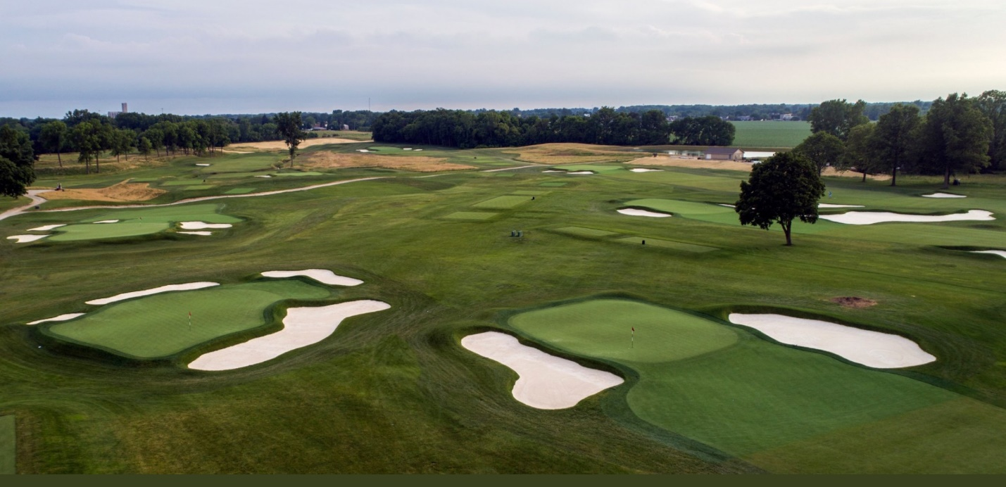
Located in Toledo, Ohio, the prestigious Inverness Club has cemented its place in professional golf history. With a rich history of hosting major tour events including the 1920,1931,1957 and 1979 U.S Opens as well as the 1986, 1993 PGA Championship and 2003 and 2011 U.S Senior Open. The Inverness Club is highly dedicated to providing the most elite playing surfaces possible for the best players in the world. The club recently hosted the 2019 U.S Junior Amateur and will be host to the 2021 Solheim Cup. Originally designed in 1903, Inverness was purchased on a unique undulated plot of land. Donald Ross was hired by the club in 1916 to construct a championship caliber golf course.

Intern/ Turf Graduate Mission:
Working with four-time major host and experienced leader, John Zimmers, Inverness is seeking highly motivated and determined interns and turf graduates. Amidst course preparations for the 2021 Solheim Cup all interns and graduates will be exposed to all facets of golf course maintenance on a day to day basis. Interns are expected to have a positive attitude, be prompt and on time in a professional manner and most importantly eager to learn.

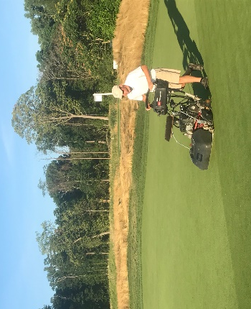
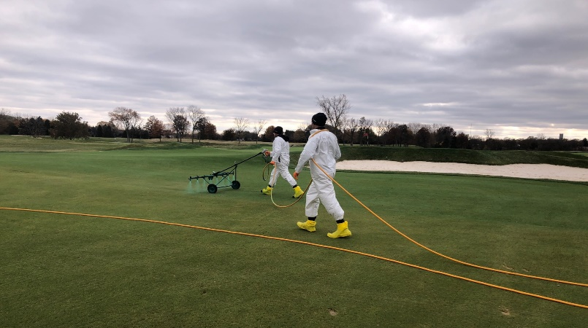
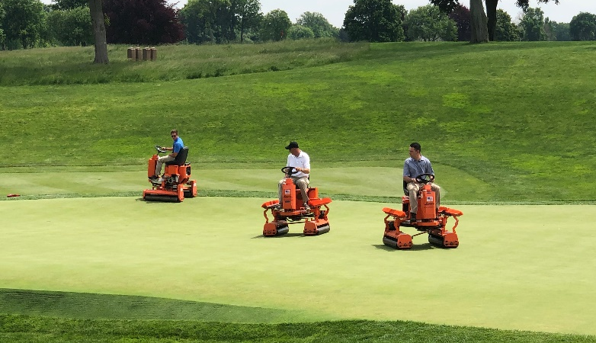
Spraying with Handgun
Weekly Sand Topdressing
Walk Mowing
Intermediate Cut
Boom Spray Fairways
Spray Hawk Greens and Approaches
Triple Rolling Greens
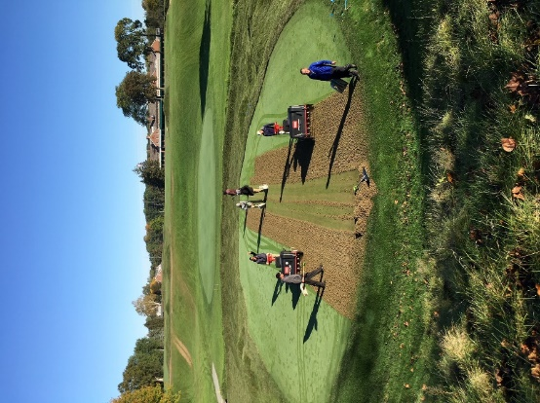
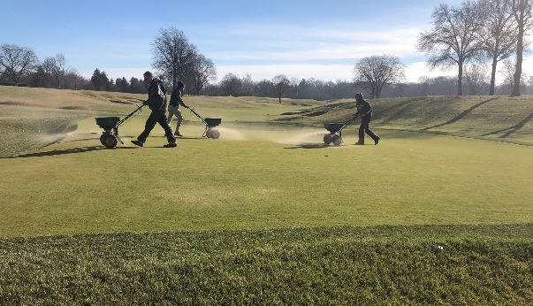
Hand-Watering
Planet Air Greens
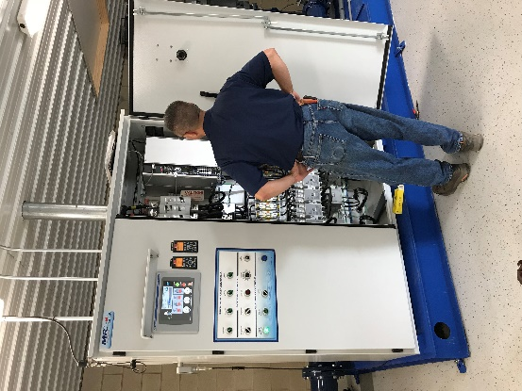
New Pump station
Aerification (Spring/Fall)

Responsibilities:
- Perform all mowing tasks on the golf course. (Greens, Approaches, Tees, Rough and Fairways)
- Rolling
- All aspects of bunker maintenance
- Participate in daily course preparation (selecting hole locations and moving tee markers).
- All types of Aerification and cultural practices.
- Chemical and fertility applications and calibration
- Irrigation and drainage installation, troubleshooting and repair
- All forms of watering on various playing surfaces
- Efficiently leading groups in various tasks
Application Instructions:
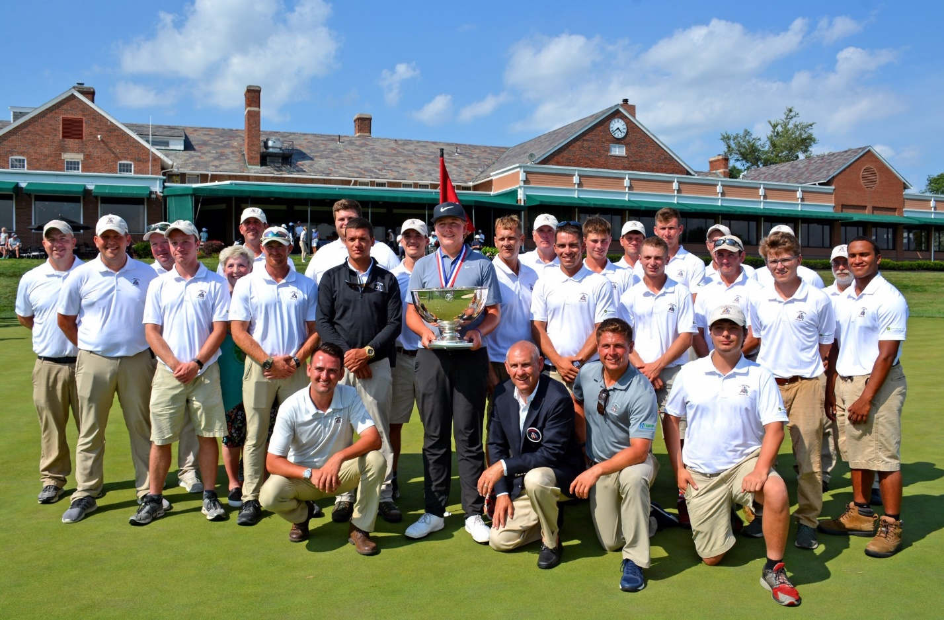
Send cover letter and resume to Ryan Kaczor at Rkaczor@Invernessclub.com.
2019 Grounds Staff

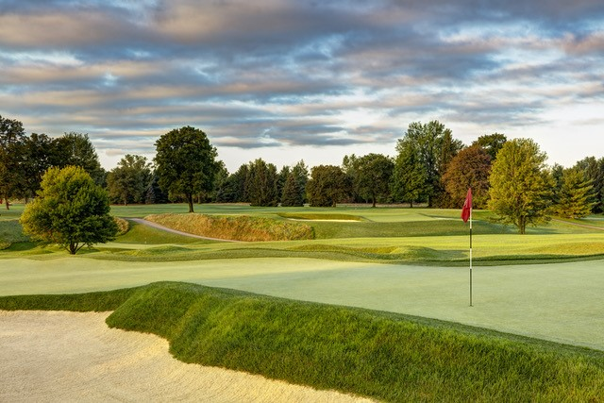
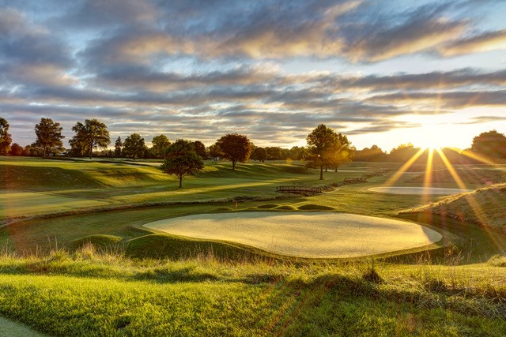
The Donald Ross design accompanied by the rolling terrain create a special environment with the flat plains that surround the property inside Toledo, OH.

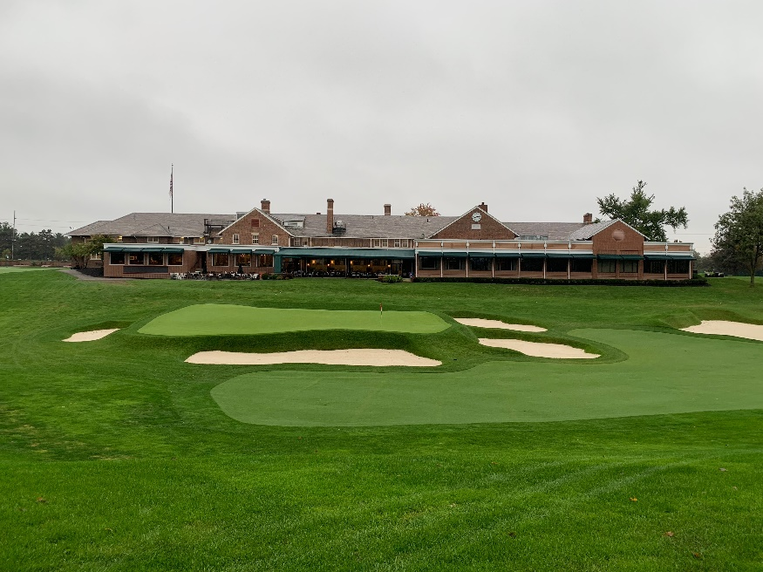

The Unique 18th Green is famous for the Bob Tway Chip-In to win the 1986 PGA Championship.

