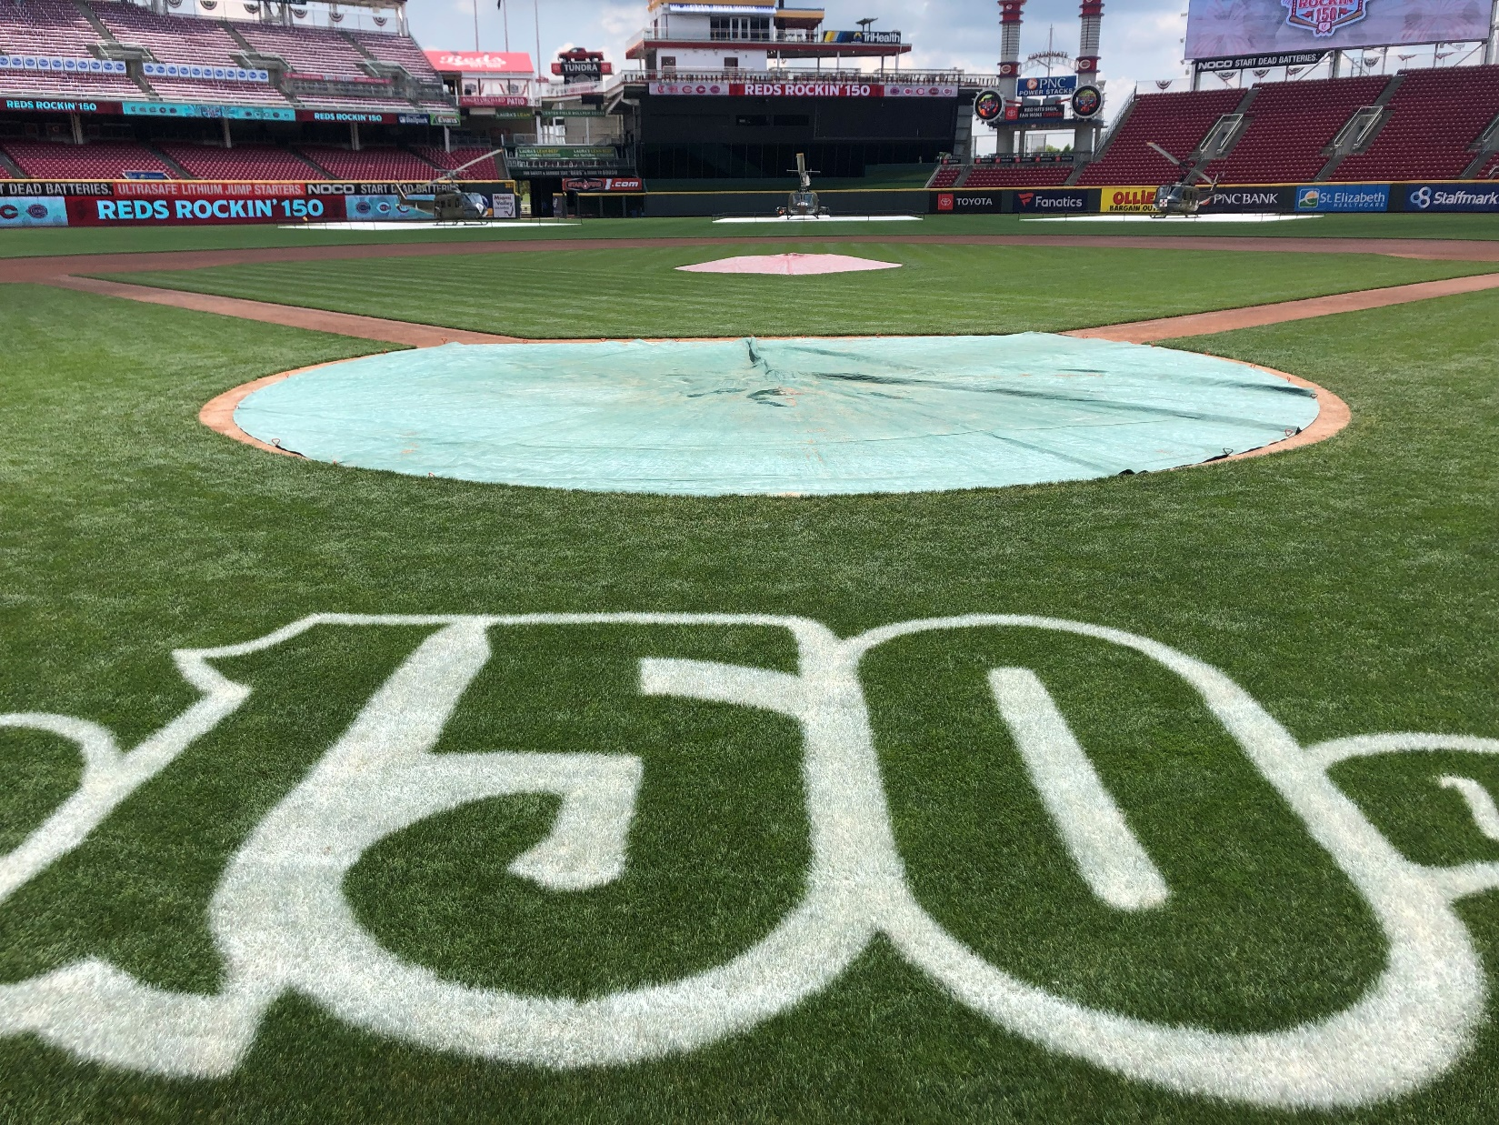
Cincinnati Reds – Seasonal Internship Program
The Cincinnati Reds are seeking highly motivated individuals for the upcoming 2020 Season. Applicants are encouraged to have a turf background and be currently enrolled or recently graduated from a 2 or 4-year university turf program. Applicants are expected to work well with a group in an environment that can include long hours and possible stressful situations. Applicants should be able to push, pull, and lift 50 lbs.. This is a seasonal position with the start date as early March and lasting through October. College students finishing school in May are encouraged to apply as well. Start and end dates are flexible based on availability.

Job Description:
Duties for this position include: mowing, edging, mound and home plate repair, infield surface maintenance, application of fertilizers, batting practice setup and break down, irrigation repair, sodding, seeding, and all other cultural practices. Applicants will work home games and special events as well. Special events may include: commercial shoots, corporate batting practices, youth camps, high school baseball games, and other non-baseball revenue generating events. These positions will provide an excellent opportunity to gain hands on experience for young professionals interested in advancing in the sports turf industry.
Compensation:
Positions will be paid hourly with time and a half paid after 40 hours. Interns will be paid $10.25/hour and are expected to work 40 hours/week, with the overtime available during home stands.
To Apply:
Please send an updated resume, cover letter, and list of references (with contact info) to the address listed below.
Cincinnati Reds
Great American Ball Park
ATTN: Steve Lord
100 Joe Nuxhall Way
Cincinnati, OH 45202
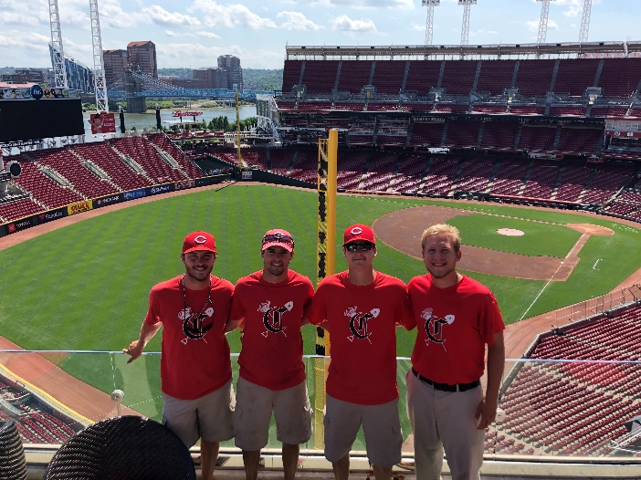
Email application information to: slord@reds.com
