Kansas State University

Workplace Chemical Protection Program (WCPP)

Methylene Chloride (DCM)

Effective Date:

Covered Locations:

Responsible Individual(s):

**This is an uncontrolled copy. Printed versions are not guaranteed to be current. For the most up-to-date version of this document, refer to [updated electronic storage location].**

Purpose:

Kansas State University is committed to maintaining a safe, compliant, and environmentally responsible research environment. This template, when completed and approved, serves as a site-specific Workplace Chemical Protection Program (WCPP) for university departments and laboratories that elect to retain Methylene Chloride (DCM), ensuring compliance with the [40 CFR Part 751](https://www.federalregister.gov/documents/2024/05/08/2024-09606/methylene-chloride-regulation-under-the-toxic-substances-control-act-tsca) (EPA Final Rule for Methylene Chloride). Compliance with OSHA Standards 29 CFR 1910.132 (Personal Protective Equipment (PPE)), 29 CFR 1910.134 (Respiratory Protection) and 29 CFR 1910.1052 (Methylene Chloride) is prioritized in this WCPP. The Workplace Chemical Protection Program outlines procedures, exposure controls, training requirements, communication, and documentation standards necessary to safely manage DCM usage and protect university personnel.

Scope:

This plan applies to [specify university location]. The provisions outlined in this WCPP apply to all faculty, staff, students, contractors, and visitors who may be exposed to methylene chloride at [specify university location] at Kansas State University. Under the EPA TSCA Methylene Chloride Final Rule, all “potentially exposed persons”, including students and non-employees, are afforded protection.

Strict adherence to these procedures is required by all individuals at all times to ensure personnel safety and adhere to federal regulatory requirements. Compliance with this policy is mandatory. Non-compliance by any individual may result in removal of DCM and disciplinary action.

Compliance:

Non-compliance with this WCPP may lead to referral to university leadership for resolution in accordance with established K-State policies and procedures. This may result in the immediate discontinuation of Methylene Chloride activities by personnel as outlined in this plan.

Program Review:

This WCPP will be reviewed at least annually by the program authority to ensure it remains effective, compliant with regulations, and aligned with institutional objectives.

Approval:

This WCPP is approved by the program authority, including the PI/Responsible Individual, Department Head/Chair, and Department Safety Coordinator and is effective immediately upon publication.

Document Tracking:

|  |  |  |  |
| --- | --- | --- | --- |
| **Version** | **Date** | **Author(s)** | **Description of Changes** |
| 1.0 |  |  | Initial creation of Workplace Chemical Protection Program (WCPP) |

This is an uncontrolled copy. Printed versions are not guaranteed to be current. For the most up-to-date version of this document, refer to [updated electronic storage location].

KSU EHS WCPP Template last updated on 06/02/2025 by Rachael M. Weiderman to reflect new EPA proposed compliance deadlines.

Laboratory/Facility Information for WCPP

Contact Information for WPCC Authority:

|  |  |
| --- | --- |
| PI/Responsible Individual Full Name: |  |
| Campus Office Location: |  |
| Phone Number: |  |
| Email Address: |  |
| Lab Manager or Alternate Contact Full Name: |  |
| Campus Office Location: |  |
| Phone Number: |  |
| Email Address: |  |
| Department Safety Coordinator Full Name: |  |
| Campus Office Location: |  |
| Phone Number: |  |
| Email Address: |  |
| Department Head/Chair Coordinator Full Name: |  |
| Campus Office Location: |  |
| Phone Number: |  |
| Email Address: |  |

Laboratories or Facilities Governed by WCPP:

|  |  |
| --- | --- |
| Laboratory Building and Room Number(s) for this WPCC: |  |

Methylene Chloride (DCM) Activities Covered Under WCPP

This section describes all uses of Methylene Chloride (DCM) covered under this Workplace Chemical Protection Program (WCPP). Any addition or modification of use requires notification to EHS prior to use and revision of this protection program prior to use. New or revised uses of DCM require updated inventory assessments, updated exposure monitoring, updated training, and verification of effectiveness of control measures for personnel protection.

Any products containing >0.1% Methylene Chloride are required to be included in the WCPP.

|  |  |  |  |  |  |  |  |
| --- | --- | --- | --- | --- | --- | --- | --- |
| Product Name | CAS #s | Manufacturer | Mixture or Pure Substance? | Maximum Quantity Maintained at Facility | Location Used (Building and Room) | Safety Data Sheet Location | All Uses of Substance (Include Procedures, Processes, Functions) |
|  |  |  |  |  |  |  |  |
|  |  |  |  |  |  |  |  |
|  |  |  |  |  |  |  |  |
|  |  |  |  |  |  |  |  |
|  |  |  |  |  |  |  |  |
|  |  |  |  |  |  |  |  |

Exposure Control Plan (ECP) for Methylene Chloride

### 1. Identification and Rationale of Exposure Controls

List and justify all selected exposure controls specific to DCM use at this site. Where Methylene Chloride cannot be eliminated or substituted for a less hazardous chemical, engineering controls, administrative controls, and PPE must be outlined for each procedure and substance for personnel protection.

**Engineering Controls**

|  |  |  |
| --- | --- | --- |
| **Engineering Control** | **Specifications (Model, Flow Rate)** | **Justification for Selection / Use** |
| Fume Hood |  |  |
| Local Exhaust Ventilation |  |  |
| Other |  |  |

**Administrative Controls**

|  |  |  |
| --- | --- | --- |
| **Administrative Control** | **Specifications** | **Justification / Use** |
| Standard Operating Procedures (SOPs) (list each SOP for Methylene Chloride activities/use individually) |  |  |
| Regulated Area Demarcation (signage, access restrictions, access logs, etc.) |  |  |

**Personal Protective Equipment**

|  |  |  |
| --- | --- | --- |
| PPE Type | Make and Model/ Specifications | Required Uses |
| Respirators (Supplied-air respirators only – no air purifying, half-mask) |  |  |
| Chemical-resistant Gloves (Polyvinyl alcohol, Silver Shield, Laminate, NO nitrile, NO latex, NO neoprene, NO polyethylene gloves) |  |  |
| Eye and face protection |  |  |
| Chemical-resistant clothing |  |  |

### 2. Procedures for Implementing Exposure Controls

The following section outlines critical procedures for ensuring the effectiveness and sustainability of exposure controls for methylene chloride (DCM). Departments must implement a consistent **Inspection and Maintenance Schedule** to maintain reliable functionality of all engineering controls and protective equipment. Additionally, comprehensive **Training Procedures** must be established and documented to ensure personnel are adequately informed, proficient, and compliant with safety measures, control practices, and regulatory obligations outlined in the EPA's methylene chloride standard.

**Inspection and Maintenance Schedule (May also reflect calibration or certification):**

|  |  |  |  |  |
| --- | --- | --- | --- | --- |
| **Control/ Equipment** | **Inspection Frequency** | **Inspection Procedure** | **Responsible Person** | **Documentation Method and Record Maintenance** |
| Fume Hood | Annual | EHS Quantitative and Qualitative Inspections | EHS | EHS and Fume Hood Inspection Sticker. Records maintained for at least five years within EHS |
|  |  |  |  |  |

**Training Procedures:**

|  |  |  |  |
| --- | --- | --- | --- |
| **Training Content** | **Training Source** | **Training Frequency** | **Documentation Method** |
| DCM Awareness, EPA Final Rule, Safe Work Practices | Environmental Health and Safety | Initial and Annual | EHS Training Records (Maintained in EHS and provided to Responsible Individuals/ Departments) |
| Laboratory/Facility Specific Training for each procedure and substance containing DCM | Responsible Individual | Prior to Use of Methylene Chloride and whenever modifications arise | Employee Lab-Specific Training Record |

### 3. Regulated Areas and Activities

To protect personnel from potential overexposure, this section must define and clearly demarcate regulated areas where methylene chloride concentrations could exceed established exposure limits. Departments must detail the specific activities requiring enhanced protective measures, along with associated signage and access controls to maintain safety and regulatory compliance.

|  |  |  |
| --- | --- | --- |
| Regulated Area (Location) | Specific Activities that use Methylene Chloride Substances | Required Signage/Warnings/PPE Notices and Access Restriction/Logs (Physical and Administrative Demarcation) |
| Building and Room Number | Procedure Name/ Process Name and SOP | Signage: Access Restriction:  Access Logs: |
|  |  |  |

### 4. Procedures for Updates and Responding to Changes

This section describes systematic approaches for reviewing, updating, and maintaining the Workplace Chemical Protection Program (WCPP). It ensures the plan remains effective by outlining procedures for responding promptly to operational changes, equipment modifications, or regulatory updates.

|  |  |  |  |
| --- | --- | --- | --- |
| **Procedure Type** | **Frequency** | **Method/ Mechanism** | **Responsible Individual(s)** |
| Annual Review of WCPP | Annually |  |  |
| Operational or Regulatory Changes | As Needed |  |  |

### 5. Performance Standards for Evaluation of Controls

Establishing measurable performance criteria is essential to validate the effectiveness of the implemented exposure controls. This section outlines the methods and criteria for periodic evaluations, including specific benchmarks, measurement procedures, and corrective action protocols when standards are not met.

|  |  |  |  |
| --- | --- | --- | --- |
| **Performance Criteria** | **Measurement Method/ Procedure** | **Frequency of Evaluation** | **Corrective Action Procedure** |
| Exposure Limits (ECEL, STEL) Compliance |  |  |  |
| Engineering Controls (specify) |  |  |  |
| Administrative Controls (specify) |  |  |  |
| PPE Effectiveness/ PPE Maintenance Requirements |  |  |  |

### 6. Monitoring Strategies and Documentation

Regular exposure monitoring is critical to ensuring personnel safety and regulatory compliance. This section details the strategies and methodologies used for initial and ongoing monitoring, specifies responsible personnel, and outlines comprehensive documentation and record-retention practices as mandated by EPA regulations.

|  |  |  |  |  |
| --- | --- | --- | --- | --- |
| **Monitoring Type** | **Sampling Method/ Equipment** | **Activities that Require Monitoring (All DCM activities)** | **Frequency/ Schedule** | **Documentation Method (Record Type and Storage)** |
| Initial Exposure Monitoring | Active Monitoring: Photoionization Detector (EHS Supported)  Passive Personnel Monitoring: Monitoring Badges (EHS Supported) |  |  |  |
| Periodic Exposure Monitoring | Active Monitoring: Photoionization Detector (EHS Supported)  Passive Personnel Monitoring: Monitoring Badges (EHS Supported) |  |  |  |

## Comprehensive Communication Plan

Effective communication is essential for ensuring personnel understand and comply with safety requirements related to methylene chloride (DCM). The following plan outlines key methods to clearly and consistently communicate hazards, exposure controls, and regulatory compliance information to all individuals who may be exposed. It also specifies schedules for training, topics to be addressed, dissemination channels, and protocols for incident reporting and corrective action communication.

|  |  |  |  |  |
| --- | --- | --- | --- | --- |
| **Communication** | **Methods/Channels** | **Frequency/Schedule** | **Responsible Individual(s)** | **Documentation Method** |
| Hazard and Control Communication (including exposure monitoring results, DCM hazards, signage, etc.) |  |  |  |  |
| Training Sessions (including training type and topics) |  |  |  |  |
| Exposure, Incident, and Corrective Action Reporting |  |  |  |  |
|  |  |  |  |  |

## Detailed Recordkeeping

Comprehensive and accurate recordkeeping is essential for verifying compliance, supporting employee health, and demonstrating adherence to EPA regulations concerning methylene chloride (DCM). Departments are required to maintain detailed records, including exposure monitoring data, training attendance and content records, medical surveillance documentation, and records of all inspection and maintenance activities related to exposure controls.

Exposure monitoring records must be maintained for a minimum of **30 years**, consistent with federal regulatory requirements. Training records, medical surveillance documentation, and maintenance logs should be retained in accordance with institutional guidelines, ensuring accessibility for audits, reviews, and regulatory inspections.

All records must be stored securely in a clearly defined, accessible location (electronic or physical), ensuring confidentiality where necessary, while allowing authorized personnel prompt access for verification and regulatory compliance purposes. Departments should clearly designate responsible individuals for maintaining, updating, and verifying the completeness of these records.

|  |  |  |  |  |
| --- | --- | --- | --- | --- |
| **Record Type** | **Required Information** | **Retention Period** | **Storage Location** | **Responsible Individual(s)** |
| Exposure Monitoring | Sampling data, methods, dates, locations, and employee names | Minimum 30 years |  |  |
| Training | Attendance, topics covered, trainers, dates, and participant signatures | Minimum 5 years (recommended) |  |  |
| Medical Surveillance | Medical evaluation results, employee details, dates, and follow-up actions | Duration of employment + 30 years |  |  |
| Inspection & Maintenance | Inspection schedules, maintenance actions, dates, findings, corrective measures | Minimum 5 years (recommended) |  |  |

## Incident and Near Miss Reporting

Prompt identification and reporting of incidents and near misses involving methylene chloride (DCM) are critical for preventing potential injuries, health effects, and regulatory noncompliance. All university personnel are required to immediately report incidents, spills, accidental exposures, and near misses to their supervisor or responsible individual and to Environmental Health and Safety (EHS). All campus and K-State activity-related incidents/injuries/illness/accidents should be reported through the Incident

Reporting System by the end of the day that the incident occurred. [KSU Incident Reporting](https://www.k-state.edu/safety/reporting/incident.html) 

Reports must include:

* **Date and time** of the incident or near miss.
* **Location** and **specific area** involved.
* **Description** of what occurred, including contributing factors and control mechanisms.
* **Individuals involved** and any **immediate actions** taken.
* **Recommendations** for corrective actions or preventive measures, including a supervisor root cause analysis.

EHS will review and document each reported incident, determine necessary corrective actions, and communicate lessons learned to prevent recurrence. Records of these reports are maintained by EHS.

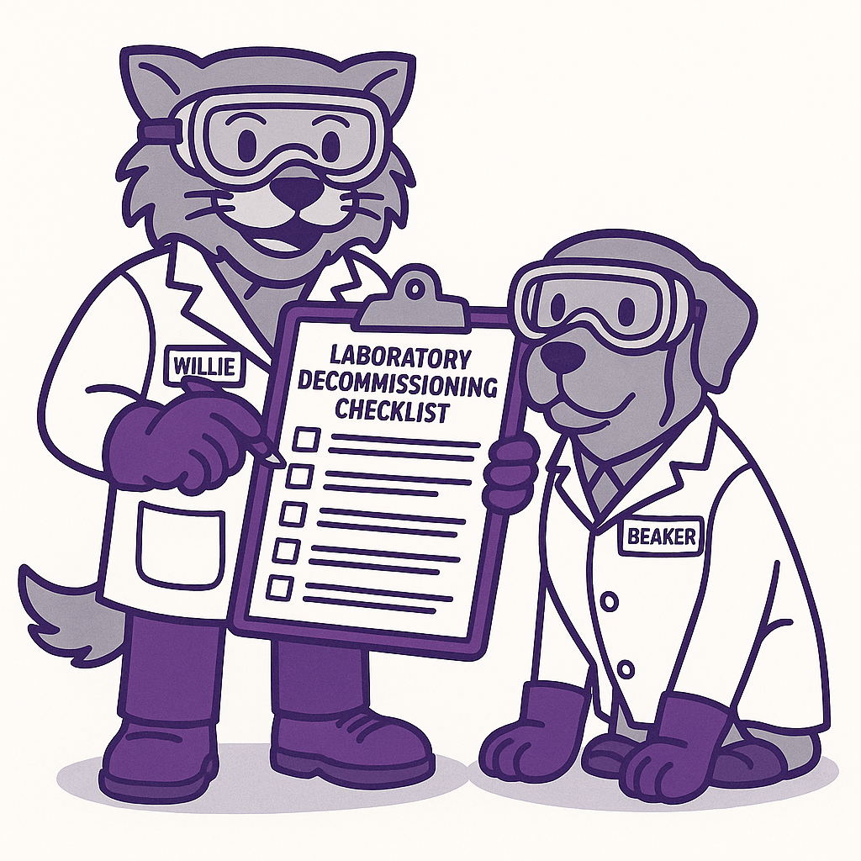WPCC DCM Compliance Checklist

The Principal Investigator/ Responsible Official, Department Head/ Chair, and Department Safety Coordinator covered under this WPCC agree to complete the following requirements for retaining Methylene Chloride (DCM) on campus aligned with EPA 40 CFR Part 751 (Methylene Chloride Final Rule) by the dates listed. These records must be maintained by the laboratory for at least 3 years. All costs incurred achieving compliance with DCM are the responsibility of the laboratory, facility, or university department. EHS will provide guidance and support toward completion of these requirements.

* Inventory Assessment

(Kansas State University Deadline June 30, 2025)

All departments must report their current use and storage of DCM to the Environmental Health and Safety (EHS) Office by June 30, 2025. [Complete the Methylene Chloride Inventory Survey](https://forms.office.com/r/BLjWvvfWGg)

* Procurement Approvals

(Effective immediately starting May 15, 2025)

Any future purchases of DCM must receive prior approval from the EHS Office immediately. Please send purchase requests to [safety@ksu.edu](mailto:safety@ksu.edu).

* Exposure Monitoring and Maintaining Personnel Exposure Below Regulatory Limits

(EPA Proposed Extended Deadline November 9, 2026)

All facilities/ laboratories declaring use of DCM must undergo initial monitoring to establish baseline exposure at the cost of the facility/laboratory/department. Facilities must establish and maintain exposure levels below the Existing Chemical Exposure Limit (ECEL) of 2 parts per million (ppm) as an 8‐hour time‐weighted average (TWA) and ensure short‐term exposure does not exceed the Short‐Term Exposure Limit (STEL) of 16 ppm over a 15‐minute TWA.

By checking this item, I agree to collaborate with EHS for initial and ongoing exposure monitoring for all activities and substances containing Methylene Chloride.

* Mandatory Training

Training sessions addressing new DCM handling protocols and safety measures will begin in July 2025 through EHS. All personnel using or working in areas that retain Methylene Chloride must attend, including faculty, staff, students, Principal Investigators/ Responsible Officials, Department Safety Coordinators, and Department Heads/Chairs.

* Workplace Chemical Protection Program (WCPP)

(EPA Proposed Extended Deadline May 10, 2027)

Laboratories, facilities, or departments electing to retain DCM must implement a comprehensive Workplace Chemical Protection Program (WCPP) by May 10, 2027. This completed, signed document serves as the WCPP for the locations and uses of DCM specified in this document only.

* Respiratory Protection

(EPA Proposed Extended Deadline February 8, 2027)

Laboratories, facilities, or departments retaining DCM must ensure that appropriate respiratory protection equipment is available and in use by February 8, 2027. Supplied air respirators (SCBA or airline) are required. All employees who will use DCM must enroll in the Respiratory Protection Program at K-State, complete a medical clearance, complete fit testing, and complete training at the cost of the employer.

* Regulated Area Demarcation

(EPA Proposed Extended Deadline February 8, 2027)

All regulated areas where Methylene Chloride may exceed established exposure limits must be demarcated by February 8, 2027. Signage, access controls, training, and recordkeeping (including access logs) are required. Details for how Regulated Area Demarcation for each location covered under this program are detailed in this WPCC.

WCPP Certification

By signing below, I certify that all procedures outlined in the Kansas State University Workplace Chemical Protection Program (WCPP) for Methylene Chloride have been implemented thoroughly, accurately, and in accordance with university policies and the Environmental Protection Agency (EPA) Final Rule on Methylene Chloride (40 CFR Part 751, Subpart B).

Signature Date

|  |  |  |  |
| --- | --- | --- | --- |
| Principal Investigator/ Responsible Individual |  |  |  |
| Department Head/ Chair |  |  |  |
| Department Safety Coordinator |  |  |  |
|  |  |  |  |

Individuals Approved for Methylene Chloride Use under this WCPP

|  |  |  |  |
| --- | --- | --- | --- |
| Individual Full Name | KSU eID (if applicable) | Position/ Job Title | Approved Activities |
|  |  |  |  |
|  |  |  |  |
|  |  |  |  |
|  |  |  |  |
|  |  |  |  |