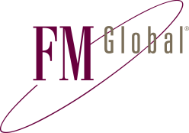
KANSAS BOARD OF REGENTS
Factory Mutual Insurance Company
12645 Olive Boulevard Ste 400
St. Louis, MO 63141 USA
T: +1 (1)314 453 9660 www.fmglobal.com

Send Request To: dawn.stilwell@fmglobal.com

Certificate Request

Insured Information
University
Facility Name | Click here to enter text.
Facility Address
City, State, ZIP

Certificate Holder Information
Certificate Holder Name
Attention
Address
City, State, ZIP

Basic Certificate Information
Type of Certificate | Please choose one.
Notices Required | Not Applicable
Description of Property Covered
Additional Information

Description of Property Covered
Property Value to be shown on Certificate (Limit of Liability)
Coverage to be evidenced on Certificate | Please choose one.  Please choose one.

