**Salary Match, Cost Share How-to**

Personnel time committed to a sponsored project that will not be paid from the project’s sponsored funds is considered cost sharing or matching. Salaries earmarked as matching funds for a grant must be allocated in HRIS to the specified match account corresponding to that award. These cost-share commitments are recorded in Cayuse, and upon issuance of FIS projects for the award, a dedicated match account, prefixed with 'M', is established for the lead department. A summary outlining the matching and cost-share commitments is dispatched by Sponsored Programs to the contact person in the lead department, with payroll match detailed on the initial page (see example below). Subsequently, upon receipt of the match account details, it becomes the department's responsibility to allocate at least the equivalent amount of payroll to the 'M' account and to execute budget/funds transfers, ensuring equal sums are deposited into the account. It is also the lead department’s responsibility to communicate with and coordinate with other departments to ensure their personnel, with time committed, are charged to the match account.

**Example**

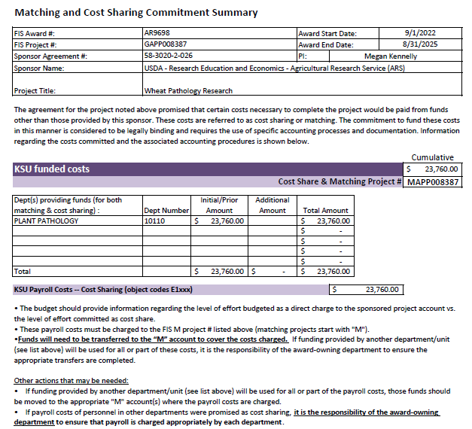

1. Upon receipt of a salary cost share matching letter, log into Cayuse to confirm the individuals listed on the project administration personnel tab and their corresponding percentage rates. Alternatively, cross-reference the cost-share details within a budget attachment to determine the appropriate payroll rates for each individual involved, as well as to check for non-faculty personnel who may have time commitments to the project. Because fringe benefits are budgeted at the maximum rate and often higher than the actual rate, it is advisable to round up the percentage that is charged to the match account to ensure that the dollar amount of cost share commitment is met within the project period.

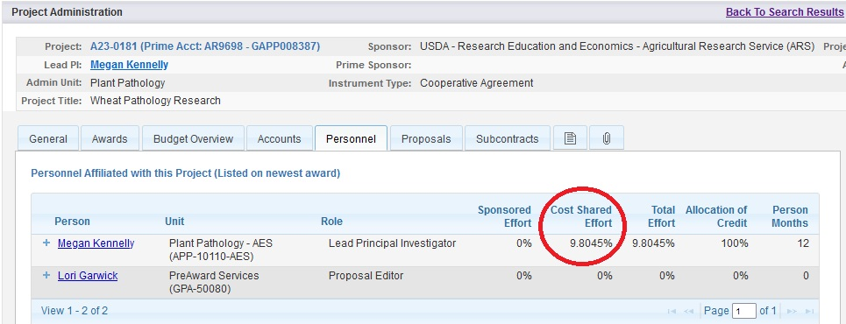

1. [Edit the payroll funding table](https://www.k-state.edu/hr/tools/hcs-liaisons/guidance-procedures/payroll/index.html) (or ask your HR liaison to do this step if you are not responsible for payroll) for the employee(s) position in HRIS (aligning with the start date of the award or the beginning of the next pay period thereafter) to direct the correct percentage of the employee’s payroll, taxes, and deductions onto the M project for the award. Use the org and fund source of the funding you’d otherwise have used to pay this person’s salary (since you will fund the M account with funds from your employee payroll accounts). If the award has been set up past the start date, then you may need to do payroll transfers to ensure cost sharing an adequate amount.

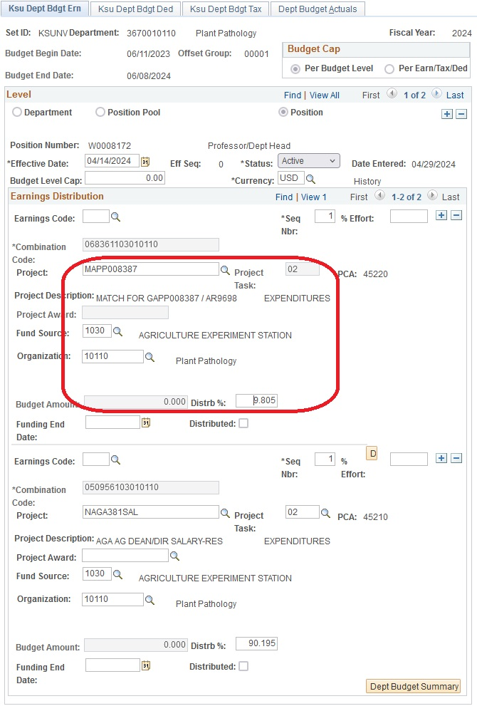

1. Monitor expenses paid from the M account in either FIS or your internal shadow system. In FIS, run the report titled KSU Acct Balance > Account Balance. There are two ways to fund the M accounts.
   1. Reimbursement method: The account balance will accumulate a negative balance. Quarterly, process a budget transfer to allocate funds into the M account, balancing it to zero. Upon reaching the required match expenditure for your project's cost share, adjust the payroll funding table to restore the employee(s) to their initial payroll funding source.
   2. Advance method: Process a budget transfer to allocate funds to the M account. The FIS account balance report will show the difference between the advanced funds and expenses that have posted. With the advance method on a multi-year award, you will probably choose to advance the funds in increments (for instance, at the beginning of each fiscal year or semester). Monitor RADAR report and once cost share commitment is met, adjust payroll funding table to restore the employee(s) to their initial payroll funding source.
   3. Note: Please be cautious if the assigned M account does contain both payroll and non-payroll expenses. It may be advisable to track payroll and non-payroll matching with two different subaccounts in a departmental shadow system since the timing and/or source of the funds being used to reimburse or advance the funds will likely be different.

**FAQ’s**

Q. **What FIS account do I use for salary cost share match?**

A. Use the FIS project starting with “M” associated with the award that is set up by SPA and listed on the match commitment letter.

Q. **What fund source and org should I use?**

A. Match the fund source and org to the funding you’d otherwise have used to pay this person’s payroll. Then when you process a budget/funds transfer to move funds from your salary account into the match account it will net to zero.

Q. **Multiple departments committed salary match. How do we handle this?**

A. The lead department is responsible for collaborating with other departments to facilitate the reallocation of payroll funding for their respective personnel. Subsequently, the collaborating units should execute budget transfers to reimburse their portions. This approach may result in multiple organization and fund source numbers associated with the same M account, with each department's allocation netting to zero. Tracking total commitments should be conducted through FIS to monitor expenditures across various departments.

Q. **What if there is a significant delay between an award’s start date and account set up?**

A. You may need to do payroll transfers to ensure the award’s total cost share commitment is met. Be sure to look at projections and determine if this is necessary when setting up the M account in the payroll funding table.

Q. **What happens if the department forgets to transfer funds into the match account to obtain a zero balance?**

A. If no funds have been transferred in for two consecutive quarters, a notice will be sent to the department contact and PI. After three consecutive quarters, if the M account is still not adequately funded, a notice will be sent to the Department Head and the account will be placed on hold in FIS.

Q. W**hat if we exceed the match requirements before reversing payroll funding?**

A. Going over the requirement is allowed and can easily happen with paycheck amount variability. Just be sure to net the M account to zero by transferring in the exact amount you spent, not just the committed match amount. If you exceed the match amount by a large amount, you could also do payroll transfers to move the payroll off the M account and back to your salary account. In other words, payroll match expenditures do not have to align exactly with committed amounts.

Q. **What FIS reports can I run that include match account information?**

A. **KSU Acct Balance > Account Balance**: YTD actual figure represents the difference between expenditures and revenue.

A. **KSU Revenue & Expenditures > Revenue and Expense – Accrual Basis**: expenditure and revenue detail by object code for each month, per fiscal year.

A. **KSU Transactions Report > Transaction Detail**: detail for each individual expenditure and revenue transaction.

A. KSU Month-End Report: combines the Account Balance and Transaction Detail in one report as of the most recent month end.