Does Semantic Knowledge Influence Event Segmentation and Recall of Text?

Kimberly M. Newberry and Heather R. Bailey Kansas State University

Author Note

Kimberly M. Newberry, Department of Psychological Sciences, Kansas State University. Heather R. Bailey, Department of Psychological Sciences, Kansas State University.
Correspondence concerning this article should be addressed to Kimberly M. Newberry, Department of Psychological Sciences, 1114 Mid Campus Drive North, Bluemont Hall 492, Kansas State University, Manhattan, K.S., 66506, USA.
Contact: kmanewberry@ksu.edu

Word count: 7,540, excludes title page, abstract, references, and appendix

Abstract

Knowledge benefits episodic memory, particularly when provided before encoding (Anderson & Pichert, 1978; Bransford & Johnson, 1972). These benefits can occur through several encoding mechanisms, one of which may be event segmentation. Event segmentation is one’s ability to parse information into meaningful units as an activity unfolds. The current experiment evaluated whether two top-down manipulations – providing context or perspective taking – influence the segmentation and memory of text. For the ambiguous texts in Experiment 1, half the participants received context in the form of a title, whereas the other half received no context. For the text in Experiment 2, half the participants read from the perspective of a burglar and the other half read from the perspective of a homebuyer. In both experiments, participants read the passages, recalled the information, and then segmented the passages into meaningful units. Consistent with previous findings, participants who received context recalled more information compared to those who received no context, and participants in one perspective were more likely to recall information relevant to their perspective. Most importantly, we found that context and perspective facilitated more normative segmentation; however, the differences were small and suggest that effects of top-down processing on the segmentation of text may be modest at best.
Thus, event segmentation processes that operate during text comprehension are influenced by semantic knowledge but may be more heavily driven by other factors (e.g., perceptual cues).

Keywords: event cognition, segmentation, knowledge, memory

Semantic Knowledge Influences Event Segmentation and Recall of Text

Decades of research have shown that prior knowledge supports memory (e.g., Anderson

& Pichert, 1978; Miller, 2003; Soederberg-Miller, Cohen & Wingfield, 2006), particularly when it can be used during encoding (e.g., Bransford & Johnson, 1972). However, the conditions under which knowledge facilitates moment-to-moment processing during encoding are less well known. Thus, the current study investigated the influence of knowledge on one specific encoding mechanism – event segmentation, which is one’s ability to parse information into meaningful units as an activity unfolds. Specifically, we evaluated the extent to which different knowledge manipulations (context and perspective taking) influence the segmentation and memory of texts. We chose texts because the influence of prior knowledge on text comprehension and memory has been well established (e.g., Anderson & Pichert, 1978; Bransford & Johnson, 1972; Hasher
& Griffin, 1978), and the saliency of perceptual cues present in video that typically drive event segmentation (e.g., motion & light; see Cutting, Brunick & Candan, 2012) must be inferred from text. Furthermore, little prior work has evaluated the influence of knowledge on the segmentation of texts. To begin, we discuss how knowledge shapes memory, and then how it may do so through event segmentation. We then discuss factors that influence segmentation, whether effects of knowledge on segmentation may be similar for video and text, and end with an overview of the approach and predictions for the current study.

How Does Knowledge Shape Memory?

A wealth of research has demonstrated the influence of top-down processing, particularly the role of prior knowledge, on memory (e.g., Anderson & Pichert, 1978; Bower, Black, & Turner, 1979; Bransford & Johnson, 1972; Brewer & Treyens, 1981; Dooling & Lachman, 1971; Gardner & Schumacher, 1977; Miller, 2003). For example, Bransford and Johnson (1972) used

Bartlett’s (1932) concept of schema to evaluate memory for ambiguous passages. Participants were asked to read and recall ambiguous passages; however, one group was given context in the form of a title and the other group was not. Recall was better for those who had been given context, especially when the context was provided prior to reading the passages (i.e., at encoding). Such effects indicate that context activates relevant knowledge or schemata and allows readers to encode the information from the passages in a more meaningful way (Auble & Franks, 1978; Bransford & Johnson, 1972; Soederberg-Miller, Cohen & Wingfield, 2006).
Similarly, Anderson and Pichert (1978) evaluated the effects of prior knowledge on text comprehension. They instructed participants to read and recall a story from different perspectives (burglar vs. homebuyer) and found that perspective-relevant information was better remembered than perspective irrelevant information, suggesting that knowledge shapes memory. This effect has been replicated using other perspective manipulations (e.g., Hasher & Griffin, 1978) and other dependent measures (eye-tracking, Kaakinen, Hyona, & Keenan, 2002, 2003; fMRI, Lahnakoski et al., 2014). However, little explanation has been offered as to the precise encoding mechanism affected by prior knowledge. We know knowledge shapes memory, but how? Work from the expertise literature suggests that experts’ superior memory in their field is due to better chunking of the to-be-remembered information (e.g., Ericsson et al., 2004; Thompson et al., 1993); therefore, readers may use prior knowledge to more effectively chunk information.

Could Knowledge Influence Memory Through Event Segmentation?

Two theories of event cognition, Event Segmentation Theory (EST; Zacks et al., 2007) and the Event Horizon Model (Radvansky, 2012), describe how information is chunked, or segmented, in time and also specify a role for prior knowledge in this process. According to these theories, people construct representations, or event models, of real-world or described

events (Radvansky, 2012; for mental models see also Johnson-Laird, 1983; van Dijk & Kintsch, 1983; Zwaan & Radvansky, 1998), to effectively perceive and remember information. According to EST, as people observe activity from a real-world experience or in a video, or read about it in a text, information pertaining to the current event is captured and maintained within an event model in working memory (Radvansky & Zacks, 2014). Information represented in the event model may be influenced by both salient perceptual features from the environment (e.g., motion, body position; Zacks, 2004) and conceptual factors such as episodic memory and semantic knowledge (e.g. knowledge structures – schemas: Bartlett, 1932; scripts: Schank & Abelson, 1977) relevant to the current situation. Thus, EST provides an explicit role for knowledge in the encoding of events (Kurby & Zacks, 2008; Radvansky & Zacks, 2017; Zacks, Speer, Swallow, Braver, & Reynolds, 2007).
When one part of an activity ends and a new part begins, EST proposes that working memory is updated to reflect the changing situation. The points in time when the event model is updated are called event boundaries and research suggests they are important for event memory (Boltz, 1992; Radvansky, 2012; Radvansky & Zacks, 2017; Schwann & Garsoffky, 2004).
Individuals tend to agree on the location of event boundaries (e.g., Sargent et al., 2013), and the extent to which they segment at normative locations (in agreement with the majority; i.e., segmentation agreement), the better memory their memory is for those events (Bailey et al., 2013; Sargent et al., 2013; Zacks, Speer, Vettel, & Jacoby, 2006).
Importantly, the Event Horizon Model expands upon EST by providing a framework for understanding how episodic memory is influenced by segmentation (Radvansky & Zacks, 2017). According to this model, memory benefits when retrieval is “noncompetitive,” and the to-be- remembered information is stored in multiple events (Radvansky, 2012, p. 271). The Event

Horizon Model claims this relationship is due to the important effect event boundaries have on memory: they reduce retroactive interference by separating information into different event models, which leads to better overall memory for the activity (Radvansky & Zacks, 2017).
However, there are also times when memory may be impaired. If the goal is to remember a single event and this event has occurred multiple times, retrieval may be hindered by interference (e.g., Radvansky & Copeland, 2006b). In the current study, we evaluated memory for the entire event; thus, we expected the event boundaries from segmentation of the texts to enhance memory.

What factors influence event segmentation?

The majority of work on event segmentation has found that perceived event structure is primarily associated with perceptual features (Zacks et al., 2007; Zacks, Speer, & Reynolds, 2009). For example, event boundaries often align with a greater number of feature changes such as changes in actor body position (Newtson, Engquist, & Bois, 1977), changes in spatial location (Magliano, Miller, & Zwaan, 2001), and body movements (Zacks, Kumar, Abrams, & Mehta, 2009). Additionally, neuroimaging studies have found increased brain activity in regions associated with motion processing (e.g., extrastriate motion complex) at perceived event boundaries (Speer et al., 2003; Zacks et al., 2001).
Despite these results, other research has provided some evidence in support of the influence of top-down processing on segmentation. For instance, segmentation is affected by expectation (Massad, Hubbad & Newtson, 1979) and the perceived goal structure of an activity. Specifically, when goals are unknown, or the activity appears random, viewers tend to segment more often (Hard et al., 2006; Wilder, 1978) and rely more on movement features to identify event boundary locations (Zacks, 2004), as compared to when they view goal-directed activity.

In fact, the goal structure of an activity is important even in infants (Baldwin, Baird, Saylor, & Clark, 2001). These findings illustrate how bottom-up and top-down processing interact to influence event segmentation, such that conceptual features, such as knowledge of goal structure may modulate how perceptual features are encoded, albeit the effect appears to be small.
More recently, researchers have evaluated effects of knowledge on segmentation behavior, specifically using an expert-novice paradigm. Blasing (2015) investigated the extent to which familiarity of observed movement influences segmentation of a dance phrase. Similar to the observation that people segmented familiar activity less often (Hard et al, 2006; Wilder, 1978; Zacks, 2004), Blasing found that experts segmented less often and, thus, perceived fewer events. Moreover, amateur dancers perceived fewer events in the dance phrase less after they were familiarized with it. Likewise, Levine, Hirsh-Pasek, Pace, and Golinkoff (2017) asked experts and novices to segment an Olympic figure-skating routine and found that experts perceived fewer, longer events.
Though these studies provide initial evidence that knowledge influences how an event is perceived, these effects have been restricted to videos. Further, the combined influence of knowledge and segmentation on memory remains unknown. Could knowledge shape memory for texts by influencing segmentation behavior? To more directly evaluate these issues, the current study manipulates knowledge in the forms of context and perspective taking, using multiple texts, and includes event segmentation and memory as dependent measures.

Is segmentation of videos and texts similar?

Although EST originally was proposed to explain visual perception, several experiments have evaluated the segmentation of text materials (Bailey & Zacks, 2015; Bailey, Kurby, Sargent
& Zacks, 2017; Kurby & Zacks, 2012; Pettijohn, Thompson, Tamplin, Krawietz & Radvansky,

2016; Speer & Zacks, 2005; Speer, Reynolds, Swallow, & Zacks, 2009; Swets & Kurby, 2016). However, it is unknown whether similar event segmentation processes occur while reading text or whether conceptual factors, such as knowledge, have a similar influence on the segmentation of texts and visual events. Readers may rely more strongly on knowledge to guide comprehension while reading text, compared to watching videos, due to the lack of perceptual cues that would normally capture attention in video (e.g., changes in motion, light, color).
Additionally, prior knowledge may differentially influence the segmentation of different types of text (Kaakinen & Hyona, 2008). Stories reveal their context as they unfold, which allows readers to focus less on detail and more on the gist, mapping information onto existing schemas and make inferences based on world knowledge. Other types of ambiguous or more procedural text may be less familiar due to a lack of causal conjunctions (Graesser, McNamara,
& Louwerse, 2003) and may therefore require more of a reliance on general knowledge. If, for example, one was tasked with reading an ambiguous text with no context, it might be difficult to construct an event model to aid comprehension of the text. Thus, impoverished event models of text could lead to idiosyncrasies in how readers segment and understand text.
However, it is also possible that knowledge may not influence the segmentation of such texts. While these texts do not contain the same perceptual cues as videos, readers may rely on aspects of the structure of the text (e.g., grammar, syntax) to segment (Hearst, 1994; Lorch, 1989). For example, research in discourse processing and computational linguistics has shown that texts can be broken into segments that reflect their subtopic structure using algorithms based on lexical cohesion, such as word overlap and co-occurrence (e.g., Hajime, Takeo, Manabu, 1998; Hearst, 1997; Manabu & Takeo, 1994) as well as using syntactic boundaries (clauses, sentence endings; Stine, Cheung & Henderson, 1995) and punctuation (Chafe, 1988).

Segmentation-memory relationship in text. Previous work has observed a relationship between segmentation and recall for dynamic events, such that normative segmentation is associated with better memory (e.g., Bailey et al., 2013; Kurby & Zacks, 2011; Sargent et al., 2013; Zacks et al, 2006). The Event Horizon Model claims that event boundaries help separate information into different event models, which reduces retroactive interference and improves recall (e.g., Pettijohn & Radvansky, 2016; Pettijohn et al., 2016). Thus, it is possible that the memory facilitation reported in Bransford and Johnson (1972) and Anderson and Pichert (1978) was due, at least in part, to differences in segmentation.

Overview

To that end, the purpose of the current study was to investigate whether knowledge shapes memory for texts through changes in segmentation. We used the materials and methodology from two previous studies, which afforded straightforward manipulations of prior knowledge, with the same set of participants. First, we used Bransford and Johnson’s (1972) use of titles as context for ambiguous passages in Experiment 1 and Anderson and Pichert’s (1978) use of perspectives in Experiment 2. Both context and perspectives should activate relevant schema, help construct the event model and result in better segmentation and better memory.
Thus, we hypothesized that readers in Experiment 1 who received context (i.e., knowledge) would recall more than those who received no context, replicating Bransford and Johnson (1972) and readers in Experiment 2 would recall more perspective-relevant information, replicating Anderson and Pitchert (1978). Further, we hypothesized readers with context and those with the same perspective would have higher segmentation agreement as a result of activating similar knowledge. Finally, we hypothesized that higher segmentation agreement would be associated with better recall for events from the text.

Experiment 1: Context

The purpose of Experiment 1 was to evaluate the influence of knowledge on the perception and memory for ambiguous texts. Specifically, we adopted the methodology from Bransford and Johnson (1972), such that knowledge, or context, was manipulated in the form of an informative title (title vs. no title) for each story. Without a title, each story is very vague and easily misunderstood.

Method

Participants. A total of 116 participants (51.72% female, M age = 19.75, SD = 2.70) were recruited from the Kansas State University Psychology Department’s SONA Participant Pool. Sample sizes were based on power analyses conducted using G*Power with an alpha level of .05, 95% power, and an effect size of 1.3 (based on effect size from Bransford & Johnson, 1972, Experiment 2). Participants were compensated with course credit as per Department policy.
Materials. The texts and tasks used in this experiment are described in detail below.

Ambiguous passages. The texts used in this experiment were passages written about familiar activities using an ambiguous style, such that a title should be necessary to understand the text. Two passages (“Washing Clothes” and “Flying a Kite”) were used in Bransford and Johnson (1972), and one passage (“Driving a Car”) was used in Miller and Stine-Morrow (1998; see Appendix). Passages varied in length from 111 to 180 words and 15 to 21 idea units.
Distractor tasks. Two-minute distractor tasks were used to reduce recency effects in text recall. The Title Recognition Test (Cunningham & Stanovich, 1990) and a demographics questionnaire were used as filler tasks. The Title Recognition Test presented book titles to the participant one at a time. The participant indicated whether or not the title was a real book.

Design and Procedure

Context was treated as a between-subjects variable such that participants were randomly assigned to either the Title (N = 58) or No Title (N = 58) group. Ambiguous text was treated as within-subjects, such that all participants read each text (Story 1 vs. Story 2 vs. Story 3). Those in the Title group received a title as context for the ambiguous stories whereas those in the No Title group received no title. Story order was not counterbalanced; however, story was included as a random effect in the analyses, where appropriate, to account for variance across the stories.
The participants entered the lab in small groups of 3 or 4. They filled out an informed consent form and then each sat down at his or her own computer. Participants were presented with an ambiguous story onscreen, with or without a title. Story 1 (“Washing Clothes”) always appeared first, followed by Story 2 (“Flying a Kite”), and finally Story 3 (“Driving a Car”).
Each story was presented in its entirety and participants self-paced their reading of each story. Once they had finished reading a story, they performed a 2-minute distractor task. After completing the distractor task, the computer screen automatically moved on to the free recall screen. Participants were presented with a blank text box and asked to recall as much information about the story as possible. Once recall for a story was completed, participants moved on to the next story in the sequence. This process was repeated for each of the stories.
After recalling information from the final story, participants were asked to segment each story. Within each story checkboxes were placed at the end of each sentence, and participants were instructed to mark each location in which, in their opinion, one part of an activity ended and another began. We constrained segmentation locations to sentence breaks only, based on previous research on the segmentation of text materials (Bailey, Kurby, Sargent & Zacks, 2017). Bailey et al. found that participants only identify event boundaries in the middle of a sentence

approximately 3% of the time and most often this occurred at a semicolon. A check mark indicated the participant perceived an event boundary. Story order for the segmentation task was the same as above. There was no time limit for the event segmentation portion of the experiment. Once the participants finished segmenting the final story, they continued on to Experiment 2.

Results

Data preparation. Prior to the main analyses, two outliers in the recall data (2.5 standard deviations away from the mean) were identified and removed from all recall analyses.
Additionally, two participants failed to identify any event boundaries and they were removed from all segmentation analyses.
Influence of context on recall. Adopting Bransford and Johnson’s (1972) method, free recall was scored as number of idea units correctly recalled. The total number of idea units for each story was predetermined (Washing Clothes = 21; Flying a Kite = 15; Driving a Car = 20). Two research assistants scored the recall data (inter-rater reliability ranged from .94 to .97 across stories), giving participants a 1 if they recalled an idea unit correctly and a 0 if they did not.
Performance was scored as the number of correctly remembered idea units for each story. A generalized Poisson multilevel model was used to determine the fixed effect of
Context (Title vs. No Title) on free recall performance, from the random effects of subject and story. The results were consistent with the first hypothesis, such that the Title group recalled a significantly higher number of idea units (M = 5.20, SE = .25, CI 95% = [4.71, 5.69]) compared to the No Title group (M = 4.10, SE = .25, CI 95% = [3.60, 4.61]), z = 2.02, p = .043, d = 0.36.
This result replicated Bransford and Johnson (1972), indicating that context provided at encoding facilitates better recall.

Influence of context on segmentation. In the next section, we evaluated whether context influences the number of perceived boundaries in an ambiguous text, as well as segmentation agreement. Segmentation was restricted to sentence breaks, following Bailey et al., (2017). As such, the maximum number of segments that could be identified varied by story (Washing Clothes = 15; Flying a Kite = 14; Driving a Car = 9).
Number of event boundaries. Given that previous evidence indicates that familiarity and expertise lead to fewer perceived event boundaries (e.g., Blasing, 2015; Hard et al, 2006; Wilder 1978a; 1978b; Zacks, 2004), we expected the Title group to segment less often than the No Title group. We conducted a generalized Poisson regression on the number of perceived boundaries, which included context as a fixed effect and subject and story as random effects. We found that the Title (M = 5.39, SE = 0.20, CI 95% = [5.00, 5.78]) and No Title groups (M = 5.46, SE = 0.21,
CI 95% = [5.05, 5.88]) segmented equally often (p > .250; Figure 1A), which did not replicate previous findings and may have been due to the limited number of opportunities at which to segment or limited influence of knowledge on segmentation.
Segmentation agreement. Segmentation agreement scores were computed for each participant by computing a point-biserial correlation for each participant, for each story, using the Title group for comparison and then scaling the correlations to control for individual differences in the number of event boundaries identified. Agreement scores could range from 0 to 1, with higher values indicating more agreement with the group (for similar methods, see Bailey et al., 2013; Kurby and Zacks, 2011). We hypothesized that the Title group would exhibit higher segmentation agreement.

Mean segmentation agreement for each group is plotted in Figure 1B. A linear multilevel model was used to determine the fixed effect of context on segmentation agreement, from the random effects of subject and story. We found a significant effect of context, such that segmentation agreement was higher for the Title group (M = 0.80, SE = .01, CI 95% = [0.77,

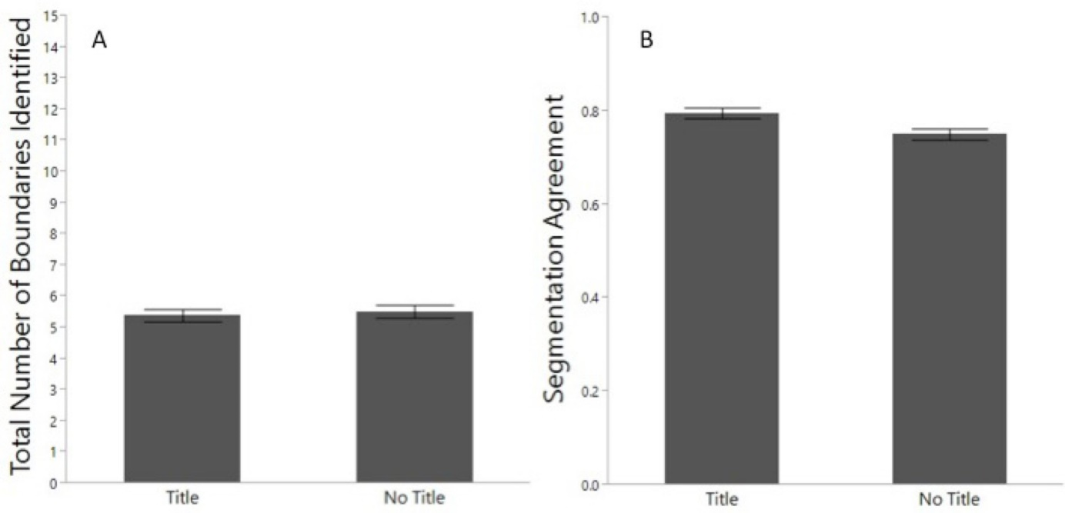

Figure 1. (A) Mean number of boundaries identified and (B) mean segmentation agreement by context group. Error bars indicate standard error of the mean.
0.82]) compared to the No Title group (M = 0.75, SE = .01, CI 95% = [0.72, 0.77]), t = 2.71, p <

.05, d = 0.33. Our agreement values were fairly high, compared to previous studies, which was likely due to the limited number of opportunities at which to segment, but the group difference in segmentation agreement was of moderate size (Cohen, 1992). This result partially supported our hypothesis, indicating that context facilitated more normative segmentation of ambiguous texts.
Readers who received a title had higher agreement on the locations of event boundaries compared to readers who do not receive a title. What drove their perception of boundaries? To address this question, all of the texts were coded for causal breaks and character-object interactions. (Other situational dimensions, such as characters, locations, and time, were not

coded because the texts did not contain changes along these dimensions.) Surprisingly, both groups were equally likely to segment at causal breaks, p = .816, and at character-object interactions, p = .866. In another analysis, we used Latent Semantic Analysis (LSA) to evaluate whether the degree of sentence cohesion predicted segmentation at each sentence (Landauer, Foltz, & Laham, 1998). We calculated the LSA values between each pair of adjoining sentences and expected that sentences with lower LSA scores (i.e., low sentence cohesion) would indicate a break in the activity and thus correspond to an increased likelihood of segmentation. We also expected that, without context, participants in the No Title group would be more likely to use cohesion as a cue for segmentation. However, LSA predicted likelihood of segmentation only for the Washing Clothes story (p < .001), and this effect was the same for both groups (p = .19).
Interestingly, even though there was a reliable group difference in overall segmentation agreement, the probability of segmenting at each sentence was remarkably similar for both groups (Figure 2). To further investigate group differences in segmentation at the sentence level, we ran a generalized linear multilevel model with the fixed effects of context, sentence, and their interaction, along with the random effect of subject, predicting segmentation. Group differences in segmentation likelihood occurred only at a few sentences, such as “Car” sentence 6 as well as “Washing Clothes” sentence 9 and 12. However, after correcting for multiple comparisons (Car α = .006; Kite and Washing Clothes α = .004), none of these differences were significant.

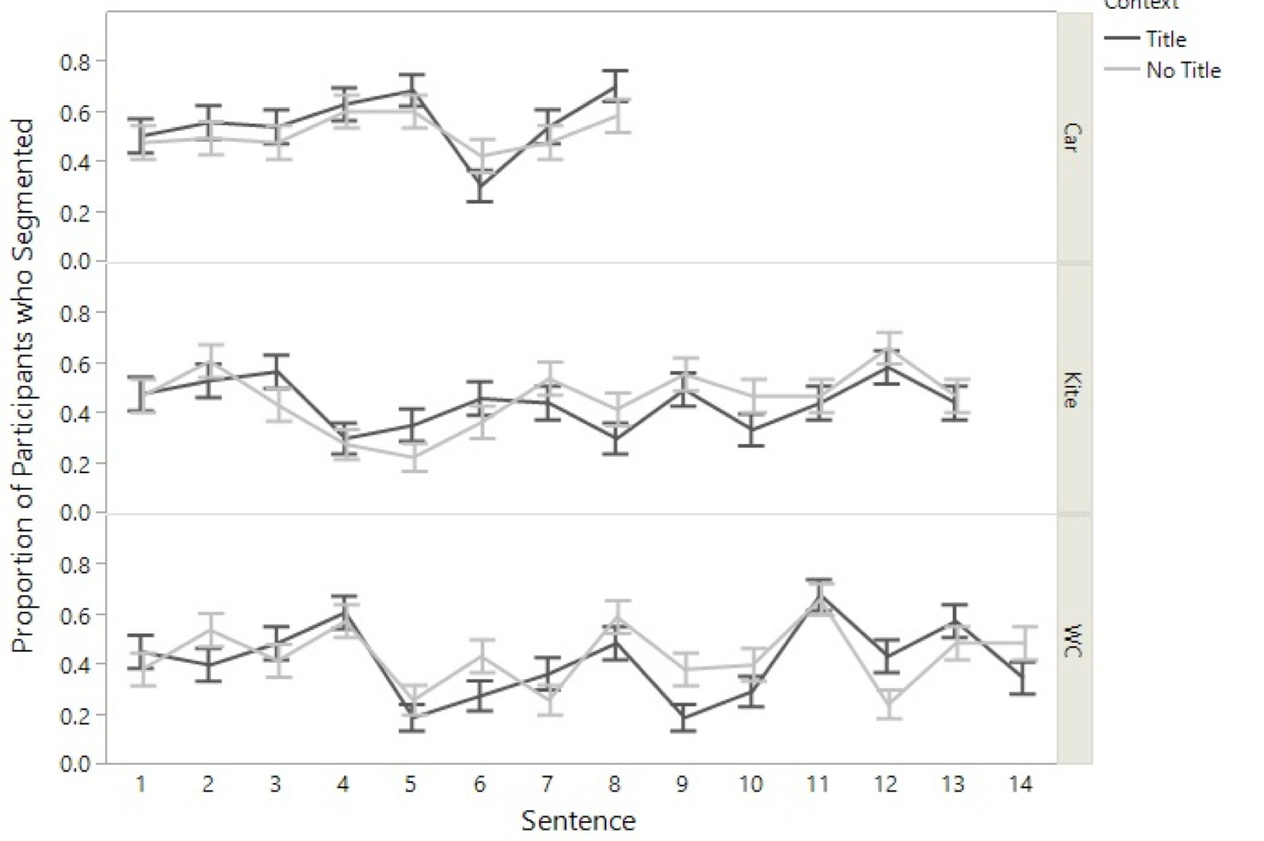
KNO 16

WLEDGE & EVENT SEGMENTATION

Figure 2. Proportion of participants from the Title and No Title groups who segmented at each sentence in each story. Error bars indicate standard error of the mean. “Car” = Driving a Car story; “Kite” = Flying a Kite story; “WC” = Washing Clothes story

Does segmentation agreement predict recall? Previous research has found a positive relationship between segmentation agreement and memory using videos (Bailey et al., 2013, Sargent et al., 2013). We evaluated this relationship using text, and evaluated whether it was stronger for the Title group. A generalized Poisson multilevel model was used to determine the full factorial of the fixed effects of segmentation agreement and context on free recall performance, from the random effects of subject and story. Neither segmentation agreement (z = 1.26, p = 0.210), context (z = 0.91, p > .250), nor their interaction (z = -0.24, p > .250) significantly predicted free recall (see Figure 3).

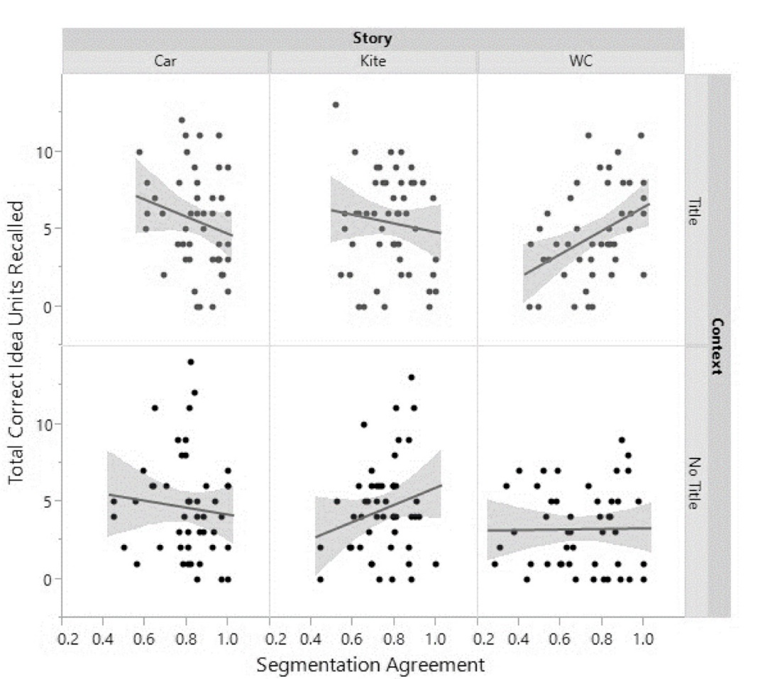

Figure 3. Recall count predicted by segmentation agreement by context group, for each story. Shaded areas indicate confidence of the fit of the line. “Car” = Driving a Car story; “Kite” = Flying a Kite story; “WC” = Washing Clothes story

Discussion

The results of Experiment 1 replicated the effect of context on memory (Bransford & Johnson, 1972) and provided initial evidence that context facilitates normative segmentation; however, it was a moderate effect. Readers given context for the ambiguous texts had higher segmentation agreement than readers given no context, but the two groups identified a similar number of event boundaries, unlike previous work (Blasing, 2015; Hard et al, 2006; Wilder 1978a; 1978b; Zacks, 2004). Further, unlike previous work, segmentation agreement did not predict memory for these texts.
There are a few possible explanations for these unexpected results. First, results obtained in prior work may be due to events presented in a visual format (i.e., videos and dance phrases). Second, although we expected people without relevant knowledge to segment less often, some

prior evidence has shown that they segment less often when they are confused by the stimuli (e.g., watching a film backwards, Hard et al., 2006). Thus, in the current study, the ambiguity of the texts may have led to confusion and difficulty in identifying boundaries. Third, the Event Horizon Model posits that memory is benefitted when information is segmented into separate event models; therefore, we expected segmentation to predict memory. However, the ambiguity and the odd, repetitive structure of the texts (even with a title provided) may have prevented readers from effectively segmenting. Finally, and relatedly, each of these texts were fairly short (9-15 sentences), constraining the number of potential perceived events. Using a different knowledge manipulation, Experiment 2 addresses the last three possibilities by using a longer, less ambiguous text and giving everyone the opportunity to activate relevant, prior knowledge.

Experiment 2: Perspective

Goals and instructions are other mechanisms by which knowledge can be experimentally manipulated. Goals, for instance, provide individuals with a framework prior to engaging in some task, which can then influence how they perform that task (Anderson & Pichert, 1978; Hasher & Griffin, 1978; Schank & Abelson, 1977; 2013). McCrudden and Schraw’s (2007) Goal-Focusing model proposes a way in which reader goals influence text processing. This model proposes that readers adopt specific goals in response to various instructions (e.g., read text for enjoyment vs. read text to prepare for an upcoming test). These strategies, in turn, lead readers to pay attention to parts of the text that are most relevant to their goals. The instructions given to readers can influence reading times (Lorch, Lorch & Mogan, 1987), eye movements (Kaakinen & Hyönä, 2005; 2008; Kaakinen, Hyönä, & Keenan, 2002; 2003); as well as comprehension and memory for the text (Bohn-Gettler & Kendeou, 2014; Lehman & Schraw, 2002; Linderholm & van den Broek, 2002; Narvaez et al., 1999; Pichert & Anderson, 1977).

Further, Bailey et al., (2017) found that reader goals influence how people segment texts. In this study, readers were instructed to pay attention to the characters or to the spatial locations mentioned in the story and then segment the text. They found considerable differences in the segmentation behavior; specifically, readers attending to space were significantly more likely to segment when a change in spatial locations occurred. To further investigate this idea, we manipulated reader goals by instructing the same participants from Experiment 1 to read a text from different perspectives, adopting the methodology from Anderson and Pichert (1978).
Since individuals in both conditions were given a perspective (i.e., both had prior knowledge), we did not expect to see differences in overall recall; however, we hypothesized that individuals would remember more perspective-relevant information, replicating Anderson and Pichert (1978). We did not expect differences in the number of perceived events, but we did expect that a participant’s segmentation behavior would be more similar to other individuals within the same perspective as compared to those from a different perspective. Finally, even though we found no relationship between segmentation agreement and memory in Experiment 1, we expected that segmentation agreement would predict memory in Experiment 2.

Method

Participants. The same participants from Experiment 1 participated in Experiment 2.

Materials. The story used in this experiment was the “House” story from Anderson and Pichert (1978; see Appendix). This story describes two boys staying home from school and touring a house. It contains 22 sentences, 374 words, and was coded for 50 idea units.
Distractor task. The Author Recognition Test (Stanovich & West, 1989) was used as a 2- minute distractor task to reduce recency effects in recall. Names were presented one at a time on the screen and participants indicated whether or not the name presented was a real or fake author.

Design and Procedure

The design and procedure were the same as in Experiment 1, with 2 exceptions. First, only 1 text was presented. Second, the main manipulation was that participants were instructed to read the “House” story from a randomly assigned perspective (n = 58 burglar or n = 58 homebuyer). After competing this portion of the study, participants were debriefed and compensated for their time with course credit.

Results

Data preparation. Prior to the main analyses of perspective, 8 outliers in the recall data (2.5 SDs away from the mean) were identified and removed from all recall analyses. Likewise, 6 participants failed to identify any event boundaries and were removed from all segmentation analyses. Similar to the ambiguous texts, the total number of idea units for the narrative House story was predetermined (N = 50). However, the text was also coded for Burglar relevant idea units (N = 17) and Homebuyer relevant idea units (N = 17). Two research assistants scored the recall data with an inter-rater reliability of .94 and gave participants a 1 if they recalled an idea unit correctly and a 0 if they did not. Performance was the total number of correctly remembered idea units as well as the number of correctly recalled burglar idea units and homebuyer idea units. Additionally, segmentation was restricted to sentence breaks. Unfortunately, due to a programming error, segmentation data for the final sentence break was not collected and, therefore, segmentation data for sentences 20 and 21 were combined into one sentence.
Influence of perspective on recall. A generalized Poisson multilevel model was used to determine whether 1) recall amount was the same across the two perspectives, and 2) whether individuals were more likely to recall information relevant to their own perspective. We expected that participants across both perspectives would recall similar amounts of information, but that

the information recalled would be relevant to their assigned perspective. Perspective, idea unit type and their interaction were treated as fixed effects and subject was treated as a random effect. A significant main effect of perspective was present, z = 3.65, p < .001, d = .25, such that the Homebuyer perspective recalled more total correct idea units (M = 16.24, SE = 1.40, CI 95% = [13.40, 19.08]) compared to the Burglar perspective (M = 13.86, SE = 1.11, CI 95% = [11.64, 16.07]). This result was unexpected, as participants were randomly assigned to a perspective and was not originally observed in Anderson and Pichert (1978).
The main effect of idea unit type was significant, z = 8.88, p < .001, such that individuals were more likely to recall idea units relevant to their perspective. This effect was qualified by a significant interaction between perspective and idea unit type, z = -7.94, p < .001, such that individuals with the Burglar perspective were more likely to recall more correct burglar idea units (M = 6.91, SE = 0.59, CI 95% = [5.73, 8.09]) compared to homebuyer idea units (M = 3.09, SE = 0.38, CI 95% = [2.32, 3.86]), but individuals with the Homebuyer perspective were equally likely to recall correct homebuyer idea units (M = 5.26, SE = 0.52, CI 95% = [4.22, 6.30]) and burglar units (M = 6.15, SE = 0.59, CI 95% = [4.97, 7.33]). This finding replicates the results of Anderson and Pichert (1978), who found individuals were more likely to remember perspective relevant information. However, we found that overall people recalled more burglar idea units (M
= 6.18, SE = 0.42, CI 95% = [5.34, 7.02]) than homebuyer idea units (M = 3.89, SE = 0.33, CI

95% = [3.23, 4.54]), t(214) = 4.28, p < .0001, which as Anderson and Pichert (1978) explained, may be due to students being relatively less familiar with purchasing real estate (p. 6).
Influence of perspective on segmentation. We then evaluated whether perspective influenced the number of perceived boundaries in the text, as well as segmentation agreement. As in Experiment 1, segmentation was restricted to sentence breaks.

Number of event boundaries. In this experiment, all individuals were given knowledge, thus, we did not expect a difference in the number of perceived event boundaries by perspective. To evaluate this, we conducted a general Poisson regression on the number of perceived boundaries, which included perspective as a fixed effect and subject as a random effect. We found that the Burglar (M = 8.46, SE = 0.57, CI 95% = [7.31, 9.62]) and Homebuyer conditions (M = 9.31, SE = 0.52, CI 95% = [8.27, 10.36]) segmented equally often (p = .165).

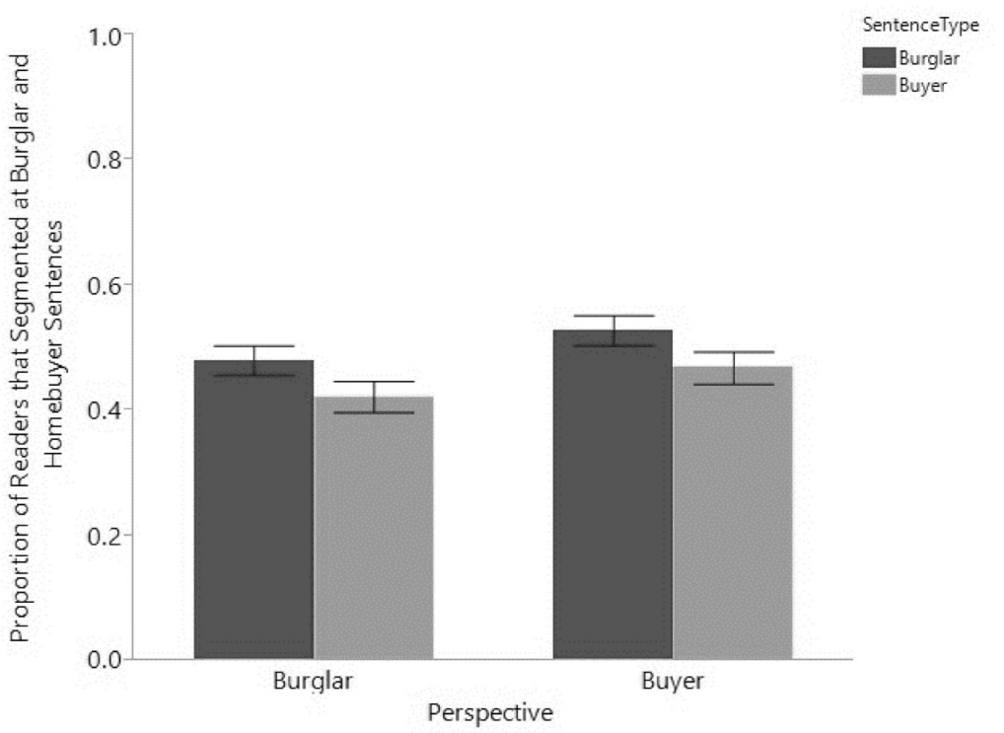

Figure 4. Likelihood of segmentation at Burglar and Homebuyer sentences by perspective. Error bars indicate standard error of the mean.
We ran a generalized logistic multilevel model to investigate whether the proportion of readers who segmented at Burglar or Homebuyer sentences differed by perspective. Perspective, Sentence Type (i.e., Burglar or Homebuyer) and their interaction were treated as fixed effects and subject was treated as a random effect. Though none of the effects were significant (all ps >
.05), there was a trend such that participants in the Burglar perspective were more likely to segment at Burglar sentences (M = .48, SE = .02, CI 95% = [.43, .53]) compared to Homebuyer

sentences (M = .42, SE = .03, CI 95% = [.37, .47]; see Figure 4). This trend was not present for those with the Homebuyer perspective.
An additional analysis was conducted to investigate segmentation differences at the sentence level. A generalized linear multilevel model with the fixed effects of perspective, sentence, and their interaction, along with the random effect of subject, was used to predict segmentation. As can be seen in Figure 5, the likelihood of segmenting differed by perspective at

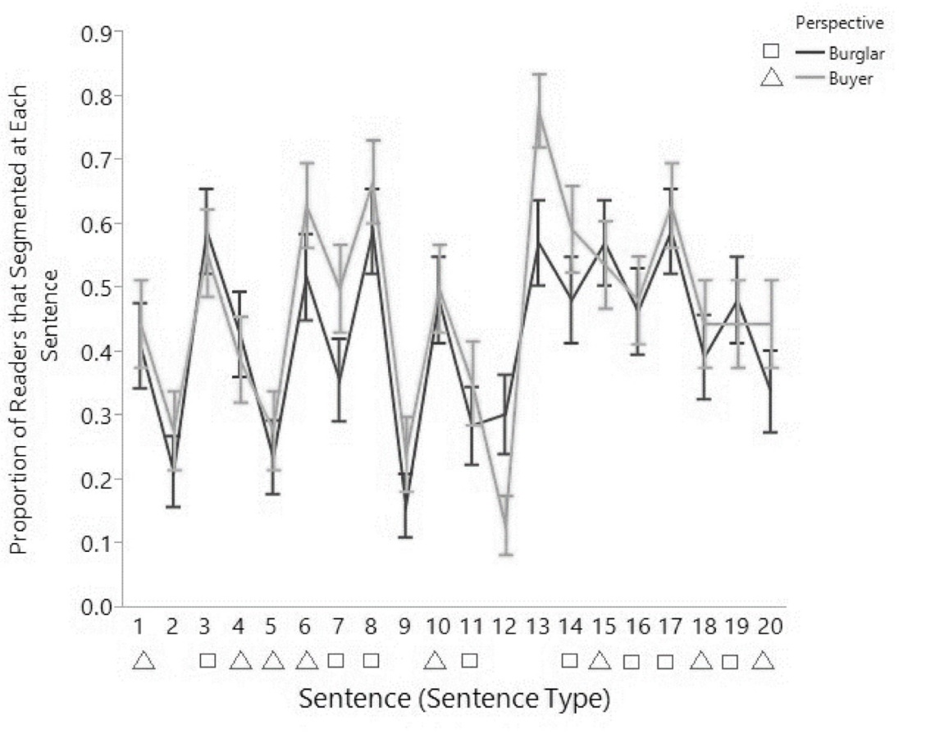

Figure 5. Proportion of readers that segmented at each sentence by perspective. Error bars indicate standard error of the mean.
several sentences (e.g., sentence 12, t = 2.42, p = .015; sentence 13, t = -1.84, p = .06); however, none of these differences were reliable after accounting for multiple comparisons (α: .05 ÷ 20 comparisons = .0025). Thus, although there were overall differences in segmentation agreement by perspective, these differences were not apparent at the fine-grained sentence level.

Segmentation agreement. Segmentation agreement scores were computed using the same method described in Experiment 1 except here we compared participants’ agreement with individuals from their own vs. the other perspective to investigate whether perspective influenced segmentation agreement. Therefore, each participant’s segmentation data was correlated with individuals from their own perspective (Comparison Group = Own) and with individuals from the other perspective (Comparison Group = Other). We expected segmentation agreement with one’s own perspective to be higher than agreement with the other perspective.
Segmentation agreement for each perspective is plotted in Figure 6. A linear multilevel model was used to determine the full factorial fixed effects of perspective and comparison group

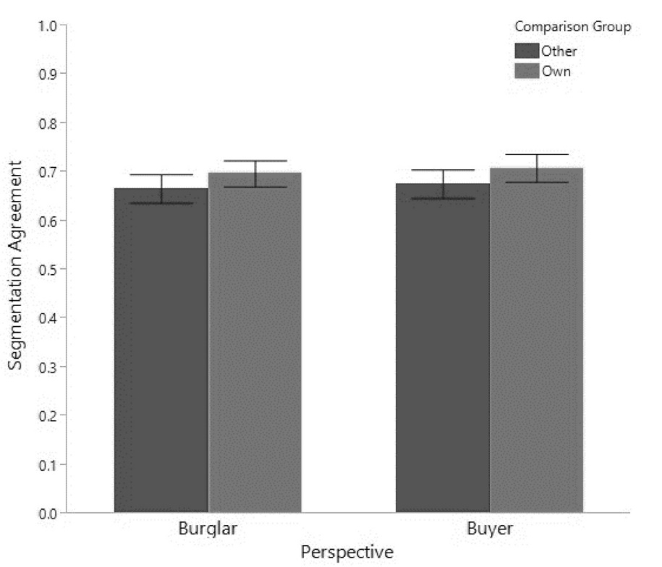

Figure 6. Segmentation agreement with Own and Other perspective by perspective. Error bars indicate standard error of the mean.
on segmentation agreement, from the random effect of subject. If segmentation agreement were higher for one’s own group, we would only expect to find a main effect of comparison group; which is what we found, t = 3.01, p = .003, d = .14. Segmentation agreement was higher for

individuals from the same perspective (Overall Own: M = 0.70, SE = 0.02, CI 95% = [0.66, 0.74]; Burglar: M = 0.70, SE = 0.03, CI 95% = [0.64, 075]; Homebuyer: M = 0.71, SE = 0.03, CI
95% = [0.65, 0.77]) compared to the other perspective (Overall Other: M = 0.67, SE = 0.02, CI 95% = [0.63, 0.71]; Burglar: M = 0.67, SE = 0.03, CI 95% = [0.61, 0.72]; Homebuyer: M = 0.68,
SE = 0.03, CI 95% = [0.62, 0.73]). As expected overall segmentation agreement did not significantly differ by perspective (Burglar Overall: M = .69, SE = 0.03, CI 95% = [0.63, 0.74]; Homebuyer Overall: M = .70, SE = .03, CI 95% = [0.64, 0.76]; p > .250) and no other effects were significant. These results suggest that perspective facilitated normative segmentation of narrative text; however, again the effect is small.
Does segmentation agreement predict recall? As in the previous study, we expected segmentation agreement to predict recall. A generalized Poisson multilevel model was used to determine the fixed effects of segmentation agreement, perspective, and their interaction on free recall performance, from the random effect of subject. A marginally significant interaction between own segmentation agreement and perspective was present, z = 1.90, p = .06, such that individuals with the Homebuyer perspective with higher segmentation agreement tended to have better memory (Homebuyer r = .44; Burglar r = .25; see Figure 7). The average correlation between own segmentation agreement and recall, regardless of perspective, was r = .36. The magnitude of this segmentation-memory correlation is similar to that observed in previous work (r = .37, Bailey et al., 2013; r = .41, Sargent et al., 2013), but it is the first to demonstrate the relationship for text materials. Such a result indicates that event segmentation is associated with memory for events presented either in a video or in text.

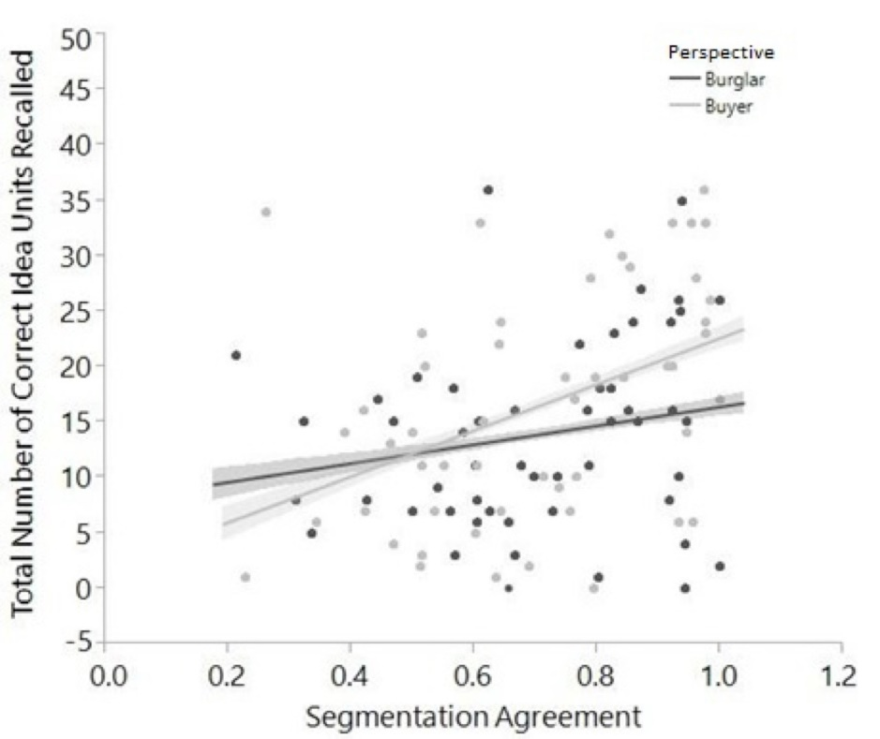

Figure 7. Recall count predicted by segmentation agreement and perspective. Shaded areas indicate confidence of the fit of the line.

Discussion

The results of Experiment 2 indicate that the top-down effects of a reader’s perspective partially influence how that reader segmented and recalled a text. That is, readers identified event boundaries that were more similar to those identified by readers from the same perspective as compared to the event boundaries identified by readers from a different perspective; however, the overall effect was small. Further, Experiment 2 partially replicated Anderson and Pichert (1978) in that individuals were more likely to recall information relevant to their perspective, but

only for the Burglar perspective – individuals from the Homebuyer perspective were equally likely to recall buyer-relevant and burglar-relevant information. Finally, individuals with the Homebuyer perspective who segmented the text more normatively also recalled more about it, thus partially supporting the Event Horizon Model in that event boundaries aid memory.

General Discussion

Previous work has found that perception, encoding, and memory are influenced by perceptual and conceptual factors; presumably both types of factors should also influence event segmentation. However, surprisingly little evidence exists for whether prior experiences and semantic knowledge affect the perception of event boundaries, particularly for text. The current study specifically investigated whether semantic knowledge – context in Experiment 1 and perspective in Experiment 2 – influences how readers segment and later remember texts. First, we did replicate the prior work on knowledge facilitating memory such that individuals recalled more information when they were given context for ambiguous stories, replicating Bransford and Johnson (1972), and the type of information that was recalled depended on their goals (Pichert & Anderson, 1978).
Second, and more importantly, we found that event segmentation was only modestly affected by our knowledge manipulations. In Experiment 1, context likely activated relevant semantic knowledge and allowed readers to encode the passages in a more organized way. However, while we observed a moderate effect of context on segmentation agreement (d = .33) across all three texts, we could not pinpoint group differences in segmentation behavior at the individual sentence level. The same was true in Experiment 2. Perspective produced differences in segmentation, such that individuals were more likely to agree on the locations of event boundaries with those who shared their perspective as opposed to those who did not. However,

the knowledge effect was small (d = .14) and was not clear at the individual sentence level. Further, previous work has suggested that normative segmentation facilitates recall (Bailey et al., 2013; Sargent et al., 2013; Zacks et al., 2006); however, in the current study, it did so only for one perspective in Experiment 2.
One possible explanation for the inconsistent effects of segmentation on recall is that segmentation is not the only encoding mechanism through which context improves memory for texts. Rather it is one of many different mechanisms (e.g., mental imagery, elaboration) that can operate while encoding an event. Relatedly, the Event Horizon Model claims that memory is affected by competing event models (Radvansky & Zacks, 2017) such that memory is impaired when information is not integrated into a common event model. It is possible that the ambiguous and procedural nature of the texts (particularly in Experiment 1) were not perceived as cohesive and therefore resulted in the creation of multiple, competing event models, thus, impairing memory for the text.
Another explanation (and limitation of the current study) is the overt segmentation task itself. Explicitly instructing people to identify event boundaries during a video or while reading text may not be the best way to capture the perceptual and conceptual influences of event segmentation processes. Rather future work could evaluate the efficacy of covert measures of segmentation, such as dwell time (Hard, Recchia, & Tversky, 2011). It is also important to note that, in the current study, participants were asked to segment the texts after the recall task. It is possible that segmentation behavior may have reflected participants’ memory for the texts more than it reflected their segmentation processes during initial encoding. However, we are less concerned about this issue given the perception of event boundaries does not change much even after multiple viewings of a video (Hard et al., 2006).

The inconsistent effects of segmentation on recall may also have been due to potential differences in the underlying organization of the different types of text (Kaakinen & Hyona, 2008) combined with the theoretical notion that event segmentation occurs at the event model level of comprehension. According to Berman and Nir-Sagiv (2007), narrative texts have a schema-based structure, whereas expository texts have a category-based structure. While reading narrative texts, individuals can map the content onto their own experiences, using their world knowledge to make inferences that promote comprehension (Graesser et al., 2003). Unlike narratives, expository texts are constructed to convey unfamiliar, technical content that is often procedural and lacks causal conjunctions, which makes them more difficult to understand. Texts are comprehended at many different levels, including the mental model level, which goes beyond what is in the text itself and relies on the individual’s ideas and world knowledge. If segmentation is proposed to occur at the mental model level, but a reader is not able to activate their relevant knowledge to generate inferences about the text (i.e., while reading an ambiguous text), then comprehension is likely to fail, and thus lead to idiosyncrasies in segmentation, which may impair memory.
Though different texts were used in the manipulations addressed in the current study, the comparison between expository and narrative text was not explicitly evaluated, thus more research is needed to investigate the conditions in which effective segmentation may benefit event comprehension and memory. This could have important implications for education if the structure (e.g., causal relatedness) of textbook information (e.g., expository text) or training videos (e.g., procedural) could influence how students are encoding and retaining information (Graesser et al., 2003).

The main take-away from the current study is that our knowledge manipulations were of small to moderate effect sizes (ds = .14 and .33), indicating that event segmentation of text is likely to be predominantly driven by other factors. These other factors could be features of the texts themselves, such as how many times certain words repeat or co-occur, or how many causal and temporal conjunctions are present (Graesser et al., 2003). Additionally, they may be other conceptual factors, such as familiarity or personal experience with the content of stories (e.g., doing laundry or buying a home) that were not directly manipulated here (Newberry, Smith, & Bailey, 2018). Regardless, the current findings only provide minimal support for EST’s claim that event models are informed by information in long-term memory, such as previous relevant experiences and other semantic knowledge, which then guide how an activity is perceived.
Future studies should continue to investigate the conditions under which perceptual and conceptual factors influence moment-to-moment processing across various modalities.

Author Contribution

Both authors contributed to the study concept, study design, and programming of the experiment. K. Newberry took the lead on data collection and data scoring. K. Newberry performed the data analyses under the supervision of H. Bailey. K. Newberry also drafted the manuscript and H. Bailey provided revisions. All authors approved the final version of the manuscript for submission.

Acknowledgments

Thanks to the undergraduate research assistants in the Memory and Aging Lab for their help with data collection and scoring. No conflicts of interest to report.

Open Practices Statement

The materials for this study are included in the Appendix; however, they are also available at: https://osf.io/3sr2v/?view_only=e10996503b6040ca84aad29f4dc5a05a
The data are available through email with the authors but may be made available after publication at the link provided above through Open Science Framework. None of the experiments were preregistered.

References

Anderson, R. C., & Pichert, J. W. (1978). Recall of previously unrecallable information following a shift in perspective. Journal of Verbal Learning and Verbal Behavior, 17(1), 1-12.
Auble, P. M., & Franks, J. J. (1978). The effects of effort toward comprehension on recall.

Memory & Cognition, 6, 20-25.

Bailey, H. R., & Zacks, J. M. (2015). Situation model updating in young and older adults: Global versus incremental mechanisms. Psychology and Aging, 30(2), 232.
Bailey, H., Kurby, C. A., Sargent, J. Q., & Zacks, J. M. (2017). Attentional focus affects how events are segmented and updated in narrative text.
Bailey, H. R., Zacks, J. M., Hambrick, D. Z., Zacks, R. T., Head, D., Kurby, C. A., & Sargent, J.

Q. (2013). Medial temporal lobe volume predicts elders’ everyday memory. Psychological Science, 24(7), 1113-1122.
Baldwin, D. A., Baird, J. A., Saylor, M. M., & Clark, M. A. (2001). Infants parse dynamic action. Child Development, 72(3), 708-717.
Bartlett, F. C. (1932). Remembering: An experimental and social study. Cambridge: Cambridge University.
Berman, R. A., & Nir-Sagiv, B. (2007). Comparing narrative and expository text construction across adolescence: A developmental paradox. Discourse Processes, 43(2), 79-120.
Bläsing, B. E. (2015). Segmentation of dance movement: effects of expertise, visual familiarity, motor experience and music. Psychological Perspectives on Expertise, 64.
Bohn-Gettler, C. M., & Kendeou, P. (2014). The interplay of reader goals, working memory, and text structure during reading. Contemporary Educational Psychology, 39(3), 206-219.

Boltz, M. (1992). Temporal accent structure and the remembering of filmed narratives. Journal of Experimental Psychology: Human Perception and Performance, 18(1), 90.
Bower, G. H., Black, J. B., & Turner, T. J. (1979). Scripts in memory for text. Cognitive Psychology, 11(2), 177-220.
Bransford, J. D., & Johnson, M. K. (1972). Contextual prerequisites for understanding: Some investigations of comprehension and recall. Journal of Verbal Learning and Verbal Behavior, 11(6), 717-726.
Brewer, W. F., & Treyens, J. C. (1981). Role of schemata in memory for places. Cognitive Psychology, 13(2), 207-230.
Chafe, W. (1988). Punctuation and the prosody of written language. Written Communication, 5(4), 395-426.
Cohen, J. (1992). A power primer. Psychological Bulletin, 112(1), 155-159.

Cunningham, A. E., & Stanovich, K. E. (1990). Assessing print exposure and orthographic processing skill in children: A quick measure of reading experience. Journal of Educational Psychology, 82(4), 733.
Cutting, J. E., Brunick, K. L., & Candan, A. (2012). Perceiving event dynamics and parsing Hollywood films. Journal of Experimental Psychology: Human Perception and Performance, 38(6), 1476.
Dooling, D. J., & Lachman, R. (1971). Effects of comprehension on retention of prose. Journal of Experimental Psychology, 88(2), 216.
Ericsson, K. A., Delaney, P. F., Weaver, G. A. & Mahadevan, S. (2004). Uncovering the structure of a memorist’s superior “basic” memory capacity. Cognitive Psychology, 49, 191–237.

Gardner, E. T., & Schumacher, G. M. (1977). Effects of contextual organization on prose retention. Journal of Educational Psychology, 69(2), 146.
Gold, D. A., Zacks, J. M., & Flores, S. (2017). Effects of cues to event segmentation on subsequent memory. Cognitive Research: Principles and Implications, 2(1), 1.
Graesser, A. C., McNamara, D. S., & Louwerse, M. M. (2003). What do readers need to learn in order to process coherence relations in narrative and expository text. Rethinking Reading Comprehension, 82-98.
Hajime, M., Takeo, H., & Manabu, O. (1998, August). Text segmentation with multiple surface linguistic cues. In Proceedings of the 36th Annual Meeting of the Association for Computational Linguistics and 17th International Conference on Computational Linguistics-Volume 2 (pp. 881-885). Association for Computational Linguistics.
Hard, B. M., Recchia, G., & Tversky, B. (2011). The shape of action. Journal of Experimental Psychology, 140, 586-604. doi:10.1037/a0024310
Hard, B. M., Tversky, B., & Lang, D. S. (2006). Making sense of abstract events: Building event schemas. Memory & Cognition, 34(6), 1221-1235.
Hasher, L., & Griffin, M. (1978). Reconstructive and reproductive processes in memory. Journal of Experimental Psychology: Human Learning and Memory, 4(4), 318.
Hearst, M. A. (1994, June). Multi-paragraph segmentation of expository text. In Proceedings of the 32nd annual meeting on Association for Computational Linguistics (pp. 9-16).
Association for Computational Linguistics.

Hearst, M. A. (1997). TextTiling: Segmenting text into multi-paragraph subtopic passages. Computational Linguistics, 23(1), 33-64.

Johnson-Laird, P. N. (1983). A computational analysis of consciousness. Cognition & Brain Theory.
Kaakinen, J. K., & Hyona, J. (2005). Perspective effects on expository text comprehension: Evidence from think-aloud protocols, eye-tracking, and recall. Discourse Processes, 40(3), 239-257.
Kaakinen, J. K., & Hyönä, J. (2008). PerspectiveIdriven text comprehension. Applied Cognitive Psychology, 22(3), 319-334.
Kaakinen, J. K., Hyönä, J., & Keenan, J. M. (2002). Perspective effects on online text processing. Discourse Processes, 33(2), 159-173.
Kaakinen, J. K., Hyönä, J., & Keenan, J. M. (2003). How prior knowledge, WMC, and relevance of information affect eye fixations in expository text. Journal of Experimental Psychology: Learning, Memory, and Cognition, 29(3), 447.
Kintsch, W., & Van Dijk, T. A. (1983). Strategies of discourse comprehension.

Kurby, C. A., & Zacks, J. M. (2008). Segmentation in the perception and memory of events. Trends in Cognitive Sciences, 12(2), 72-79.
Kurby, C. A., & Zacks, J. M. (2011). Age differences in the perception of hierarchical structure in events. Memory & Cognition, 39(1), 75-91.
Kurby, C.A. & Zacks, J.M. (2012). Starting from scratch and building brick by brick in comprehension. Memory & Cognition, 40(5), 812-826.
Lahnakoski, J. M., Glerean, E., Jääskeläinen, I. P., Hyönä, J., Hari, R., Sams, M., & Nummenmaa, L. (2014). Synchronous brain activity across individuals underlies shared psychological perspectives. NeuroImage, 100, 316-324.

Landauer, T. K., Foltz, P. W., & Laham, D. (1998). An introduction to latent semantic analysis. Discourse Processes, 25(2-3), 259-284.
Lehman, S., & Schraw, G. (2002). Effects of coherence and relevance on shallow and deep text processing. Journal of Educational Psychology, 94(4), 738.
Levine, D., Hirsh-Pasek, K., Pace, A., & Michnick Golinkoff, R. (2017). A goal bias in action: The boundaries adults perceive in events align with sites of actor intent. Journal of Experimental Psychology: Learning, Memory, and Cognition, 43(6), 916.
Linderholm, T., & van den Broek, P. (2002). The effects of reading purpose and working memory capacity on the processing of expository text. Journal of Educational Psychology, 94(4), 778.
Lorch, R. F. (1989). Text-signaling devices and their effects on reading and memory processes. Educational psychology review, 1(3), 209-234.
Lorch Jr, R. F., Lorch, E. P., & Mogan, A. M. (1987). Task effects and individual differences in onIline processing of the topic structure of a text. Discourse Processes, 10(1), 63-80.
Luo, L., & Craik, F. I. (2008). Aging and memory: A cognitive approach. The Canadian Journal of Psychiatry, 53(6), 346-353.
Magliano, J., Kopp, K., McNerney, M. W., Radvansky, G. A., & Zacks, J. M. (2012). Aging and perceived event structure as a function of modality. Aging, Neuropsychology, and Cognition, 19(1-2), 264-282.
Magliano, J. P., Miller, J., & Zwaan, R. A. (2001). Indexing space and time in film understanding. Applied Cognitive Psychology, 15(5), 533-545.
Massad, C. M., Hubbard, M., & Newtson, D. (1979). Selective perception of events. Journal of Experimental Social Psychology, 15(6), 513-532.

McCrudden, M. T., & Schraw, G. (2007). Relevance and goal-focusing in text processing. Educational Psychology Review, 19(2), 113-139.
Manabu, O., & Takeo, H. (1994, August). Word sense disambiguation and text segmentation based on lexical cohesion. In Proceedings of the 15th conference on Computational Linguistics-Volume 2 (pp. 755-761). Association for Computational Linguistics.
Miller, L. M. S. (2003). The effects of age and domain knowledge on text processing. The Journals of Gerontology Series B: Psychological Sciences and Social Sciences, 58(4), 217-223.
Miller, L. M. S., & Stine-Morrow, E. A. (1998). Aging and the effects of knowledge on on-line reading strategies. The Journals of Gerontology Series B: Psychological Sciences and Social Sciences, 53(4), 223-233.
Mura, K., Petersen, N., Huff, M., & Ghose, T. (2013). IBES: a tool for creating instructions based on event segmentation. Frontiers in Psychology, 4, 994.
Narvaez, D., Van Den Broek, P., & Ruiz, A. B. (1999). The influence of reading purpose on inference generation and comprehension in reading. Journal of Educational Psychology, 91(3), 488.
Newberry, K., Smith, M., & Bailey, H. (May, 2018). The role of knowledge in age-related changes in segmentation and memory. Poster presented at the International Meeting of the Psychonomic Society, Amsterdam, The Netherlands.
Newtson, D. (1973). Attribution and the unit of perception of ongoing behavior. Journal of Personality and Social Psychology, 28(1), 28.
Newtson, D., Engquist, D., & Bois, J. (1977). The objective basis of behavior unit. Journal of Personality and Social Psychology, 35(12), 847-862.

Pettijohn, K. A., & Radvansky, G. A. (2016). Walking through doorways causes forgetting: Event structure or updating disruption?. Quarterly Journal of Experimental Psychology, 69(11), 2119-2129.
Pettijohn, K. A., Thompson, A. N., Tamplin, A. K., Krawietz, S. A., & Radvansky, G. A. (2016).

Event boundaries and memory improvement. Cognition, 148, 136-144.

Pichert, J. W., & Anderson, R. C. (1977). Taking different perspectives on a story. Journal of Educational Psychology, 69(4), 309.
Radvansky, G. A. (2012). Across the event horizon. Current Directions in Psychological Science, 21(4), 269-272.
Radvansky, G. A., & Copeland, D. E. (2006b). Walking through doorways

causes forgetting. Memory & Cognition, 34, 1150–1156.

Radvansky, G. A., & Zacks, J. M. (2014). Event Cognition. Oxford University Press.

Radvansky, G. A., & Zacks, J. M. (2017). Event boundaries in memory and cognition. Current opinion in behavioral sciences, 17, 133-140.
Rosch, E. H., Mervis, C. B., Gray, W. D., Johnson, D. M. & Boyes-Braem, P. (1976). Basic objects in natural categories. Cognitive Psychology, 8, 382-439.
Sargent, J. Q., Zacks, J. M., Hambrick, D. Z., Zacks, R. T., Kurby, C. A., Bailey, H. R., ... & Beck, T. M. (2013). Event segmentation ability uniquely predicts event
memory. Cognition, 129(2), 241-255.

Schank, R. C., & Abelson, R. P. (1977). Scripts, plans, goals, and understanding: An inquiry into human knowledge structures. Lawrence Erlbaum Associates, Inc.
Schank, R. C., & Abelson, R. P. (2013). Scripts, plans, goals, and understanding: An inquiry into human knowledge structures. Psychology Press.

Schwan, S., & Garsoffky, B. (2004). The cognitive representation of filmic event summaries. Applied Cognitive Psychology: The Official Journal of the Society for Applied Research in Memory and Cognition, 18(1), 37-55.
Soederberg-Miller, L. M., Cohen, J. A. & Wingfield, A. (2006). Contextual knowledge reduces demands on working memory during reading. Memory & Cognition, 34, 1355.
Speer, N. K., Reynolds, J. R., Swallow, K. M., & Zacks, J. M. (2009). Reading stories activates neural representations of perceptual and motor experiences. Psychological Science, 20, 989-999.
Speer, N. K., Swallow, K. M., & Zacks, J. M. (2003). Activation of human motion processing areas during event perception. Cognitive, Affective, & Behavioral Neuroscience, 3(4), 335-345.
Speer, N. K., & Zacks, J. M. (2005). Temporal changes as event boundaries: Processing and memory consequences of narrative time shifts. Journal of Memory and Language, 53, 125-140.
Stanovich, K. E., & West, R. F. (1989). Exposure to print and orthographic processing. Reading Research Quarterly, 402-433.
Stine, E. A. L., Cheung, H., & Henderson, D. (1995). Adult age differences in the online processing of new concepts in discourse. Aging and Cognition, 2, 1-18.
Swets, B., & Kurby, C. A. (2016). Eye movements reveal the influence of event structure on reading behavior. Cognitive Science, 40(2), 466-480.Wilder, D. A. (1978). Predictability of behaviors, goals, and unit of perception. Personality and Social Psychology
Bulletin, 4(4), 604-607.

Tanaka, J. W., & Taylor, M. (1991). Object categories and expertise: Is the basic level in the eye of the beholder? Cognitive Psychology, 23, 457-482.
Thompson, C. P., Cowan, T. M. & Frieman, J. (1993). Memory Search by a Memorist. Hillsdale, NJ: Lawrence Erlbaum Associates.
Zacks, J. M. (2004). Using movement and intentions to understand simple events. Cognitive Science, 28(6), 979-1008.
Zacks, J. M., Braver, T. S., Sheridan, M. A., Donaldson, D. I., Snyder, A. Z., Ollinger, J. M., ...

& Raichle, M. E. (2001). Human brain activity time-locked to perceptual event boundaries. Nature Neuroscience, 4(6), 651-655.
Zacks, J. M., Kumar, S., & Abrams, R. A., Mehta, R. (2009). Using movement and intentions to understand human activity. Cognition, 112, 201-216.
Zacks, J. M., Kurby, C. A., Eisenberg, M. L., & Haroutunian, N. (2011). Prediction error associated with the perceptual segmentation of naturalistic events. Journal of Cognitive Neuroscience, 23(12), 4057-4066.
Zacks, J. M., Speer, N. K., & Reynolds, J. R. (2009). Segmentation in reading and film comprehension. Journal of Experimental Psychology: General, 138(2), 307.
Zacks, J. M., Speer, N. K., Swallow, K. M., Braver, T. S., & Reynolds, J. R. (2007). Event perception: a mind-brain perspective. Psychological Bulletin, 133(2), 273.
Zacks, J. M., Speer, N. K., Vettel, J. M., & Jacoby, L. L. (2006). Event understanding and memory in healthy aging and dementia of the Alzheimer type. Psychology and Aging, 21(3), 466.
Zacks, J. M., Tversky, B., & Iyer, G. (2001). Perceiving, remembering, and communicating structure in events. Journal of Experimental Psychology: General, 130(1), 29.

Zalla, T., Pradat-Diehl, P., & Sirigu, A. (2003). Perception of action boundaries in patients with frontal lobe damage. Neuropsychologia, 41(12), 1619-1627.
Zalla, T., Verlut, I., Franck, N., Puzenat, D., & Sirigu, A. (2004). Perception of dynamic action in patients with schizophrenia. Psychiatry Research, 128(1), 39-51.
Zwaan, R. A., & Radvansky, G. A. (1998). Situation models in language comprehension and memory. Psychological Bulletin, 123(2), 162.

Appendix

Washing Clothes

The procedure is actually quite simple. First you arrange things into different groups. Of course one pile may be sufficient depending on how much there is to do. If you have to go somewhere else due to lack of facilities that is the next step, otherwise you are pretty well set. It is important not to overdo things. That is, it is better to do too few things at one time than too many. In the short run this may not seem important but complications can easily arise. A mistake can be expensive as well. At first the whole procedure will seem complicated. Soon, however, it will become just another facet of life. It is difficult to foresee any end to the necessity for this task in the immediate future, but then one can never tell. After the procedure is completed one arranges the materials into different groups again. Then they can be put into their appropriate places.
Eventually they will be used once more and the whole cycle will then have to be repeated. However, that is a part of life.

Flying a Kite

A newspaper is better than a magazine. A seashore is a better place than the street. At first it is better to run than to walk. You may have to try several times. It takes some skill but it’s easy to learn. Even young children can enjoy it. Once successful, complications are minimal. Birds seldom get too close. Rain, however, soaks in very fast. Too many people doing the same thing can also cause problems. One needs lots of room. If there are no complications, it can be very peaceful. A rock will serve as an anchor. If things break loose from it, however, you will not get a second chance.

Driving a Car

The strength and flexibility of this equipment is remarkable. Not everyone is capable of using it even though most try at one point or another. The soothing sounds and comfort can be deceiving. Keep in mind that all the components must be carefully con-trolled to prevent injury or even death. You must find a comfort-able position and be ready with your hands, while at the same time, prepare one or both feet (depending upon the model). Complications can occur if you allow the equipment to become noisy or interfere with someone else. But the possibilities are limitless. In addition to being practical, it allows you to see new perspectives and opens up new territory. The initial investment may be high, but when you realize all its capabilities, there really is no other way to go.

House

The two boys ran until they came to the driveway. “See I told you today was good for skipping school,” said Mark. “Mom is never home on Thursday,” he added. Tall hedges hid the house from the road so the pair strolled across the finely landscaped garden. “I never knew your place was so big,” said Pete. “Yeah, but it’s nicer now than it used to be since Dad had the new stone siding put on and added the fire place” said Mark. There were front and back doors and a side door which led to the garage which was empty except for three parked 10-speed bikes. They went in the side door, Mark explaining that it was always open in case his younger sisters got home earlier than his mother. Pete wanted to see the house so Mark started with the living room. It, like the rest of the downstairs, was newly painted. Mark turned on the stereo, the noise of which worried Pete. “Don’t worry, the nearest house is a quarter of a mile away” Mark shouted. Pete felt more comfortable observing that no houses could be seen in any direction beyond the huge garden. The dining room with all the china, silver and cut glass was no place to play so the boys moved into the kitchen where they made sandwiches. Mark said they wouldn’t go to the basement because it had been damp and musty ever since the new plumbing was installed. “This is where my Dad keeps his famous paintings and his coin collection,” Mark said as they peered into the study. Mark boasts that he could get spending money whenever he needed it since he’d discovered that his Dad kept a lot in the desk drawer. There were three upstairs bedrooms. Mark showed Pete his mother’s closet which was filled with furs and the locked box which held her jewels. His sisters’ room was uninteresting except for the color T.V. which Mark carried to his room. Mark boasts that the bathroom in the hall was his since one had been added to his sisters’ room for their use. The big highlight in his room though was a leak in the ceiling where the old roof had finally rotted.

