Water Level Task
Citation:
Brase, G.L. & Hill, W.T. (2017). Adding up to Good Bayesian Reasoning: Problem Format Manipulations and Individual Skill Differences. Journal of Experimental Psychology: General, 146, 577-591. doi: 10.1037/xge0000280

Scoring Directions: Correct answers, numbering the glasses from left to right are.
Question 1 = #2
Question 2 = #1
Question 3 = #3
Question 4 = #3
Question 5 = #2
Question 6 = #1
Question 7 = #2

Instructions: Below is a picture of a glass on top of a table, half filled with water. In the example below, the glass is tilted at an angle, and the line shows how the surface of the water will look while the glass is being kept at that angle.
On the following pages you will be presented with pictures of a glass that is tilted at a particular angle, with different options for how the surface of the water will look while the glass is being kept at that angle. Your job is to pick which picture is the closest to the correct appearance of an actual glass with water, being held at that angle.
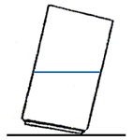

1. Click on the picture which is the closest to the correct appearance of an actual glass with water, being held at that angle.
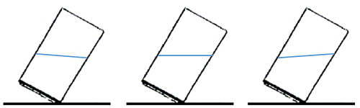

2. Click on the picture which is the closest to the correct appearance of an actual glass with water, being held at that angle.
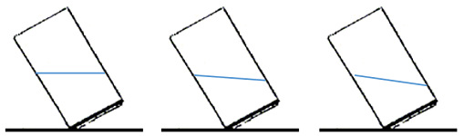

3. Click on the picture which is the closest to the correct appearance of an actual glass with water, being held at that angle.
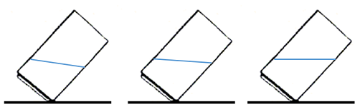

4. Click on the picture which is the closest to the correct appearance of an actual glass with water, being held at that angle.
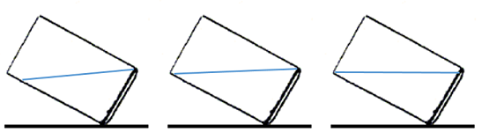

5. Click on the picture which is the closest to the correct appearance of an actual glass with water, being held at that angle.
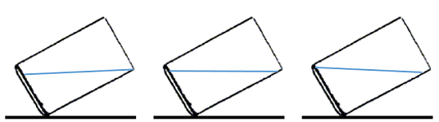

6. Click on the picture which is the closest to the correct appearance of an actual glass with water, being held at that angle.
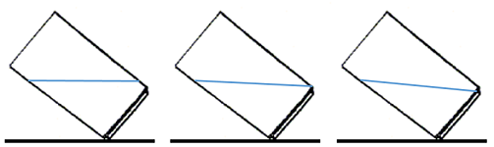

7. Click on the picture which is the closest to the correct appearance of an actual glass with water, being held at that angle.
