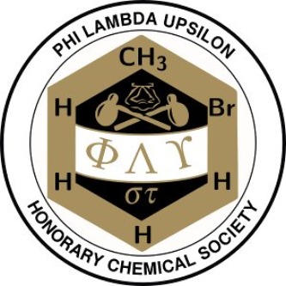
Phi Lambda Upsilon
Alpha Epsilon Chapter
Kansas State University

TRAVEL GRANT POLICY

All applicants must meet the following criteria to be eligible for a Phi Lambda Upsilon – Alpha Epsilon Chapter Travel Grant.

Criteria:

- Applicant must be an active member of PLU-AE. Participation in fundraising (e.g., lab manual sales) at least once per academic year and attending the annual general meeting will count as the bare minimum to be considered as an active member.

- Applicant must be attending a regionally, nationally, or internationally recognized conference.

- Recipients will be awarded no more than two grants per calendar year (i.e., 1 January – 31 December) up to a maximum of $595 in total per calendar year.

- Applicant must be presenting a poster or oral presentation to obtain the maximum allocated travel grant per academic year (i.e., $595). In the case of participating in a conference without presenting a poster or oral presentation, a maximum of $200 will be awarded in total per calendar year.

- Applicant must apply by filling out the official application form (second page of this document) and emailing it to philambdaupsilon@ksu.edu. No other mode of submission is accepted.

- Include PLU in your acknowledgements for travel support, either in the text or by using the PLU logo. For example: “Partial support provided by PLU travel grant.” or “Travel supported by PLU.”

Please submit the application four weeks before the date of your scheduled conference, as late applications will not be accepted. Please allow three weeks from the date of submission for processing and review. Applicants will be contacted via email to obtain the award.

TRAVEL GRANT APPLICATION FORM

Name:

Advisor:

Conference:

Dates Attending:

Title of Presentation:

Travel Arrangement (e.g., car, plane):

Expenses:
Transportation -
Lodging -
Registration fee -
Other -

Total Budget:

Other Sources of Support and Amount Awarded: (Mention all)
Graduate Student Council - $
Arts and Sciences - $
Other -

Please Attach Abstract Here

