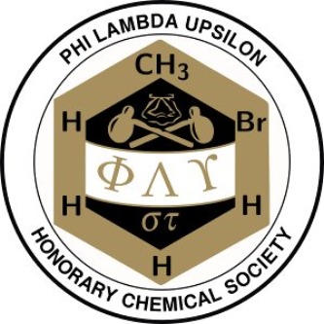
Phi Lambda Upsilon
Alpha Epsilon Chapter
Kansas State University

TRAVEL GRANT POLICY

All applicants must meet the following criteria to be eligible for a Phi Lambda Upsilon – Alpha Epsilon Chapter Travel Grant.

The awards will be based on a mathematical model that considers distance, cost of travel and other factors determined suitable by PLU. Recipients will be awarded no more than two grants per academic year (1 August – 30 July).

Criteria:

1. Applicant must be an active member of PLU-AE. Participation in fundraising and yearly meetings is required.

2. Applicant must be attending a nationally recognized conference.

3. For research conferences, the applicant must be presenting a poster or oral presentation. Representing Kansas State University, the Department of Chemistry or PLU at a conference will be considered on a case-by-case basis.

4. Applicant must apply by filling out the official application form (second page of this document) and email it to philambdaupsilon@ksu.edu. No other mode of submission is accepted.

5. Include PLU in your acknowledgements for travel support; either in text or by using the PLU logo. For example: “Partial support provided by PLU travel grant.” or “Travel supported by PLU.”

Please submit the application four weeks before the date of your scheduled conference, as late applications will not be accepted. Please allow three weeks from date of submission for processing and review. Applicants will be contacted personally to obtain award. The award and its amount are subject to change at any time.

TRAVEL GRANT APPLICATION FORM

Name:

Advisor:

Conference:

Dates Attending:

Title of Presentation:

Travel Arrangement (e.g., car, plane):

Expenses:
Transportation -
Lodging -
Registration fee -
Other -

Total Budget:

Other Sources of Support: (Mention all)

Please Attach Abstract here

