 | Feed the Future  USAID – Honduras  University of Nebraska – Lincoln  Kansas State University | SOP # | SOP-TM-001
 |  | Revision # | V-01
 |  | Last Reviewed | 11/01/2017
 |  | Effective Date | 11/01/2017
SOP Title: Corn Sampling Protocol for Mycotoxin Analysis – Bulk Grain

 | Name | Date
Author | Luis Sabillón | 10/24/2017
Reviewer | Andréia Bianchini | 11/01/2017
Approver | Andréia Bianchini | 11/01/2017

- Purpose
  - To describe the procedures to collect a representative sample of corn from bulk grain in stationary containers for the analysis of mycotoxins.

- Scope
  - This standard operating procedure applies to all INVEST-H Field Technicians, who will be collecting samples of corn from stationary containers for the analysis of mycotoxins.

- General Provisions and Responsibilities
  - Personnel
    - The Field Supervisor will be responsible for (a) training technicians in the performance of this protocol, and (b) assuring that technicians are qualified to operate a double-tube compartment probe to collect a representative sample of corn.
    - Technicians must make sure all sampling equipment is in good operating condition, clean, and properly checked before use.

  - Precautions to be taken
    - In the course of sampling and preparation of the samples, precautions shall be taken to avoid:
      - Any changes in the sample, which would affect its mycotoxin content, adversely affect the analytical determination or make the aggregate samples unrepresentative.
      - Potential contamination of the lot being sampled, which would compromise its safety for consumption.
IMPORTANT: All measures necessary to ensure the safety of the individuals taking the samples shall be taken.

  - Number of samples
    - It refers to the number of samples to be drawn from a single lot of corn.
As much as possible, incremental samples shall be taken at various places distributed throughout the lot of corn, according to the following table:

Table 1: Number of incremental and aggregate samples.
Type of  Storage | Number of  Containers | Number of  Samples | Aggregate Sample  Weight (lb)
Silos *  Drums * | 1 | 5 | 5
 | 2 | 6 | 6
 | 3 | 9 | 9
 | 4 | 12 | 12
 | > 5 | ≥ 15 | ≥ 15
Sacks † | 1 | 5 | 5
 | > 2 ≤ 5 | 5 | 5
 | > 5 ≤ 10 | 7 | 7
 | > 10 ≤ 15 | 10 | 10
 | > 15 ≤ 20 | 12 | 12
 | > 20 | ≥ 14 | ≥ 14

* When there is more than 1 storage container, 3 samples must be drawn from each container.
† When there are more than 5 sacks, sacks should be chosen randomly according to the table and one sample per sack must be drawn.

  - Aggregate sample
    - It refers to the combined total of all the samples taken from the lot of corn.

  - Packaging and transportation of samples
    - Each sample shall be placed in a clean, inert double bag offering adequate protection from contamination and against damage in transit.

IMPORTANT: All necessary precautions shall be taken to avoid any change in composition of the sample, which might result from conditions encountered during transportation or storage.

  - Sealing and labelling of samples
    - Each sample taken for mycotoxin analysis shall be sealed at the place of sampling along with its corresponding Individual Sample Label and Survey (Appendix Document 1 and Document 2).

- Materials and Equipment

  - Double-tube Compartment Probe
  - Container/Bucket
  - Sampling Bags
  - Individual Sample Label
  - Sample Survey
  - Pen

- Procedure
  - Prior to sampling
    - Make sure all sampling equipment is in good operating condition.
    - Visually examine the whole lot of grain.
    - Record any unusual conditions and all required information on the Individual Sample Label (Appendix Document 1) corresponding to the sample to be collected.
    - Fill out the Sample Survey (Appendix Document 2).
    - Randomly, select the number of storage containers (i.e., silos, drums, or sacks) to be sampled according to Table 1.
    - Take the number of samples corresponding to the number of storage containers as shown in Table 1 by following the instructions below.

REMEMBER:
- Silos/Drums: When there is more than 1 storage container, 3 samples must be drawn from each container.
- Sacks: If there are more than 5 sacks, randomly select the required amount of sacks according to the Table 1 and take one sample per sack.

  - Drawing the sample from silos / drums
    - Open the top door and insert the probe at an approximately 10 degree angle from the vertical with the slots facing upward and completely closed (Figure 1-A).
A
B
C
D
~ 10°

Figure 1. Operating a double-tube compartment probe.

NOTE: The 10 degree angle eases the resistance of the compacted grain against the probe while still allowing the probe to reach the bottom of the container.

IMPORTANT: Keep the slots closed until the probe is inserted as far as it will go. Otherwise, a disproportionate amount of grain from the top of the load will fall into the probe compartments as it is being inserted.
    - After the probe is fully inserted (with the slots facing upward), open the slots by rotating the inner tube 180° and move the probe up and down quickly in two short motions to fill the compartments (Figure 1-B).
    - Close the slots completely by rotating the inner tube 180°, grasp the probe by the outer tube, and withdraw it from the grain (Figure 1-C).

CAUTION: Do not pull the probe by the handle. This can result in the inner tube being pulled out of the outer tube. When this occurs, the probe must be emptied, reassembled, cleaned, and the lot probed again.

    - Empty the probe by pouring the grain from the open end directly into a clean, dry sampling container/bucket (Figure 1-D).
    - Repeat the previous steps (5.2.1. through 5.2.4.), from different angles as shown in Figure 2, until the required amount of samples described in Table 1 has been reached.

2
3
1

Figure 2. Collecting samples from a Silo / Drum.

    - Once all samples have been collected, thoroughly mix the samples deposited onto the sampling container/bucket to obtain a composite sample.
    - Take 5 lb of the composite sample and place it in a double bag along with a completed sample label and sample survey.

NOTE: When transferring the grain from the container to the sampling bag, take care not to allow fine material to be blown from the container.

    - After placing the sample, completed sample label and sample survey into the sample bag, tighten the zip lock at the top of the bag so that it is closed securely.

  - Drawing the sample from sacks
    - Determine the number of sacks in the lot.
    - Then, follow the rules described in Table 1 to define how many samples will need to be collected.

For example:
- If there is only one sack of corn, randomly select 5 sampling points and take a sample per each point.
- If there are more than 5 sacks, randomly select the required amount of sacks according to the Table 1 and take one sample per sack.

    - Randomly select the number of sacks to be sampled, when needed.
    - Stand each selected sack on end and insert the probe into the top corner of the sack (Figure 3).
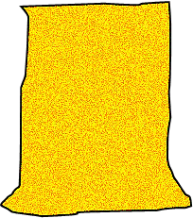
B
A

Figure 3. Collecting samples from a sack.

    - Push the probe, with the slots facing upward, diagonally through the sack until the end of the probe touches the opposite bottom corner (Figure 3-A).
    - Open the probe, make two quick up-and-down motions, and then close and remove the probe.
    - Empty the contents of the probe onto a sampling container (Figure 3-B).
    - Repeat the previous steps (5.3.4. through 5.3.7.), from different angles, until the required amount of samples described in Table 1 has been reached.
    - Once all the samples have been collected from the selected sampling points/sacks, thoroughly mix the samples deposited onto the sampling container to obtain a composite sample.
    - Take 5 lb of the composite sample and place it in a double bag along with a completed sample label and sample survey.

NOTE: When transferring the grain from the container to the sampling bag, take care not to allow fine material to be blown from the container.

    - After placing the sample, completed sample label and sample survey into the sample bag, tighten the zip lock at the top of the bag so that it is closed securely.

- References
  - Grain Inspection, Packers and Stockyards Administration (GIPSA)/Federal Grain Inspection Service (FGIS). 1995. Grain Inspection Handbook, Book 1, Grain Sampling.
  - GIPSA/FGIS. 1996. Equipment handbook, Chapter 7, Manual Sampling Devices.
  - European Commission. "Commission Regulation (EC) No. 401/2006 of 23 February 2006. Laying down the methods of sampling and analysis for the official control of the levels of mycotoxins in foodstuffs." Official Journal of the European Union 70 (2006): 12-34.

- Appendix
  - Individual Sample Log

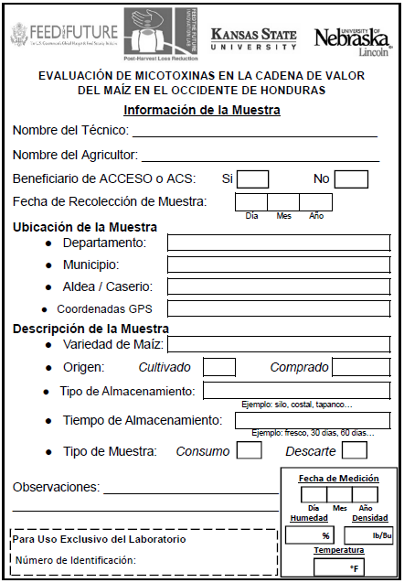
Appendix Figure 1. Individual Sample Log

