 | Feed the Future  USAID – Nepal  Kansas State University  University of Nebraska – Lincoln  CSIRO | SOP #
 |  | Revision # | V-01
 |  | Last Reviewed | 13 February, 2018
 |  | Effective Date | 02/13/2018
SOP Title: Sampling Protocol for Mycotoxin Analysis – households, hanging maize

 | Name | Date
Adapted from | Guatemala Maize sampling protocol by Luis Sabillón and Andreia Bianchini | 10/24/2017
Author | Jagger Harvey | 02/13/2018
Reviewer | Ross Darnell | 02/13/2018
Approver | Jagger Harvey | 02/13/2018

- Purpose
  - To describe the procedures to collect representative samples of hanging maize from households for the analysis of mycotoxins.

- Scope
  - This standard operating procedure applies to all PHLIL Nepal Mycotoxin Survey Field Technicians, who will be collecting samples from stored commodities for the analysis of mycotoxins.

- General Provisions and Responsibilities
  - Personnel
    - The Field Supervisor will be responsible for (a) training technicians in the performance of this protocol, and (b) assuring that technicians are qualified to operate a sampling string and sheller to collect a representative sample of hanging maize

    - Technicians must make sure all sampling equipment is in good operating condition, clean, and properly checked before use.

  - Precautions to be taken
    - In the course of sampling and preparation of the samples, precautions shall be taken to avoid:
      - Any changes in the sample, which would affect its mycotoxin content, adversely affect the analytical determination or make the aggregate samples unrepresentative.
      - Potential contamination of the lot being sampled, which would compromise its safety for consumption.
IMPORTANT: All measures necessary to ensure the safety of the individuals taking the samples shall be taken.
  - Number of samples
    - It refers to the number of samples to be drawn from a single lot of corn or rice.
As much as possible, incremental samples shall be taken at various places distributed throughout the lot of corn, according to the following table:

Table 1: Number of incremental and aggregate samples.
Type of  Storage | Number of hanging  cobs | Number of  cobs collected
hanging | <200 | 10
 | >200 | 20

  - Sampling strategy for selecting cobs
    - Use the appropriate length sampling string to guide random selection of cobs.

  - Aggregate sample
    - It refers to the combined total of all the samples taken from the lot.

  - Packaging and transportation of samples
    - Each sample shall be placed in a clean, inert double bag offering adequate protection from contamination and against damage in transit.

IMPORTANT: All necessary precautions shall be taken to avoid any change in composition of the sample, which might result from conditions encountered during transportation or storage.

  - Sealing and labelling of samples
    - Each sample taken for mycotoxin analysis shall be sealed at the place of sampling along with its corresponding sample information and survey.

- Materials and Equipment

  - Sampling strings (3 lengths; 5 knotted strings per length, with knots spaced differently)
  - Container/Bucket
  - Sampling Bags
  - Individual Sample Label
  - Sample Survey
  - Pen

- Procedure
  - Prior to sampling
    - Make sure all sampling equipment is clean and in good operating condition.
    - Visually examine the whole lot of hanging maize.
    - Record any unusual conditions and all required information corresponding to the sample to be collected.
    - Fill out the PHLIL Sample Survey.

  - Sampling
    - Measure the line of cobs to select the appropriate length of sampling string (see 3.4.1 and 3.4.2 for length dimension).
    - For a single line of hanging cobs, run a sampling string the length of the hanging cobs.
    - For an array (2 dimensional rectangle, which has cobs several or more deep; e.g., hanging from rafters or hanging several deep), run a sampling string from one corner of the array to the opposite far corner.
    - Select the cobs touching the colored marks along the string, and shell them into a bucket.
    - Once all samples have been collected, thoroughly mix the samples deposited onto the sampling container/bucket to obtain a composite sample.
    - Take 1 kg of the composite sample and place it in a double bag along with a completed sample label and sample survey.

    - After placing the sample, completed sample label and sample survey into the sample bag, tighten the zip lock at the top of the bag so that it is closed securely.

Figure 1: Selecting cobs using the sampling string - maize hanging in a line.

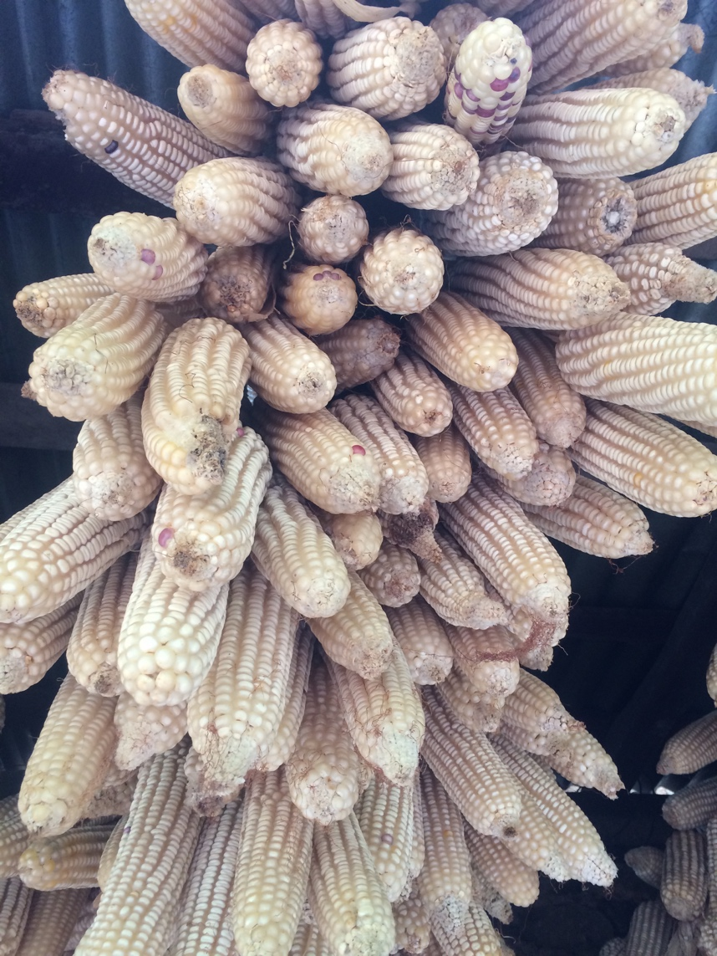

Figure 2: Selecting cobs using the sampling string - maize hanging in an array.

- References

