Each question in the template is formatted into a table. Each table can be modified to suit your needs by adding content, rows, or columns.
To create new question:
- Copy the table that holds a question with a similar formatting style to the new question you want to create.
  - To copy the entire table, hover over the table with your mouse. Click the four-directional arrow that appears in the upper left corner of the table (all rows will be highlighted in blue). Either right-click the mouse and select Copy or press Ctrl+C on your keyboard.
  - The screenshot below shows how the table will look once you have selected it. The green circle indicates the four-directional arrow you will click on when you hover over the table.
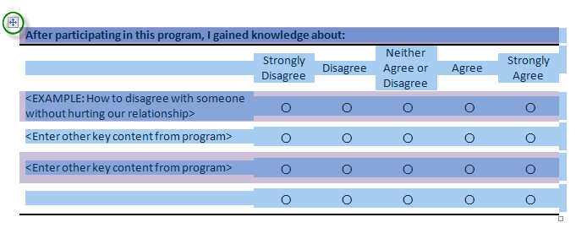
- Place your cursor where the new question should appear.
- Press Enter twice. Your cursor should be in the center space between the preceding and following table.
  - This will ensure that the table you paste does not become a part of the table before or after it.
- If you are using Word 2007, right click your mouse and select Paste. If you are using Word 2010, right click your mouse and select the Paste option ‘Keep Source Formatting.’
  - By pasting in this manner you ensure that all formatting elements including spacing and color shading will be kept in the new table.
  - Sometimes if you paste by pressing Ctrl+V, the formatting from the original table is stripped from the pasted table or this new table is placed oddly on the page, and you would either have to re-format the table or re-complete the copy/paste process.

To remove a table:
- Hover over the table with your mouse. Click the four-directional arrow that appears in the upper left corner of the table (all rows will be highlighted in blue).
- Right click your mouse and select Delete Table.
  - If you highlight a row or column and press delete on the keyboard, the content will be removed but the table will remain on the page.

