Tuition Assistance How-To

- Go to web-site: https://www.goarmyed.com/login.aspx
- Log-in using CAC or if you do not have an account already, go ahead and create a new account by clicking the “Create/Activate Account” box after selecting student or cadet.
- If you are creating a new account, you will be prompted to enter your social and date of birth. You will then be asked to enter your personal information on the following screen.
- Click the request TA bubble and you will be prompted to fill out your degree plan through VIA. Click the “Access Via” tab. (Remember to disable the pop-up blocker on your web browser).
- Click the “Request TA” bubble and follow the prompts to complete your request.
- If you have any questions or concerns about the site, please call the Go Army Ed Help Desk: 1-(800) 817-9990.

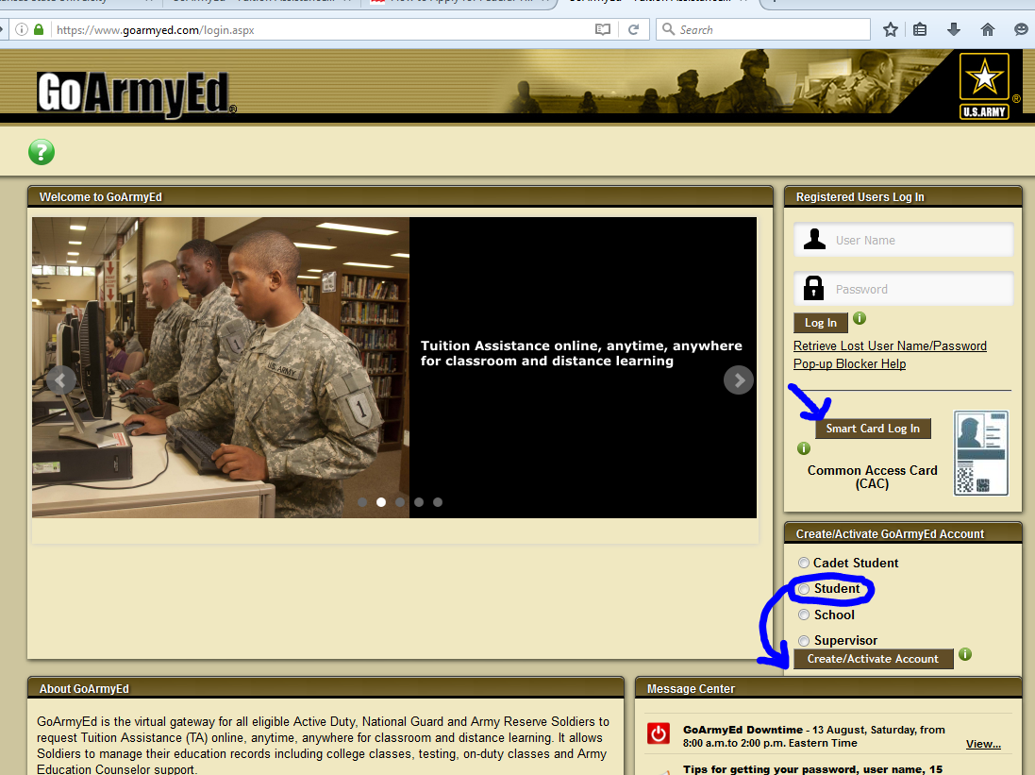
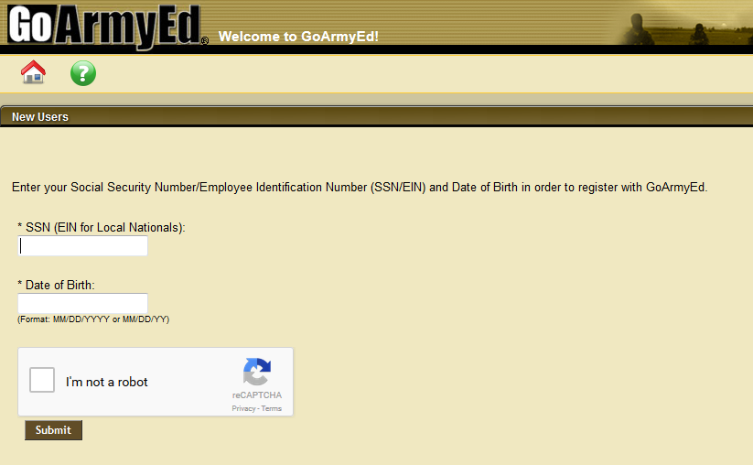
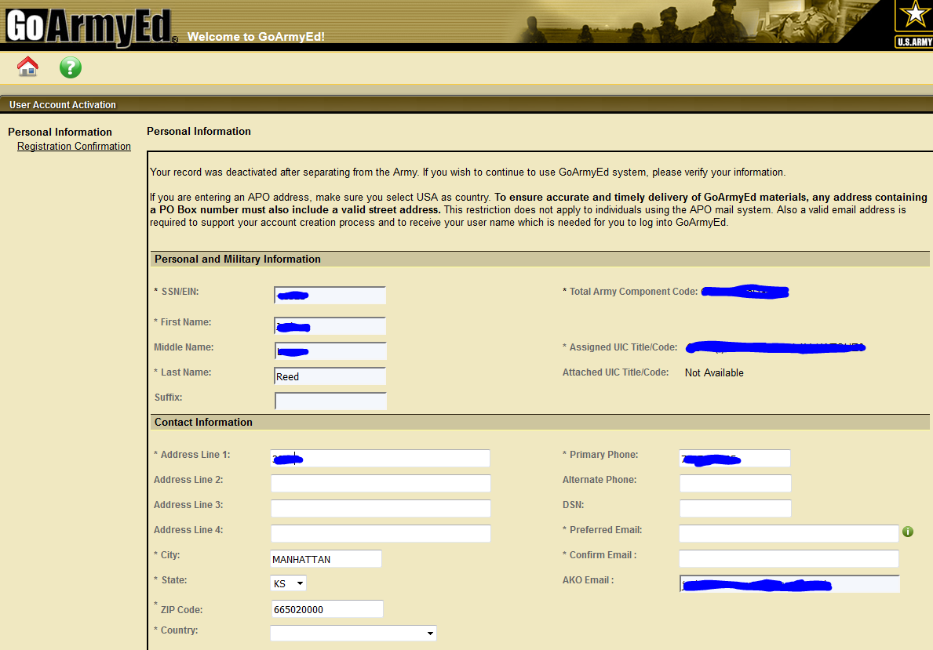
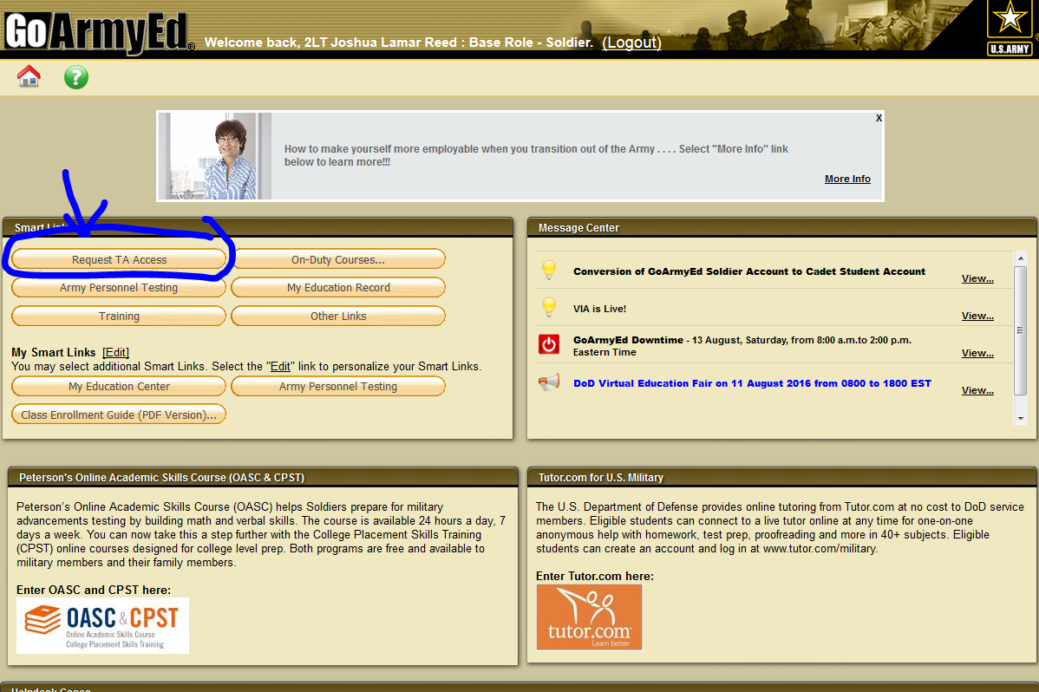
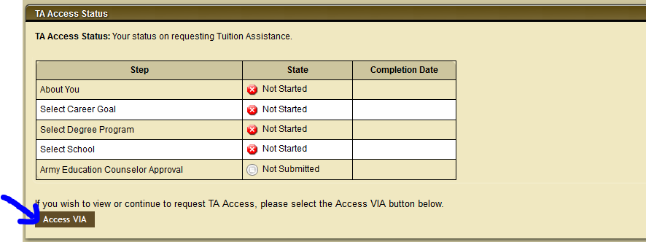
*****NOTE: Disable POP-UP Blocker or you will not be able to see the new window.
