Cultivating Critical Thinking Skills in the Music Classroom
Dr. Phil Payne and Dr. Ruth Gurgel
KMEA 2/26/15

How do you currently encourage critical thinking in your music classroom? (Ideas from the teachers in attendance)

- I use rubrics (peer and self eval), think-alouds and wait time.
- Performance self-evaluations and evaluations of others performing.
- Squilt
- I have them determine the high point of the phrasing (where the music is moving).
- I have my students compose small pieces using a piece we are performing as an example (i.e. a passacaglia, a menuet/trio, sonata allegro)
- Asking students what it is that they like most about the music they listen to.
- Comparing and contrasting different arrangements of pop songs.
- Student recitals.
- Students creating a rubric for assessing a performance.
- Students assess themselves. Students create a Kagen activity where they think/pair/share with “shoulder partners.” (One plays, the other assesses. They repeat with others.)
- Partner discussions and concept evaluations.
- Students create rhythms and put notes to it to create one-line singing exercises. They combine their rhythms with others to create bigger exercises.
- Ask them to rate their practice of a song in rehearsal.
- We sing in Latin and use root word reading strategies to create translations. Reading for meaning, hidden meaning, theme, meter, etc.
- Active listening activities during class.
- Performance rubrics.
- Identifying chord progressions and improvising a melody over the top of the progression.
- Asking the students how the lesson could be applied with other subjects.

A slide from our presentation (that wasn’t in the handout):

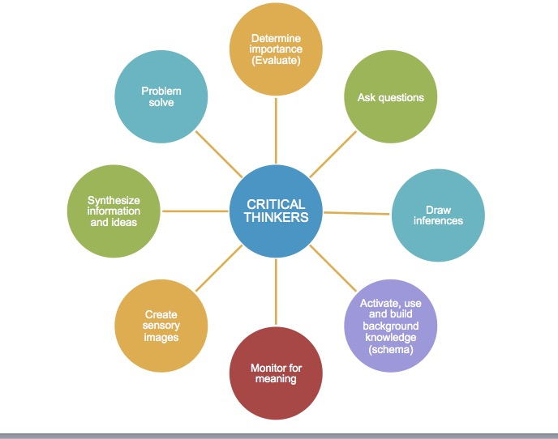

Sample H.S. Band Assessments (Designed by Travis Hale, Kansas State University):

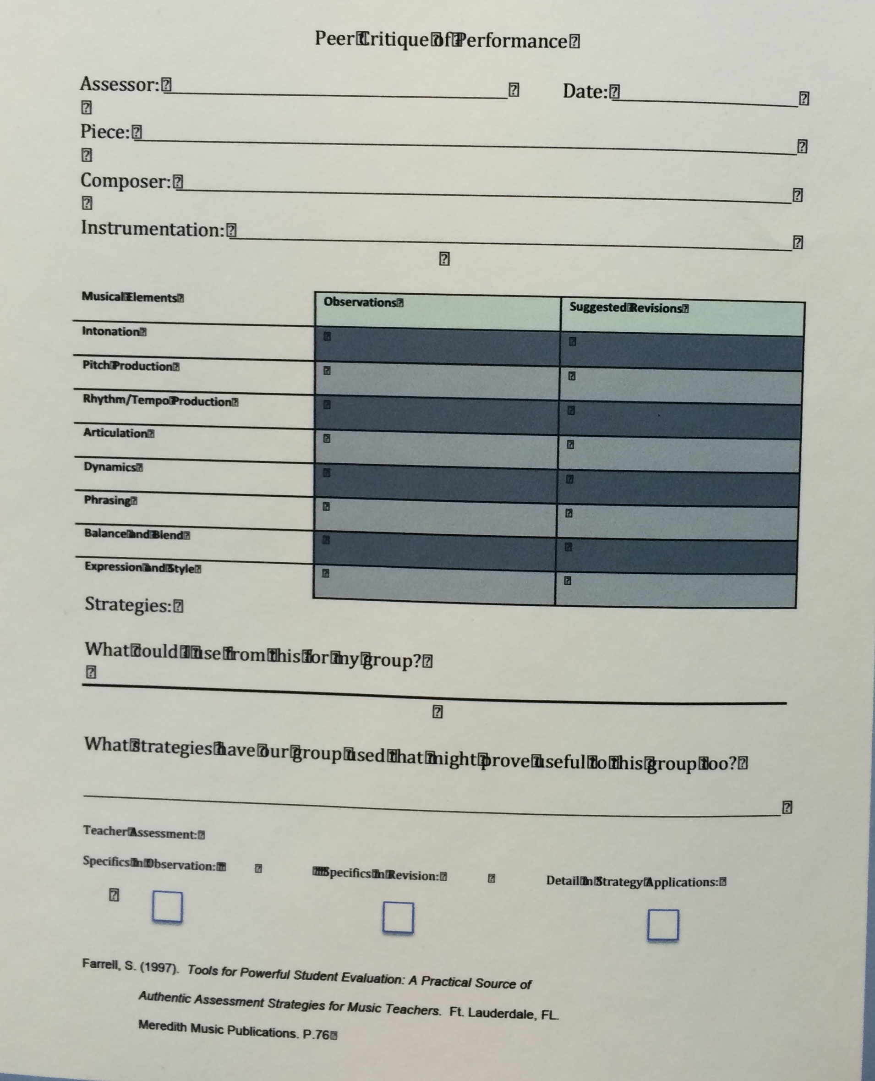
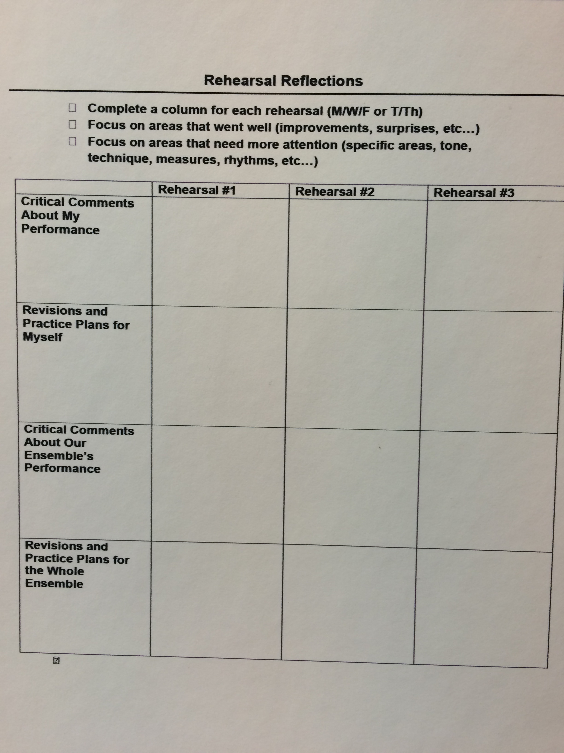

Here is a sample of a M.S. Band/Orchestra self-evaluation after a concert (google doc) (Designed by Jennifer Hawkins, Douglas County Schools, Colorado):
