**USACC 104-R Instructions**

NOTE: DO NOT USE AN APPLE COMPUTER TO COMPLETE THIS FORM.

The 104-R is your academic plan to complete your degree and is required for all students competing for a scholarship and all contracted Cadets regardless of scholarship status. This must be updated every semester with grades from the previous semester and any changes in your coursework. This instruction is broken down block by block.

Once the Form 104-R is completed by yourself and your Academic Advisor (with signature), it should be forwarded to your Military Science Instructor for review. He/She will then have the PMS sign it.

You MUST understand that this form is used to keep track of Cadets academic progress and keep them on-track toward commissioning with the stated degree. This form is also used to provide verification (receipt) of scholarship funds. You must give FULL, ACCURATE information on this form.

You are not authorized to change degree plans without approval from the PMS. Classes can be changed as long as you have approved it through your advisor and been counseled by your instructor, but doing so will require a new 104-R to be completed. Any changes in your 104-R must result in the same commissioning date as stated in your scholarship/contract. Deviation (commissioning early or later) must be approved through the PMS.

**BLOCKS 1-3**



* **BLOCK 1-** Self Explanatory
* **BLOCK 2-** Academic Major (e.g.. Mechanical Engineering, Nursing, Psychology, etc.)
  + **2a**- CIP Code- HRA will take care of this
* **BLOCK 3-** Date of preparation of the form (Essentially this is the date you updated this form for the current semester)

**BLOCK 4**

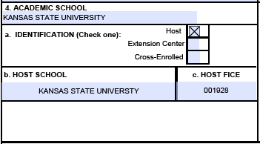

* **BLOCK 4-** Your School name (Kansas State University)
  + **4a-** If you are attending KSU, then check “Host”.
  + **4b-** The HOST FICE for KSU is 001928.

**BLOCK 5**

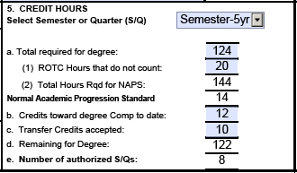

**PLEASE NOTE IF YOU ARE USING MICROSOFT EXCEL TO COMPLETE YOUR 104R AND NOT THE FILLABLE PDF VERSION, THE FOLLOWING MAY NOT WORK AUTOMATICALLY. YOU MAY HAVE TO FILL IN THE NUMBERS MANUALLY.**

* **BLOCK 5-** Select the drop down to display Semester/Quarter/Etc. Select the appropriate time that you have been authorized to complete your degree and commission from the drop down menu. (If you are pursuing an Engineering degree, typically you will be authorized a 5yr Semester (9 SEMESTERS TOTAL) unless you are transferring in.) Kansas State University is by Semesters
  + **5a- Total Required for Degree-** This is the total credit hours required to earn YOUR degree. Typically, this is 120 hours for most degree programs. There are programs such as engineering that require more hours to earn a degree. For graduate students this may be between 36-48 hours.
    - **5a1- ROTC Hours that do not Count-** This is the number of Military Science credit hours that do no not count towards your degree. This includes any Military History courses that ROTC requires you to take. Most Liberal Arts programs will accept ROTC classes towards electives in your degree program. Others, such as engineering programs, do not have many electives built into the degree program, and ROTC classes may not count toward the degree, so this number may be higher. **This is determined by your advisor.**
    - **5a2- Total Hours Rqd for NAPS-** This should self-populate. This is the sum total number of hours required for the degree and ROTC hours that do not count. (Ex.- 124 credit hours for the degree + 18 credit hours of ROTC that do not count toward the degree + 2 credit hours of ROTC required Military History Course = 144 Total Hours Required for NAPS)
  + **Normal Academic Progression Standard-** This should self-populate. This is the average number of hours, per Semester/Quarter, that a student should be taking every Semester/Quarter.
  + **5b-** **Credit toward degree Comp to date-** This is the number of hours you have completed *AT YOUR COLLEGE* the day you are completing this form. *THIS DOES NOT INCLUDE TRANSFER CREDITS TO INCLUDE AP CLASSES IN HIGH SCHOOL.* These are credits completed toward the degree you are seeking/authorized. If you changed your major and have classes that do not count toward your new degree then they do not count here.
  + **5c- Transfer Credits accepted-** These are the number of credit hours that the University has accepted *TOWARD YOUR STATED DEGREE*, not just any and all transfer credits. This includes AP classes taken in High School.
  + **5d-** **Remaining for Degree-** Should self-populate; this is how many hours you have left to complete your degree and Commission to include the current semester.
  + **5e- Number of authorized S/Qs (Semesters/Quarters) -** This is the number of semesters/quarters you are authorized to obtain your degree. This number determines the length of scholarship you are eligible for (i.e. 2-year, 2.5 year, 3-year, etc.)

**BLOCK 6**

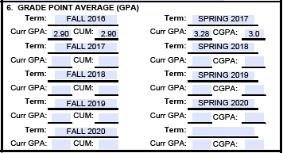

* **BLOCK 6- GRADE POINT AVERAGE-** This is your GPA for every term you have been in college. This does not include GPA from AP classes taken in High School or transfer credits.
  + **Term-** Fall, Spring, or Summer, and year taken.
  + **Curr GPA-** The GPA awarded for THAT TERM ONLY.
  + **CUM-** Your cumulative GPA based on all college hours taken based on your University transcripts.

**BLOCK 7**

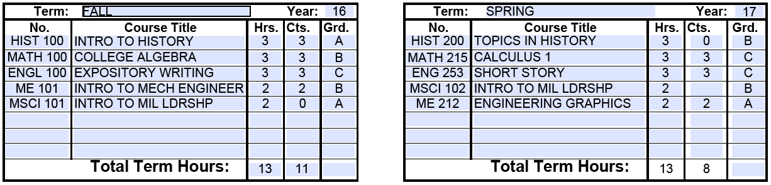

* **BLOCK 7-** This block covers your entire academic plan for your degree to include courses you have taken and courses you must take to earn your degree. *THE ROTC COURSES HAVE ALREADY BEEN INPUT FOR YOU (MSCI 101, MSCI 102, ETC)*
  + **Term-** Fall, Spring, or Summer, and year taken.
  + **Year-** The year the class was/will be taken. *LAST TWO DIGITS ONLY.*
  + **No.**– This is the prefix and course number (i.e. HIST100, MATH215, etc.)
  + **Course Title-** This is the full title of the course. (May have to be abbreviated if it cannot fit)
  + **Hrs.**- This is the number of hours of credits the class is worth according to the University. These blocks sum should be equal to block **5a2 Total Hours Rqd for NAPS**.
  + **Cts.**- This is the number of hours of credits that are awarded for the class taken. These blocks sum should be equal to block **5 “Total required for degree”**. ROTC hours that do not count are a good example of hours taken **(Hrs.)** but no credits **(Cts.)** awarded. Other cases include classes that were taken but resulted in a failing grade. If you are taking “filler classes” to maintain full-time student status, you would enter “0” here because the class is not worth anything toward your degree and not required by ROTC; you are proving in this document that you are taking the class to maintain 12 credit hours taken for full-time status.
  + **Grd.**- This is the grade you received for that class; this will be blank if the class is in the future.
  + **Total term hours-** This is the total number of hours and credits by block. This should self-populate.

**IMPORTANT THINGS TO REMEMBER ABOUT BLOCK 7**

* The only courses/credits/hours that should be in this block are the ones that COUNT TOWARD YOUR DEGREE YOU ARE SEEKING or classes required by ROTC.
* The number of hours you have taken toward your degree in Block 7 should match the “Credits toward degree complete to date” in Block 5. The “Remaining for degree” numbers should match as well.
* **If you have transfer credits, put them in the first block (Block 7a) along with grades.**
* If you have taken summer classes, make a summer term in block 7 and list them there. Usually the GPA from the summer term fill calculate into a fall or spring term. SEE YOUR ACADEMIC ADVISOR for which term to count the GPA toward. You should not anticipate taking summer classes while participating in ROTC so do not pre-plan summer classes on the 104-R. You are allowed to take summer classes as a Cadet, but you may not be entitled to scholarship benefits during the summer. Sumer courses should be planned only when necessary (Failed a class and cannot be made up during the normal school semester) and recommended by your Advisor and authorized by the PMS.
* The numbers in block 7 do not self-populate to anywhere else in the form 104-R.

**BLOCK 8**



* **BLOCK 8-** Each term, beginning with Term 1, should be initialed up to your current term when you receive your counseling from your instructor every semester. For example, a college sophomore has taken two college terms and is currently in their third term, so, they would initial Term 1, 2, and 3 upon counseling from their instructor.

**BLOCK 9-13**

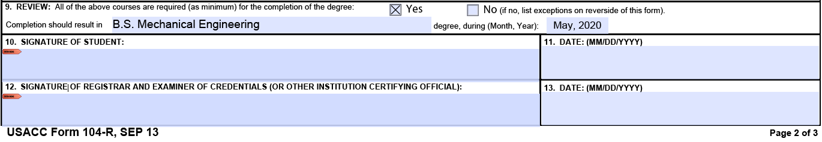

* **BLOCK 9-** Should check “YES” box. Only check “NO” if there are additional requirements for the degree. This should indicate your degree to include type (i.e. BA, BS, MS, MA, etc.) and your graduation month and year (must type this in a MMM YYYY format if the drop box defaults to an error).
* **BLOCK 10-** Student signature. This can be digitally signed.
* **BLOCK 11-** Date signed by student.
* **BLOCK 12-** Your ADVISOR’S signature. This can be digitally OR ink signed. A typed name will not be accepted.
* **BLOCK 13-** Date your Advisor signed.

**PAGE 3**

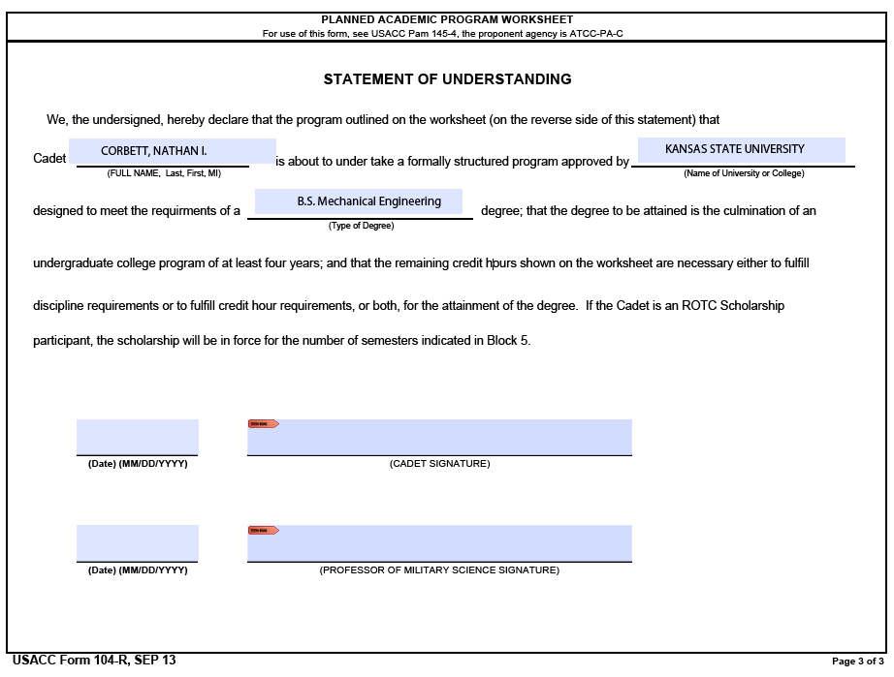

* **PAGE 3- Statement Of Understanding-** This should include your name, University, Degree to include type (i.e. BA, BS, MS, MA, etc.) along with your signature in the “Cadet Signature” block. This completes the USACC Form 104-R.