Program/Plan Overview

Purpose
Use this procedure to get an overview of the screens involved in maintaining Programs and Plans for students.

Trigger
Perform this procedure as a reference for Plan Maintenance.

Prerequisites
None

Menu Path
Use the following menu path(s) to begin this task:
- Records and Enrollment Career and Program Information Student Program/Plan

Helpful Hints
 The primary Academic Plan (Major) must be assigned a Plan Sequence of 10 (and should be the only Academic Plan with a Plan Sequence of 10).
- All non-primary Academic Plans should have Plan Sequences of 20, 30, 40, etc.
- Minors are Academic Plans, just like Majors. To add a minor, follow the procedure for adding a Plan.

 When performing Program Actions, always insert a new Effective Dated Row (click the button) in order to maintain the history of the student’s record.

Procedure
1. Records and Enrollment Career and Program Information Student Program/Plan

Student Academic Program/Plan
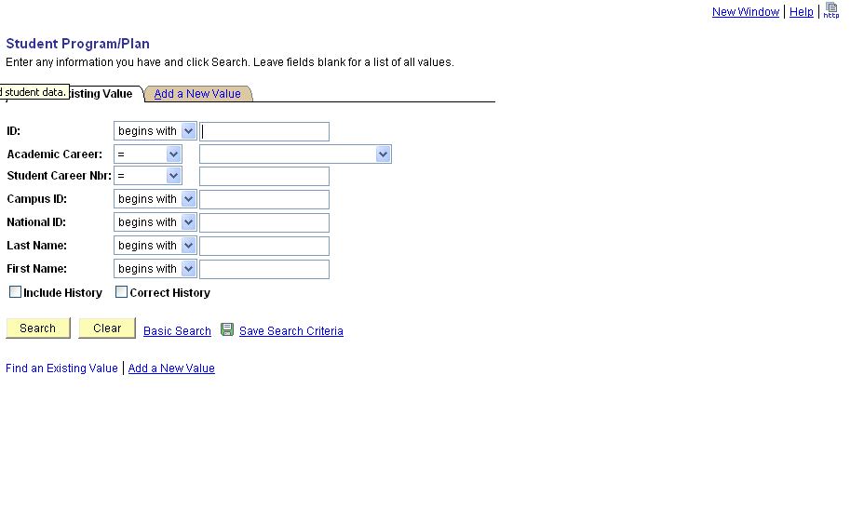

2. At a minimum, complete the following required fields to find the appropriate record:
Field Name | R/O/C | Description
ID | R | iSIS unique system identifier.  Example: 0000000051
Academic Career | O | A Grouping of all academic work undertaken by a student grouped into a single statistical record. KSU will use Undergraduate, Graduate, and Veterinary Medicine careers to designate their students.  Example: (left blank)
Student Career Nbr | O | Order in which Academic Programs are processed within a given Academic Career.   Lower Student Career Numbers are processed before higher numbers.  The first Student Career Number for a student is 0. Additional Student Career Numbers increment by 1.  For students with multiple Programs within the same Career, each Program must have a unique Student Career Number.  When an Academic Program is changed for a student, the Student Career Number does not change.  Primary Programs are to have the LOWEST Career Number. The Primary Academic Program controls the values on various fields on the student’s career term record.  Example: (left blank)
Campus ID | O | K-State issued student identifier. Also called, the Wildcat ID (WID).  Example: (left blank)
National ID | O | National identification number issued by the government. Social Security Number (SSN).  Example: (left blank)
Last Name | O | Person's last name.  Example: (left blank)
First Name | O | Person’s first name.  Example: (left blank)

If the search has only one matching value, that record will open automatically. If a student has more than one Program within a Career, you will be provided with a list of all the available Academic Programs. The only way to determine which of the Programs for a student are active is to open each individual Program.

Student Academic Program/Plan – Student Program
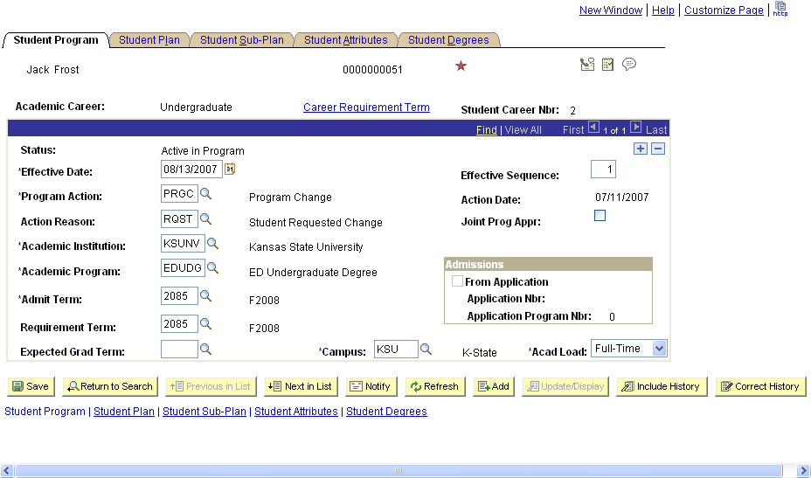

3. As required, complete/review the following fields:
Field Name | R/O/C | Description
Status | R | Indicates the Status of the Academic Program as of the Effective Date below.  A student must have a Status Active in Program for at least one Program to be able to enroll in Classes.  Example: Active in Program
Effective Date | R | The date on which the settings become effective.  Effective Dates are to be set to 01/01/YYYY to be effective for a given Spring term, 05/01/YYYY for a Summer term, and 08/01/YYYY for a Fall term.  Effective Dates must be set to a date prior to the beginning of the term in which any processing within iSIS should occur.  Example: 08/01/2007
Program Action | R | Change to be performed to a student's Program.  Common Program Actions include:  - PRGC (Program Change): used to change a Program and Plan within the same Career  - PLNC (Plan Change): used to change the Plan within the same Program  - Data (Data Change): used to change data for an existing Program or Plan  - ACTV (Activate): used to make the student active in an additional Program within the same Career  - DISC (Discontinuation): used to discontinue a Program  Example: EDUDG
Action Reason | R | Reason code that describes why the action was taken or offers a further description of the Program Action.  Example: RQST (Student Requested Change)
Academic Institution | R | Kansas State University, indicated as ‘KSUNV’.  Example: KSUNV
Academic Program | R | The academic entity to which the student applies and which oversees the degree progress of a particular Academic Plan. For example, Undergraduate in the College of Education, Degree Seeking.  Example: EDUDG
Admit Term | R | Term in which the student is admitted to the Academic Program or Plan.  This is not the term in which the student is admitted to K-State.  If the Program Action is set to PLNC, DATA, or DISC, then DO NOT change the Admit Term. If the Program Action is set to PRGC or ACTV, then the Admit Term must be set to match the Effective Date.  Example: 2085
Requirement Term | R | Indicates the term in which academic degree progress requirements apply to the student for this Academic Program or Plan.  This value will default to the Admit Term. Since K-State will be using the Requirement Term at the Plan level (not here at the Program level), accept the default value.  This field must be populated for requisite checking against pre-requisites that require a specific Academic Plan or Program.  Example: 2085
Expected Grad Term | O | Term in which the student expects to graduate from the specified Academic Program.  This field is to be left blank until a student applied for graduation. Errant values here will effect the student’s eligibility for Financial Aid in iSIS.  Example: (left blank)
Effective Sequence | R | Order in which conditions are to be assessed.  Higher Effective Sequence numbers take precedence over lower Effective Sequence numbers.  This value will be set by the system unless the same record is adjusted twice in the same day. Then the higher number will indicate the most recent change to the record.  Example: 1
Action Date | R | Date a specific action was taken within iSIS.  This field is for display only and will likely be different from the Effective Date. This value is stored for tracking purposes.  Example: 07/11/2007
Joint Program Appt | O | This field is not being used by K-State.
Campus | O | "KSU". The Campus in iSIS is used to designate entities that use a single transcript, course catalog, and other academic differences. The Salina and Continuing Education classes are designated as Locations in iSIS.  Example: KSU
Academic Load | O | Estimate of whether the student will complete the Academic Program as a Full-Time or Part-Time student.  There is no functionality to date that is effected by this field. K-State is recommending that this value be set to Full-Time.  Example: Full-Time

4. Click .

Student Academic Program/Plan – Student Plan
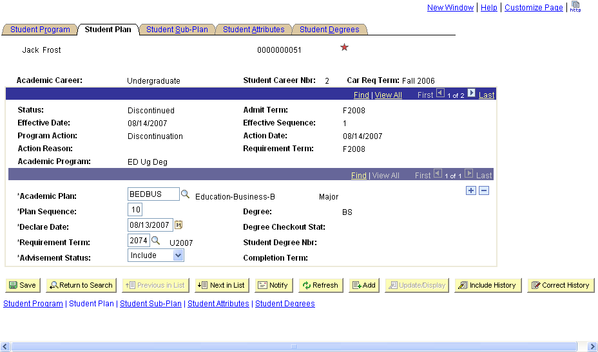

5. As required, complete/review the following fields:
Field Name | R/O/C | Description
Academic Plan | R | A course of study leading to a formal award given by an institution, such as a degree, diploma or certificate. For example, Bachelor of Arts in Mathematics.  A student may have multiple Academic Plans within the same Academic Program.  Example: BEDBUS
Plan Sequence | R | Order in which Academic Plans are to be processed.  Primary Academic Plans are to be assigned a Plan Sequence of 10. All other Plans should be assigned values of 20, 30, 40, etc.  There can be only one active Plan Sequence with a value of 10 across all active Academic Careers and Programs. Plan Sequence values increment by 10 with each successive Plan.  Example: 10
Declare Date | R | Date corresponding to the term for which the Academic Plan became active.  This value defaults to the Effective Date.  Example: 08/13/2007
Requirement Term | R | Indicates the term in which academic degree progress requirements apply to the student for this Academic Program or Plan.  This value defaults to the Requirement Term from the Program, and may be adjusted manually, if necessary.  This value will be used by DARS in determining the Catalog Year.  Double-check this value before saving the record.  Example: 2074
Advisement Status | R | For use in Academic Advising. K-State is not using this field.  This field is required by iSIS to be completed. K-State recommends keeping the default Include value.  Example: Include
Degree | O | The degree title associated with the Academic Plan.  This value is for display only.  Example: BS
Degree Checkout Stat | O | Status of a student’s application for graduation.  Possible values include Applied and Awarded.  This value is for display only.  Example: (blank)
Student Degree Nbr | O | Order in which this Academic Plan will appear on the student’s diploma.  Lower numbers will appear before higher numbers.  Example: (blank)
Completion Term | O | Term in which the student graduated from the Academic Plan.  This value is for display only.  Example: (blank)

6. Click .

Student Academic Program/Plan – Student Sub-Plan
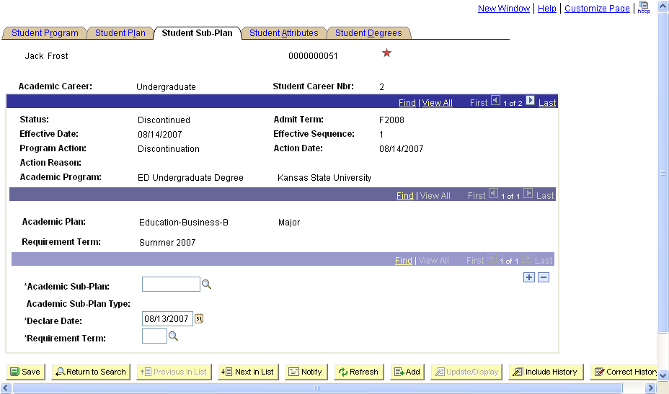

7. As required, complete/review the following fields:
Field Name | R/O/C | Description
Academic Sub-Plan | R | The further specialization os an academic plan or major. Sub-plans may include concentrations, specializations, or, in some cases, minors.  Example: (left blank)
Academic Sub-Plan Type | C | Type of Sub-Plan offered.  Example: (left blank)
Declare Date | R | Date corresponding to the term for which the Academic Plan became active.  This value defaults to the current date.  Example: 08/13/2007
Requirement Term | R | Indicates the term in which academic degree progress requirements apply to the student for this Academic Program or Plan.  This value defaults to the Requirement Term from the Plan.  Double-check this value before saving the record.  Example: 2074

8. Click .
9. You have completed this task.

Result
You have reviewed the fields associated with assigning a Program/Plan to a student.

Comments
For further information, refer to these specific documents relating to Academic Programs and Plans:
- Changing an Academic Plan (within the same Academic Program)
- Changing an Academic Plan (outside the same Academic Program)
- Adding an Academic Plan
- Inactivating an Academic Plan
- Changing Data About an Existing Program or Plan
- Adding an Academic Program
- Inactivating an Academic Program
- Changing the Student Career Number
- Adding an Academic Career
- Inactivating an Academic Career

