Reserve Capacity
HELP

Description: Courses can have reserved capacities to save and control enrollment for a certain student population such as specific majors, academic levels, etc. In KSIS, department/college schedulers create Enrollment Requirement Groups (ERG) to identify the specific student population the seats are being reserved for.
--For information on creating ERG rule, see separate document: “Requisites HELP”

●Enter Reserved Capacity
Navigation: Curriculum Management>Schedule of Classes>Maintain Schedule of Classes>Reserve Cap tab

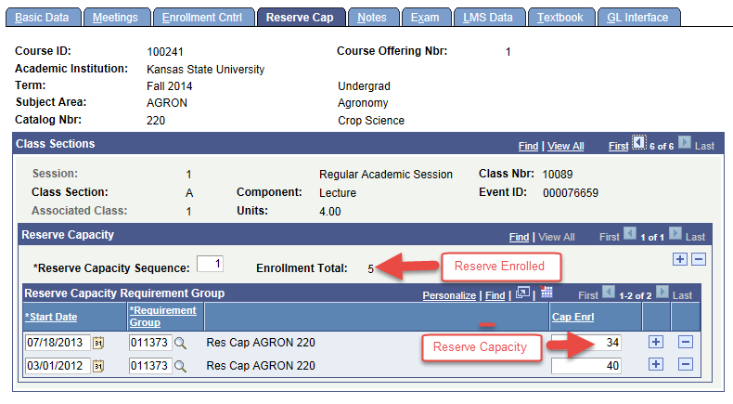
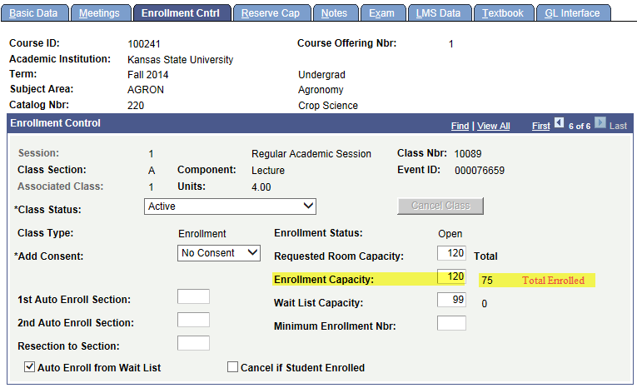

●Display Seats Available in Class Details
--Navigation: Curriculum Management>Schedule of Classes>Class Search>Click on class link
--page displayed in the same Class Details used in Quick Enroll and Student Self Service Enrollment
--displayed in Class Search>Class Details (KSU mod)

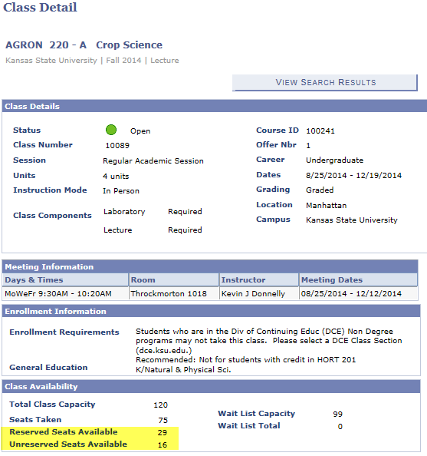

●Display Reserved Icon in Class Search Results
- If only Reserved Seats remain, then the Reserved icon is displayed as Status icon in the Class Search Results and Class Detail pages

●Display Seats Available in KSU Class Center
--Navigation: Curriculum Management>Schedule of Classes>KSU Class Center
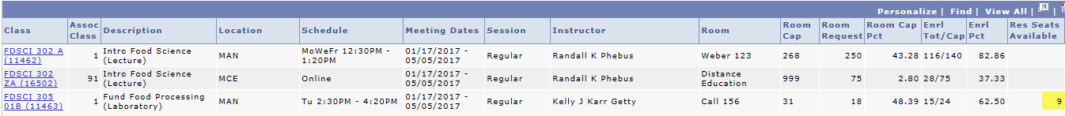

●Display Seats Available in Class Capacities Report
--Navigation: Curriculum Management>Schedule of Classes>KSU Reports>Class Capacities Report
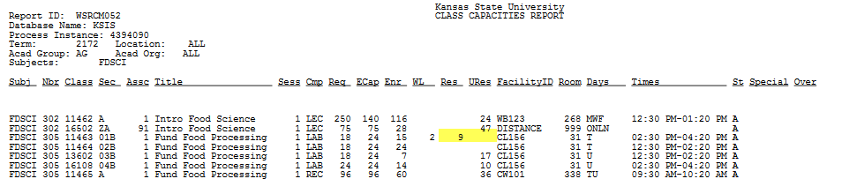
●Attach Reserved Capacity to “Enrollment” components only
--The Enrollment/Graded component will be the only section listed with a Reserve Capacity area.
--Reserve Capacity is added using Enrollment Requirement Group rules (ERG)

●To add Reserved Capacity to a class
--Start Date: Enter the effective date for your reserve capacity.
--if you want effective beginning with first day of early enrollment, then use a date a few days prior
--standard dates work well: 3-1-yyyy for Fall and Summer; 10-1-yyyy for Spring
--rollover dates from previous year are ok if Reserve Cap in effect from start of enrollment
--Requirement Group: enter ERG
--Cap Enrl: cannot be GT “Enrollment Capacity”

●To add an “additional” Reserved Capacity rule to a class
--Click Plus icon to add a new Reserve Capacity Sequence (click “top” + to right of Enrollment Total)
--Start Date: Enter the effective date for your reserve capacity.
--Requirement Group: enter ERG
--Cap Enrl: sum for all sequence numbers cannot be GT “Enrollment Capacity”
--if the intent of reserve cap is to have more than one rule in effect at the same time then an additional “Reserve Capacity Sequence” should be used for the additional rules
--adding a second row within the same sequence will not accomplish this
--create Reserve Capacity Sequences in order—from most restrictive to least restrictive Requirement Group.
--Each sequence may be assigned a separate desired Reserve Enrl Cap
--Each sequence should be assigned with SAME Start Date
--set as many Reserve Capacity Sequences as you want, controlling up to, but not more than, the entire Enrollment Capacity.
--could do more than one rule; turn one off then start another

●To add a “row” within a Reserved Capacity sequence
--Click Plus icon to add a row in the “Reserve Capacity Requirement Group” area (click bottom +)
--Start Date: Enter the effective date for your reserve capacity.
--Requirement Group: enter ERG
--Cap Enrl: cannot be GT “Enrollment Capacity”
--if the intent is to have one rule in effect but control the number of reserved seats over a range of effective dates then adding a row within an existing sequence should be used
--if the intent of reserve cap is to have more than one rule in effect at the same time then an additional “Reserve Capacity Sequence” should be used for the additional rules
--If there is a second row in the SAME sequence, both rows should show the same Requirement Group. You must change the Requirement Group on the second line if you change the Requirement Group on the first line.
--the system selects and uses only one Requirement Group per Reserve Capacity Sequence—the one that has the most current effective date.

●Guidelines for using more than one Enrollment Requirement Groups
--Create separate Enrollment Requirement Groups for each rule
--if the intent of reserve cap is to have more than one rule in effect at the same time then an additional “Reserve Capacity Sequence” should be used for adding the additional rules (1,2,3, etc)
--Each sequence may be assigned a separate desired Reserve Enrl Cap
--Each sequence should be assigned with SAME Start Date
--set as many Reserve Capacity Sequences as you want, controlling up to, but not more than, the entire Enrollment Capacity.
--create Reserve Capacity Sequences in order—from most restrictive to least restrictive Requirement Group.
(If a student enrolls who is a member of two groups for which a reserve capacity has been set, the enrollment total will be incremented for the first sequence that applies)
--If there is a second row in the SAME sequence, both rows should show the same Requirement Group. You must change the Requirement Group on the second line if you change the Requirement Group on the first line.
--the system selects and uses only one Requirement Group per Reserve Capacity Sequence—the one that has the most current effective date.

●To change Reserve Capacity
--Start Date: change as needed
--Requirement Group: change ERG as needed
--Cap Enrl: change the existing number
--“Reserve Cap” must be LE “Enrollment Capacity” AND must be GE Reserve Enrollment Total

●To reserve X more seats
If Reserve is full:
Reserve Enrollment Total + X more seats = New Reserve Cap Enrl
New must be LE Enrollment Capacity

If Reserve is not full:
Reserve Cap Enrl + X more seats = New Reserve Cap Enrl
New must be LE Enrollment Capacity

●To reduce number of reserved seats
Reserve Cap Enrl must be GE Reserve Enrollment Total

●To change “Enrollment Capacity”
If you lower “Enrollment Capacity”
--Reserve Capacity” must be LE the NEW “Enrollment Capacity”
If you are setting “Enrollment Capacity” EQ 0,
--Then use Delete Rows icon (-) to delete all Reserve Cap rows
--If at a later date you will increase Enr Cap above 0, then add Res Cap rows back in at that time

●To release all remaining reserved seats:
--Locate the Reserve Capacity Sequence for which you want to release seats
--click the Add Row icon (+) next to the Reserve “Cap Enrl” field
--Start Date: enter the date when you want to release the seats.
--Requirement Group: enter the ERG
--Cap Enrl:
If Reserve Enrollment Total GT 0, then enter a value equal to Reserve Enrollment Total
Note: this will in effect turn the rule off; student already enrolled under rule will not be affected
Note: You cannot delete a reserve capacity sequence if enrollment for that group has already
begun and any seats are filled
If Reserve Enrollment Total EQ 0, and other Reserve Capacity Sequence rows exist, then enter “1”
Important! Do not reduce the number to 0 if there are additional reserve capacity sequences, since
this will inactivate all reserves for this course, in all reserve capacity sequence rows.
If Reserve Enrollment Total EQ 0, and no other Reserve Capacity Sequence rows exist , then enter “0”
??cannot do this if there is only one row in the Reserve Capacity Sequence??

●If Reserve Capacity was added in error and you need to correct:
--Locate the Reserve Capacity Sequence for which you need to release seats
--If Reserve Enrollment Total EQ 0 then click the Delete Row (-) icon next to the Reserve “Cap Enrl” field
--If Reserve Enrollment Total GT 0, then enter the Reserve Enrollment Total in “Cap Enrl” field

● If you expire (set to 0) the Cap Enrl field value for any reserve capacity sequence row within the section, the system inactivates all reserve capacity sequence values for the section.

●To override reserve capacity, you must use Quick Enroll and use the "Override Closed Class" checkbox;
--class permission and Quick Enroll (override requisites) will not work

●Reserve Capacity and Waitlist
--students can get on Waitlist if:
--class is full
--class is not full but all reserve capacity slots for which student qualifies are full
--If a student does not meet reserve capacity rule, and there are no Unreserved seats left, although there may be Reserved seats left, then student can be placed on the Waitlist
--When Auto-enroll from Waitlist is run, it again checks the Reserve Capacity rules
--If student doesn’t meet the rule, and only Reserved Seats remain, then student will not be enrolled
Important! If Reserve Cap numbers are too high, then Auto-Enroll from Waitlist may not work as expected
**the basic rule is that if “all” seats are reserved and student does not meet reserve capacity rule, then the student cannot get on waitlist for class because there is no possibility that they would every get into the class
**if only “some” of the seats are reserve capacity then the student could get on waitlist because there is a chance that if a seat opens up that is Unreserved then the student could get into the class

●Reserved Capacity Formulas
Enrollment Capacity - Total Enrolled = Seats Available
EC – TE = SA
Reserve Capacity – Reserve Enrolled = Reserved Available (adjusted range 0-SA)
RC – RE = RA (adjusted range 0-SA)
Seats Available – Reserved Available = Unreserved Available
SA-RA=UA

Example:
Enrollment Capacity - Total Enrolled = Seats Available
120 – 75 = 45
Reserve Capacity – Reserve Enrolled = Reserved Available (adjusted range 0-SA)
34 – 5 = 29 (adjusted range 0-SA)
Seats Available – Reserved Available = Unreserved Available
45-29=16

●View Reserved Capacity Rule
Navigation: Curriculum Management>Enrollment Requirements>Enrollment Requirement Groups
--Search for “Requirement Group” number used in Reserve Cap Tab
--although all tabs may be used; typically most logic of the rule is defined on “Requisite Detail” tab

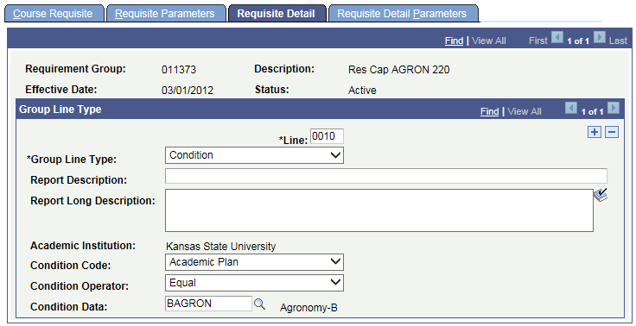

PROBLEM SOLVING:

●Problem: There are seats left, but student gets waitlist message:
Resolution: The problem is the Class Associations are all 1 on each enrollment section, they should be unique
If the res cap is met on one of the sections, then it will apply to all the section since they have the same associated class. Correct the Class Associations.

●Academic Plan or SubPlan in ERG
There is a big difference in how Plan vs Plans works in the rule; if Plans is used the student must meet ALL of the plans listed; therefore
--recommend using “Plan” not “Plans” --also use “Program” not “Programs”
--recommend using “Subplan” not “Subplans” --also use “Student Group” not “Student Groups”

●Academic Level in ERG
Requisite and Reserve Cap rules use the student’s “PROJECTED” standing. It is calculated based on completed AND in-progress units for a term (in other words what they are projected to be the next term). This is the field used by enrollment requirements, although that's not clear since rules just say 'Academic Level' when building them.

●Negative numbers displayed in the KSU Mod to display Reserved and Unreserved Seats
--Res Cap - Reserve Enrollment Total GT Total enrollment Capacity
--lower Res Cap to value of Res Cap – Res Enr
--Res Cap LT Reserve Enrollment Total
--change Res Cap EQ to value of Reserve Enrollment Total

ERROR: The Enrollment Reserve Capacity Total must not exceed the Class Enrollment Capacity
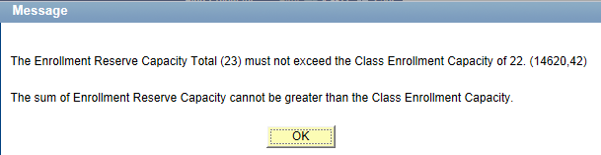
Resolution:
Lower “Reserve Capacity” so that it is not GT “Enrollment Capacity”

ERROR: Error in creating Reserve Capacity Expiration
Error in creating Reserve Capacity Expiration. (14620, 81)
When creating a Reserve Capacity expiration date for a single class section, the following criteria must be met:
--only one row can be created within an individual class section with an ENRL_CAP of ZERO,
--there must be at least 2 or more reserve capacity rows for an individual class section,
--an ENRL_CAP of ZERO can only be entered on the row with the latest Start date for the class section.

Resolution:
1)If the only row is one where Cap Enrl = 0, then use Delete Row icon (-) to delete the rows.
If at a later date they need to increase Enr Cap >0 then add Res Cap rows back in

2)If a row exists where Cap Enrl = 0, then it must be the rows with the latest start date
If it is not, then use Delete rows icon (-) to delete the rows with 0

3)Look for a similar problem on another section than the one throwing the error
Fix that error and then you should be able to continue

ERROR: Reserve Capacity Sequence cannot be changed or deleted
Tried to delete 6-18-2014 cap enrl=0 row; it could not be deleted got the error message below
“Reserve Capacity Sequence cannot be changed or deleted. (14620,44)
Modification or deletion to the Reserve Capacity Sequence is not allowed. However, the Enrollment Capacity and/or the Requirement Group fields may be altered”
--so instead change cap enrl from 0 to 5 (since 5 students enrolled)
