>>Class Topics
Choose ONE of the following options and complete appropriate fields:
___ TITLE DOES NOT VARY*
Class Topic region
Course Topic ID: Do not select a class topic (delete topic if one exists)
 Print Topic in Schedule (Not checked)
Class Attributes region Do not select VARY-By Section or VARY-by Student
(use minus to delete those values if they exist)
*Used when Course does not allow variable titles, OR
Course allows Vary By Section but the section Class Topic title is the SAME as the Course Catalog title
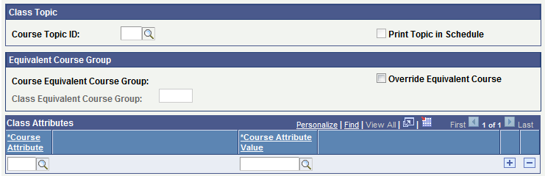

___ VARY BY SECTION
Class Topic region
Course Topic ID: Select topic**
Description: Class topic title (Display only)
 Print Topic in Schedule (Checked)
Class Attributes region
Class Attribute VARY Vary Title
Class Attribute Value*** BY SECTION Vary Title by Section
**if a title you need is not listed, then email Sharon Hauck (hauck@ksu.edu) with term, subject and catalog #, and title needed (no more than 30
Characters; all variable titles begin with TOP/ even if course title contains SEM, PRB, RDG, IS, SS
***Class Attribute values default from Course setup; if both BY SECTION and BY STUDENT values are displayed here then delete the value that
is not needed for this section
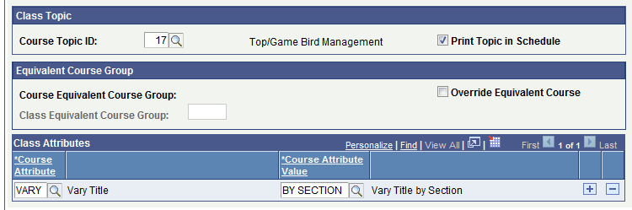

___ VARY BY STUDENT
Class Topic region
Course Topic ID: Select “Top/Vary By Student”
 Print Topic in Schedule (Checked)
Class Attributes region
Class Attribute VARY Vary Title
Class Attribute Value*** BY STUDENT Vary Title by STUDENT
***Class Attribute values default from Course setup; if both BY SECTION and BY STUDENT values are displayed here then delete the value that
is not needed for this section
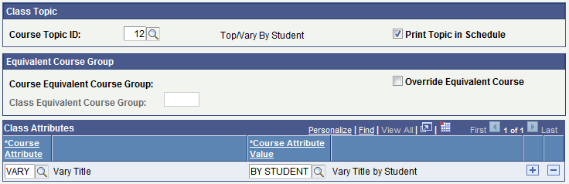

Report: Curriculum Management>Schedule of Classes>KSU Reports>Vary Title by Sec/by Stu (WSRCM040)
