Class Associations

iSIS pages:
Curriculum Management>Schedule of Classes>Update Sections of a Class
Curriculum Management>Schedule of Classes>Adjust Class Associations

iSIS report:
Curriculum Management>Schedule of Classes>KSU Reports>Update Sections of a Class

Basics
Class Section:
--must be unique
--naming
--A, B, C….. for Manhattan Enrollment/graded sections
--All Non-enrollment components start with number followed by suffix
--B=Lab, L=Lec, Q=Quiz, R=Recitation, T=Studio
--01B, 02B, 02R, 03Q, 04 R, etc
--begin single digit numbers with 0
--all components will have separate Class Numbers
--Precede Olathe on campus sections with O (OA, OB, OC, etc)
--Precede Olathe DCE sections with Q (QA, QB, QC, etc)
--Precede Salina on campus section with S (SA, SB, S01B, etc)
--Precede Salina DCE sections with T (TA, TB, TC, etc)
--Precede Manhattan DCE sections with Z (ZA, ZB, ZC, etc)

Component:
--ACT, AUD, FLD, HLP, IND, INT, LAB, LEC, LES, OTH, PRC, QZ, REC,
RDG, RSH, SEM, SLF, STD, TCH
--One is selected as Enrollment/Graded/Primary component
--Others are Non-enrollment components
--Class Schedule expects setup at Course level
--if you do otherwise you will need to Adjust Class Associations

Class Type:
--Enrollment component must be primary/graded component
--Non-enrollment for other components

Associated Class:
--an additional class identifier (in addition to Class Nbr and Section)
--used to link class sections that constitute a single course offering
--unique for each Enrollment component
--naming
--numeric values beginning with 1 (1 is default)
--starting values:
--MAN = 1, MCE = 91, OLT = 71, OCE = 771, SAL =81, SCE=881
--9999=associates section with any other Non-enrollment sections
--used when student may choose a section
--cannot be applied to “Enrollment” section
Auto Enrollment:
--Enter a section in which the system should automatically enroll students
--Must have a different component from parent section
--Enrollment sections can only auto-enroll Non-enrollment sections
Common Types of Associations

●SINGLE COMPONENT
--only one component required for enrollment
--all components named the same
--Associated Class is unique for each enrollment component

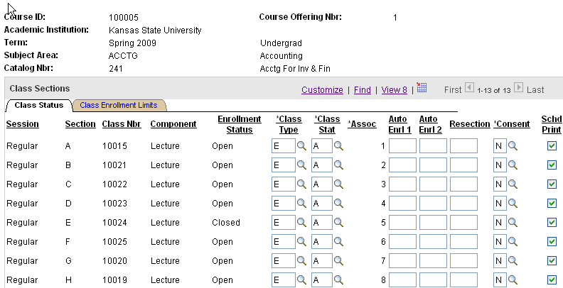
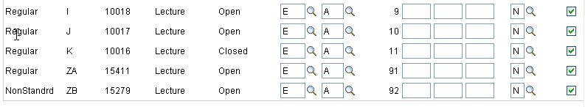
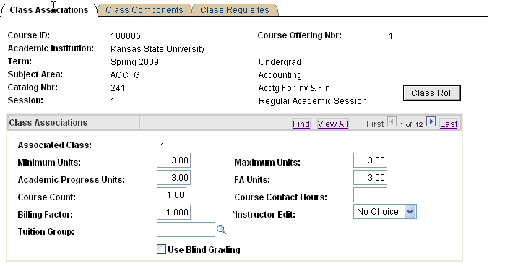
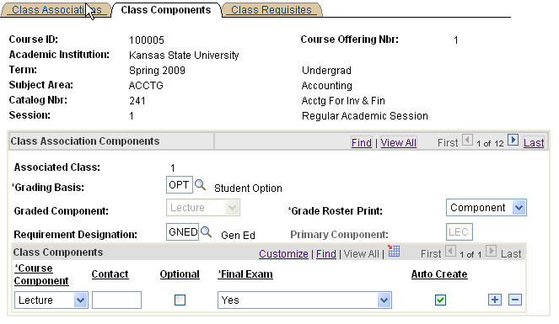

●ONE-TO-ONE COMPONENTS
--more than one component required for each enrollment
--Enrollment component (carries hours/grades)
--additional Non-enrollment component(s) which match one-to-one with a specific Enrollment component
--Associated Class is unique for each Enrollment component
--each has matching non-enrollment component
--Enrollment component has Auto-Enrollment in Non-enrollment component
--Enrollment Capacity for Enrollment component should equal that of the matching Non-enrollment component

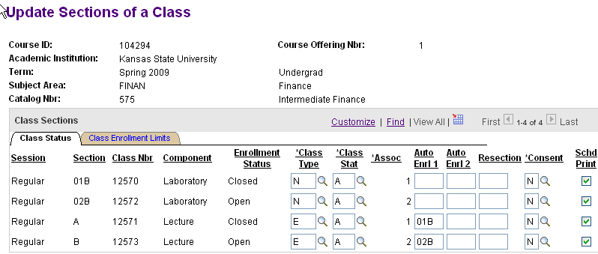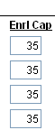
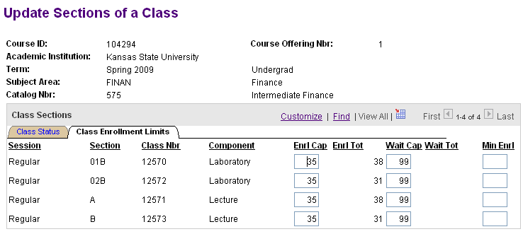

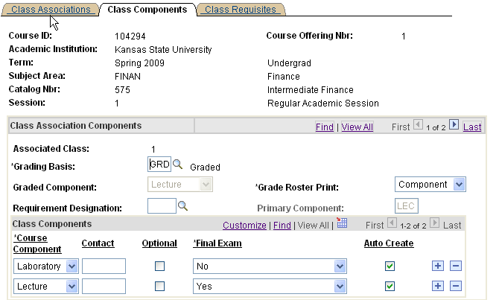

●ONE-TO-MANY COMPONENTS
--more than one component required for each enrollment (such as LEC and REC)
--One Enrollment component (carries hours/grading)
--student chooses one additional Non-enrollment component
--Associated Class is unique for the Enrollment component
--non-enrollment components = 9999
--no auto enrollment
--Compare Enrollment Capacity for Enrollment component to the total of the non-enrollment section capacities

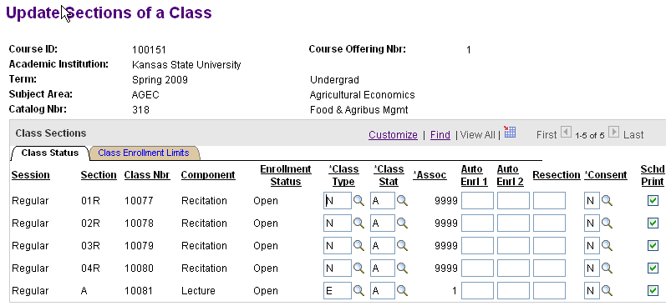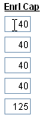

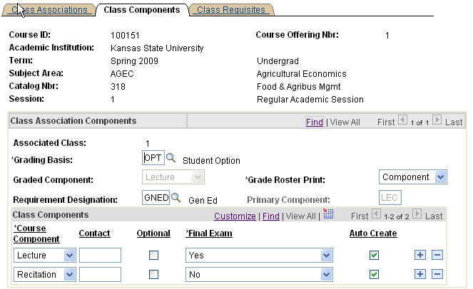
●ONE-TO-MANY COMPONENTS WITH AUTO-ENROLLMENT
--more than one component required for each enrollment (such as LAB and REC)
--Many Enrollment components (carries hours/grading)
--student is auto-enrolled in Non-enrollment component
--Associated Class is unique for each Enrollment component
--non-enrollment components = 9999
--Compare Enrollment Capacity for Non-enrollment component to the total of the Enrollment section capacities

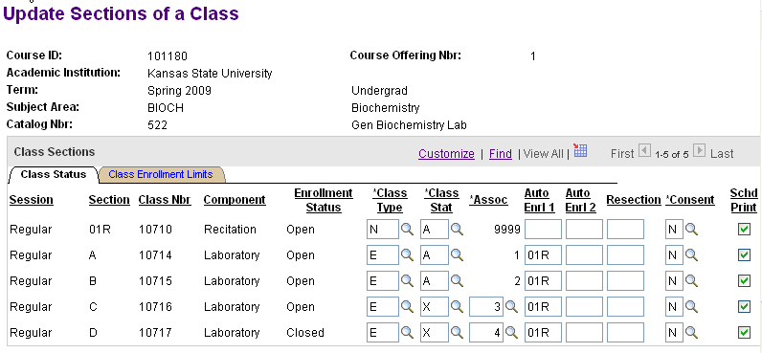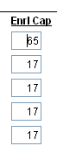

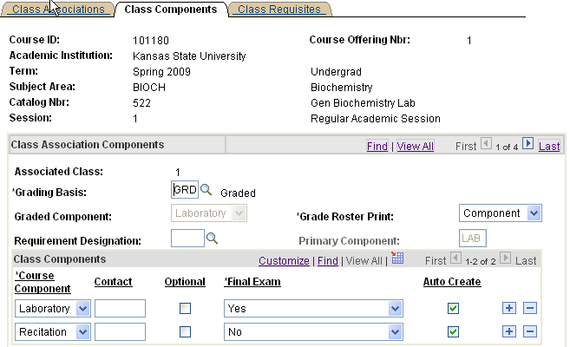
●MANY-TO-MANY COMPONENTS
--more than one component required for each enrollment (such as LEC, LAB and QZ)
--Many Enrollment components (carries hours/grading)
--in this example LEC is Enrollment component
--student may be auto-enrolled in a Non-enrollment component (optional)
--in this example 01Q is auto-enrolled
--student chooses an additional Non-enrollment component
--in this example student chooses any LAB to go with any LEC
--Associated Class is unique for each Enrollment component
--non-enrollment component = 9999
--compare the total of the Enrollment section capacities to the total of the Non-enrollment section capacities

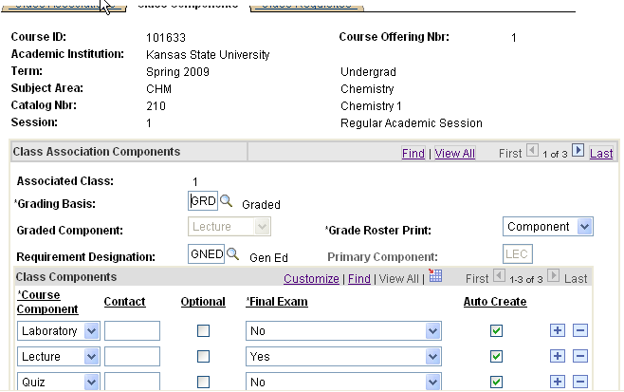
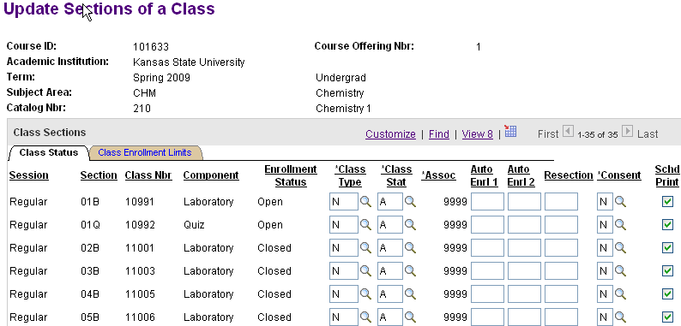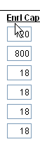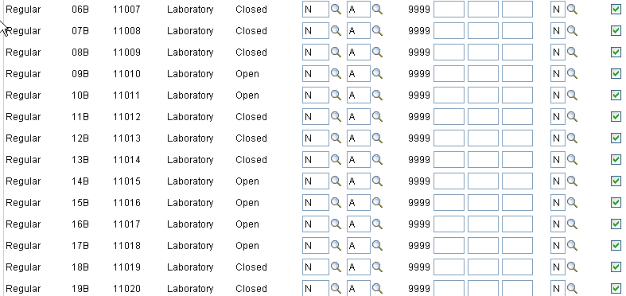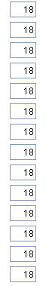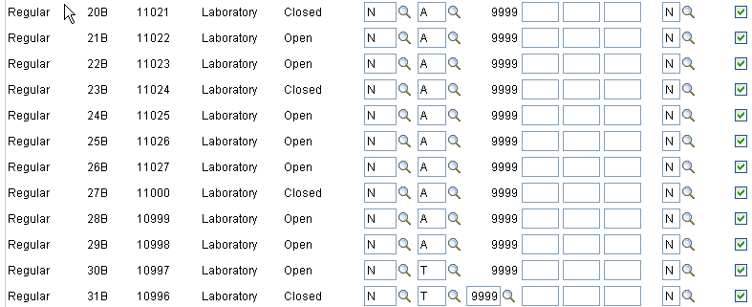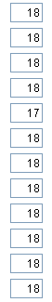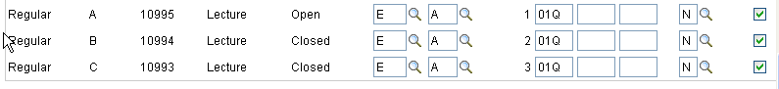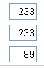

Adjust Class Associations page
--Identifier is Associated Class value

--To change Course Units (hours) for a particular section to a value other than Course default
Example: GENAG 200; default is 0-3 units; Associated class 4 is 0
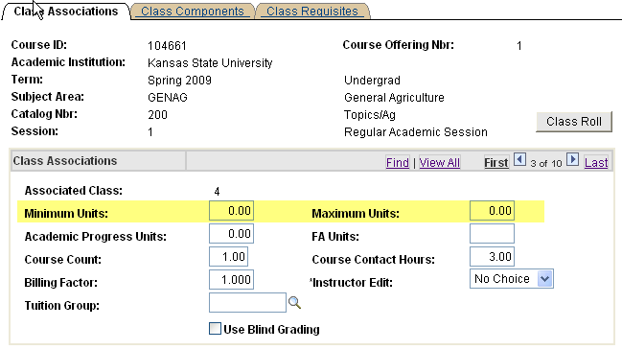

--To change Grading Basis for a particular section to a value other than Course default
Example: FREN 213; default is OPT; Associated class 3 is CNC
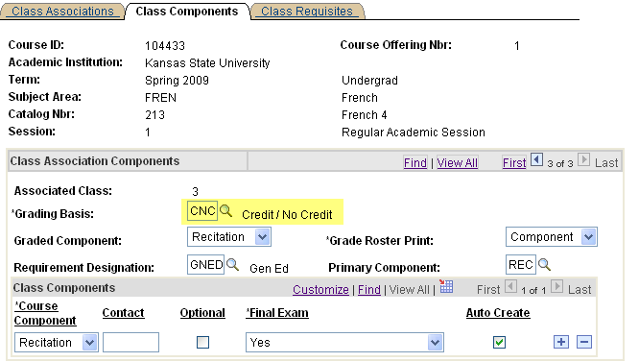

--To adjust or add components for an Associated Class other than Course default
--common for DCE and Salina classes
--Example: MATH 220 normally requires REC, LEC and QZ
--Salina Section only requires REC
--Delete the unneeded component rows
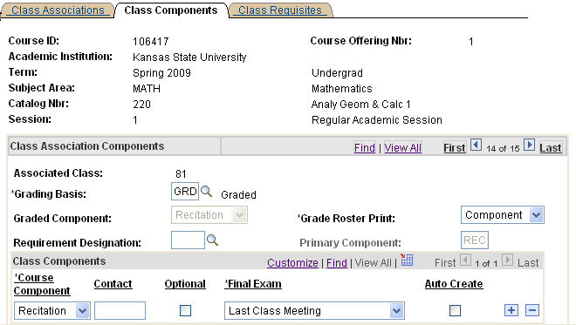
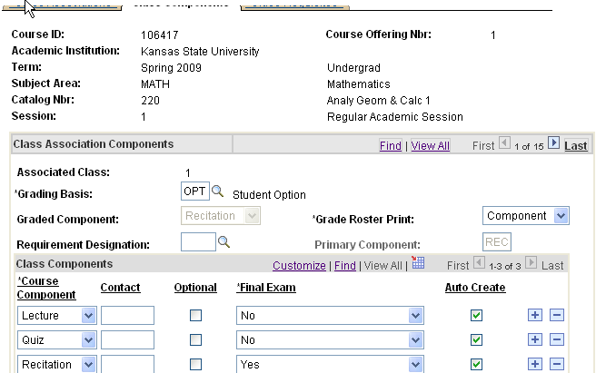

What happens if you don’t associate properly

May result in one or more of the following:
Student cannot get enrolled at all
Student cannot get on Waitlist
Student receives “time conflict” error during enrollment, when there really is no time conflict
(have seen situations where student was able to get enrolled in course with setup error, but the
“time conflict” message appeared when they attempted to get enrolled in another course)
Student cannot drop a class once enrolled
Student is dropped from more than one Enrollment section of the course
Student gets enrolled without all required components
Student really only needs one component, but system says they need more when attempting to enroll
Student can’t use “Edit” tab in Self Service to switch non-graded components (i.e. switch labs)
Student gets enrolled in 0 units (hours)

How do we fix these errors?
Drop students from original sections
Fix the course setup
Re-enroll the students in the sections

Report to assist in reviewing associations:
Curriculum Management>Schedule of Classes>KSU Reports>Update Sections of a Class
--similar to iSIS page
--WSRCM038

