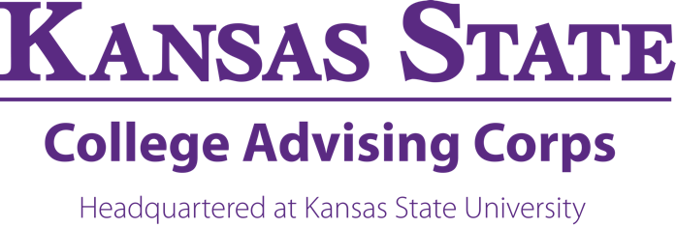

Kansas State College Advising Corps
College Adviser
College Advising Fellow Position Description

The mission of the National College Advising Corps, of which the Kansas State College Advising Corps (KSCAC) is a constituent program, is to increase the number of first-generation, low-income and underrepresented high school students entering and completing higher education. KSCAC places College Advising Fellows (hereafter referred to as College Advisers) full-time in select high schools in either Wyandotte or Johnson (KS) county. The College Adviser assists by providing guidance and encouragement needed for the students to navigate the college admissions and financial aid processes.
College Advisers must be eligible to and shall enroll as AmeriCorps members, through the National College Advising Corps. The service term is limited to a maximum of two years.
Responsibilities
College Advisers aim to help students find a “best-fit” post-secondary opportunity in order to increase the likelihood of post-secondary success in college or career. Additionally, advisers create and foster a college-going culture in their individual schools by engaging administration, teachers, and staff to help build an environment that encourages and supports college attendance and completion. The advisers are available to assist all students and families.
College Advisers will:
- Advise students through individual, small group, and classroom settings.
- Provide guidance for students and families in all aspects of the college and career planning process.
- Plan, execute and host a variety of college planning and financial aid workshops
- Facilitate campus tours virtually and in-person to prepare students for college going life.
- Assist students with ACT preparation and registration.
- Ensure student participation in college exploration opportunities, such as college fairs, summer programs, and campus representative visits.
- Produce and disseminate materials targeted to family and community members.
- Help students find scholarship resources.
- Assist students in understanding and completing the FAFSA as well as related forms.
- Provide outreach to students and families who would not make postsecondary plans on their own.
- Review and provide knowledge for students with college application materials.

Position Type
Full-time 12-month position, receives a $27,000 annual living allowance (prorated for start dates after July 1), paid monthly, health insurance provided as members of AmeriCorps. College Advisers are appointed for one year of full-time service, with a maximum service term of two years. The service term runs from July 1 – June 30. Upon satisfactory completion of a term of service, KSCAC College Advisers may receive an Education Award in the amount of the $6,345 per year of service that may be credited toward undergraduate loans or held for future educational costs.
Reporting
KSCAC College Advisers will report directly to the KSCAC Director. Additional input may be received from the site supervisor at the high school, as well as other KSCAC and KSU staff.
Required
- A bachelor’s degree earned in any field no more than two years prior to KSCAC service (2018 – May 2021 graduates).
- Must be eligible to and shall enroll as an AmeriCorps member.
- Verbal and written communication skills, as well as proficiency in basic computer skills.
- Organizational skills, including the ability to effectively prioritize and execute tasks while under pressure.
- Self-motivated with demonstrated ability to take initiative and work independently.
- Able to work effectively with youth, including those a from a diverse background.
Preferred
- Experience working with youth from economically disadvantaged backgrounds.
- Experience or knowledge of college admissions and financial aid processes.
- Previous experience demonstrating strong leadership abilities and collaboration with others to achieve a shared goal.
For More Information
Applicants are encouraged to review both the National College Advising Corps and Kansas State College Advising Corps websites to understand the vision, mission, and scope of service.
www.advisingcorps.org
www.k-state.edu/kscac
To Apply
Apply online or send a letter of interest, current resume, and contact information for three professional references to the KSCAC Director.
Meaghan Higgins
mcbhiggins@ksu.edu
The application will open March 30th, 2021. Screening of applicants begins April 15 and is ongoing and will continue until the positions are filled.
Contact Information
For more information, and/or to submit your application materials, please contact:
Meaghan Higgins
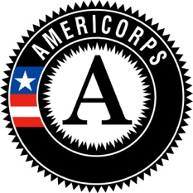
Director
Kansas State College Advising Corps
8080 Ward Pkwy Ste 400
Kansas City, MO 64114
mcbhiggins@ksu.edu

