Calorimeter Lab
Students may have done this lab in Food and Nutrition Science Course 1. Below is the lab as they may have experienced it. Following, is a different setup along with procedures and a data table.
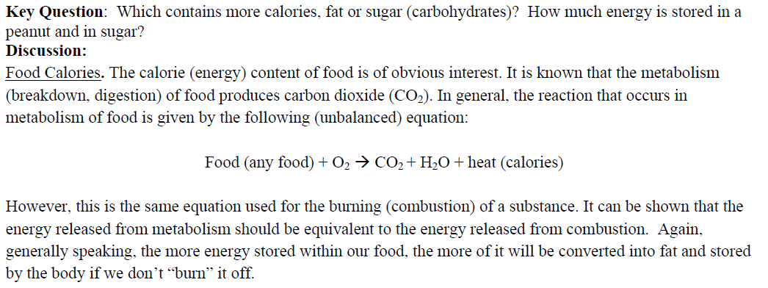
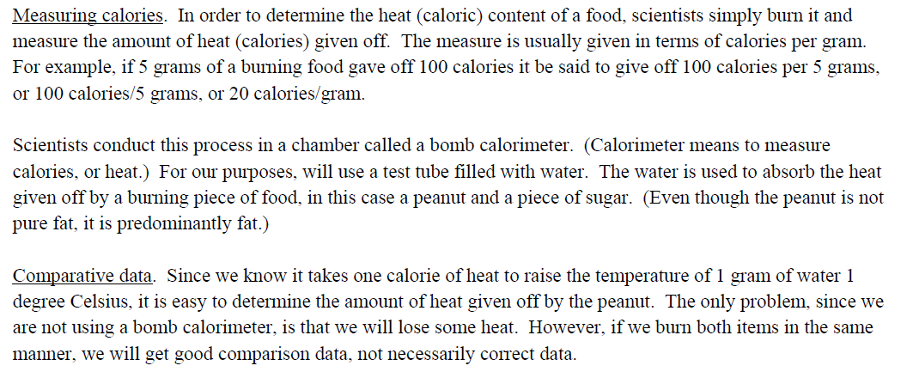
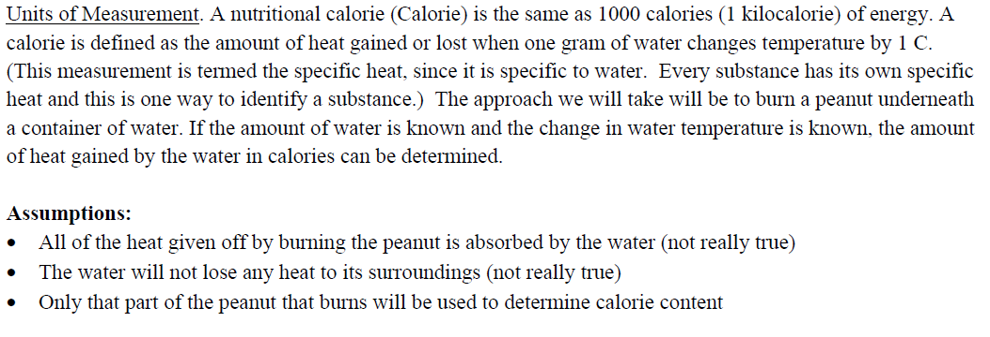

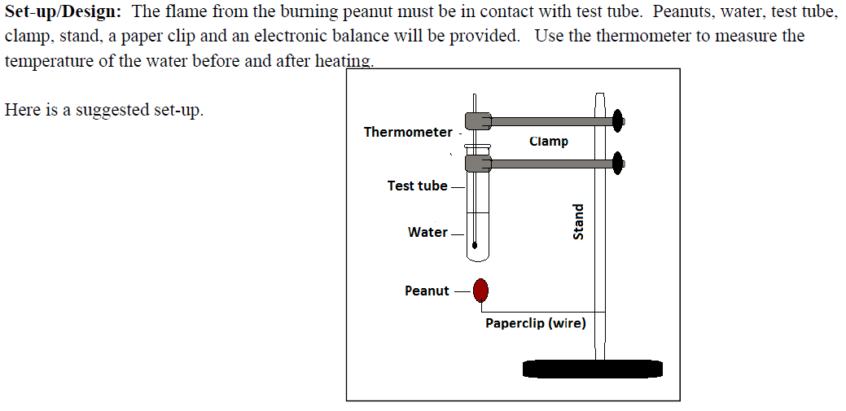
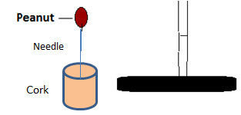
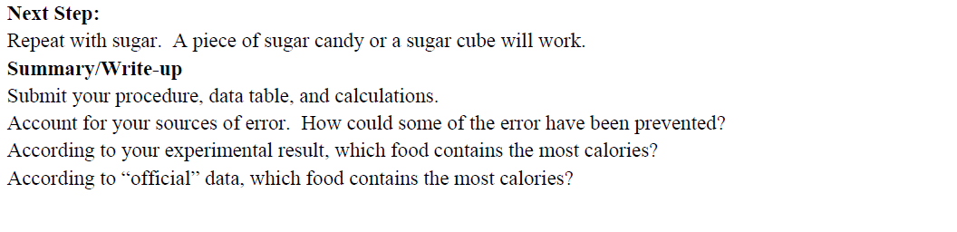

Nutrition Science
Calorimeter Lab
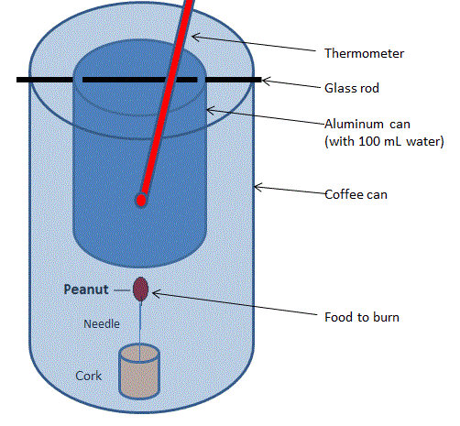
Equipment and Materials per lab group
A variety of shelled nuts
Large cork
Long needle
Balance or electronic scale
Coffee can or large juice can (top and bottom removed)
Soup can (top removed)
Water
100 mL graduated cylinder
Lab thermometer
Glass Stirring rod
Wooden matches or grill lighter

Procedure
- Create a nut assembly: stick the eye of the needle in the narrow end of the cork, then on the point of the needle mount the shelled nut assigned by your teacher.
- Determine mass of the nut assembly. Record it in your data table.
- Remove both ends of a large can, and punch holes in the sides near the bottom. This will serve as a chimney to minimize heat loss during the experiment.
- Remove one end of a small aluminum can. Punch two holes, opposite to each other, in the sides of the can near the open end.
- Pour exactly 100 mL of tap water into the small can. Record the temperature of the water in your data table.
- Insert a glass stirring rod through the holes in the sides of the small can. Use the glass rod to balance the small can within the large can.
- Place the nut on a nonflammable surface, and ignite it with a match. Immediately place the large can around the nut assembly so the small can of water is above the nut.
- Allow the nut to burn for 2 minutes or until it goes out.
- Stir the water with the thermometer. In your data table, record the water’s highest temperature.
- Mass the nut assembly, and record it in your data table.
- Copy the results for other kinds of nuts in your data table. Expand your data table on separate paper if needed.

DATA TABLE
Kind of |  | Mass |  |  | Temperature
Nut | Original | Final | Change | Original | Final | Change

Analyzing Results

- Using the equation below, calculate the calories of heat from the burning nut. The 100 mL of water has a mass of 100 grams.

calories = grams of water x degrees of temperature change

- Divide the figure from question 1 by the change in mass of the nut. This gives the calories released per gram of nut burned.

- Which kind of nut released the most heat per gram? The least?

