Busy Family Nutrition Counseling Challenge Presentations Rubric
Company Name: ___________________________________________

NOTE: There is no time minimum or maximum for these presentations
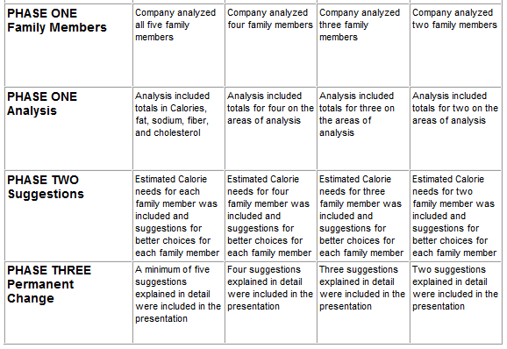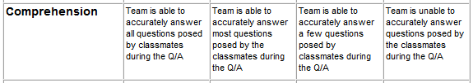

Busy Family Nutrition Counseling Challenge Presentations Rubric
Individual Presentation Score
NAME: _________________________________________
