How does food become contaminated with STEC? How do we detect it?
Your food product might be a source of pathogens such as E. coli 0157:H7 and other shiga-toxin producing E. coli (STECs), Salmonella app., and others. Testing food products for pathogens is an important step in the development and sale of foods. To test your food product and commercially available alternatives for contamination, follow the procedure below.
Purpose
Shiga toxin-producing Escherichia coli (STEC-8) creates a health risk when it contaminates beef and other food products. Researchers at University of Nebraska-Lincoln and several other research and educational institutions across the country are working together to develop procedures to identify STEC contamination and decontaminate food. You will follow the procedure developed by these scientists – outlined below – to identify the presence of E. coli and other pathogens in your food item and the commercially available alternative.
Hypothesis Development
You will have the food product you developed and the commercially available version of it. Develop a hypothesis for each food and the two different types of microorganisms – aerobic and anaerobic - in the form of “(Food product) __(will/will not)__ have E. coli present in detectable levels.” Write these in your research journal.
Materials:
Gloves
2 g your food product(s)
2 g of the commercially available alternative
4 Ziploc Bags
Forceps or tongs
Water
120 mL sterile peptone water (PW)
Pipette
Pipette tips
Aerobic Plate Counts Petrifilms
E. coli Petrifilms
8 test tubes to hold 10 mL each

Procedure
- Put your gloves on and wear them for the entire lab. Do not touch your face, eyes, or mouth. Do not eat during this lab. Wash your hands thoroughly after the lab.
- Place 1 g samples of your food product in 2 different Ziploc – each labeled as” our product 1”, “our product 2” - bags using forceps or tongs.
- Add 10mL of sterile peptone water (PW) to each sample bag and seal the bags.
- Stomach the samples in the sealed bags manually, or use the stomacher. Manual stomaching is done by “squishing” the sample in the water and swirling gently. This creates the 4 rinsates for your food product.
- Prepare 8, 9 mL blanks – PW only – in test tubes in racks. Put them in 4 rows of two and label each row with “our product 1”, “our product 2”, “commercial 1”, “commercial 2”.
- Pipette 1 mL of the rinsate from sample “our product 1” into your first blank labeled “our product 1”.
- Mix for 30 seconds by drawing and emptying the rinsate into/out of the pipette.
- Withdraw 1 mL from the rinsate + blank test tube and place into the other blank in this row. You have created a dilution of 10⁻¹ .
- Transfer 1 mL of the sample to an E. coli Petrifilm and 1 mL of the sample to an Aerobic Petrifilm. Label them with the same label as the Ziploc containing the sample.
- Change pipette tips.
- Repeat for “our food product 2” rinsate.
- Repeat the entire process for “commercial 1”, and “commercial 2”.
- You will have 2 Aerobic and 2 E. coli Petrifilms for your food product and 2 of each for the commercially available version.
- Incubate the films at room temperature:
  - 24 hours for E. coli
  - 48 hours for Aerobic
- Look for colonies on the films. Blue colonies with gas (will look like gnats) on your E. coli Petrifilm indicate that the food product is contaminated with a strain of E. coli. It is not necessarily STEC. Red colonies on your Aerobic Petrifilm indicate that your product contains another pathogen, such as Salmonella (further testing would be required to determine what the exact pathogen is).
- Photograph your Petrifilms to include in your reports and explain the absence or presence of pathogens.

Processing Questions
- Why did the lab call for you to use two samples of the same product?
- Why did you use two blanks for each sample?
- If your food product has pathogens, how might they have gotten there?
- What if some samples are contaminated and others are not?
- If we can test food for pathogens, how do outbreaks happen?

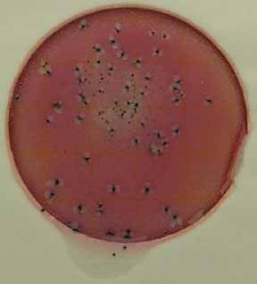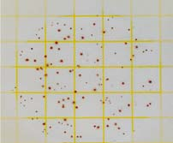
Aerobic microorganisms present
E. coli present

