Appendix 8
Calorie Lab Activity

Key Question: Which contains more calories, fat or sugar (carbohydrates)? How much energy is stored in a peanut and in sugar?

Discussion:
Food Calories. The calorie (energy) content of food is of obvious interest. It is known that the metabolism (breakdown, digestion) of food produces carbon dioxide (CO₂). In general, the reaction that occurs in metabolism of food is given by the following (unbalanced) equation:

Food (any food) + O₂ CO₂ + H₂O + heat (calories)

However, this is the same equation used for the burning (combustion) of a substance. It can be shown that the energy released from metabolism should be equivalent to the energy released from combustion. Again, generally speaking, the more energy stored within our food, the more of it will be converted into fat and stored by the body if we don’t “burn” it off.

Measuring calories In order to determine the heat (caloric) content of a food, scientists simply burn it and measure the amount of heat (calories) given off. The measure is usually given in terms of calories per gram. For example, if 5 grams of a burning food gave off 100 calories it be said to give off 100 calories per 5 grams, or 100 calories/5 grams, or 20 calories/gram.

Scientists conduct this process in a chamber called a bomb calorimeter. (Calorimeter means to measure calories, or heat.) For our purposes, will use a test tube filled with water. The water is used to absorb the heat given off by a burning piece of food, in this case a peanut and a piece of sugar. (Even though the peanut is not pure fat, it is predominantly fat.)

Comparative data Since we know it takes one calorie of heat to raise the temperature of 1 gram of water 1 degree Celsius, it is easy to determine the amount of heat given off by the peanut. The only problem, since we are not using a bomb calorimeter, is that we will lose some heat. However, if we burn both items in the same manner, we will get good comparison data, not necessarily correct data.

Units of Measurement A nutritional calorie (Calorie) is the same as 1000 calories (1 kilocalorie) of energy. A calorie is defined as the amount of heat gained or lost when one gram of water changes temperature by 1 C. (This measurement is termed the specific heat, since it is specific to water. Every substance has its own specific heat and this is one way to identify a substance.) The approach we will take will be to burn a peanut underneath a container of water. If the amount of water is known and the change in water temperature is known, the amount of heat gained by the water in calories can be determined.

Assumptions:
- All of the heat given off by burning the peanut is absorbed by the water (not really true)
- The water will not lose any heat to its surroundings (not really true)
- Only that part of the peanut that burns will be used to determine calorie content

Set-up/Design: The flame from the burning peanut must be in contact with test tube. Peanuts, water, test tube, clamp, stand, a paper clip and an electronic balance will be provided. Use the thermometer to measure the temperature of the water before and after heating.
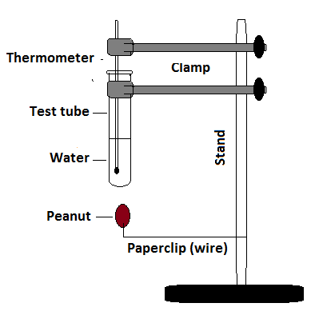

Here is a suggested set-up.

Measurements: The researcher must know --
- The mass of the peanut and the mass of the water.
- The original and final temperature of the water. “∆T”
- The final mass of the peanut (after cooling).

Data:
Set up a data table to collect your data. Be sure that all pertinent data is collected. If there is a question regarding some data, collect it. It might be useful.

Procedure:
Write up a procedure as to how to collect the data. Keep it brief. The teacher will review it and approve it. (This should go into your research journal along with the data and calculations.)

Calculations:
Remember, we must know how much heat was given off by the portion of the peanut that burned. We assume that all of this heat is absorbed by the water in the test tube.
- Heat gained by the water = “∆T” of H₂0 x g H₂0.
- Energy given off by peanut (per g) = Heat gained by water/(initial mass – final mass of the peanut)
- Find the “official” caloric content of a peanut (per g) and calculate your error.

Next Step:
Repeat with sugar. A piece of sugar candy or a sugar cube will work.

Summary/Write-up:
Submit your procedure, data table, and calculations.
Account for your sources of error. How could some of the error have been prevented?
According to your experimental result, which food contains the most calories?
According to “official” data, which food contains the most calories?

