Pie Chart Pre-Test
- Answer the following questions about this pie chart:
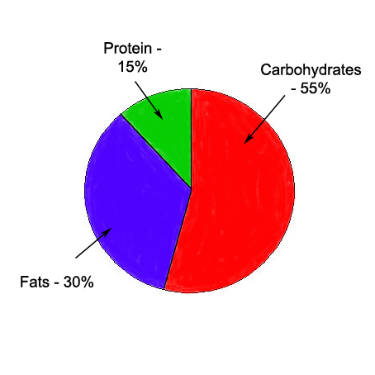
  - What is the top category for food consumption?

  - What total percentage do protein and fats make up?

  - What is the difference in consumption between carbohydrates and protein?

  - What is the total percentage for all of the categories of consumption in this chart? What should it be?

- Answer the following questions for this pie chart on the sources of trans-fat for American adults:
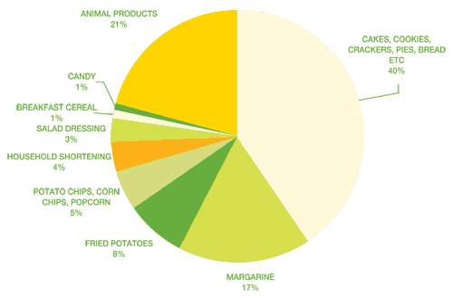
  - What is the largest source of trans-fat in the diets of American adults?

  - What percentage of the trans-fat in the diet of American adults comes from margarine, salad dressing, and household shortening?

  - What are the bottom four sources of trans-fat in the diet of American adults?

  - What is the total percentage represented in this chart?

- Create a pie chart based on the data below for the Average American’s annual Consumption. Ask you teacher for any tools you would like to use:

Type of Food | Pounds Consumed
Flour & Cereal | 192.3
Caloric Sweeteners | 141.5
Vegetables | 415.4
Coffee, Cocoa & Nuts | 24
Fruits | 273.2
Fats & Oils | 85.5
Red Meat | 110
Poultry | 73.6
Fish & Shellfish | 16.1
Eggs | 32.7
Cheese | 31.4
Dairy (non-cheese) | 600.5

