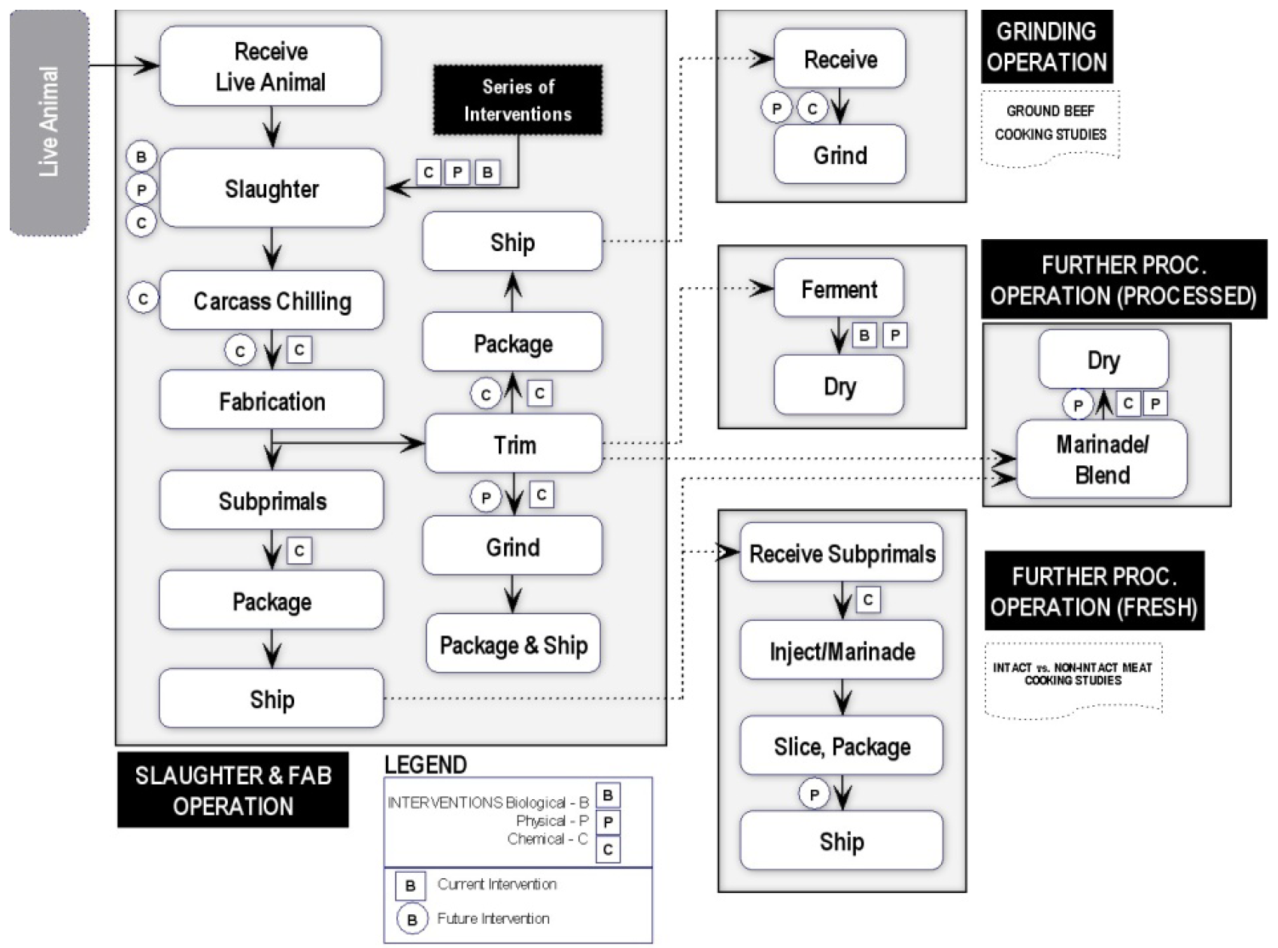
Which steps are the responsibility of: producers? Processors? Distributors? Food Service professionals? Government Regulators? Research Groups? Consumers?

