1. Navigate to the Canvas page for your K-State First course.
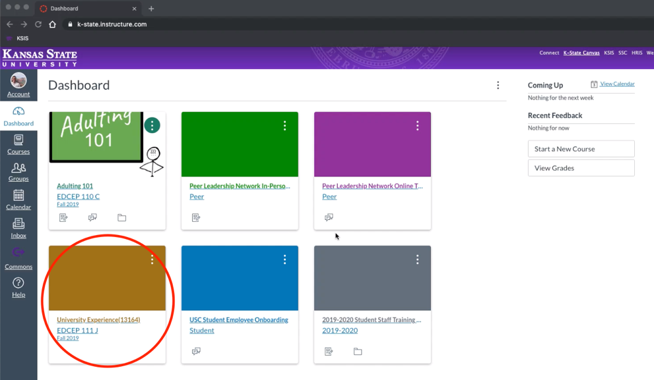
2. On the left hand navigation bar, click on “assignments.”
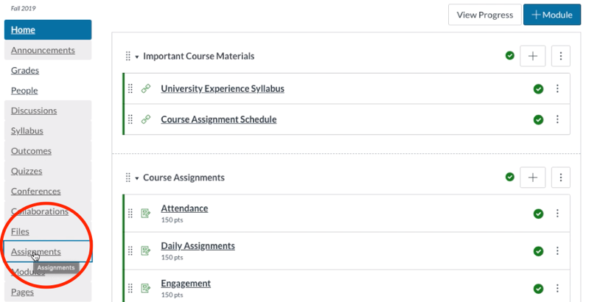
3. Create a new assignment by clicking the blue “+ Assignment” button.

4. Title the new assignment “SLO Assessment”; click the box next to “Do not count this assignment towards the final grade.” This step ensures the assessment does not impact student grades. Under “Available from” select any date after finals week. These steps ensure students do not see this assignment. You will not need to adjust the rest of the settings on this page, as they impact the submission of a graded assignment.
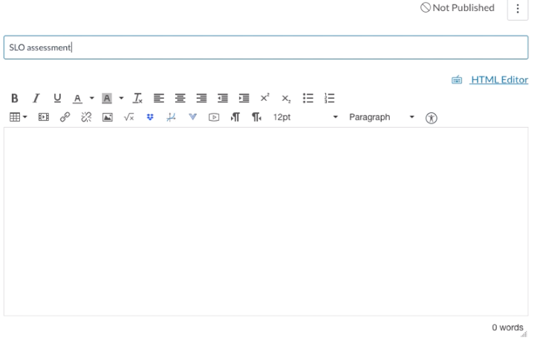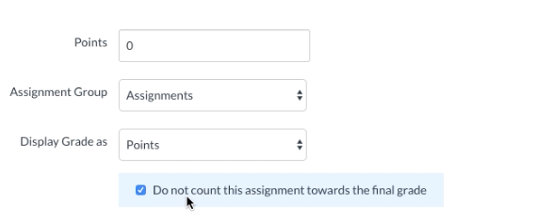

Additionally, select “no submission” as the submission type.

5. Click save and publish at the bottom of the page.

6. To add the rubric, click the “+ Rubric” button.
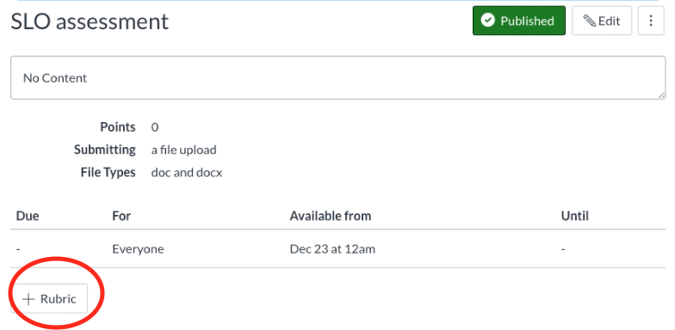

8. When the rubric window appears, click “Find a Rubric.”

Next, click on Kansas State University, and then select either the CAT Community Student Learning Outcome Rubric or the First-Year Seminar Student Learning Outcome Rubric – depending on which course you teach.
9. Scroll to the bottom of the rubric on the right hand side of the window, and click “use this rubric.”
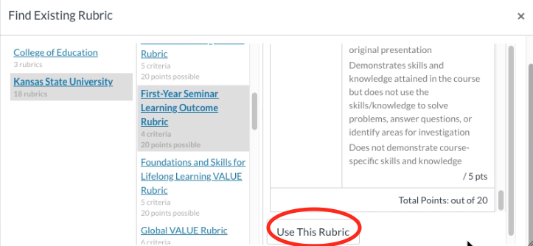

Your assignment is now created and the rubric is ready to be scored!
10. When you’re ready to score the assignment at the end of the semester, click into your “SLO Assessment” assignment and click on SpeedGrader.
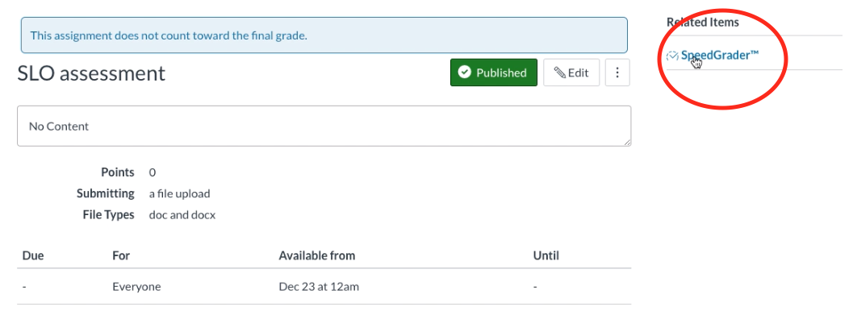
11. Click “view rubric.”
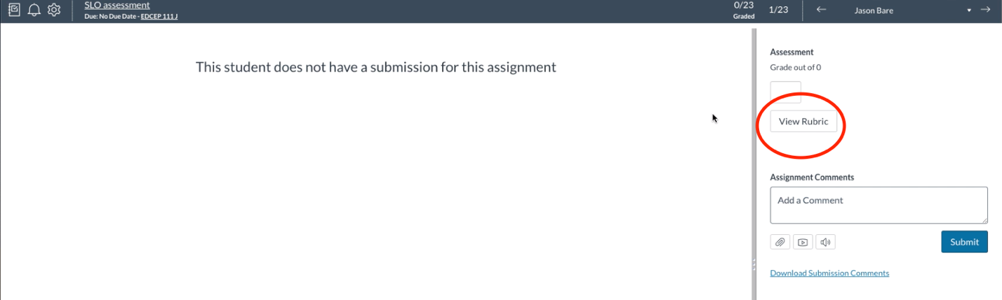
12. Drag the window to the left to view the rubric in full, and then score your student based on evidence you’ve gathered on their performance during the semester. Remember: read carefully through the rubric criteria and assign the score that is accurate. Scores on this rubric may not reflect their grades in the class. Click “Save” and score the rest of your students!
