1. Navigate to your profile page on Canvas by clicking on “Account.”
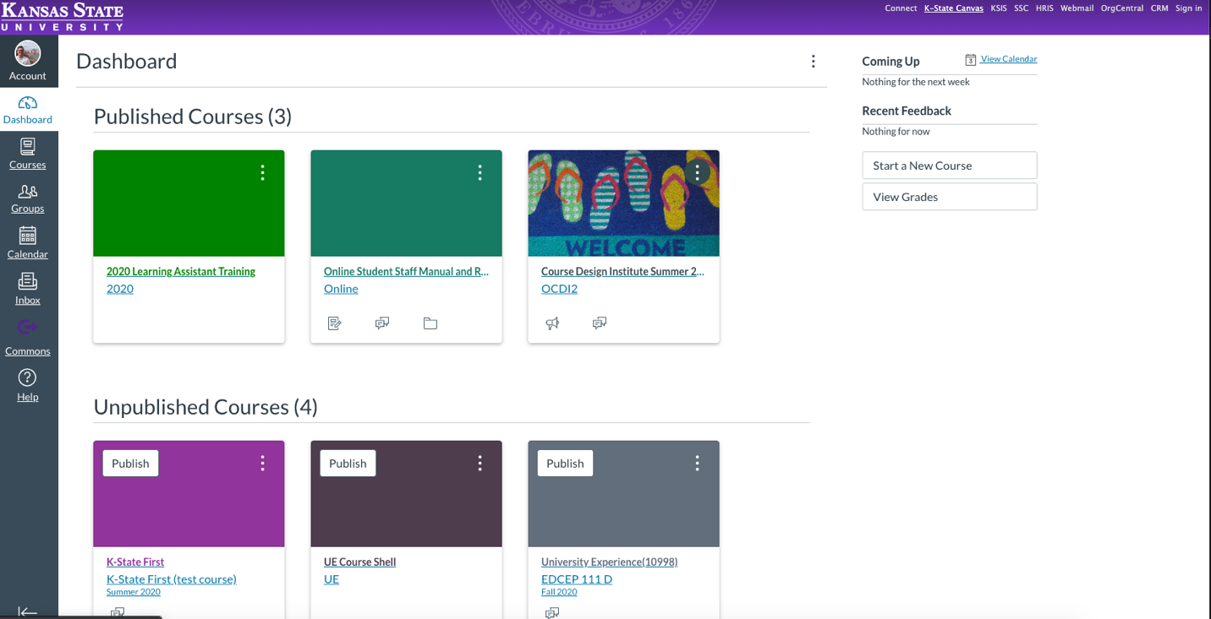
2. Click on “profile.”
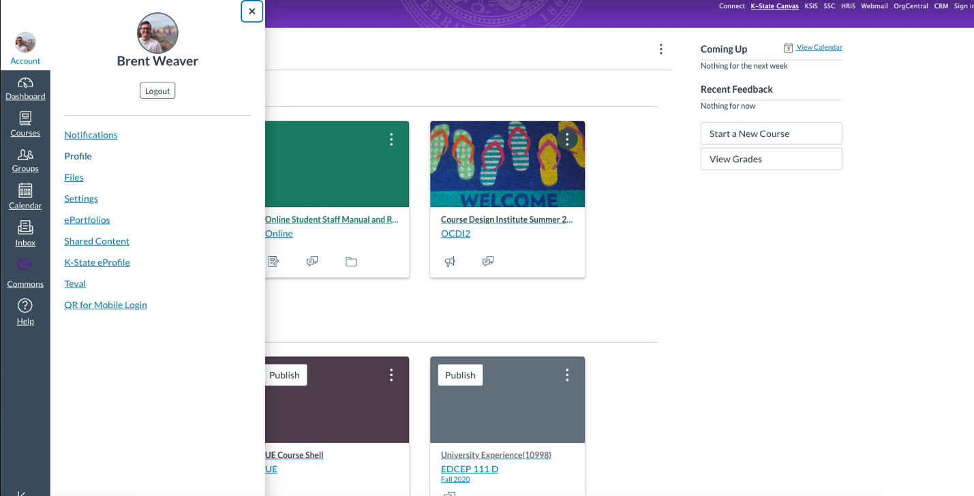

3. Click on “TEVAL.”
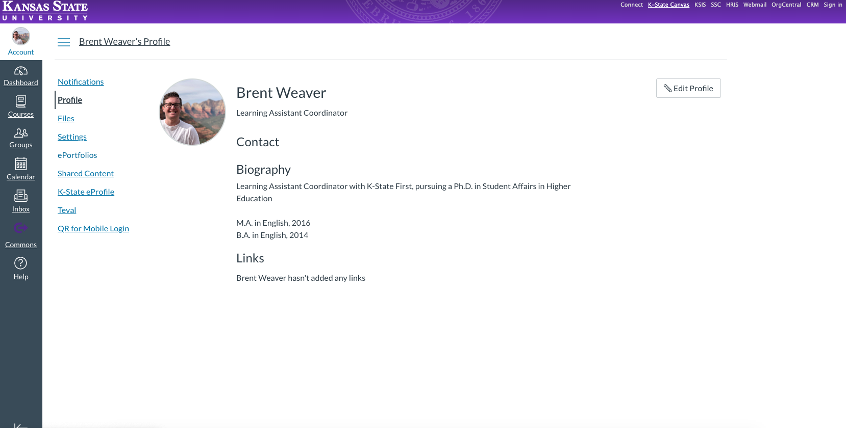
4. Click on “New TEVAL.”
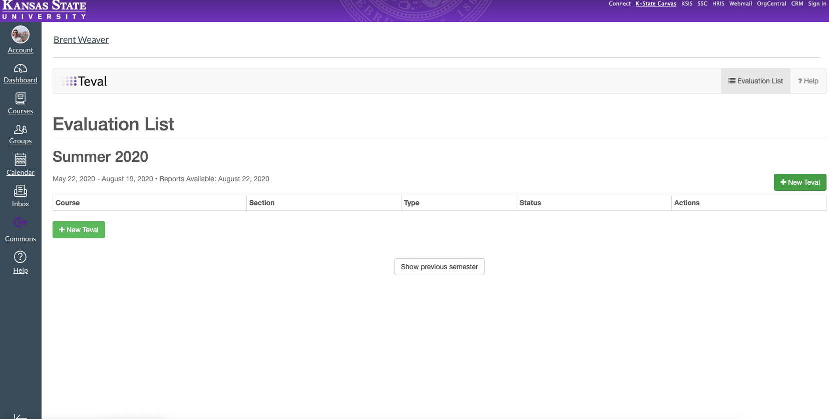

5. Select your K-State First course and enter your course information as indicated.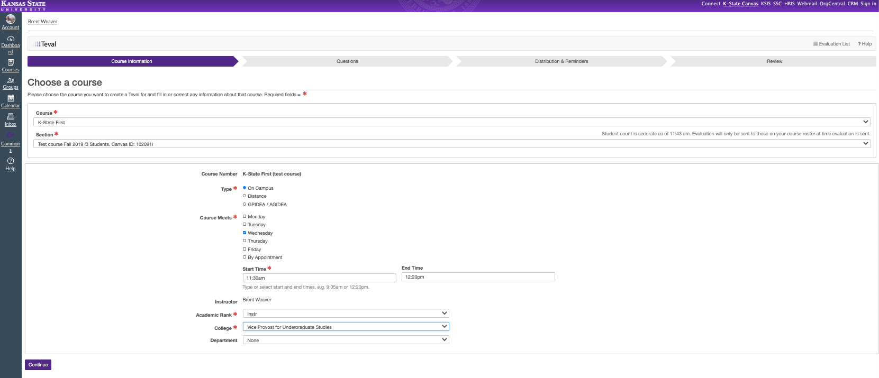
6. Select the K-State First department template.
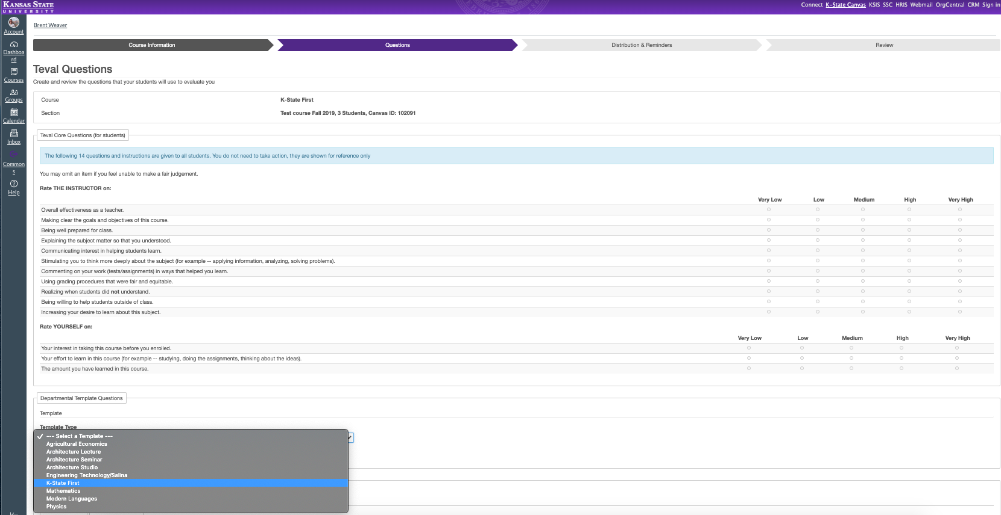

7. After the K-State First questions populate, click “continue.”
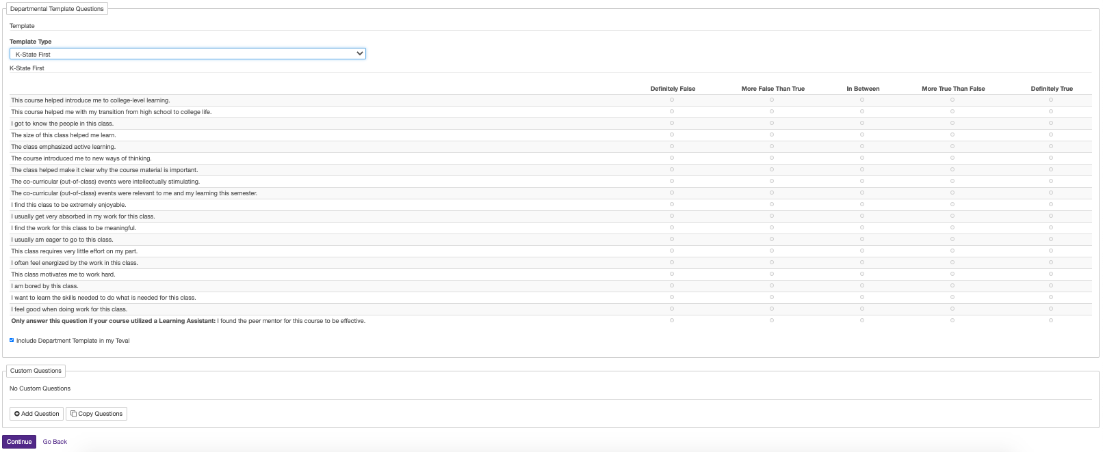
8. Enter information on when you would like the TEVAL open to your students, and when you’d like reminders sent. Then, click “continue.”
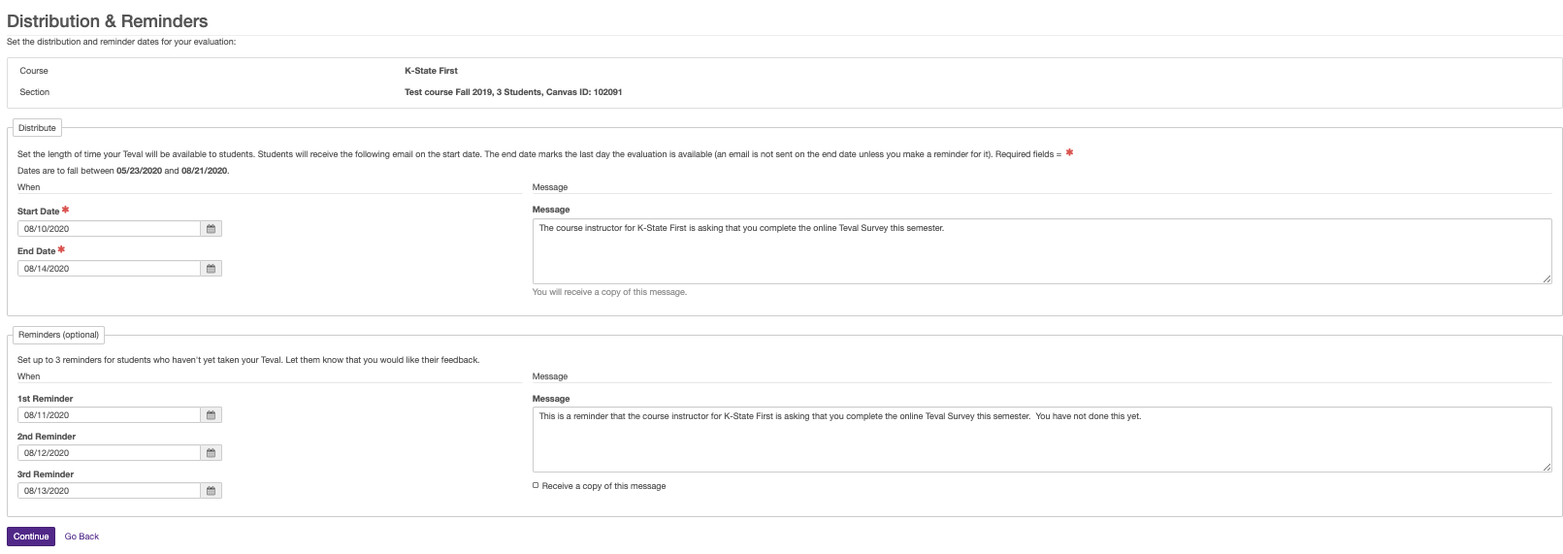
9. You will be shown a preview of your TEVAL. If the information looks correct, click “finish” to finalize your online TEVAL.
