**REQUEST FOR DOMESTIC WIRES**

1. Open the Domestic Wire Request found in eForms:
   1. Please complete all required fields on the Domestic Wire Request Form
      1. Include information in optional fields as needed
         1. Example: Add reference detail
         2. Voucher # should be blank (DFS enters the Voucher info)
2. In eForms create your Agency Payment Voucher, APV
   1. Payment indicator will be “A”
   2. Check type is State
   3. Wire Type will be **U.S. Dollars – Domestic**

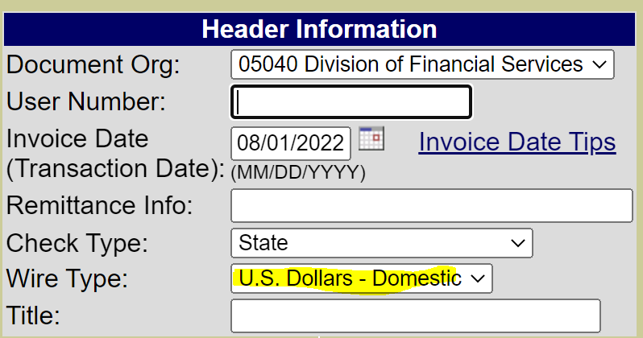

* 1. VENDOR INFORMATION
     1. Search and select the Vendor you are wanting to send a Wire. The vendor should match the invoice.
  2. AGENCY INFORMATION
     1. Fill out department information or select to use saved information.
  3. FUNDING INFORMATION
     1. Enter your funding string
     2. Object codes for wires are the same as for any other APV.
        1. Reference the [Expense Object Code Listing](https://www.k-state.edu/finsvcs/systems/chartofaccounts/coalinks.html) if you have questions.
  4. PURCH INFORMATION
     1. Enter the purchase requisition or contract number associated with the purchase if necessary for the purchase.
  5. DESCRIPTION INFORMATION
     1. Enter the needed invoice and cost information.
     2. Include a brief summary of what is being purchased.
        1. Do not include any bank information on the APV.
  6. FLAG INFORMATION
     1. Click any applicable flags to help clarify the voucher.
  7. TRUSTEES
     1. This will show others that have access to the voucher.
     2. Add other Trustees as needed.
  8. FINAL FORM
     1. Click View Form and print/download to
        1. obtain a wet signature (or)
        2. electronic signature
     2. Upload approved APV, Wire form, invoice/receipts and other substantiation.
        1. All documentation attached should be in PDF format.
  9. CHECK IN
     1. Click Send Electronically Button