KANSAS STATE UNIVERSITY
POLICY FOR STANDARD CLASS MEETING TIMES
Revised: 10/6/2026
Contents
Contact Hour Requirements 2
One Credit Hour Courses 3
Two Credit Hour Courses 3
Three Credit Hour Courses 3
Four Credit Hour Courses 3
Five or greater Credit Hour Courses 3
Variable Credit Hour Courses 3
Standard Class Periods for Fall and Spring Semesters 4
Table 1: LECTURE/RECITATION CLASS and TEST PERIODS 4
Laboratory, Studio, and Multiple-Hour Class Meeting Times 4
Laboratories and studios with 50-minute class periods. 4
Laboratories, studios, and classes with multiple-hour class periods meeting only one day per week during a regular semester. 4
Table 2: LABS and MULTIPLE-HOUR CLASS PERIODS 5
Fall and Spring Part-of-Term Classes 6
Eight-Week Parts of Term 6
Five-Week Parts of Term 6
Standard Starting and Ending Times 6
Alternative Meeting Patterns 7
Five or Greater Credit-Hour and Variable Credit-Hour Courses 7
Table 3: Standard Meeting Patterns for Fall and Spring Parts of Term 7
Summer Semester/Session Classes 7
Table 4: Summer School Standard Starting and Ending Times 8
Non-Standard Class Times 9
Petitions/Exceptions 9
D.V.M. and P.A. Program Exception 9
Reviews 9
Figure 1: K-State Standard Class Meeting Times for Fall and Spring Semesters 9
Appendix 10
College of Veterinary Medicine: D.V.M. Program only 10
College of Health and Human Sciences: P.A. Program only 11
Approval/Amendment History: 11

Standard scheduling times for classes (course sections) provide students with maximum scheduling flexibility, allow departments to meet unique needs, and to more efficiently utilize instructional space. Courses exempt from these standard class meeting time policies, are 1) specialized programs such as institutes, non-university credit training sessions, workshops, conference courses, certificate programs, grant related courses, intersession courses, and off campus courses which do not conflict with the use of campus space by on campus academic activities, 2) any course which is taught remotely using various delivery methods such as an audio tapes, audio communication lines, electronic blackboards, tv links, video tapes, CD-ROMs, and all forms of internet communications, and 3) graduate classes (course numbers 800 and above) which do not need access to general classroom use (GSU) space.

Any time periods associated with a course in which a student is not required to participate in order to earn academic credit, such as help sessions, will not be listed in the official "Course Schedule." These sessions must be scheduled through the Facilities Room Reservation Office and care should be exercised to prevent conflicts with course sections required for credit and course tests.

The policies below are to be used for scheduling all classes (course sections) for all academic sessions. All course sections must also meet applicable contact-hour requirements based on the credit hours awarded and the length and meeting pattern of the academic session. This policy provides a common framework for scheduling classes.

Requirements regarding the distribution of classes across this framework are to be addressed separately, as the need arises. Current requirements can be found in Section F50 of the University Handbook.

A standard academic day begins at 7:15 a.m. and ends at 10:30 p.m., Monday through Saturday. Standard class meeting periods within the academic day are established in the tables below.

All fifteen-week semester lecture/recitation class periods are to adhere to the following guidelines and Table 1. (Figure 1 provides visual clarification)

Contact Hour Requirements

Standard class meeting times establish the approved scheduling framework for university courses but do not supersede applicable contact hour requirements. Courses must be scheduled to provide the instructional time appropriate to the number of credit hours awarded, the length of the academic session, and the number of scheduled meeting days.

For scheduling purposes, the university uses 750 instructional minutes per credit hour as the standard contact-hour calculation for the 15-week instructional period of the regular Fall and Spring semesters. The five-day final examination period occurs in addition to the 15-weeks of regularly scheduled instruction.

Accordingly, courses should provide the following minimum scheduled instructional time:

Credit Hours | Instructional Minutes
1 | 750 minutes
2 | 1,500 minutes
3 | 2,250 minutes
4 | 3,000 minutes
5 | 3,750 minutes

Courses offered in shortened sessions or alternative meeting patterns must adjust the length and/or frequency of individual class meetings as necessary to satisfy the applicable contact-hour requirement. The equivalent instructional-minute requirement is based on 750 minutes per credit hour, regardless of the length of the part of term. The standard class meeting periods contained in this policy should be used when establishing those meeting patterns.

One Credit Hour Courses
- One credit hour course sections should be scheduled in time slots left open due to two-hour course sections being scheduled on any two-day combination sequence. Standard 50-minute period starting times must be used.

Two Credit Hour Courses
- Two credit hour courses with sections meeting on two separate days each week must utilize Standard 50-minute periods with the preferred combination days, MW, MF, TU, TS, WF, and US.

Three Credit Hour Courses
- Three credit-hour courses with sections meeting on three separate days each week must schedule Standard 50-minute periods on an M-W-F sequence, or a T-U-S sequence.
- Three credit-hour courses with sections meeting on two separate days each week must use Standard 75-minute periods on T-U. A M-W or W-F sequence could be scheduled because of extenuating circumstances and if approved by CAPP.

Four Credit Hour Courses
- Four credit hour course sections may be scheduled for Standard 50-minute periods during any four-day sequence.

Five or greater Credit Hour Courses
- Five credit hour course sections must seek guidance and approval from CAPP to enhance the opportunity of students to enroll in additional classes and provide efficient use of space.

Variable Credit Hour Courses
- Variable credit-hour courses must follow A through E above or be arranged by appointment to meet the needs of enrolled students.

Standard Class Periods for Fall and Spring Semesters
Standard class periods for the Fall and Spring semesters establish consistent start and end times for regularly scheduled courses. These periods are designed to support student scheduling flexibility, minimize class conflicts, and promote the effective use of instructional space. Courses should be scheduled according to the standard meeting patterns and times identified in Table 1.

Table 1: LECTURE/RECITATION CLASS and TEST PERIODS
STANDARD STARTING and ENDING TIMES for FIFTEEN-WEEK SEMESTER

 | M/W/F  T-U-S  Or two-day combinations  (MW, MF, TU, TS, WF, US)  50 min. periods | T/U Sequence  75 min. periods | Singular Saturday Classes  170 min. period
A.M. | 7:30 – 8:20 a.m. | 7:15 - 8:30 a.m.
A.M. | 8:30 – 9:20 a.m. | 8:40 – 9:55 a.m. | 8:30 – 11: 20 a.m.
A.M. | 9:30 – 10:20 a.m. | 10:05 – 11:20 a.m.
A.M. | 10:30 – 11:20 a.m. | 11:30 – 12:45 p.m.
A.M. | 11:30 – 12:20 p.m. |  | 11:20 – 2:20 p.m.
P.M. | 12:30 – 1:20 p.m. | 1:05 – 2:20 p.m.
P.M. | 1:30 – 2:20 p.m.
P.M. | 2:30 – 3:20 p.m. | 2:30 – 3:45 p.m. | 2:30 – 5:20 p.m.
P.M. | 3:30 – 4:20 p.m. | 3:55 – 5:10 p.m.
P.M. | 4:30 – 5:20 p.m.
P.M. | 5:30 – 6:20 p.m. | 5:30 – 6:45 p.m. | 5:30 – 8:20 p.m.
P.M. | 6:30 – 7:20 p.m. | 7:05 – 8:20 p.m.
P.M. | 7:30 – 8:20 p.m.
P.M. | 8:30 – 9:20 p.m. | 8:30 – 9:35 p.m.
P.M. | 9:30 – 10:20 p.m.

* The schedule for 75-minute periods presented for Tuesday-Thursday classes may also be used as an alternative class schedule on Monday-Wednesday evenings beginning at 5:30 p.m. (e.g., 5:30 - 6:45, etc.). Use of 75-minute periods for a Monday-Wednesday or Wednesday-Friday sequence before 5:30 p.m. requires approval (IV-A).
** As an alternative, the existing 8:05-9:20 a.m. and 9:30-10:45 a.m. meeting patterns remain available and may be used when suitable for the course and instructional needs.

Laboratory, Studio, and Multiple-Hour Class Meeting Times

Laboratory, studio, and multiple-hour courses must satisfy the applicable contact-hour requirement based on the credit hours awarded and are to adhere to the following scheduled meeting patterns. Standard extended meeting periods are established in Table 2.

Laboratories and studios with 50-minute class periods.
- Laboratory classes with 50-minute periods are to be scheduled to correspond with the starting/ending times of the Standard 50-minute class periods

Laboratories, studios, and classes with multiple-hour class periods meeting only one day per week during a regular semester.

- Laboratories, studios, and other classes requiring extended instructional periods are to be scheduled using the standard extended meeting periods identified in Table 2.

- Standard extended meeting periods include 110-minute, 170-minute, 230-minute, and 290-minute blocks. These periods are intended to accommodate laboratories, studios, and other courses that cannot reasonably be scheduled within a standard 50- or 75-minute class period.

- Tuesday/Thursday laboratories, studios, and other extended-time classes should be scheduled using the applicable standard extended meeting periods in Table 2. The Tuesday/Thursday 75-minute morning class pattern identified in Table 1 does not eliminate or replace the extended meeting periods available for these courses.

- A morning section of a multiple-hour laboratory class may be scheduled only when an afternoon section is also provided. If an afternoon laboratory section is offered, there is no requirement that a morning section be offered as well.

Table 2: LABS and MULTIPLE-HOUR CLASS PERIODS
STANDARD STARTING and ENDING TIMES for FIFTEEN-WEEK SEMESTER

Course Meeting Length | Standard Instructional Block
1-hour class | 50 minutes
2-hour class | 110 minutes
3-hour class | 170 minutes
4-hour class | 230 minutes
5-hour class | 290 minutes

M-W-F / M-T-W-U-F-S LABS AND MULTIPLE-HOUR CLASSES
 | 1-Hour Class | 2-Hour Class | 3-Hour Class | 4-Hour Class | 5-Hour Class
A.M. | (50 min.) | (110 min.) | (170 min.) | (230 min.) | (290 min.)
A.M. | * | * | 7:30-9:20 | 8:30-11:20** | 7:30-11:20
A.M. | * | * | 9:30-11:20 | 11:30-2:20
P.M. | * | * | 12:30-2:20# | 2:30-4:20#
P.M. |  | 2:30-5:20 | 12:30-4:20*** | 12:30-5:20
P.M. | * | 5:30-7:20 | 5:30-8:20**** | 5:30-9:20
P.M. | * | 7:30-9:20

T/U LAB MULTI-BLOCK PATTERNS
Lab Length | Approved T/U Meeting Times
150 min. (2 blocks) | 7:15-9:55; 8:40-11:20; 10:05-12:45; 11:30-2:20; 1:05-3:45; 2:30-5:10
225 min. (3 blocks) | 7:15-11:20; 8:40-12:45; 10:05-2:20; 11:30-3:45; 1:05-5:10
300 min. (4 blocks) | 7:15-12:45; 8:40-2:20; 10:05-3:45; 11:30-5:10
375 min. (5 blocks) | 7:15-2:20; 8:40-3:45; 10:05-5:10

* Same as Standard Class Periods (Table 1)
** 7:30-10:20 a.m. is an alternate period
*** 1:30-5:20 p.m. is an alternate period
**** 7:05-9:55 p.m. is an alternate period
# 11:30-1:20, 1:30-3:20, and 3:30-5:20 are alternate periods to replace these two 110-min. afternoon class periods when student demands require a department to schedule five periods during the day. Does not require CAPP approval, but if five periods are not consistently used, CAPP may deny future use of this alternative schedule.

Fall and Spring Part-of-Term Classes

Courses offered during an approved Fall or Spring part of term must meet the applicable contact-hour requirements based on the number of credit hours awarded, the length of the part of term, and the number of scheduled meeting days.

Standard meeting patterns for Fall and Spring 8-week and 5-week parts of term are established below. These meeting patterns apply equally to each occurrence of a part of term (e.g., 8W1 and 8W2).

Eight-Week Parts of Term

Courses offered during an 8-week part of term should adhere to the following standard meeting patterns:

- One-credit-hour courses should meet two days per week for a minimum of 50 minutes per meeting. The preferred meeting patterns are Monday/Wednesday (MW) or Tuesday/Thursday (TU).
- Two-credit-hour courses should meet four days per week for a minimum of 50 minutes per meeting. The preferred meeting pattern is Monday through Thursday (MTWU).
- Three-credit-hour courses should meet five days per week for a minimum of 60 minutes per meeting. The preferred meeting pattern is Monday through Friday (MTWUF).
- Four-credit-hour courses should meet five days per week for a minimum of 80 minutes per meeting. The preferred meeting pattern is Monday through Friday (MTWUF).

These patterns correspond to the contact-hour calculations in the supporting grid, including 50 minutes twice weekly for one credit, 50 minutes four times weekly for two credits, 60 minutes five times weekly for three credits, and 80 minutes five times weekly for four credits.

Five-Week Parts of Term

Courses offered during a 5-week part of term should adhere to the following standard meeting patterns:

- One-credit-hour courses should meet three days per week for a minimum of 55 minutes per meeting. The preferred meeting pattern is Monday/Wednesday/Friday (MWF).
- Two-credit-hour courses should meet five days per week for a minimum of 65 minutes per meeting. The preferred meeting pattern is Monday through Friday (MTWUF).
- Three-credit-hour courses should meet five days per week for a minimum of 100 minutes per meeting. The preferred meeting pattern is Monday through Friday (MTWUF).
- Four-credit-hour courses should meet five days per week for a minimum of 130 minutes per meeting. The preferred meeting pattern is Monday through Friday (MTWUF).

The 5-week meeting lengths are consistent with the contact-hour grid and its practice of rounding instructional periods up to the next five-minute increment.

Standard Starting and Ending Times

Part-of-term courses should be scheduled with standard start and end times established by the Office of the Registrar. To the extent practicable, starting times for Fall and Spring part-of-term courses should align with the standard class-period framework established in this policy to minimize conflicts with fifteen-week courses and preserve students' ability to enroll in courses across different parts of term.
Departments should consider the impact of accelerated meeting patterns on students' overall schedules when selecting among available standard periods.

Alternative Meeting Patterns

Alternative meeting patterns may be used when they:

- satisfy the applicable contact-hour requirement;
- are appropriate to the instructional requirements of the course; and
- do not create unreasonable conflicts with standard class meeting periods.

Courses that cannot be accommodated within the approved part-of-term scheduling framework must follow the Non-Standard Class Times provisions of this policy. The current policy already requires variations from standard class times to receive CAPP approval.

Five or Greater Credit-Hour and Variable Credit-Hour Courses

Courses carrying five or more credit hours, and variable-credit-hour courses offered in a shortened part of the term, must be scheduled to ensure that the instructional time required for the awarded credit hours is met. Departments should consult with the Office of the Registrar regarding an appropriate meeting pattern before scheduling these courses.

Table 3: Standard Meeting Patterns for Fall and Spring Parts of Term

Part of Term | Credit Hours | Preferred Meeting Pattern | Minimum Minutes per Meeting
8W1 / 8W2 | 1 | MW or TU | 50
8W1 / 8W2 | 2 | MTWU | 50
8W1 / 8W2 | 3 | MTWUF | 60
8W1 / 8W2 | 4 | MTWUF | 75
5W1 / 5W2 / 5W3 | 1 | MWF | 50
5W1 / 5W2 / 5W3 | 2 | MTWUF | 60
5W1 / 5W2 / 5W3 | 3 | MTWUF | 90
5W1 / 5W2 / 5W3 | 4 | MTWUF | 120

Note: Minimum meeting times are based on 750 scheduled instructional minutes per credit hour. Where necessary, calculated meeting times are rounded up to the next five-minute interval. Actual meeting patterns may require adjustment based on the academic calendar, holidays, or other days on which classes are not held.

Summer Semester/Session Classes
Summer session classes will be scheduled according to the Board of Regents-approved calendar and scheduled as outlined in Table 4

Classes offered outside of this schedule must be approved by CAPP as non-standard courses unless identified in paragraph 1 of this policy.

Departments may request a non-standard schedule if several classes will be offered outside of the approved Board of Regents calendar. This request must be approved by CAPP as a non-standard request.

Table 4: Summer School Standard Starting and Ending Times

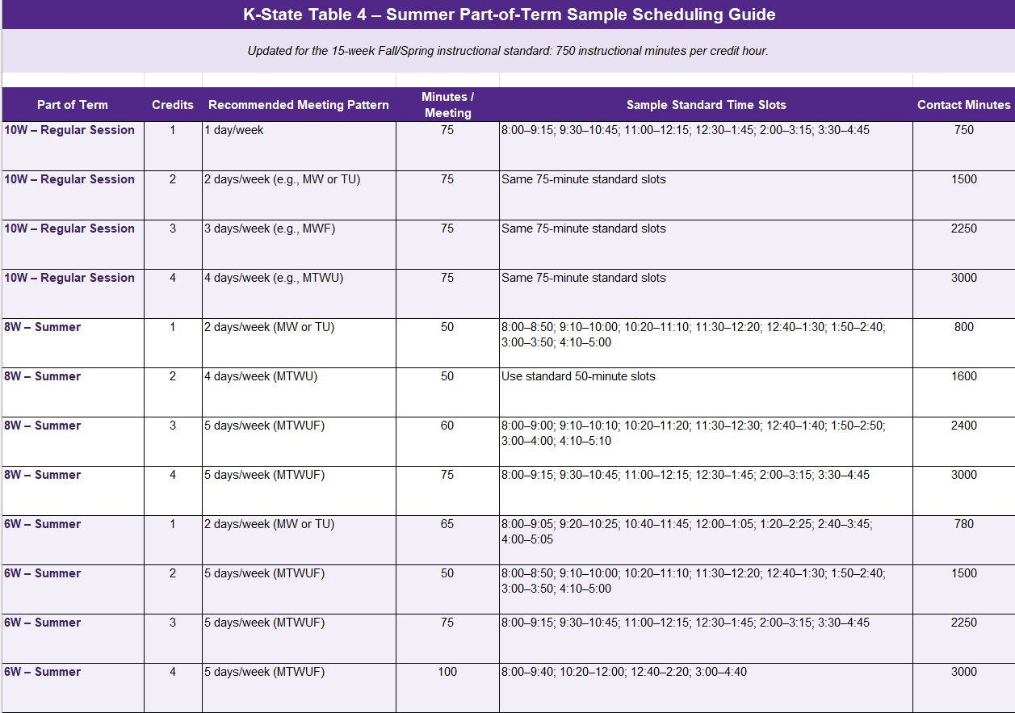

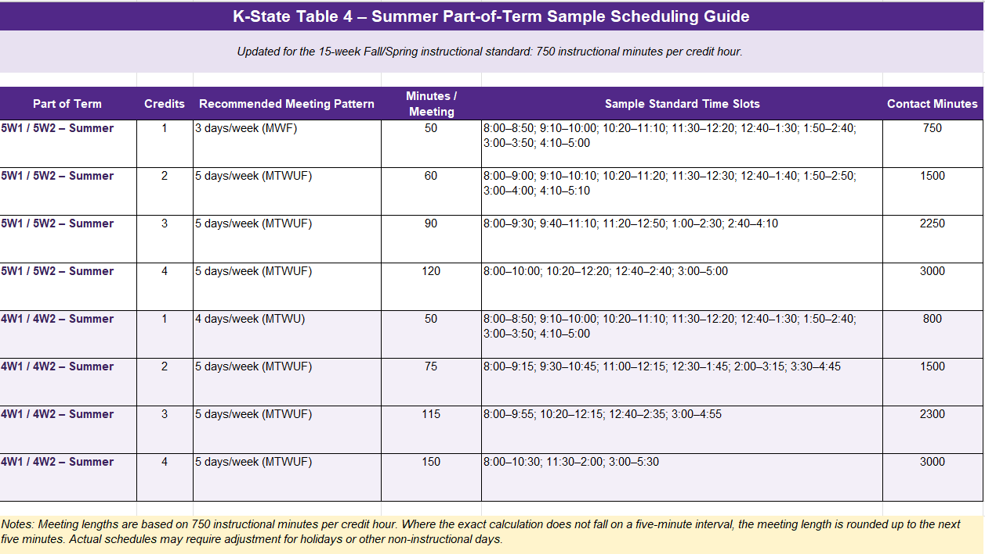

Non-Standard Class Times

Petitions/Exceptions
- Petitions for any variations from standard class times must be approved by the Committee on Academic Policy and Procedures (CAPP).
- A petition form may be obtained from the instructor's Dean's Office. The form must be returned to the instructor's Dean's Office and given to the Dean's representative on CAPP, who will present it to CAPP for consideration.
- Petitions for spring semester courses must be considered by May. Petitions for fall semesters and summer session courses must be considered by November (CAPP meets the second Wednesday of each month, August through May).

D.V.M. and P.A. Program Exception
The Doctor of Veterinary Medicine (D.V.M.) and Physician Assistant (P.A.) programs are exempt from the standard class meeting schedules established in this policy because accreditation, clinical education, and licensure preparation requirements necessitate alternative scheduling structures. This exception applies only to the D.V.M. and P.A. programs and shall not be interpreted as extending to other graduate, professional, cohort-based, or specialized academic programs. Additional rationale for this exemption is provided in the Appendix.

Reviews
- Petitions that have been approved for non-standard times will be reviewed annually each March by CAPP.
- The Standard Class Meeting Times policy will be reviewed annually, between the Spring and Fall semesters by CAPP, to determine its effectiveness and to improve any problem areas that arise in the implementation of the policy.

Figure 1: K-State Standard Class Meeting Times for Fall and Spring Semesters

Standard academic day begins at 7:15 a.m. and ends at 10:30 p.m., Monday through Saturday.
MONDAY / WEDNESDAY / FRIDAY  (50-MINUTE PERIODS) |  |  |  | TUESDAY / THURSDAY  (75-MINUTE PERIODS)
Period | Meeting Time | Label |  | Period | Meeting Time | Label
1 | 7:30–8:20 a.m. | First Period |  | 1 | 7:15–8:30 a.m. | First Period
2 | 8:30–9:20 a.m. | Second Period |  | 2 | 8:40–9:55 a.m. | Second Period
3 | 9:30–10:20 a.m. | Third Period |  | 3 | 10:05–11:20 a.m. | Third Period
4 | 10:30–11:20 a.m. | Fourth Period |  | 4 | 11:30 a.m.–12:45 p.m. | Fourth Period
5 | 11:30 a.m.–12:20 p.m. | Fifth Period |  | 5 | 1:05–2:20 p.m. | Fifth Period
6 | 12:30–1:20 p.m. | Sixth Period |  | 6 | 2:30–3:45 p.m. | Sixth Period
7 | 1:30–2:20 p.m. | Seventh Period |  | 7 | 3:55–5:10 p.m. | Seventh Period
8 | 2:30–3:20 p.m. | Eighth Period |  | 8 | 5:30–6:45 p.m. | Eighth Period
9 | 3:30–4:20 p.m. | Ninth Period |  | 9 | 7:05–8:20 p.m. | Ninth Period
10 | 4:30–5:20 p.m. | Tenth Period |  | 10 | 8:30–9:45 p.m. | Tenth Period
11 | 5:30–6:20 p.m. | Eleventh Period
12 | 6:30–7:20 p.m. | Twelfth Period |  | Passing periods vary between 10 and 20 minutes under the approved Tuesday/Thursday schedule.
13 | 7:30–8:20 p.m. | Thirteenth Period
14 | 8:30–9:20 p.m. | Fourteenth Period
Note: Time blocks shown are class meeting times. Instructors are expected to begin and end class on time.

Appendix

The Doctor of Veterinary Medicine (D.V.M.) and Physician Assistant (P.A.) programs have curricular and accreditation requirements that necessitate scheduling practices outside the standard class meeting time framework. These programs include substantial laboratory, clinical, simulation, experiential, and competency-based instructional activities that often require extended instructional periods, specialized facilities, coordinated faculty participation, and alignment with external clinical or professional partners.

In addition, these programs' instructional schedules are largely determined by professional accreditation standards, licensure preparation requirements, clinical education expectations, and the availability of specialized instructional environments. These factors may necessitate meeting patterns and instructional blocks that differ from the standard scheduling periods established for most university courses.

The exception for the D.V.M. and P.A. programs recognizes these operational and educational requirements while maintaining the university's commitment to appropriate contact-hour standards, effective instructional delivery, and responsible stewardship of instructional space resources. The exception is intended to support the unique scheduling demands of these identified programs and does not alter the scheduling expectations applicable to other academic offerings.

College of Veterinary Medicine: D.V.M. Program only

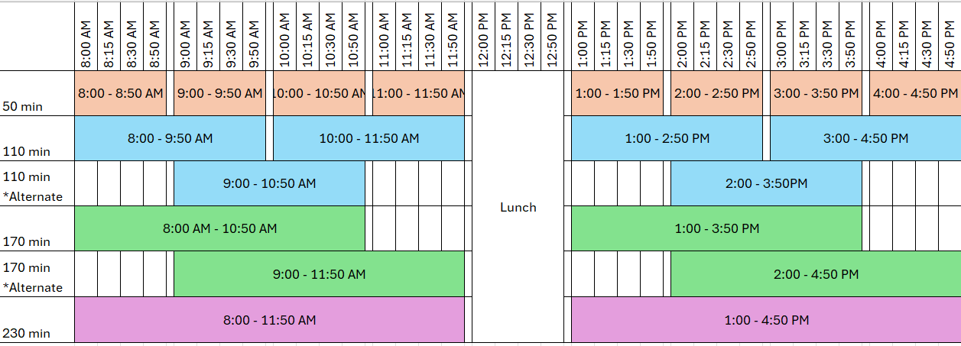

 | 1-hour class  50 min. period | 2-hour class  110 min. period | 3-hour class  170 min. period | 4-hour class  230 min. period
A.M. | 8:00 - 8:50 AM | 8:00 - 9:50 AM* | 8:00 AM - 10:50 AM*** | 8:00 - 11:50 AM
A.M. | 9:00 - 9:50 AM
A.M. | 10:00 - 10:50 AM | 10:00 - 11:50 AM*
A.M. | 11:00 - 11:50 AM
P.M. | 1:00 - 1:50 PM | 1:00 - 2:50 PM** | 1:00 - 3:50 PM*** | 1:00 - 4:50 PM
P.M. | 2:00 - 2:50 PM
P.M. | 3:00 - 3:50 PM | 3:00 - 4:50 PM**
P.M. | 4:00 - 4:50 PM
* 9:00-10:50 AM is an alternate period (allows 50 min bookings before and after)
** 2:00-3:50 PM is an alternate period (allows 50 min bookings before and after)
*** 9:00-11:50 AM and 2:00-4:50 PM are alternate periods

College of Health and Human Sciences: P.A. Program only

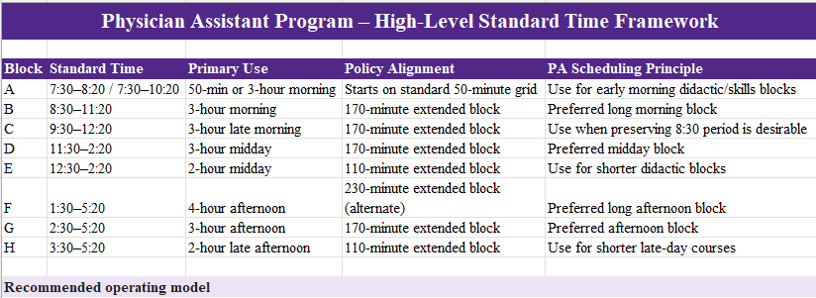

1. Treat the PA didactic curriculum as a coordinated cohort schedule, using a small, repeatable set of university-aligned start/end times rather than unique times for each course.
2. Preserve the existing day-of-week pattern where practical; the principal change is alignment of starts/ends to the standard class-period/extended-block framework.
3. Keep clinical rotations/internships and appointment-based experiences outside this didactic grid; they remain scheduled by appointment/clinical placement.
4. Credit/contact-hour compliance must still be validated course-by-course. A standard time block is a scheduling framework, not a substitute for the required instructional minutes.
5. Where a PA course cannot fit the approved framework, use the university non-standard-time/exception process rather than creating a new recurring time pattern.

Approval/Amendment History:
Approved by FSAAC on December 10, 2002
Approved by FSAAC on November 9, 2004
Approved by FSAAC on February 8, 2005
Approved by FSAAC on November 12, 2019
Approved by CAPP and endorsed by FSAAC on February 3, 2026, and FYI to FS on February 10, 2026
*Updates to the T/U schedule, contact hour connections, and new visuals to include the parts of the term that started in spring 2025
Approved by CAPP: 9/9/2026 – Endorsed by FSAAC on XX/XX/2026
*Addition of the T/U Lab schedule

