Coursedog view-only access | User guide
Introduction to Curriculum Management for New Users

Log in
- Go to https://app.coursedog.com/#/products
- Click to sign in.
- Log in with your K-State e-mail and password.

Navigation

Select Curriculum Management
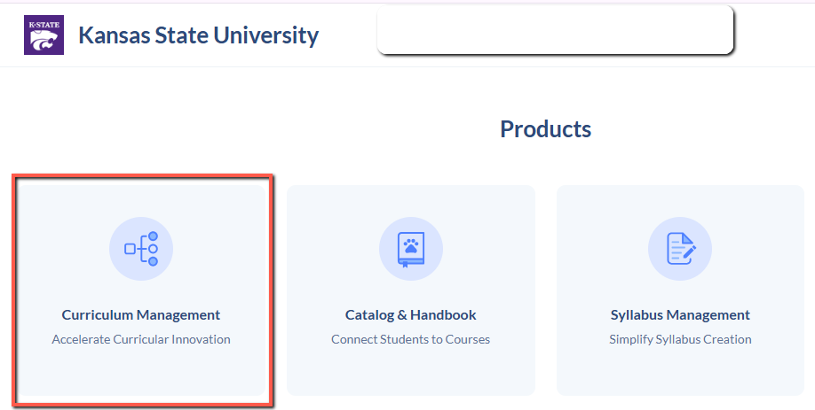

Curriculum Management page
Menu options appear on the left.
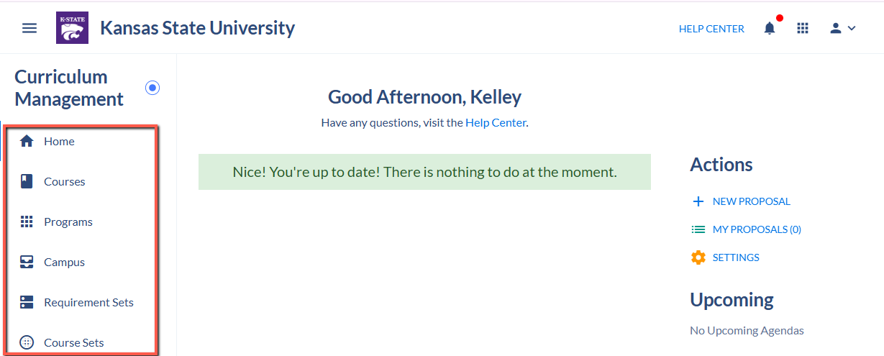
- Courses - Click to view a course.
- Programs - Click to view a program.
- Proposals - Click to find proposals that have been submitted, but not yet fully approved.

Courses and Programs pages
Use the Filter and Search features to find courses or programs.
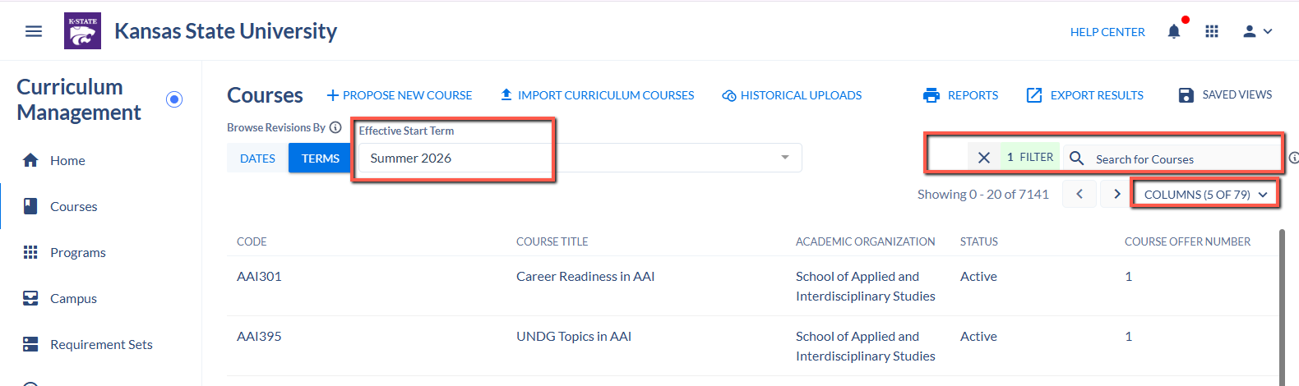
- To find a specific course search on Code, which is Subject + Course Number, with no space between. For example: MATH100
- To view additional columns, remove columns, or reorder columns in your results, use the COLUMNS selection menu.
- To view courses and programs approved for a future term, use the Effective Start Term drop-down and select the term of approval or later.

Viewing course and program records
- From the Course or Program page, click a course or program to view it.
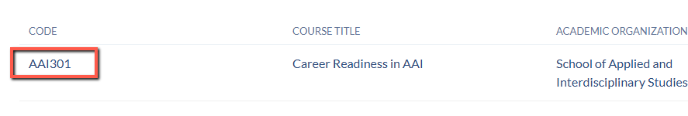
- The Revision dropdown will show any past updates that were made using a new effective term in Coursedog.

