Simple Requirements Procedure
Table of Contents
Simple Requirements Procedure 1
CourseDog Knowledge Base 2
Log in 2
Navigation 2
Select Curriculum Management 2
Curriculum Management page 2
Summary: 3
Narrative Text: 3
Course Prerequisites: 3
Program Prerequisites: 3
STEP 1: Select Course 4
STEP 2: Edit Course 4
STEP 3: Requirements Card 4
STEP 4: Add Narrative Text 5
STEP 5: Add Courses 6
Prerequisite = GREEN 6
Corequisite = PURPLE 6
Recommended = ORANGE 6
Minimum Grade = BLUE 6
Programs = LIGHT BLUE 6
STEP 6: Add Programs 11
STEP 7: Save Changes 14
STEP 8: Verify the accuracy of your entry 15
SPECIAL INSTRUCTIONS for grouping courses using “and” and “or” combinations 17

CourseDog Knowledge Base
https://coursedog.my.site.com/support/s/article/REQUIREMENTS-Understanding-Creating-Requirements

Log in
- Go to https://app.coursedog.com/#/products
- Click to sign in.
- Log in with your K-State e-mail and password.

Navigation

Select Curriculum Management
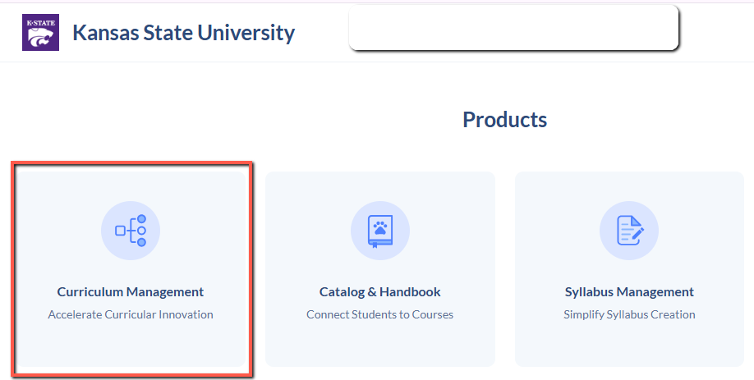

Curriculum Management page
Menu options appear on the left. – Select Courses
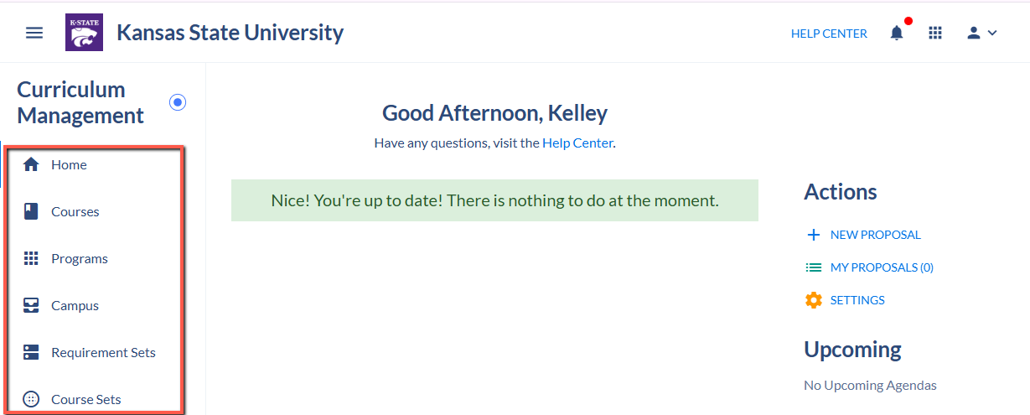
- Courses - Click to view a course.
- Programs - Click to view a program.
- Proposals - Click to find proposals that have been submitted, but not yet fully approved.

Summary:
Using a file downloaded from the current Acalog catalog, use the textual Requisites field to build coded Simple Requirements in CourseDog. This includes Prerequisites, Corequisites and Recommended Foundation Courses.

The coding may consist of three parts:

Narrative Text:
All requisites (total-4237) will build a Narrative Text requirement where Requisite text is pasted into a text field to display the complete worded description of the requisite.

Then one or both of the following requirements may be built as applicable for each requisite using the rules and condition operators available (and/or)

Course Prerequisites:
specific courses are selected
--includes additional notations of minimum grade when applicable

Program Prerequisites:
specific majors are selected

NOTE: CourseDog only provides for building of Course and Program type prerequisites using Requirement rules. Additional types of prerequisites built in PeopleSoft using other criteria such as academic level, student groups, test scores, cumulative gpa and grad bypass will only be reflected in Narrative Text.

STEP 1: Select Course

Search for the course by entering the course number in the search box:
--located in upper right corner


Enter prefix and number with no space between
--example: sales450

Place your cursor over the course and click on the course row in the list to select
--if more than one result is returned, always choose “Active” and “OFFER 1”

STEP 2: Edit Course

Click EDIT COURSE
--located in upper right corner

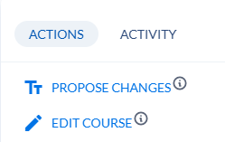

STEP 3: Requirements Card

Go to Requirements card
Hint: Use the Contents area on right side to select “Requirements”
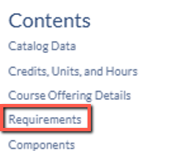

View Requirements card
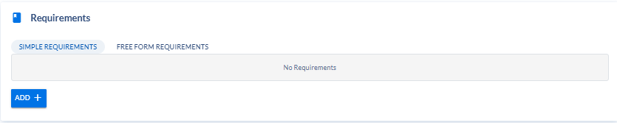

STEP 4: Add Narrative Text

Click ADD +
(add a REQUIREMENT)
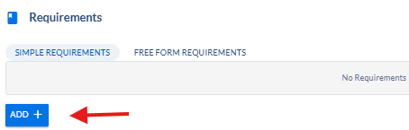

Select Narrative Text
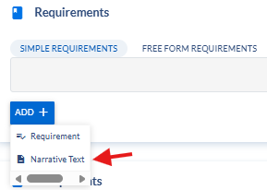

Click “Narrative Text” placeholder to expand the entry area
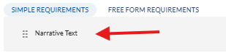

Additional Comments = copy and paste requisite rule text in the TEXT BOX provided
--from “Requisites” field in Acalog spreadsheet
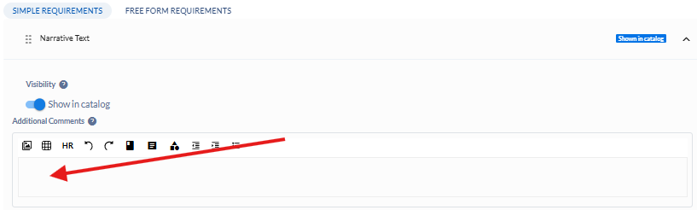
Completed Entry:
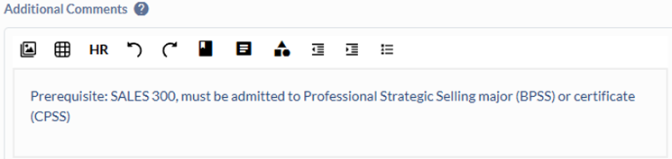

STEP 5: Add Courses

Note: in this document you will find specific instructions for

Prerequisite = GREEN

Corequisite = PURPLE

Recommended = ORANGE

Minimum Grade = BLUE

Programs = LIGHT BLUE

5a Click ADD + (for Prerequisite)
--add a REQUIREMENT

Select Requirement
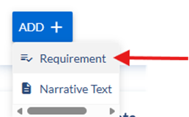

Click the “Untitled Requirement” row to expand the entry area

Type = Prerequisite
Corequisite
Recommended

Name = Prerequisite Courses
Corequisite Courses
Recommended Foundation Courses
--note as you type the “Untitled Requirement” is replaced
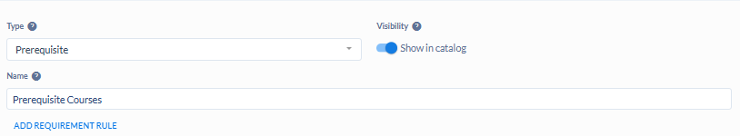

5b Click ADD REQUIREMENT RULE (for Prerequisite)

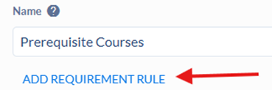

5c Rule Condition = (for Prerequisite)
Complete All Of: Select this option if all courses are required;
--connected with AND or there is only one course listed
Complete Any Of: Select this option if courses are chosen from a list
--connected with OR
Minimum Grade: Select this option if a minimum grade must be earned (see below)
--Note: may need to add another rule if grade doesn’t apply to all courses
Complete At Least X Of: Select this option if a set number of components from a
data type [courses, programs, course sets, or requirement sets] is required
--used for more complex requirements

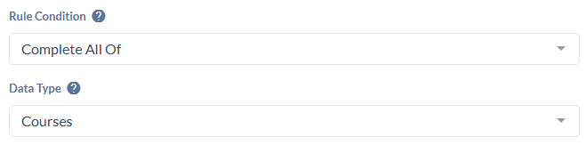

Rule Condition = (For Minimum Grade)
Minimum Grade = select this option if a minimum grade must be earned
Grade Type = Grade
Grade Value = enter grade (A, B, C, D)

Rule Condition = (for Corequisites)
Enroll In: Select this option if students must be enrolled in a specific data type --For Corequisite only
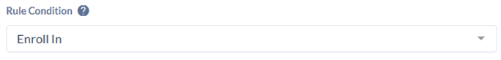

Rule Condition = (for Recommended)
Complete All Of: Select this option if all courses are recommended
--connected with AND or there is only one
Complete Any Of: Select this option if recommended courses are chosen from list
--connected with OR
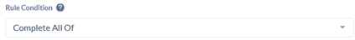

5d Data Type = Courses (for Prerequisite)


5e Select course – Type here to start searching (for Prerequisite)
Enter prefix and number with no space between
--example: sales300
--it is recommended to not use the “Filter by” area as it can yield unexpected results



As course is found, it is displayed in the course area, and if there is only one match is often displayed in blue
Click the course row to select the course
--if more than one row is returned, always choose OFFER #1 and Active

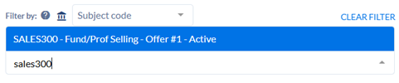
The selected course is now displayed


If rule needs only one course, continue to 5i (for Prerequisite)

5f If rule needs additional courses selected (for Prerequisite)
To add more courses: click + (Add additional courses)



5g Select your operator (AND/OR) (for Prerequisite)
--AND is default
--it is appropriate for condition “Complete All Of”
--Click the AND operator to toggle between AND and OR for your course selections
--you can only use all AND’s or all OR’s in a single RULE
--see STEP 5h for an example using the OR operator
--Note: If you need an additional operator for complex requisites, then see SPECIAL INSTRUCTIONS at end of document

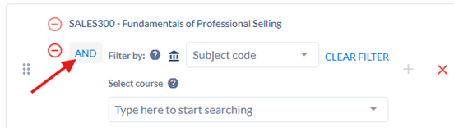

Continue to search/select your additional courses using the UPPER “indented” search box
--do not use the lower left-aligned search box

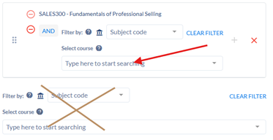

Repeat until all courses are entered

Completed example
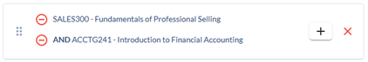

5h Complete Any Of (EXAMPLE) (for Prerequisite)
Note: this example illustrates a requirement using the Complete Any Of with the OR operator
selecting courses works the same way as Complete All Of with the AND operator
Select and add courses as described above, however, select the OR operator
--AND is default
--Click the AND operator to toggle to OR for your course selections
--OR is appropriate for condition “Complete Any Of”

Completed example
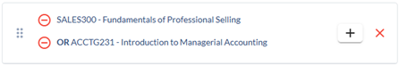

5i Rule Name = RULE (for Prerequisite)
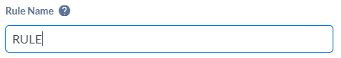

5j Fields generally left blank (for Prerequisite)
Rule Description (displays at top of rule) = blank
Rule Notes (displays at bottom of rule) = blank

5k Completed Example: (for Prerequisite)
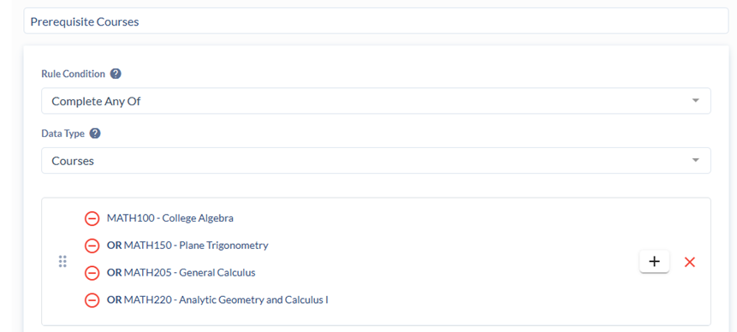

5l For grouping courses using “and” and “or” combinations, see SPECIAL INSTRUCTIONS at the end of this document (for Prerequisite)

STEP 6: Add Programs

6a Click ADD + (for Program)
--add a REQUIREMENT

Select Requirement

Click “Untitled Requirement” row to expand the entry area
Type = Prerequisite

Name = Prerequisite Programs
--note as you type the “Untitled Requirement” is replaced

6b Click ADD REQUIREMENT RULE (for Program)
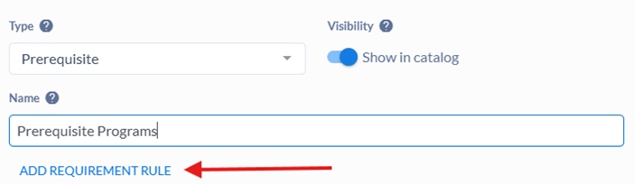

6c Rule Condition = (for Program)
Enroll In: Select this option if students must be enrolled in a specific data type 

6d Data Type = Programs (for Program)


6e Select programs – Type to search for programs (for Program)
--enter program code (BPSS)
--or begin typing name of program such as “professional strategic”
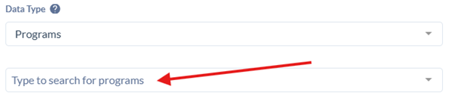

As program is found, it is displayed in the program area, and if there is only one match is often displayed in blue
Click the program row to select it
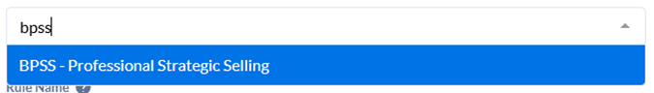
The selected program is now displayed
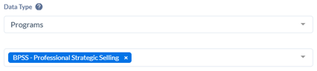

If rule needs only one program, continue to 6h (for Program)

6f If rule needs additional programs selected (for Program)
Click in the row of the existing program

Search for additional programs by using Type to search for programs area
--select each program as described above
--remember to include all online, Salina, and/or Olathe versions of the program,
if applicable
--You may have to check KSIS for ERG to be sure

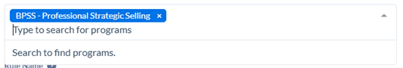

As you select additional programs they are displayed in the programs area

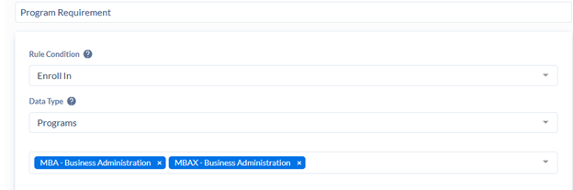

6g The default connector is considered “OR”; you do not have to select one here (for Program)

Repeat until all program codes are selected

6h Rule Name = RULE (for Program)
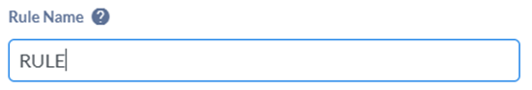

6i Fields generally left blank (for Program)
Rule Description (displays at top of rule) = blank
Rule Notes (displays at bottom of rule) = blank

6j Completed Example: (for Program)
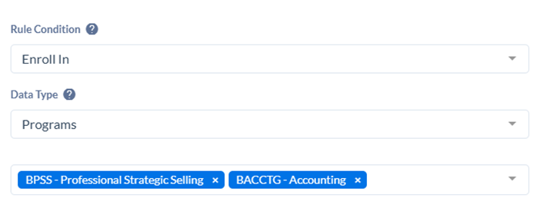

STEP 7: Save Changes

Click SAVE CHANGES


NOTE: IT IS VERY IMPORTANT that you ONLY update the Simple Requirements information for a course

DO NOT UPDATE ANY OTHER COURSE INFORMATION IN THIS EDIT PROCESS

GO TO STEP 8

NOTE (As of 3-23-2026): Bi-directional syncing is not yet turned on in PROD so the following does not yet apply; this procedure will be updated to include the syncing notation upon complete implementation.
--Be aware that Simple Requirements are Non-integrated data to PeopleSoft
--Do not update any other course information in this process
--Integrated fields that are inadvertently updated will not be updated in PeopleSoft

Syncing will begin shortly (after 10-15 seconds)
--Scroll to top of page, the yellow ribbon is displayed while syncing is taking place
--do not make changes during this time
--this make take a few minutes
--When the yellow ribbon disappears, you can move on

STEP 8: Verify the accuracy of your entry

Click to review the Requirements card again
--View a summary of the rule you just created (expanded view)
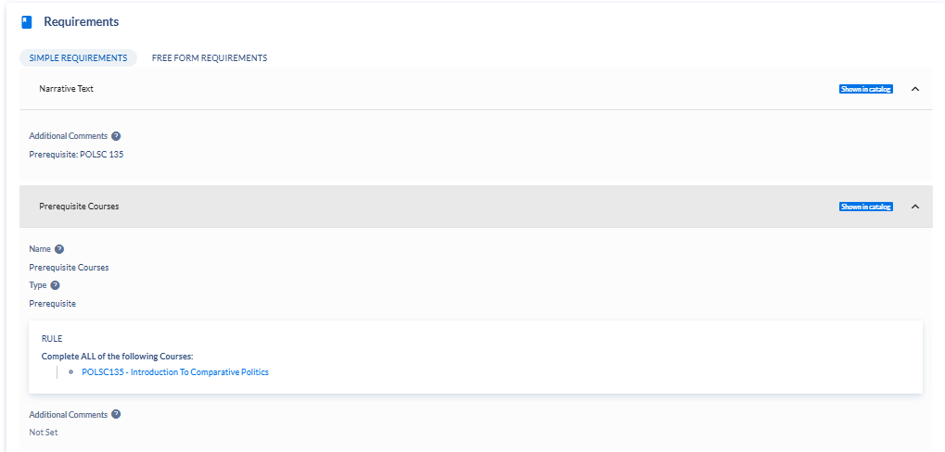

In Collapsed view:
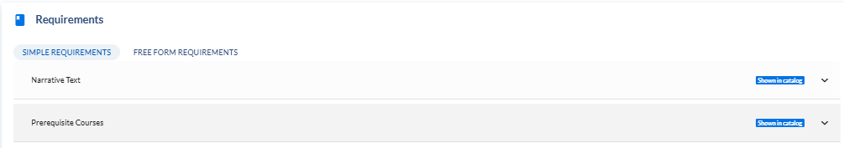

Click CATALOG PREVIEW


Click VISIT (for 2026-2027 Catalog)
Course Details are displayed
Click Prerequisites/Corequisites tab

“Narrative Text” is always displayed in FIRST line
“Prerequisite Courses” and/or “Prerequisite Programs” follow with rule detail
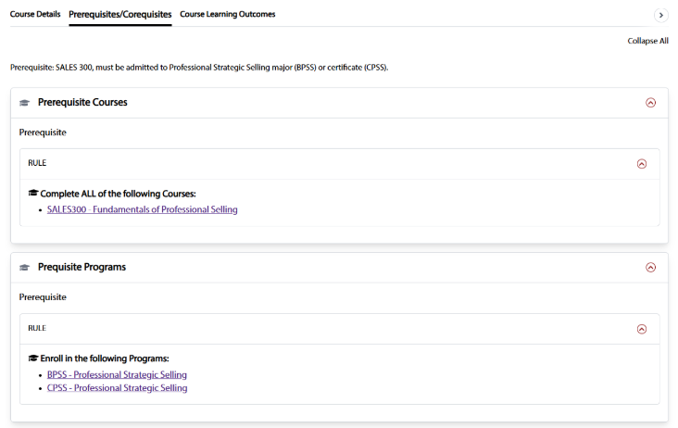

SPECIAL INSTRUCTIONS for grouping courses using “and” and “or” combinations

Enter the FIRST group of course as designated in STEP 5 using “Complete All Of” and the + to add additional courses as needed
--use AND operator, if needed
--this could also be a list “Complete Any Of” with OR operator, if appropriate

When you have selected all the courses in the first grouping and are ready for next grouping:
In the Select course area BELOW the original course list, search for and select the first course in the grouping
--this search area is aligned with the LEFT margin
--do not use + to add the course with the indented Select course area

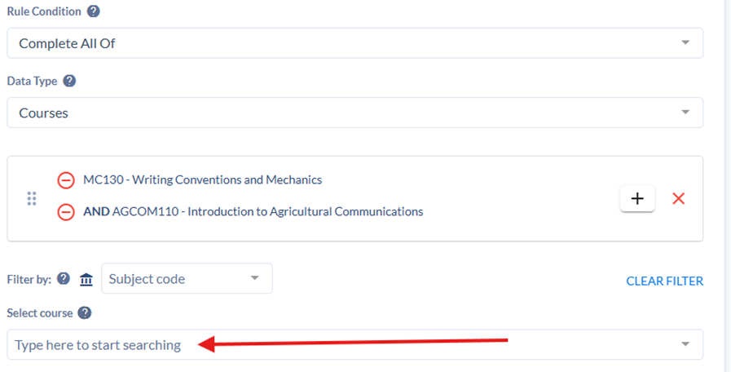

To select additional courses in the second grouping, use the +, select your operator (and/or), and use the indented Select course area

Your end result will produce two distinct course groups
