Coursedog: New Program Proposal

Table of Contents
Adding Requirements 9
Adding Requirement Rule 11
Requirement set: 12
Courses: 12
Total Hours Required 18
Catalog Preview 18
Programs with Subplans 18
Adding Degree Maps 20

Coursedog Curriculum End User Guide
Login to Coursedog
with “@ksu.edu” email -To log into Production, go here

Click on the Curriculum Management card. 

- New Proposal
You have two places where you can start a new program proposal.
  - On the Home screen, click on + New Proposal on the right side of the screen under Actions.
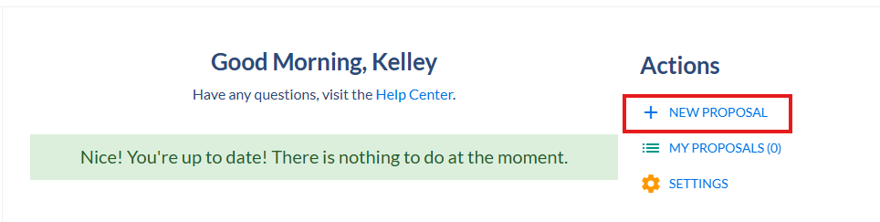

  - Or CLICK ON Programs in the Left Menu
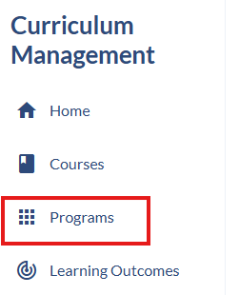

  - On the Programs screen, click on + Propose New Program at the top of the screen.
This popup will appear for you to select the correct form to use for this proposal.

Select Program New, 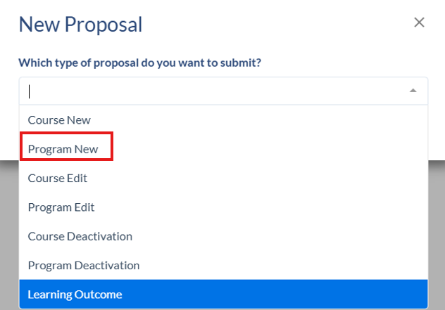
then Go to Form.
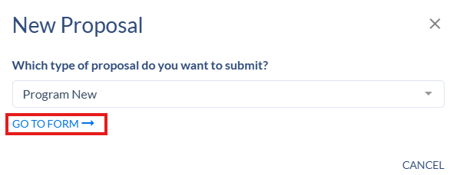

- Academic Plan Details
Fill in all required fields in this section:
- Contact Person email and telephone number
- Catalog Display Name – enter a name for the new program using the format of Title (Degree Code). A link to the KSIS degree type codes and a list of example program titles are provided on the form.
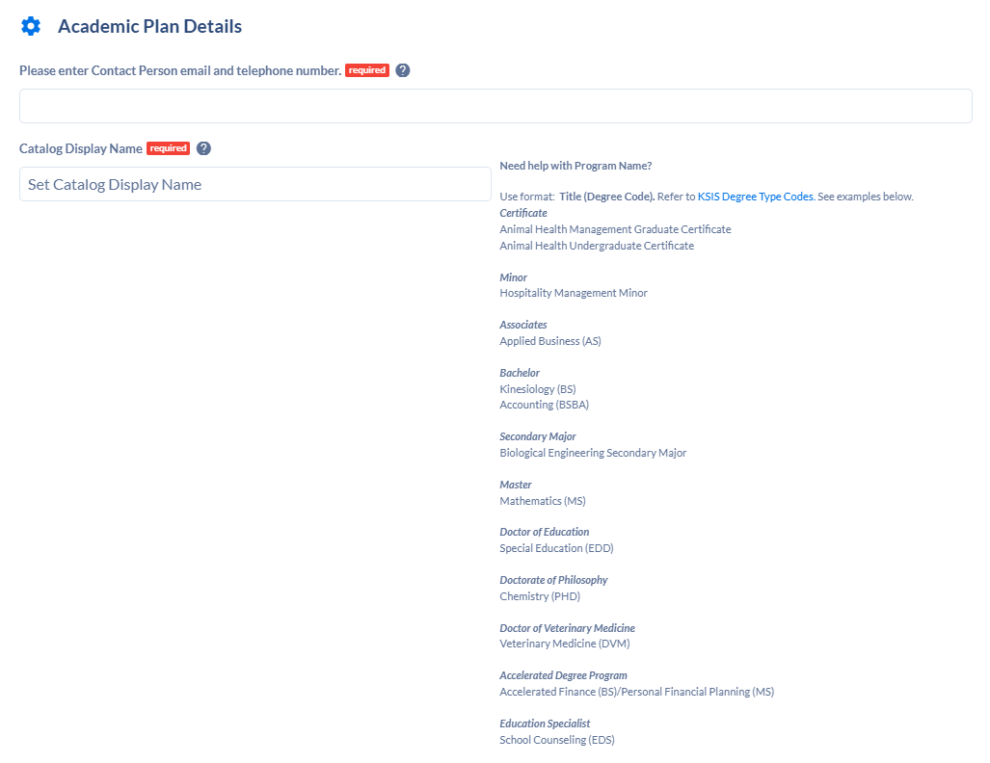
- Catalog Full Description – a description of the program that will display in the academic catalog
- Program Type – select the appropriate program type from the dropdown list: Accelerated Degree Program, Associate, Bachelor, Certificate, Doctorate, etc.
- Academic Plan Code – for a new program, enter a plan code that is based on the program type and program title. The code should start with an A for an associate's degree, B for a bachelor's degree, C for a certificate, D for a doctorate, and M for a Master’s. The code for an online program should end with an X. The code will be checked by curriculum staff and may be changed to adhere to academic plan code standard practice.
- Academic Plan Description – This is the program title shortened (if necessary) to 30 characters.
- Status – will be set to Active
- Effective Start Term – choose the term for the new program to start
- Effective Start Date – will fill automatically based on the start term
- Degree – KSIS degree code. Don’t select any of the historically used numerical codes, like 01, 20, 32, etc. Scroll down in the list to find BA, BS, BMED, MS, PHD, CERTGR, CERTUG, etc, or type the code.
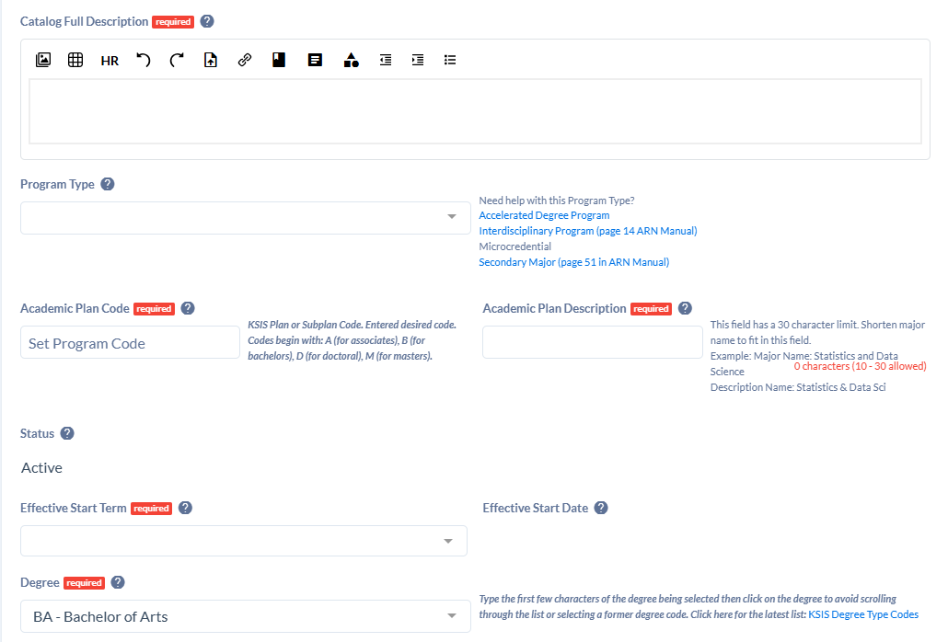
- Academic Organization – multi-select field for the colleges/departments that own the program
- Academic Organization Ownership - multi-select field to indicate the percentage of ownership. Click on the + sign to add all applicable academic organizations that will have ownership in the program. Total percentage must add up to 100% and one organization must have a higher percentage than the others to be the primary owner. Use Add Department to add additional lines.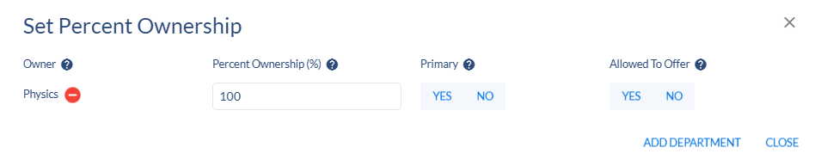
- College – academic group code for primary college
- Career – Undergraduate, Graduate, or Veterinary Medicine. (Either Career or Academic Program is required to complete the proposal.)
- Total Hours Required – enter the number of hours needed to complete the program. This can be a single number or a range, examples:120 for a bachelor’s degree, 12-15 for a certificate.
- Academic Program – Degree type by academic group code. (Either Career or Academic Program is required to complete the proposal.)
- New courses – list any new courses that are being proposed (in a separate Course New proposal) that will be a part of this new program.
- Upload supporting documentation – files can be added to the proposal for documentation
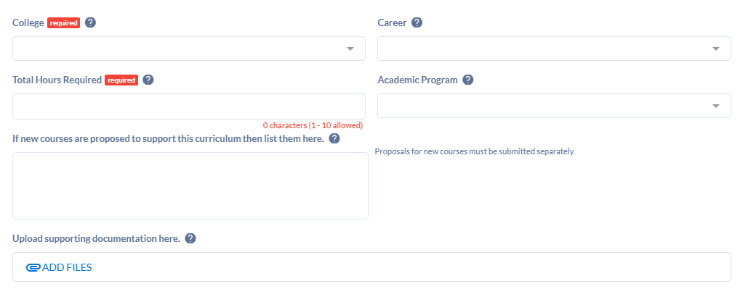

- Kansas Board of Regents New Program
- KBOR Rationale - Enter a rationale, if needed, for programs requiring over 120 credits.
- KBOR New Program Guidelines – contains links to website with KBOR policies
- Assessment of Student Learning (ASL) - contains links to websites for assessment
- KBOR New Program OR Assessment of Student Learning – Attach forms and documentation by clicking on Add Files. A search popup will allow you to select files from your computer.
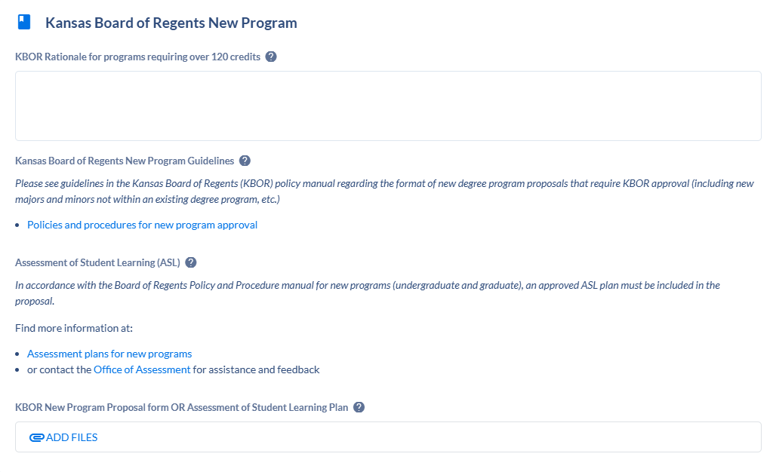

- Requirements
This card is for adding the program requirements and includes sections for Admission Requirements, Graduation Requirements, Program Requirements (which includes K-State Core, if applicable), Major, Subplan, and Total Hours Required.
See Adding Program Requirements section below for instructions on how to complete this card.
- Campus Plan
- HEGIS Code – Select the HEGIS code for the primary program location from the dropdown list. Use only the following codes: MANHAT, ONLINE, SALINA, ONLSAL, OLATHE, ONLOLT.
- CIP Code - Use the dropdown list to select the correct CIP code for the program.
- Campus Plan – Select all campus locations from the dropdown list. This is a multi-select field.
- Explain Campus Offerings
- Online Program Percentage – Enter the percentage of the program’s online content.
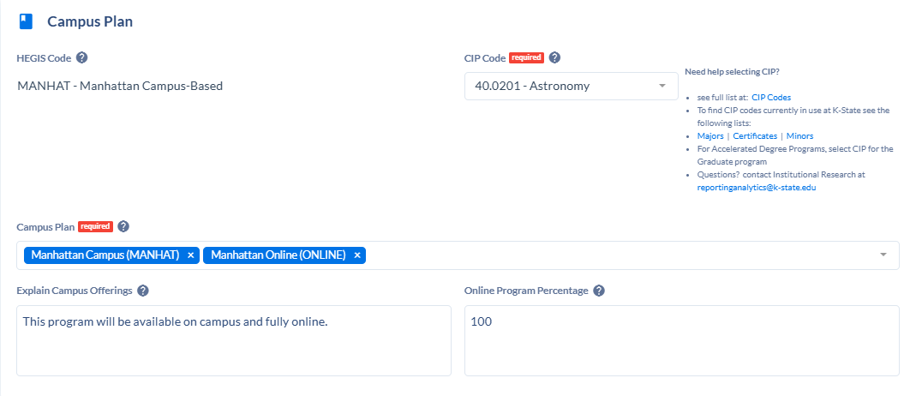

- Rationale and Impact
- Rationale - Enter a detailed rationale for the new program
- Impact statement – Enter information on how this program impacts other colleges and departments.
- Upload any supporting documentation – Attach any supporting files like emails to other colleges and departments regarding the program impact by clicking on Add Files.
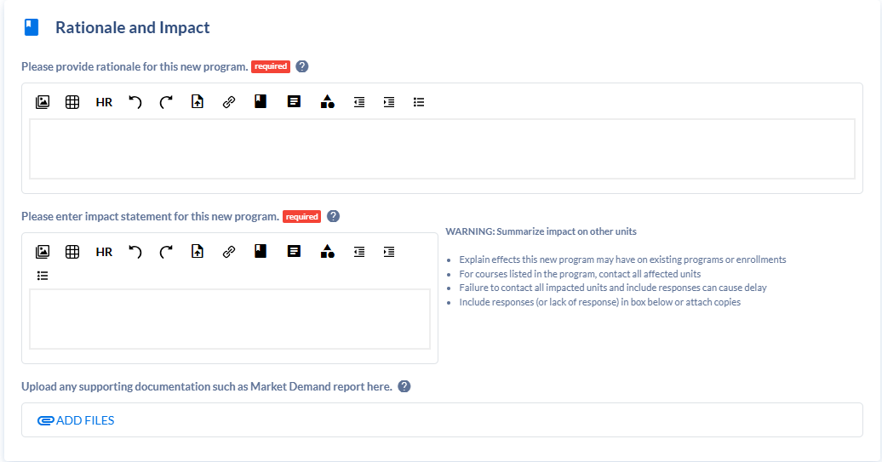

- Licensed Programs
Use this section to enter information for any program that leads to licensure. If the program doesn’t lead to licensure, select No for the “Does this program lead to licensure? question.
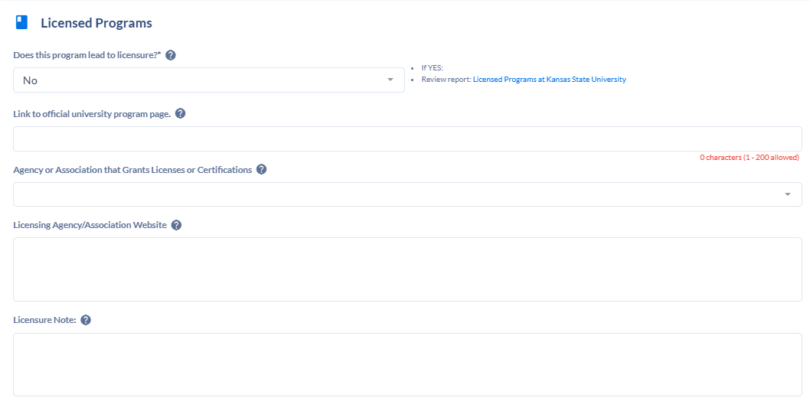

- Specializations
If the program has subplans, enter them in this section. Click on + New Specialization to open the window. Complete all the required fields. Add additional specializations if needed.
- Status – will default as Active
- Effective Start Date – enter the date that the specialization will be active
- CIP Code – Search for CIP code in dropdown list
- HEGIS Code – Enter the HEGIS code for the campus location – MANHAT, ONLINE, SALINA, ONLSAL, OLATHE, or ONLOLT
- Transcript Description – Enter the name of the subplan
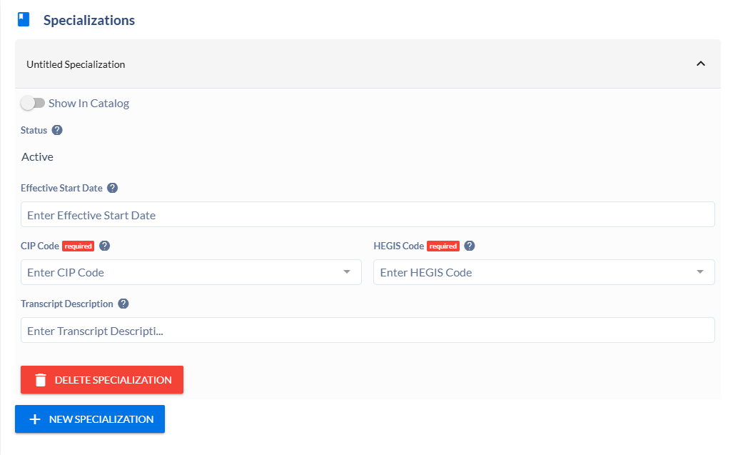

- Degree Maps
Use this card to add a degree map for the program. If there are specializations, there needs to be a degree map for each one. See the Adding Degree Maps section below for instructions on this section.
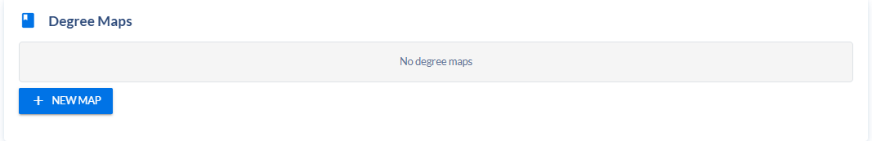

- Learning Outcomes
Learning Outcomes must be entered on a separate proposal.

Actions
Under the Actions menu on the right side of the screen, there are 2 choices:
- Submit Proposal – submit the proposal and send it for approval.
- Delete Proposal – delete this proposal from the system

Adding Requirements
Requirements Card
Scroll down to the Requirements Card section
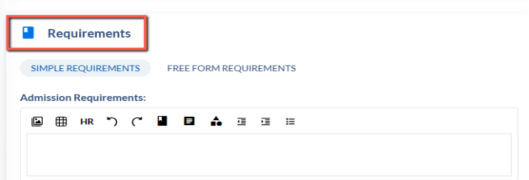
In the Requirements card, scroll down to the bottom of the card and click on ADD+ to add a requirement.
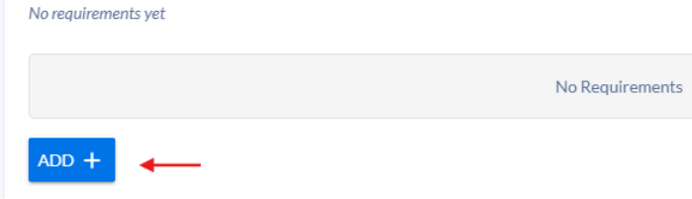
Choose Requirement to add a course requirement, requirement set, or course set or Narrative Text to add free text.
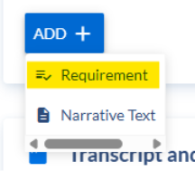

Click on the Untitled Requirement to open the requirement
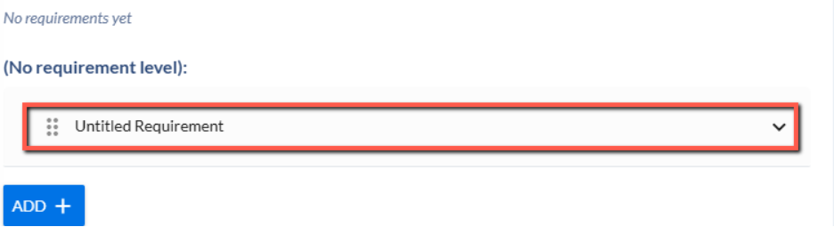

Set the correct Requirement level by going into the drop-down menu – In this Case choosing Program Requirements
Requirement levels are: Admission Requirements, Graduation Requirements, Program Requirements, Program, Total Hours Required, and Subplan.
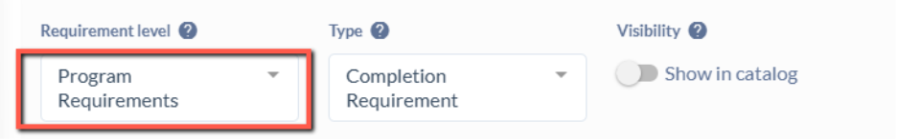

As soon as you choose this option, the box will close out, and this untitled requirement has now moved up into the Program Requirements Section Above
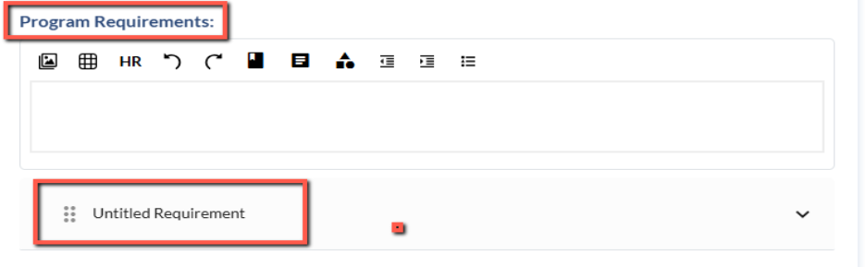
Find the untitled requirement at the requirement level and click on it to open it again.
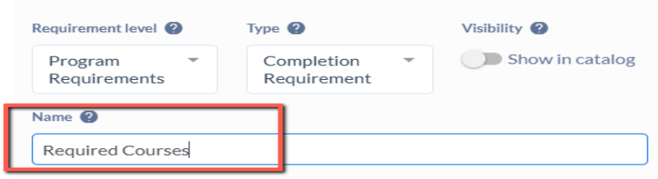
Enter a Name for the requirement and click on the Visibility setting so the requirement will show in the catalog. In the Untitled requirements section you will add the Name: Required Courses

Make sure to click/turn on the Show in Catalog button under Visibility
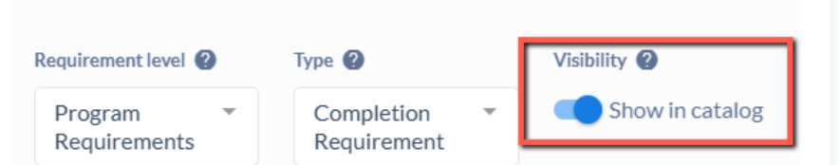

Adding Requirement Rule
Click on the Add Requirement Rule option in blue to start building/listing the courses
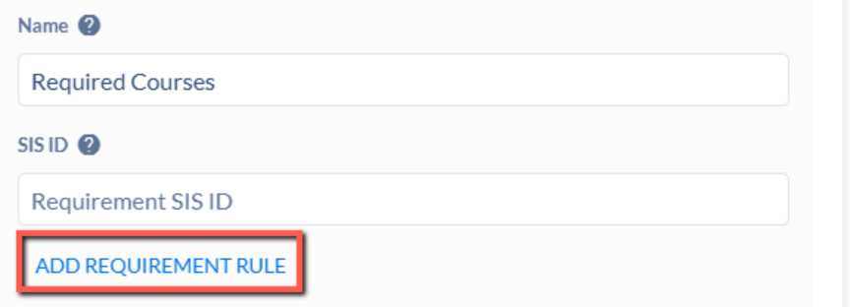

You have some options below for what Rule conditions and Data Types can be available.

Make sure to add the Rule Name – located below the Select Course list - making it the same as the name of the requirement
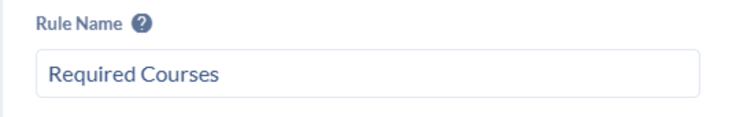

Requirement set:
If in a major (Associates or Bachelors), insert K-State Core first in the Program Requirements by searching for it under the requirement sets. Requirement Name should be Kansas State University Core: 34-36 Credit Hours. Rule Name should be General Education.
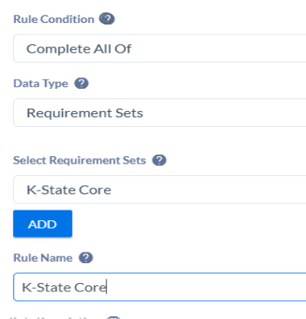
Then click Add.

Courses:
This will be the most common option used
Choose the Rule Condition
- Complete All Of
- Complete At Least X of
- Complete Any of
- Minimum Credits
- Number of
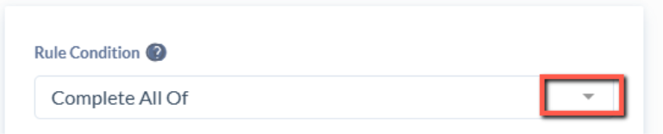

Choose the Data Type of Courses

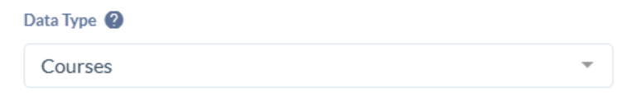

Start searching for courses:
In the Select Course box, type in the subject and course number.
It may take a second to sync.
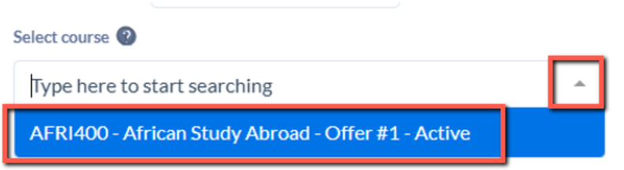
Choose the course by click on it and it will show in the list above the Filter By option. Make sure you choose a course that has “Active” displayed next to the name. Inactive courses will come up in your search, too.
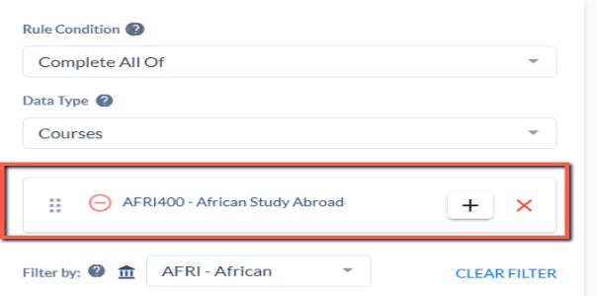
Search for the next course.
Continue on until all courses have been added
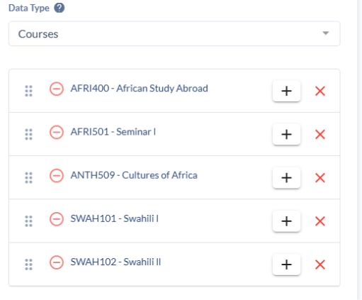
Once completed Stop Editing this section to close it out


AND or OR options in the Course List
To link courses together with AND or OR, click on the + to the right of the course. Set the AND or OR by clicking on that box, and then search for the course to link with the first course.
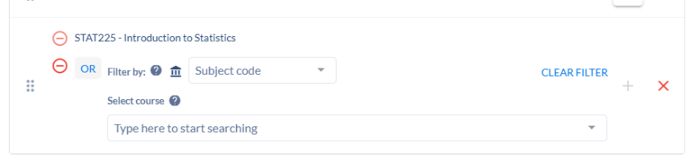
Note: Pay attention to the courses when you search for them and select only active courses.
The order of the course list can be changed by clicking and dragging a course to a different location in the list.
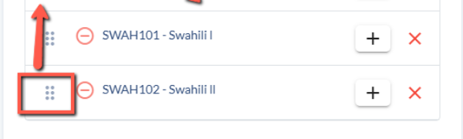

Adding Free Text or Notes:
This is for free-text entries – any line in the program requirement that is not an existing course or requirement, or course set will be free-text. (Note: there are currently no course sets built except for K-State Core buckets that are used in degree maps.)
There are two ways to do this:

Add the comment under Rule Notes
For this example below, the free text statement that goes with the required course list is best placed in the Rule Notes
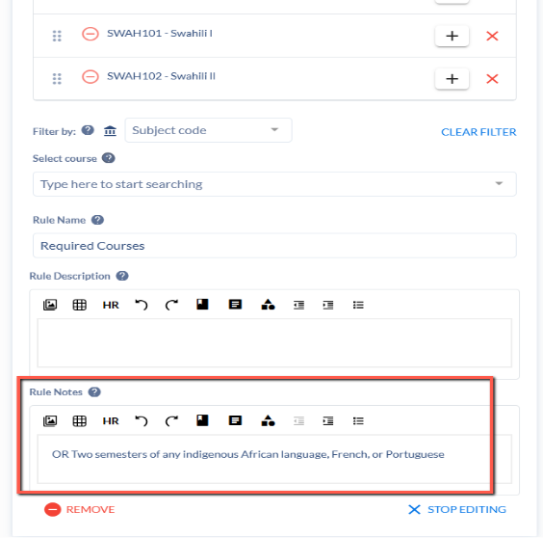
You will see the following in the Catalog View
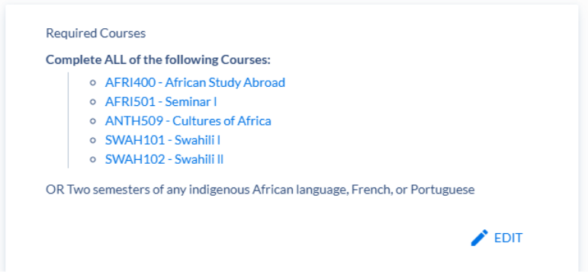

ADD Rule Condition: Freeform Text
To add below a current list - Click on ADD Requirement Rule

Rule Condition: Freeform Text and then Enter the Text in the box below
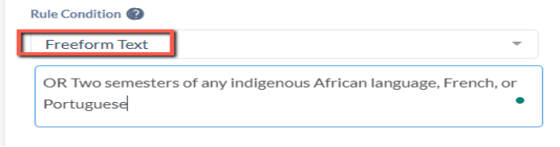

Stop editing the requirement

Continue Process for ALL Remaining Requirements/Sections of the Program/Plan
Continue to create the remainder of the program using this option by creating new Requirement Rules as needed based on the various blocks/sections within your program.
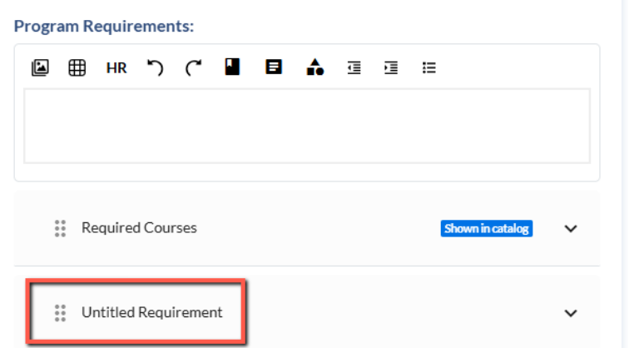
Requirement rules can be rearranged by clicking and dragging to the correct position.

Total Hours Required
Add in the Total Hours in the bottom section of the Requirements Card – located in the Total Hours Required Section
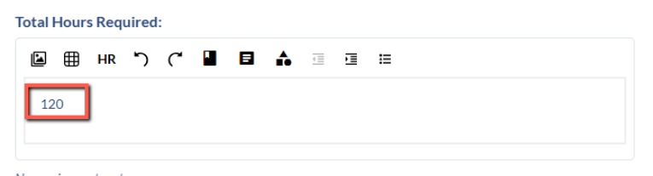

SAVE CHANGES
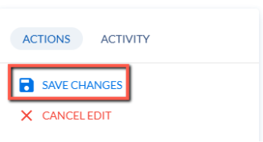

Catalog Preview
You can see how the requirements will display in the catalog by clicking on Catalog Preview in the right-side menu. This will open the catalog in another browser tab.
Open the Program Requirements tab to see the program requirements.
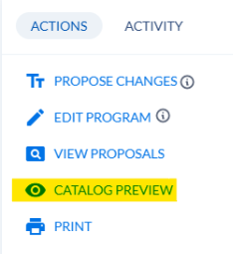

Programs with Subplans
In the 2025-2026 catalog, each subplan had its own page.
In the 2026-2027 catalog in Coursedog, programs that have subplans (called specializations in Coursedog) will have all requirements listed under the main/primary KSIS plan code in Course Dog on the Program Requirements page.
You will have to compare the subplans to determine what requirements are common to all subplans. Those requirements should be entered under the Program Requirements and Major sections. Any requirements that are unique to a subplan should be entered under the Subplan section with separate requirements for each subplan.
For example, the Mathematics (BS) program has 3 subplans for Actuarial Mathematics, Applied Mathematics, and Pure Mathematics. Requirements that are in all 3 subplans are listed under Program Requirements and Major. Requirements unique to each subplan are listed under Subplan with a heading for each subplan.

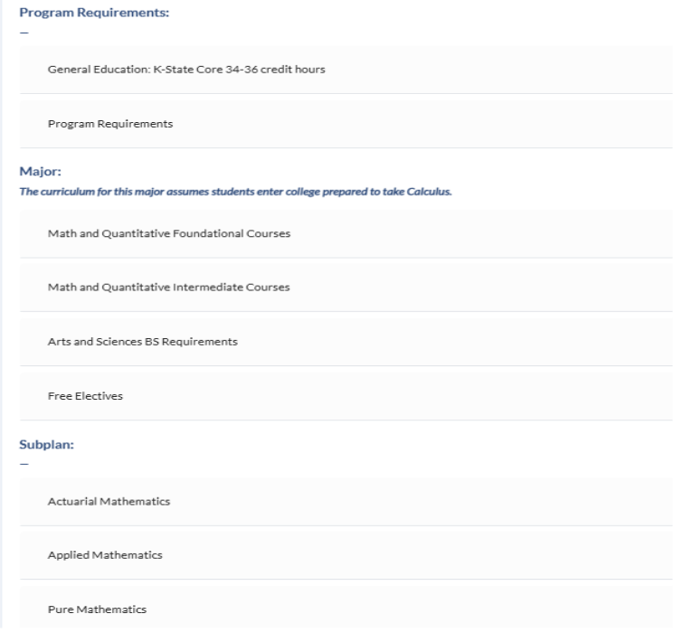

Adding Degree Maps
Degree Maps Card
Scroll down in the Program Template to the Degree Maps Card section
Click on + New Map button to start the process
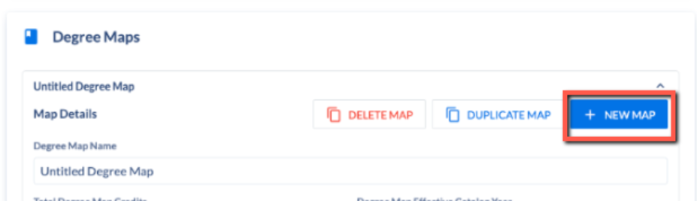

Enter a Degree Map Name and turn on Displayed in Catalog.
Total Degree Map Credits will be calculated as you add courses to the degree map.
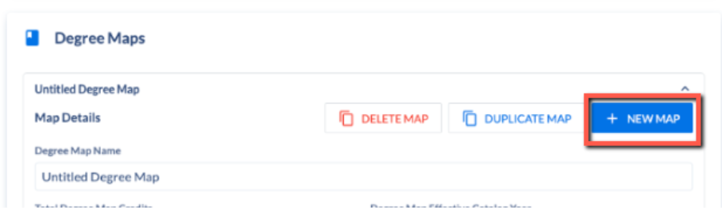
Make sure you choose/click on the Displayed in Catalog button under the Miscellaneous section
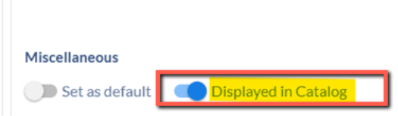
Under the Semester section, you will click on + New Semester to start entering the degree map.
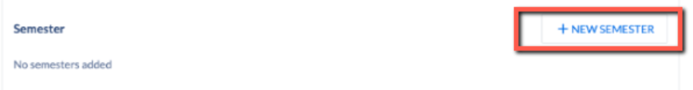
Select the Year and Semester from the dropdown lists. Actual credits will be calculated as you add courses to the semester.
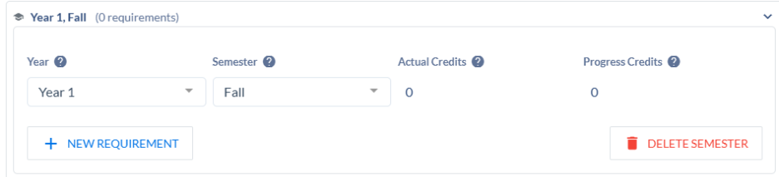

Click on + New Requirement to add each item to the degree map.


Click on the requirement to open it and then Edit to add the line to the degree map.
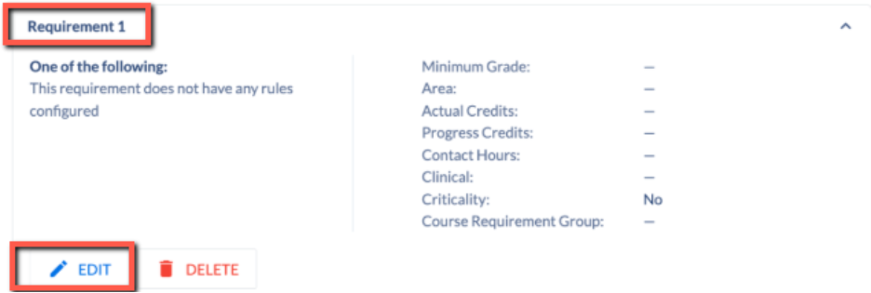

Courses:
Set the Requirement Type to Courses and search for a course in the Requirement Select box. Click on the course to select it and add it to the requirement.
Then click Save.
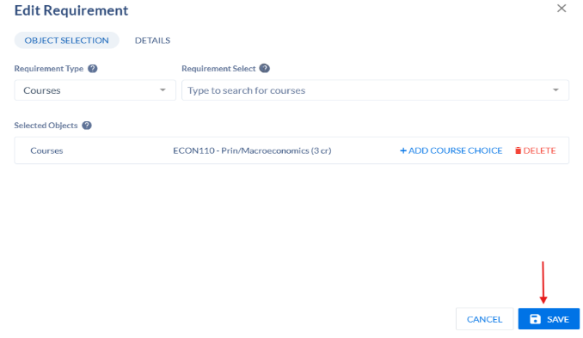
If you need to add an OR option to the requirement, search for the course and click on it to add it. It will be linked to the first course with OR.
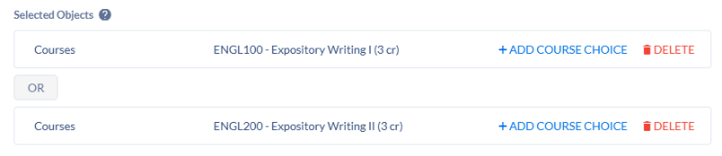
If you need to add an AND option to the requirement, click on + Add Course Choice, search for the course, and click on it to add it. It will be linked to the first course with AND.
If the course is from the K-State Core and will fulfill the general education requirements for this program, add the correct KSC tag for the core by click on the Details tab and entering the KSC tag in the K-State Core field. The tag will display under the course in the degree map.
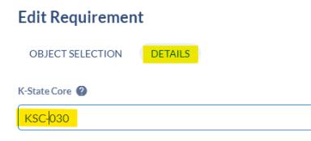
If the course has variable credit hours but needs to have a specific number of credit hours to fulfill the semester credit hours, enter the specific credit hour in the Actual Credits field on the Details tab. In this example, the course has a variable credit range of 0-1 credit hours, but it needs to be set at 1 credit hour to get the correct number of semester hours.
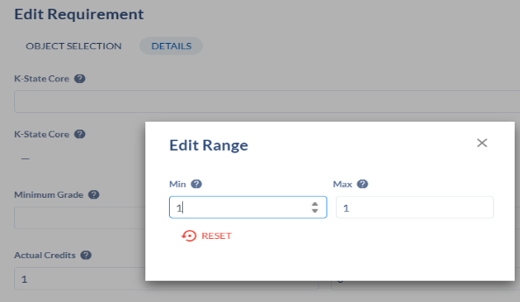
Continue entering courses to complete the semester by adding New Requirement and searching for the courses.

Course sets:
Change Requirement Type to Course Sets and search for the name of the course set in the Requirement Select box. Click on the correct course set to add it.
If the course is from the K-State Core and will fulfill the general education requirements for this program, add the correct KSC tag for the core by click on the Details tab and entering the KSC tag in the K-State Core field. The tag will display under the course in the degree map.
Set the number of credit hours needed for the course set under the Details tab in the Actual Credits box.
Click Save.
Note: Course sets must be set up before searching for them here.

Generic:
- This is for free-text entries – any line in the degree map that is not an existing course or course set will be free-text.
- Change the Requirement Type to Generic. Enter the free-text in the Requirement Select box.
- Set the number of credit hours needed for the course set under the Details tab in the Actual Credits box.
- Click Save.
Continue adding requirements to the semester to complete it.
Add additional semesters and their requirements to complete the degree map.
When the degree map is complete. Click Save Changes in the right-hand menu to save the program and degree map.
You can see the degree map on the catalog page by clicking Catalog Preview in the right-hand menu to open the catalog page. Click on the Degree Maps tab.
