Contents
Supported Browsers 1
Accessing Coursedog 1
Logging In 1
Single Sign On (SSO) 1
Logging Out 3

Supported Browsers
- Coursedog ensures full compatibility with the latest general availability release of the following browsers: Microsoft Edge, Mozilla Firefox, Google Chrome, and Apple Safari.
- Microsoft Internet Explorer 11 may be used to access Coursedog applications, but it will result in a subpar experience.
- We recommend Internet Explorer users switch to Microsoft Edge.
- Other browsers (including older versions of Internet Explorer) are not supported.
- Although users are able to access the app, we cannot ensure full compatibility for all in-app functionality for browser versions that are more than two years old.

Accessing Coursedog
To log into Production, go here.

Logging In

Single Sign On (SSO)

Step 1: Enter your email address into the standard login page.
This should be your @ksu.edu email address only. If this doesn’t work, you can try @k-state.edu as an alternative option. Alternative ksu.edu emails, such as vet.ksu.edu or math.ksu.edu, are not connected to this system.

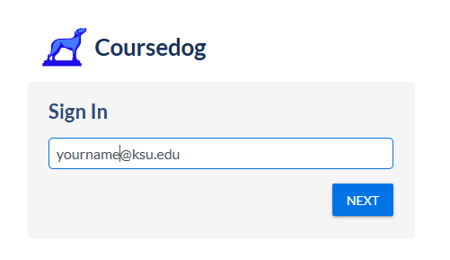

Step 2: You will then be redirected to the K-State login page, where you will enter your institution eID password.

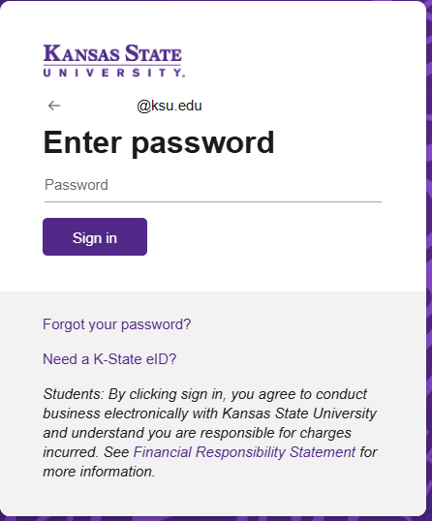

You will be taken to the Kansas State University Coursedog dashboard where you will see any modules/products assigned to your level of access.

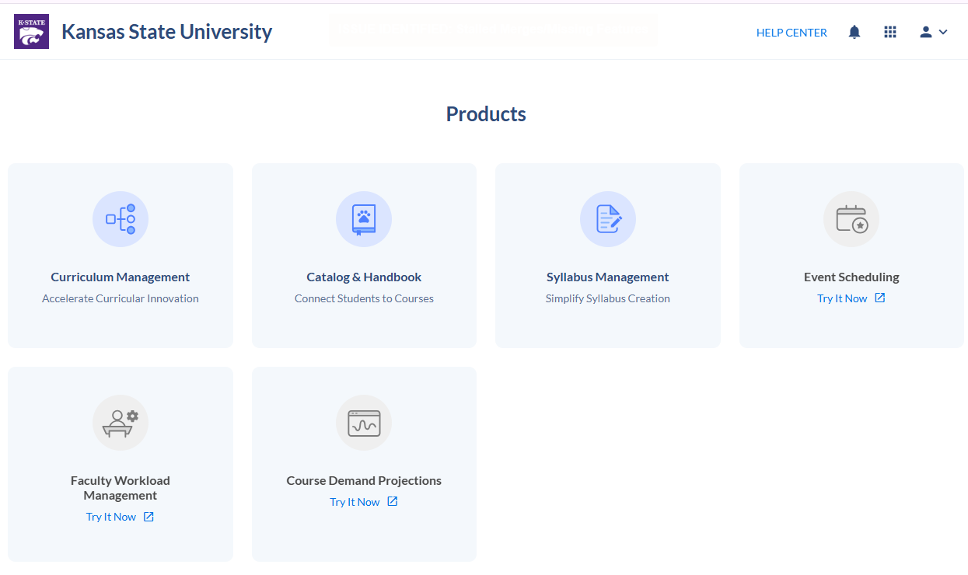

Logging Out
- To log out of Coursedog, click on the profile icon in the upper right-hand corner of your screen and select “Log Out”.
- If you are inactive for more than 24 hours, you will automatically be logged out of Coursedog.
