Coursedog: Edit Program Proposal 1
Editing Requirements 9
Editing Degree Maps 11
Submitting changes for: 15
To add a specialization (subplan) 15
To inactivate a specialization (subplan) 15
Add a Campus Location 15
Remove a Campus Location 15
Program Name Change only 15

Coursedog: Edit Program Proposal
Coursedog Curriculum End User Guide
- Login to Coursedog with ksu.edu email.
- Click on the Curriculum Management card. 
- Edit Proposal
You have two places where you can start a program proposal.
  - On the Home screen, click on + New Proposal on the right side of the screen under Actions.
  - On the particular program’s page, click on Propose Changes under the Actions menu on the right side of the screen.
This popup will appear for you to select the correct form to use for this proposal. Select Program Edit, then Submit.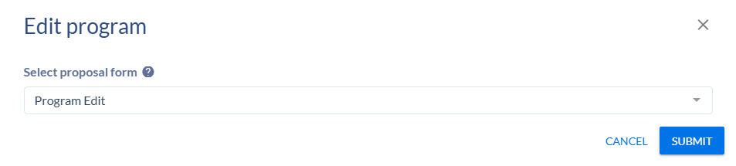If you started the proposal from the Home screen, you’ll get this popup where you can set the effective start term and search for the program. You can search by the academic plan code or the title of the program. If the program is offered at more than one campus, there will be multiple plan codes in the search. Select the primary location plan code (usually Manhattan campus). You don’t have to do an edit proposal for each campus plan code, only the primary one.
Note: If you’re searching by the program title, be aware that Associates degree plan codes start with an A, Bachelor’s degree plan codes start with a B, certificates with a C, doctorates with a D, Master’s with an M, etc. Be sure to select the correct program.
Click on Go to Form to start the proposal.
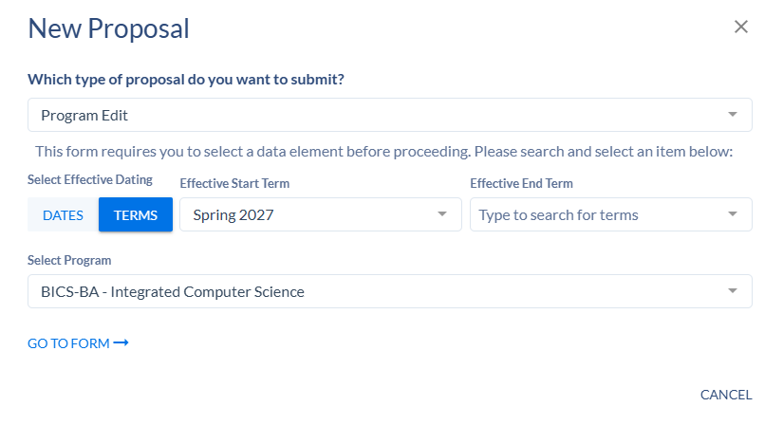

- Academic Plan Details
Fill in all required fields in this section:
- Contact Person – search for contact person in the box. You can enter more than one person.
- Contact Person email and telephone number
- Catalog Display Name
- Catalog Full Description – program description that is displayed in the catalog
- Program Type - select the appropriate program type from the dropdown list: Accelerated Degree Program, Associate, Bachelor, Certificate, Doctorate, etc.
- Academic Plan Description - This is the program title shortened (if necessary) to 30 characters.
- Effective Start Term - choose the term for the new program to start
- Effective Start Date – will fill automatically based on the start term
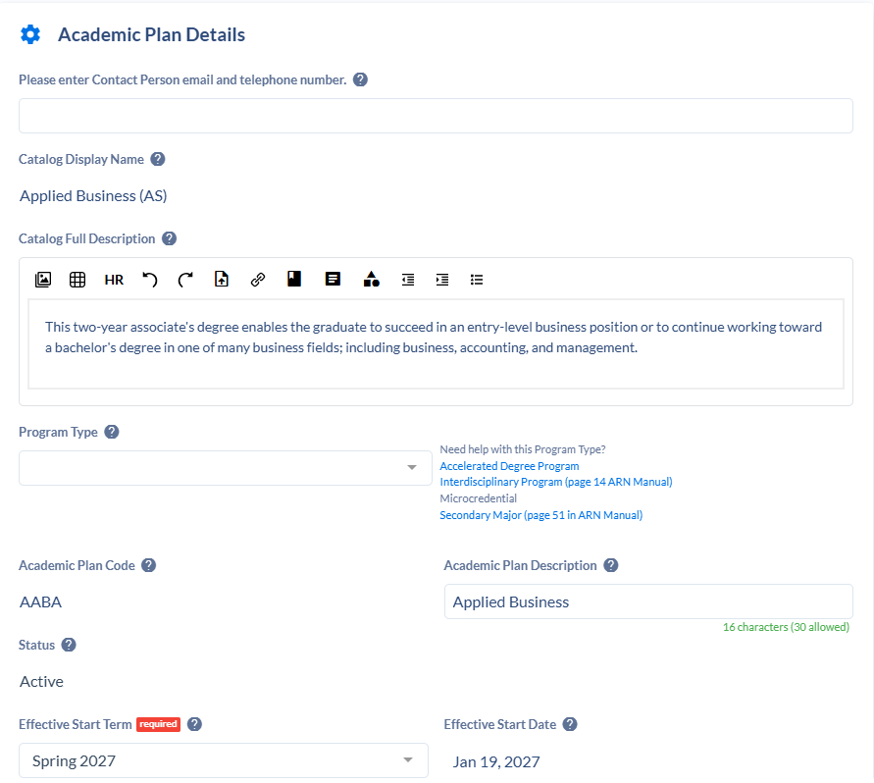
- Degree - KSIS degree code. Don’t select any of the historically used numerical codes, like 01, 20, 32, etc. Scroll down in the list to find BA, BS, BMED, MS, PHD, CERTGR, CERTUG, etc, or type the code.
- Academic Organization – multi-select field for the colleges/departments that own the program
- Academic Organization Ownership - multi-select field to indicate the percentage of ownership. Click on the + sign to edit academic organizations that have ownership in the program. Total percentage must add up to 100% and one organization must have a higher percentage than the others to be the primary owner. Use the minus sign to remove owners and Add Department to add additional lines.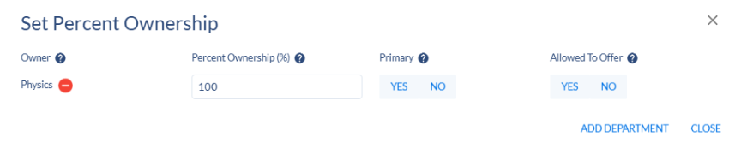
- Total Hours Required – enter the number of hours needed to complete the program. This can be a single number or a range, examples:120 for a bachelor’s degree, 12-15 for a certificate.
- New courses – list any new courses that are being proposed (in a separate Course New proposal) that will be a part of this program.
- Attachments/Supporting documentation
- Is a Transition Plan Required? - Yes or No
- Describe your Transition Plan – if you entered Yes to previous question, required: enter transition plan.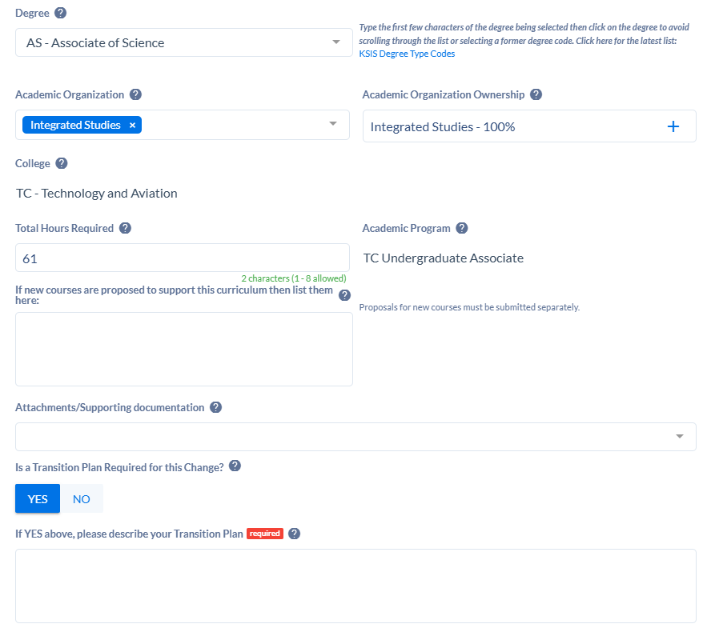
- Approval Type
- Is the Proposal eligible for Expedited Review? - Select all applicable answers from dropdown list. Select All of the above if all apply. Select No if none apply.
- Please select Approval Type – Expedited if All of the above was chosen above. Standard if not all the answers above are true.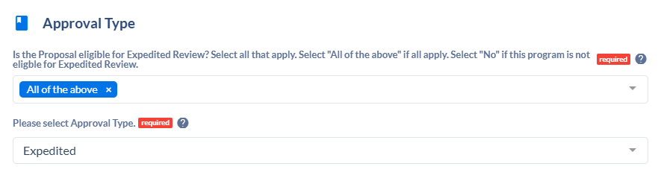
- Rationale and Impact
- Overview of what is changing – select all answers that apply from the dropdown list
- Provide a detailed list of what is changing. - Detail all changes to the program.
- Provide a rationale for the changes
- Provide information on how this might impact other departments or units...
- Upload correspondence here if applicable – attach emails between departments about program change impacts
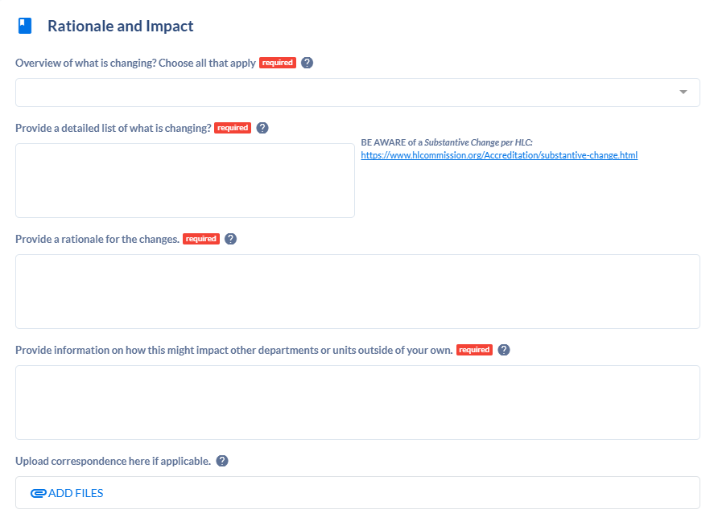
- Kansas Board of Regents
- KBOR Policy Manual – text box has a link to the KBOR Policy Manual for reference.
- KBOR Approval Required? - see the notes to decide whether to answer Yes or No.
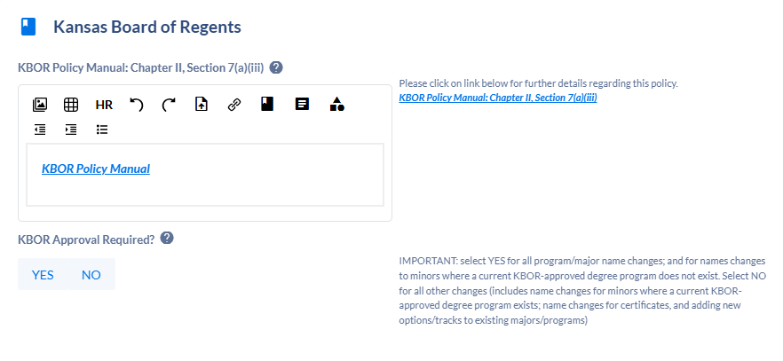
- Requirements
Program requirements can be edited in this card – adding, deleting, or changing courses or whole requirements, editing text entries, editing credit hours, and adding or removing subplan requirements.
See Editing Requirements section below for instructions on how to edit this card.

- Transcript and Diploma Print Options
Current transcript and diploma descriptions are listed in this card. They are not editable. If the program name is changed, curriculum staff will edit these fields.

- Campus Plan
- Campus Plan – Add or remove campus locations.
- Explain Campus Offerings
- Online Program Percentage – For an online program, enter the percentage of the program available online.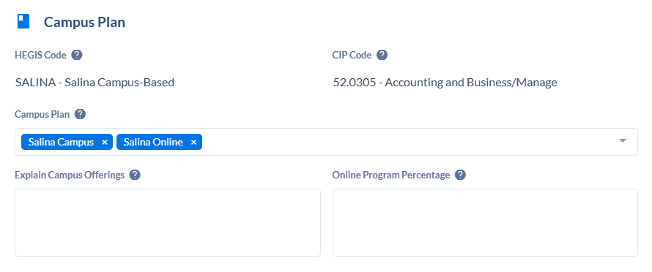
- Licensed Programs
Use this section to enter information for any program that leads to licensure. If the program doesn’t lead to licensure, select No for the “Does this program lead to licensure? question.
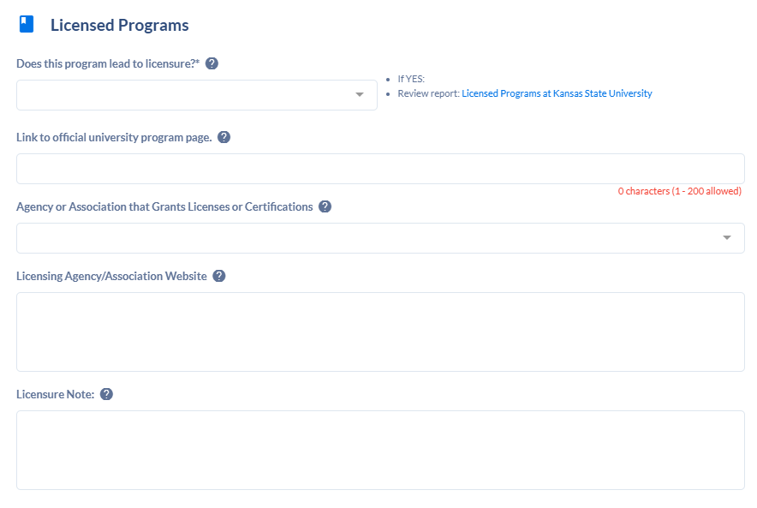
- Specializations
If adding a new subplan, enter it in this section. Click on + New Specialization to open the window. Complete all the required fields. Add additional specializations if needed.
You can edit an existing subplan, by selecting it and editing the fields.
If you want to discontinue a subplan, use the Program Discontinue form. Do not delete a specialization.
- Status – Set to Active for a new subplan.
- Effective Start Date – enter the date that the specialization will be active
- CIP Code – Search for CIP code in dropdown list
- HEGIS Code – Enter the HEGIS code for the campus location – MANHAT, ONLINE, SALINA, ONLSAL, OLATHE, or ONLOLT
- Transcript Description – Enter the name of the subplan
- Diploma Description – Enter the name of the subplan
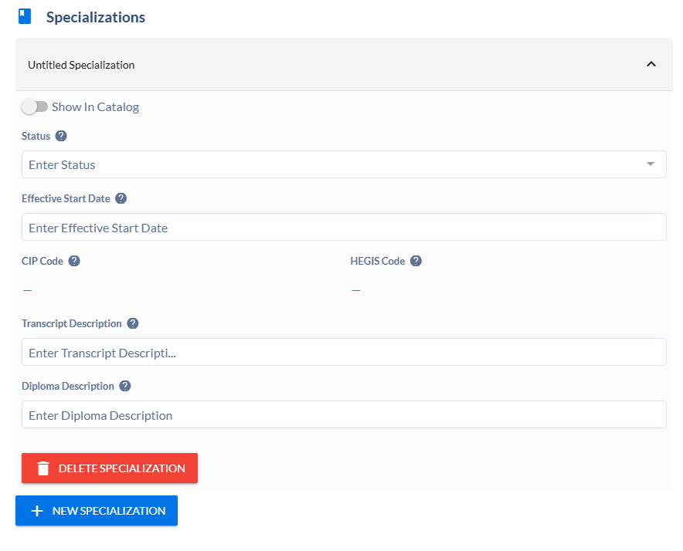

- Degree Maps
Use this card to edit the degree map or add a degree map for a new subplan. If there are specializations, there needs to be a degree map for each one. See the Editing Degree Maps section below for instructions on this section.
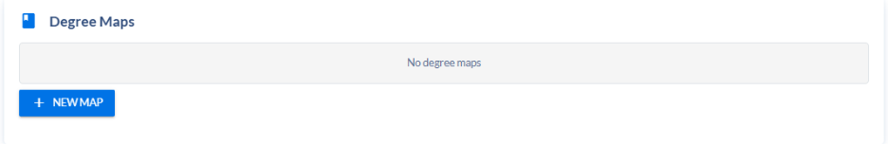
Actions
Under the Actions menu on the right side of the screen, there are 3 choices:
- Submit Proposal – submit the proposal and send it for approval.
- View Changes – a popup will appear showing all changes made in the program
- Delete Proposal – delete this proposal from the system
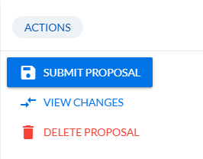

Editing Requirements
Text entries in WYSIWYG editor
To edit or add any entry in a WYSIWYG box, click inside the box and edit the text. These text editor boxes are in the requirement sections (Admission Requirements, Graduation Requirements, etc.) and in the requirement rules (Rule Description and Rule Notes).

Editing requirements
To edit any requirement, click on the requirement in the proposal to open it.
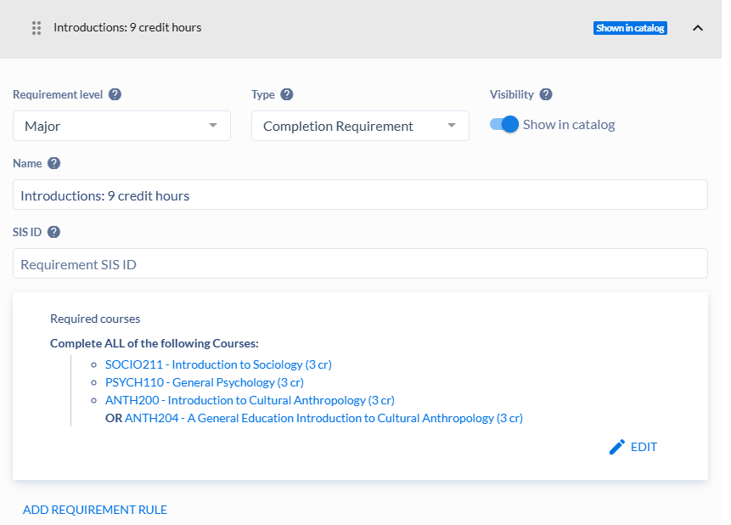
Edit the Requirement Name by clicking into that field and editing the text.
You can edit the existing requirement rule (ex. Required courses) by clicking on Edit in the rule or add a new rule by clicking on Add Requirement Rule.
Editing course lists
Click Edit in the requirement rule.
Delete a course – Click on the next to the course you want to delete.
Add a course – Search for the course by subject and number in the Select course search box. Click on the course to add it. Be sure to choose an Active course!
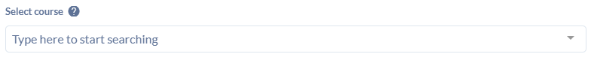AND or OR a course with one on the list – Click on the to add a course linking it to the existing course. Click on AND to toggle it to OR, if needed, then search for the course in the Select course box within that box.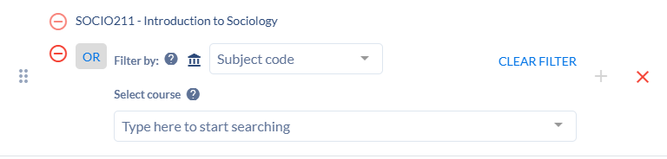
Removing a course that is AND’ed or OR’ed with another course – Click on the to the left of the course to remove it from the list.
Adding requirements
To add a new requirement, scroll down to the bottom of the Requirement card and click on . A new Untitled Requirement will appear right above. Please see the Adding Requirements document for instructions on how to complete adding a new requirement.

Editing Degree Maps
It’s helpful to have the current degree map open in the catalog when you’re editing the map in the proposal so you can see where the courses and other requirements are in the map. This makes it easier to find what you want to change during editing. Go to the program in the catalog and click on the degree map tab.
To edit the existing degree map, click on the degree map to open it.
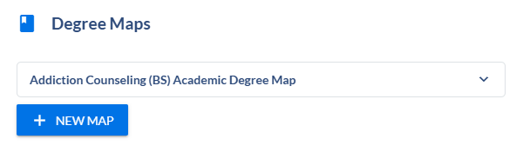
Click on the semester of the requirement that you want to change.
Click on the requirement that you want to change, then Edit. To remove the requirement from the map, click on Delete.
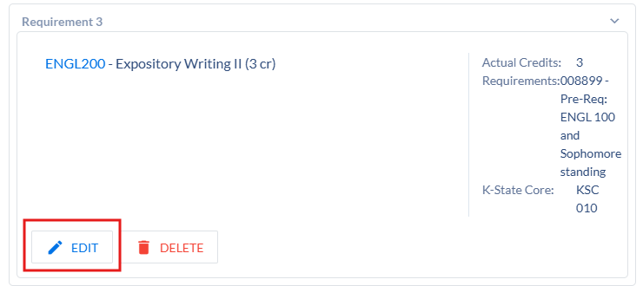
In the Edit Requirement box: 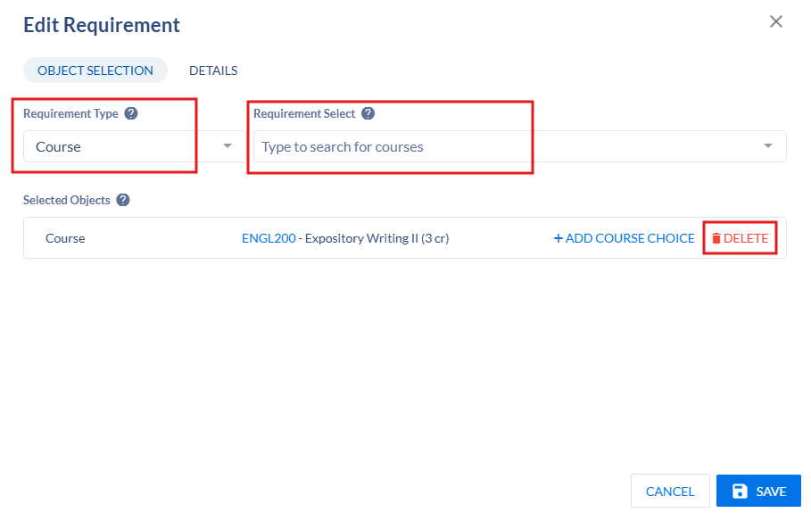
Delete the entry under Selected Objects, then:
- To change to a different course: search for the new course in the Requirement Select box and click on it to add it.
- To change to a text entry: change Requirement Type to Generic and type the text in the Requirement Select box. Click Add.
- To change to a course set (K-State bucket course list): change Requirement Type to Couse Set, search for the course set in the Requirement Select box (i.e., “K-State Core Communication”) and click on the course set to add it.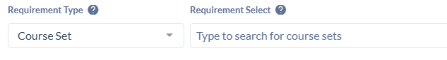
Click on the Details tab to:
- Enter a K-State Core tag or remove one if no longer needed.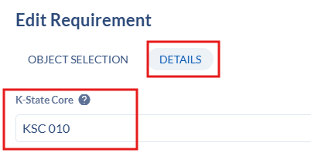
- Adjust the credit hours, if needed. Click in the Actual Credits box, then you can click Reset to pull in the default hours for a course, or you can type in the credit hours in the Min and Max boxes. Credit hours will have to be adjusted when a course has a range of credit hours or when a course set is used, so the correct number of hours are calculated for the semester total. Close the Edit Range box after adjusting the hours.
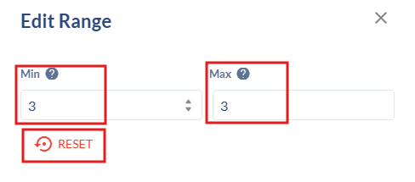

Click Save to save your changes.

You can add additional requirements to a semester by clicking on New Requirement, click on the added requirement, and then Edit. Follow the steps above to add the requirement details.
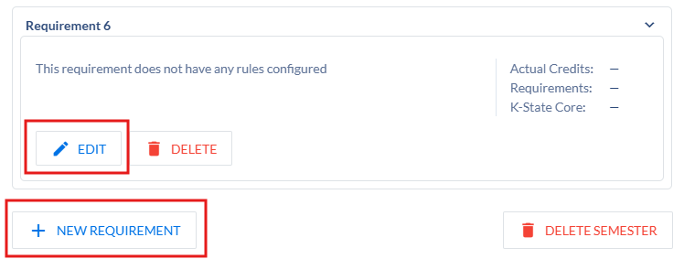
Verify that the semester totals and program total are correct. Adjust course hours if needed to have the correct totals. Semester totals are at the top of each semester. Program total is in the header area for the degree map. 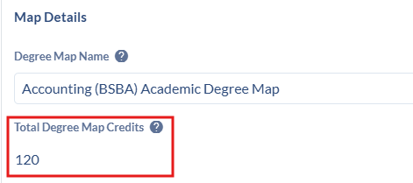

For a new specialization (subplan), you will need to add a new degree map for that specialization. Follow the Adding Degree Maps procedure.

Submitting changes for:

To add a specialization (subplan)
On the Specializations card,
- Click on + New Specialization 
- Select Show in Catalog
- Set Status to Active
- Enter the effective start date: January 1st, May 1st, or August 1st
- Select the HEGIS code: MANHAT, ONLINE, SALINA, ONLSAL, OLATHE, or ONLOLT
- Enter the Transcript Description: subplan title
- Enter the Diploma Description (if needed): subplan title
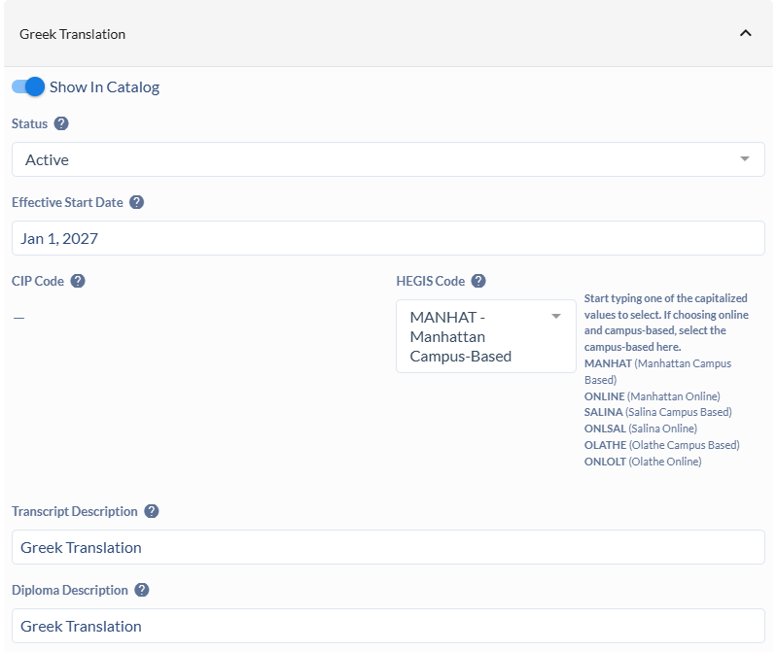

To inactivate a specialization (subplan)
On the Specializations card,
- Click on the specialization to open it.
- Unselect Show in Catalog.
- Change the Status to Inactive.
- Enter the Effective Start Date
- Do NOT click on Delete Specialization. 
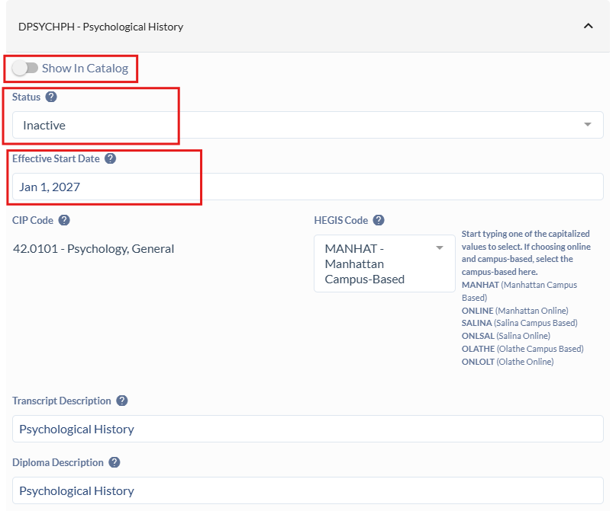

Add a Campus Location
Do a Program Edit proposal on the primary campus location program (i.e. if the program has Manhattan campus and an Online program, select the Manhattan campus program).
On the Campus Plan card,
- Add the new Campus location in the Campus Plan field. In this example, we are adding Salina Campus to the program.
- Enter information in the Explain Campus Offerings box
- Be sure to include some details about adding this location in the Rationale card.
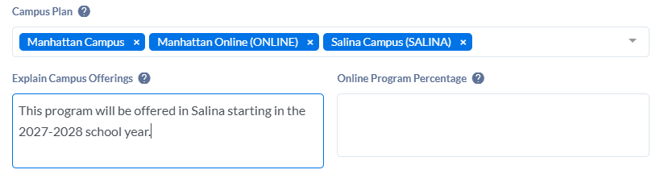

Remove a Campus Location
Do a Program Edit proposal on the primary campus location program (i.e. if the program has Manhattan campus and an Online program, select the Manhattan campus program).
On the Campus Plan card,
- In the Campus Plan field, click on the X on the campus location that you are removing to remove it from the list. In this example, Manhattan Online has been removed.
- Enter an explanation in the Explain Campus Offerings box.
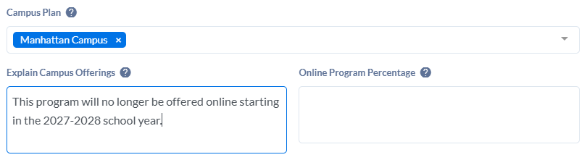

Program Name Change only
For a program name change that does not involve a curriculum change, use a Program Edit proposal form and change the name in the Catalog Display Name field. Enter information about the name change in the Rationale.
Approval Type must be Standard and KBOR Approval is required for all major name changes.

