Curriculum Specialization Deactivation User Guide

Table of Contents
Overview
Determining if a subplan is active or inactive
Discontinuing an active subplan

Overview
A subplan is an Emphasis, Track, Concentration, Option, or other specialization within a major. Subplans appear on the student transcript. Not all majors use subplans.
Subplan coursework requirements are created in Coursedog using the Program Requirements Builder Card. The Specialization Details card displays all active and inactive subplans associated with a Program in PeopleSoft Campus Solutions. This guide provides instructions for entering data on the Specialization Details card.

How to determine if a subplan is active or inactive
- On the Programs page, select the program you wish to review.
- Scroll to the Program Specialization card.
- Click the down arrow to expand the specializations/subplan details.
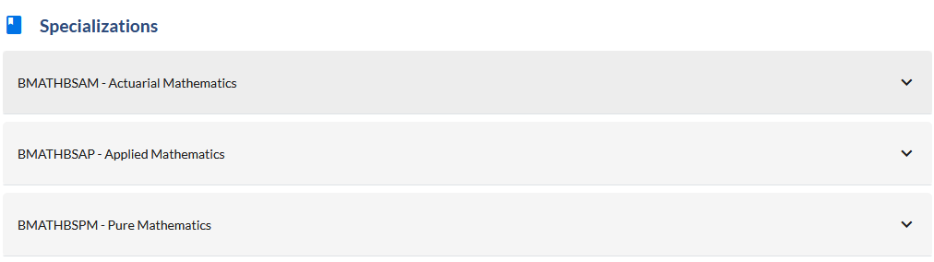
- Look for Status field. Field will display “Active” or “Inactive”.
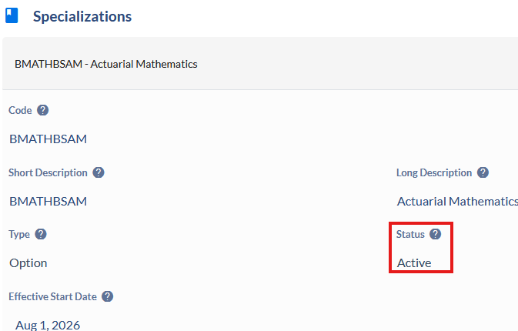

Deactivating an active subplan
- On the Programs page, select the program you wish to update a subplan on.
- Select Propose Changes.
- Select the Program Edit form and then click Submit.
- Enter the Effective Start Term on the Academic Plan Details card for this change to the program.
- Select Yes to the question Is a Transition Plan Required for this Change? and complete the following box with details about the transition plan.
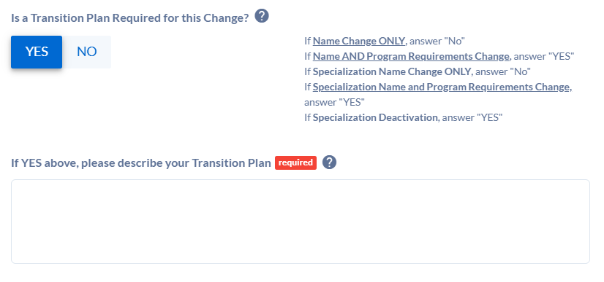
- Complete all required fields on the Rationale and Impact card. 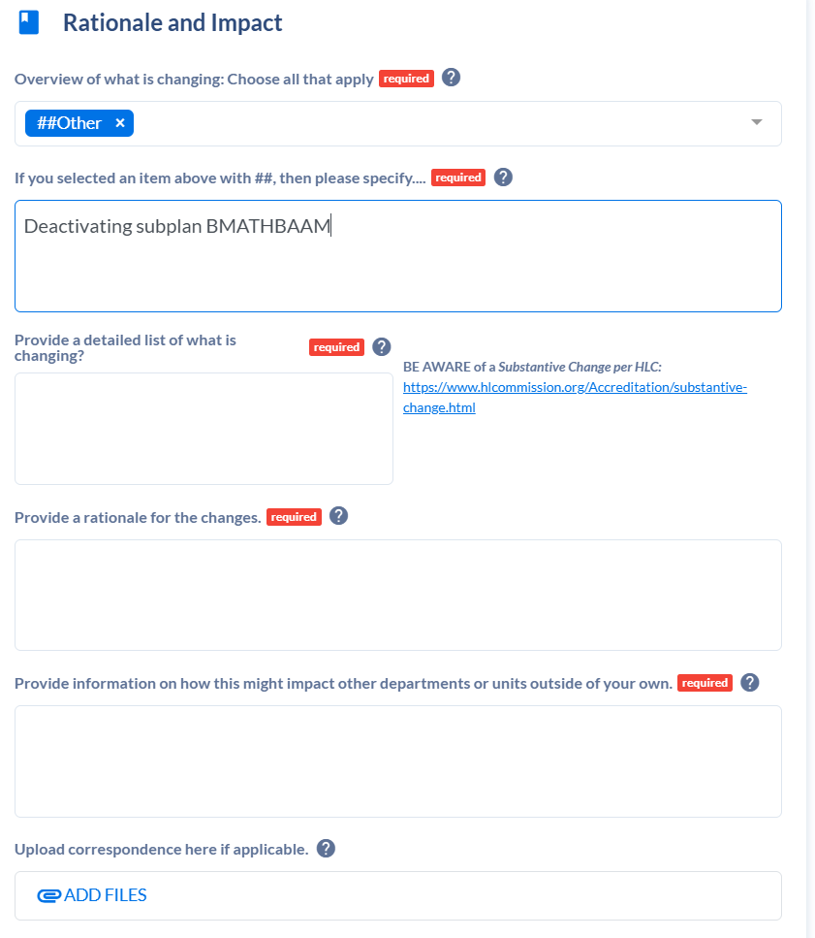
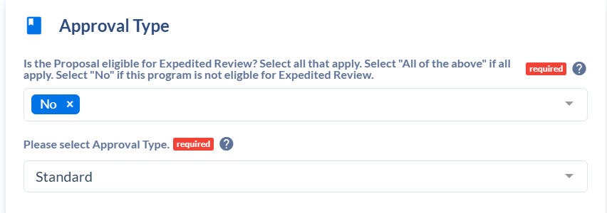
- On the Approval Type card, select No to the question Is the Proposal eligible for Expedited Review? The approval type will be set to Standard.

- Scroll to the Program Requirements card (Option: Click Requirements under Contents menu).
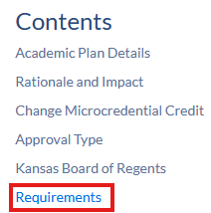
- Locate any requirements that relate to the subplan that will be deactivated. These requirements are usually found in the Subplan section of the Requirements card.

- Click Delete Requirement.

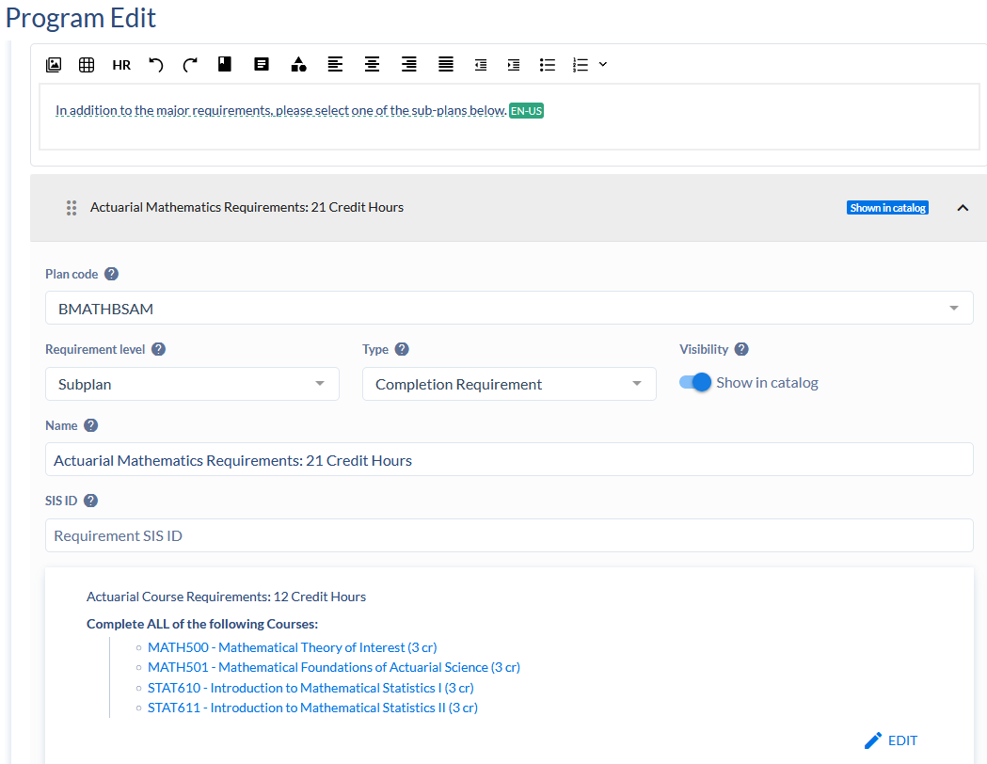
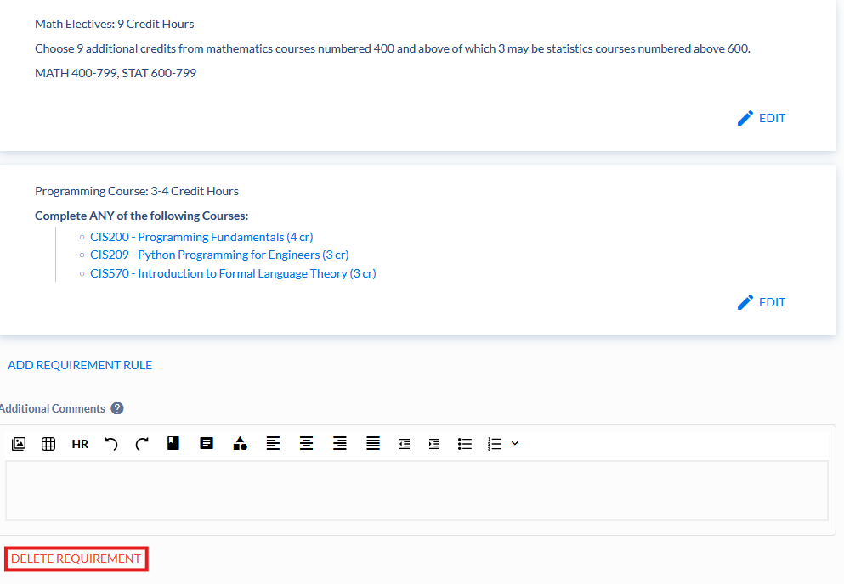
- If the program is a bachelor’s degree major, scroll to the Degree maps card. Open the subplan’s degree map. Click Delete Map.
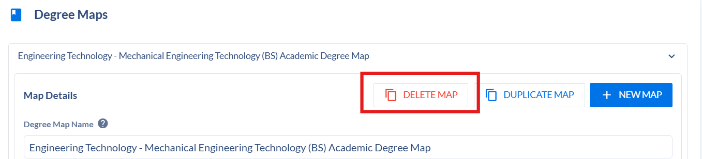
- Scroll to the Program Specializations card (Option: Click Specializations under Contents menu).

- Expand the subplan (specialization) you want to discontinue.

- Update Status field to Inactive.
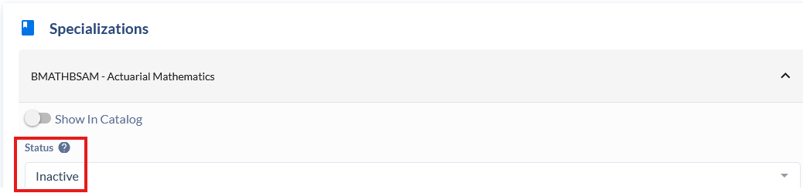
- Enter Effective Start Date.
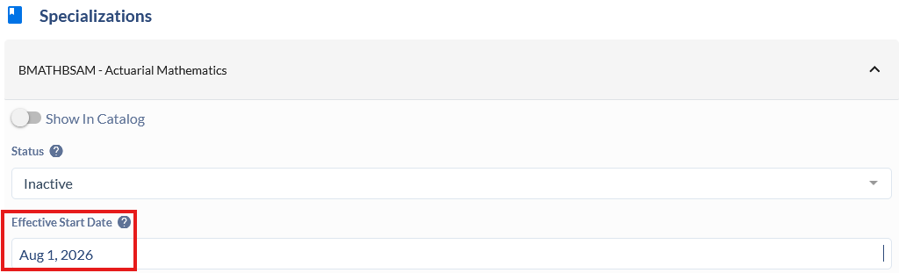
- Once you’ve entered all your updates, click Submit Proposal.
Notes:
- ONLY use the  IF you accidentally add a subplan.
- If you would like to deactivate (discontinue) an existing subplan, DO NOT use the Delete Specialization button. Instead, follow the instructions in the section: Deactivating an active subplan.

