Curriculum Program Deactivation User Guide
Table of Contents
Overview
How to determine if a program is active or inactive
Deactivation of a Program
Deactivation of a Program (All plan codes and locations)
Deactivation of Microcredential Credit

Overview
A program is defined as a major, minor, certificate, accelerated program. Subplans appear on the student transcript. Not all majors use subplans. When discontinuing a subplan and not the whole major, use the Curriculum Specialization User Guide.
Program coursework requirements are created in Coursedog using the Requirements builder card. The Coursedog Only Catalog Fields card displays all active and inactive programs in PeopleSoft Campus Solutions. This guide provides instructions for entering data on the Program Deactivation form.

How to determine if a program is active or inactive
- On the Programs page, select the program you wish to review.
- Look for Status field. Field will display “Active” or “Inactive”.
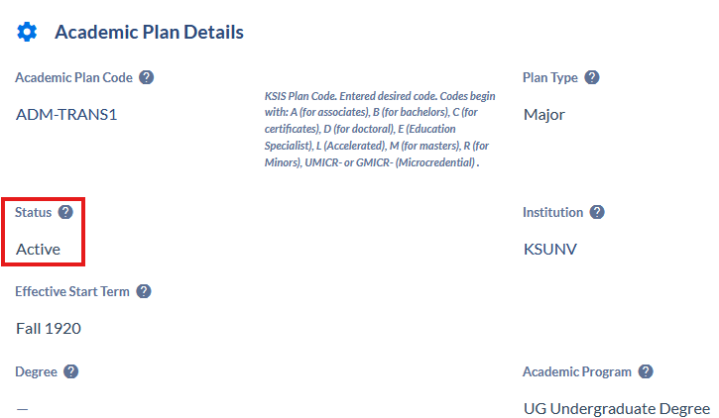

Deactivation of a Program
- Click PROPOSE CHANGES>Program Deactivation form>Submit.
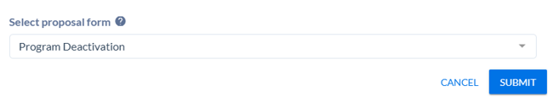
- Select the last term this program will be offered in the Last Term Offered field.

- Read the Deactivation Student Impact card for detailed information regarding number of future admitted students, currently enrolled, and eligible to enroll students along with a 5 year teach-out plan details.
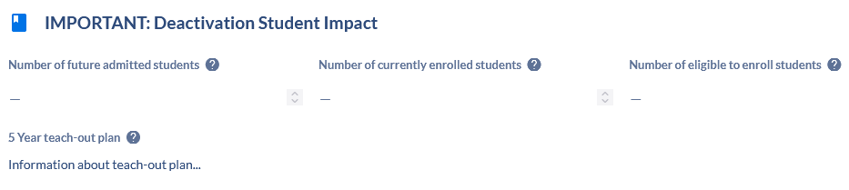
- Scroll down to Deactivation Details/Rationale and Impact card. Answer the following questions.
- What is being discontinued?
- Select the Reasons/Rationale for Deactivation of this program:
- Other reason for deactivation
- Provide detailed rationale for why the program is being deactivated.
- What Term Should Admissions Stop:
Note: This term should match the Last Term Offered.
- Upload any supporting documentation here.
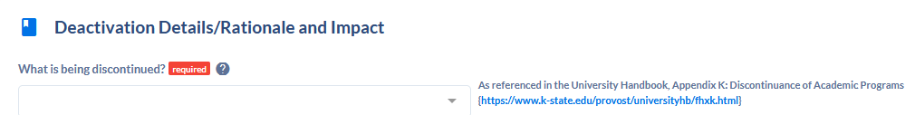
- Scroll down to HLC Teach-Out Plan – Kansas State University card. Fill out all required fields listed below:
- Overview and Triggering Circumstances
- Student Inventory and Completion Pathways
- Communication Plan
- Financial Aid, Accreditation, and Licensure
- Faculty and Staffing for Teach-Out
- Teach-Out Agreements. If not moving institutions enter “N/A”.
- Risk Assessment and Contingencies
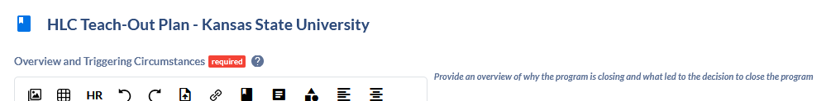

- Once you’ve entered all your updates, click Submit Proposal.

Deactivation of a Program (All plan codes and locations)
NOTE: Deactivation of all plan codes for a program requires a proposal to be submitted for each plan code.
- Follow Deactivation of a Program steps above.
- Continue steps 2-6 until you have submitted a proposal for every plan code.

Deactivation Microcredential Credit
- Follow steps 1-5 above.
- Scroll to Deactivation Microcredential Credit card. Answer all questions on card.
- Microcredential Level
- List the Program Link of the Original Approval of the Credit Microcredential:
- IF this is an interdisciplinary microcredential, then list multiple units here:
- Microcredential Description
- Reason for Deactivation
- Does the microcredential stack into an existing certificate or degree at K-State?
i. If “Yes”, answer If it stacks into a specific degree program, specify program name here:
ii. If “No”, answer next question.
- Enter transition/sunset plan:
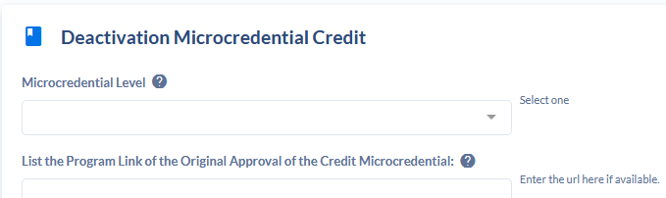
- Once you’ve entered all your updates, click Submit Proposal.

