Adding Program Requirements in Coursedog – New UI
- Start by adding a new requirement. Click on + New Requirement.

- Click on the Untitled Requirement to open it. It will open in full screen editing mode.
- Complete the following fields:
  - Requirement Name – enter a name for the requirement. Examples are: Required Courses: 21 credit hours, Program Requirements: 44 credit hours, Major Requirements: 35 credit hours
  - Requirement type – if you want a type to display in the catalog, select it from the dropdown list. Appropriate types for program requirements are: Completion Requirement and Recommended. Leave blank to have no requirement type display in the catalog.
  - Requirement level – select the requirement level
Admission Requirements – requirements specific to admission
Graduation Requirements – requirements specific to graduation
Program Requirements – for majors, requirements that are shared by across programs, for example K-State Core. Use this for programs like certificates and minors that do not have major requirements
Major – requirements specific to the major
Subplan – requirements specific to a given subplan (specialty) if any
Total Hours Required – to enter the total hours to complete the program
  - Visibility – turn on Displayed in Catalog
  - Comments (optional) – text entered in this box will appear in the catalog below all rules in the requirement.
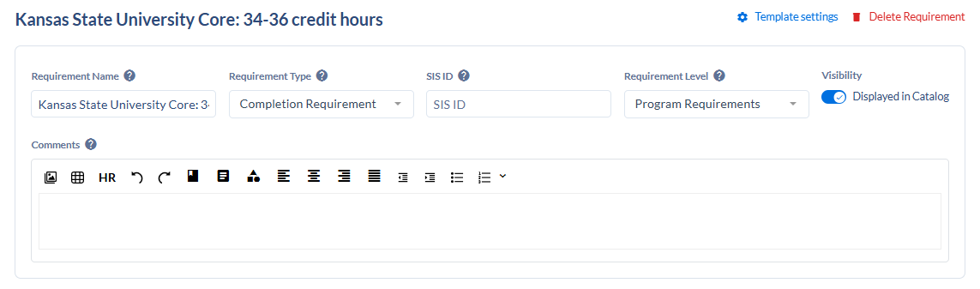
- Click on +Add requirement rule to begin adding course lists or requirement sets.


- Click in the new untitled rule to open the Edit Requirement Rule sidebar.


- Complete the following fields:
  - Rule name – enter a rule name like Required courses, Electives, etc.
  - Rule Description – any text that you want to display above course lists
  - Rule Condition – choose from the dropdown
  - Data Type – choose from the dropdown: Courses, Programs, or Requirement Sets (K-State Core only)
  - Requirement – search for courses, programs, or requirement set
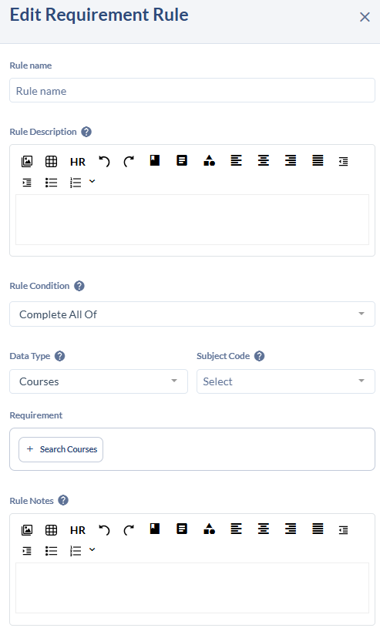
  - Rule Notes – any text that you want to display below course lists

- Click Update Requirement to save the rule. Sidebar will close.
- Credit Summary will update based on course lists. A sum will be calculated based on the credit hours listed on each course.
- On the Requirement screen, click Save Requirement.
For K-State Core requirement:
Rule name: General Education
Rule Description:
K-State Core is the foundation for an impactful life and career after time at K-State.
The K-State Core framework covers six disciplinary areas: English, Communications, Mathematics & Statistics, Natural & Physical Sciences, Social & Behavioral Sciences, and Arts and Humanities. In addition, a seventh area is reserved for institutionally designated use, which K-State is keeping as free electives. In total, the framework takes up 34-35 credit hours of 100 and 200-level coursework. Students who complete their general education elsewhere cannot be required to take additional general education coursework in the disciplinary areas of the framework without permission from KBOR to continue requiring courses in the K-State Core.
Rule Condition: Complete All Of
Data Type: Requirement Sets
Requirement: Search for K-State Core

Course lists:
- Search for courses in the Requirement box of the Edit Requirement Rule sidebar.
Caution: The system doesn’t show offering numbers for a course. If a course has multiple offerings, they will display all in one list. Select the first one in the list. It does show if a course is inactive, never select an inactive course.
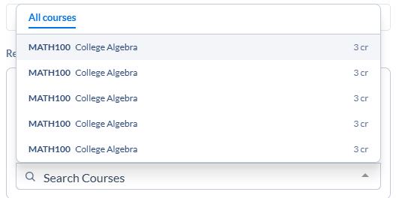
- Click on Search Courses to open the search box and add additional courses.
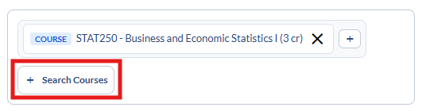
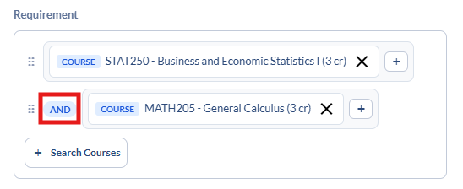
  - Courses will be AND’ed together when the Rule Condition is Complete All Of

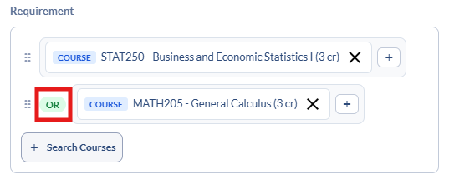
  - Courses will be OR’ed together when the Rule Condition is Complete Any Of

- To group courses together, click on the + symbol to the right of the course and then search for additional courses in the group within that box. Click on the white AND to change the grouping to an OR.
