Adding Degree Maps in Coursedog – New UI
- Start by adding a new degree map. Click on + New Degree Map. The degree map editor will open in full-screen mode.
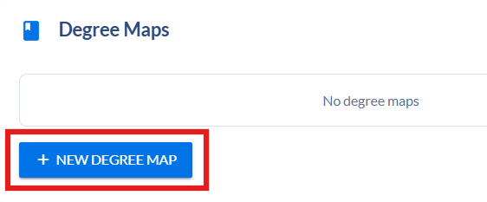
- Complete the following fields:
  - Degree Map Name – enter a name for the degree map. It should be the major followed by (BS) or (AA) and then “Academic Degree Map”. Example: Psychology (BS) Academic Degree Map. If this is for a subplan, add the subplan name after the major with a dash. Example: Agronomy – Range Management (BS) Academic Degree Map.
  - Visibility – turn on Displayed in Catalog
  - Degree Map Narrative – text entered in this box will appear in the catalog above the degree map.
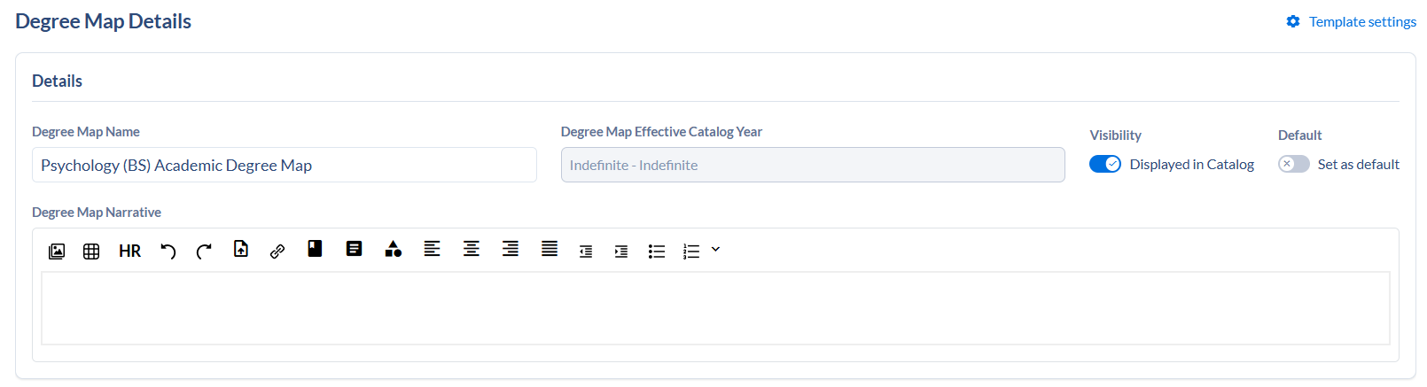
- Click on +Add year rule to begin adding years and semesters to the degree map.


- Click on Add requirement to add a course to the semester. An Add Requirement sidebar will open.

- Select the Requirement Type. The following are most commonly used:
  - Course – add a course
  - Course set – select a course set. Used for K-State core buckets.
  - Generic – to enter free text.
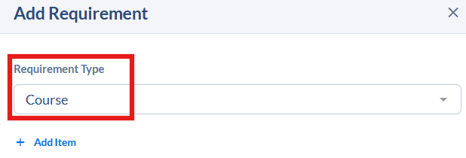

- Click Add Item to search for a course or course set or to add free text.
  - Course – click on Search Courses to find courses and select them from the list.
Caution: The system doesn’t show offering number or course status of active or inactive. If a course has multiple offerings or older inactive versions, they will display all in one list. Verify the course title and select the first correct one in the list.
  - Course Set – click on Search Course Sets and search for K-State Core. Select the appropriate course set.
  - Generic – enter free text in text box.

- To add another course, course set, or generic AND’ed with the first selection, search within the same item box. 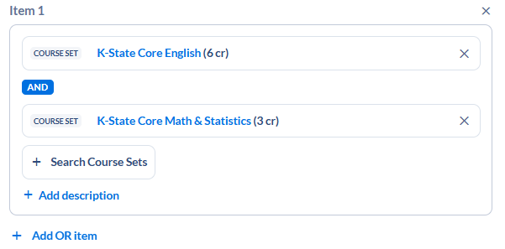
- To add another course, course set, or generic OR’ed with the first item, click on Add OR item. You can OR different requirement types. For example, you can OR a course with a course set or a generic text with a course.
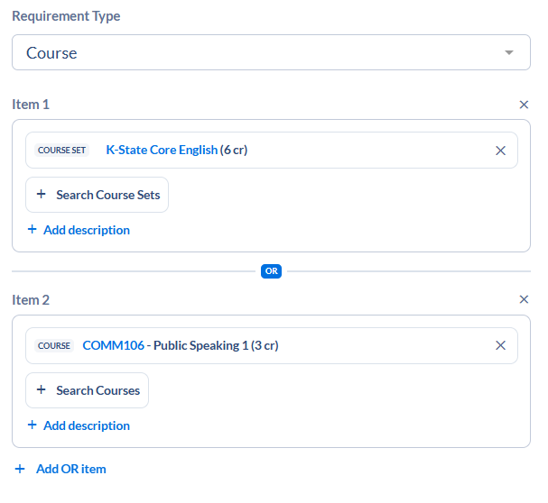
- Edit the Actual Credits, if needed, for variable credit courses so the semester, year, and 4-year totals are correct.
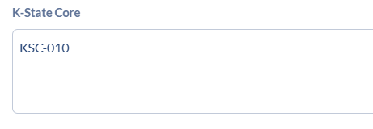
- To add a K-State Core tag to a course, course set or generic, enter the tag in the K-State Core box. Format for those tags should be KSC-010, KSC-020, KSC-030, etc.

- Click Add Requirement to save the rule. Sidebar will close.
- Continue adding requirements to the semester.
- Continue adding years and semesters to complete the degree map.
- Degree Map Credit Summary will update based on course lists. A sum will be calculated based on the credit hours listed on each course. Semester totals will show in the semester box.
- Requirements can be dragged to other locations within a semester or to a different semester.
- On the degree map editor screen, click Save Degree Map.

