Adding Program Requirements in Coursedog – New UI
- Start by adding narrative text for the ERG. Click on + Narrative Text.
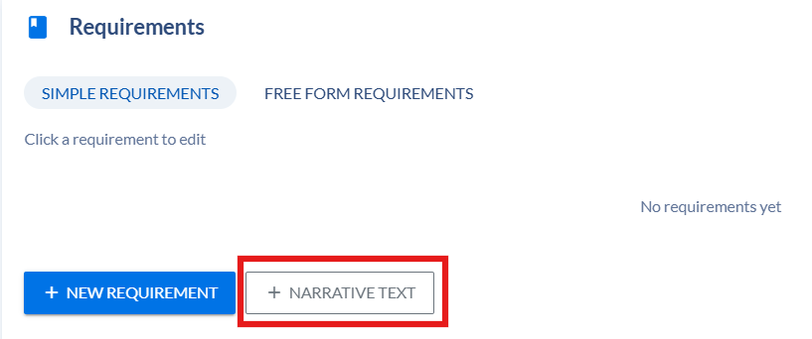
- Click on the Narrative Text added to open the full screen editor.
- Enter the text in the WYSIWYG box.
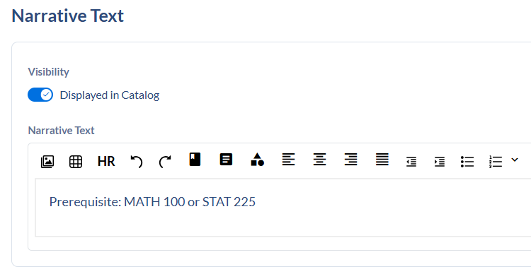
- Click Save Requirement. It will return to the proposal.
- Click on + New Requirement.

- Click on the Untitled Requirement to open it. It will open in full screen editing mode.
- Complete the following fields:
  - Requirement Name – enter a name for the requirement. Examples are: Prerequisite, Corequisite, Programs.
  - Requirement type – if you want a type to display in the catalog, select it from the dropdown list. Appropriate types for program requirements are: Prerequisite, Corequisite, Recommended, or Pre- or Corequisite. Leave blank to have no requirement type display in the catalog.
  - Visibility – turn on Displayed in Catalog
  - Comments – text entered in this box will appear in the catalog.
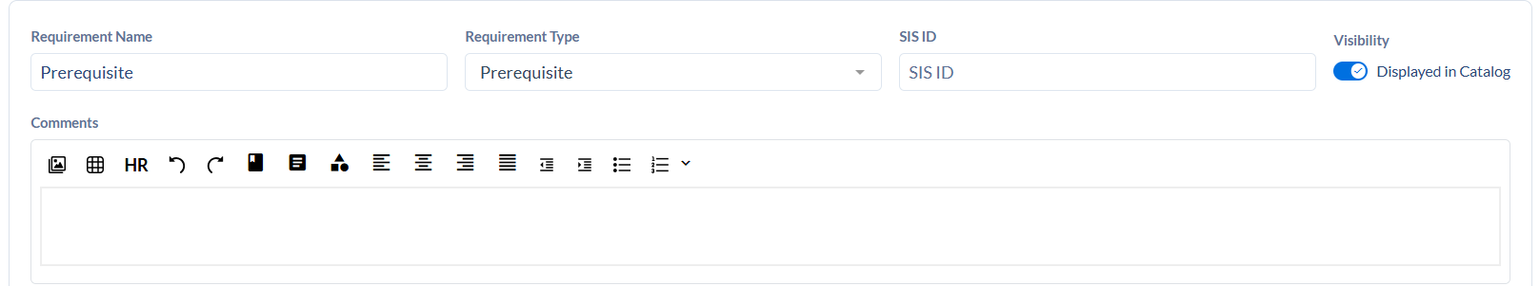
- Click on +Add requirement rule to begin adding course lists.


- Click in the new untitled rule to open the Edit Requirement Rule sidebar.


- Complete the following fields:
  - Rule name – leave blank
  - Rule Description – any text that you want to display above course lists
  - Rule Condition – choose from the dropdown
  - Data Type – choose from the dropdown: Courses, Programs, or Course Sets
  - Requirement – search for courses, programs, or course set
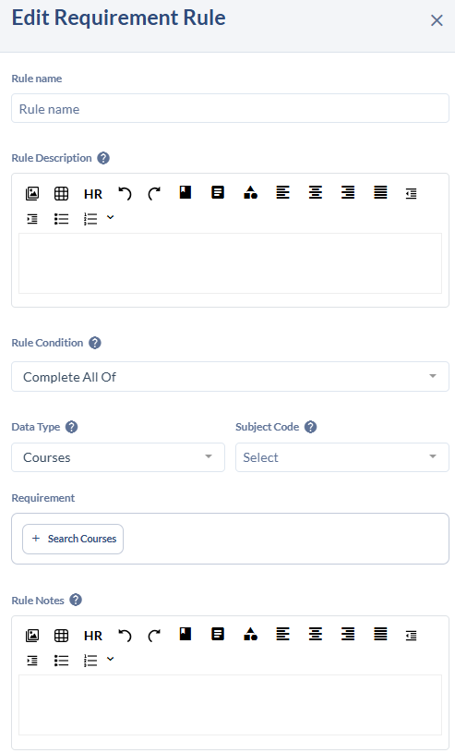
  - Rule Notes – any text that you want to display below course lists

- Click Update Requirement to save the rule. Sidebar will close.
- Credit Summary will update based on course lists. A sum will be calculated based on the credit hours listed on each course.
- On the Requirement screen, click Save Requirement.
Course lists:
- Search for courses in the Requirement box of the Edit Requirement Rule sidebar.
Caution: The system doesn’t show offering number for a course. If a course has multiple offerings, they will display all in one list. Select the first one in the list. It does show if a course is inactive, never select an inactive course.
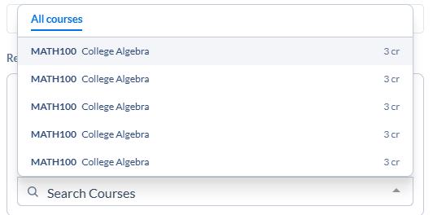
- Click on Search Courses to open the search box and add additional courses.
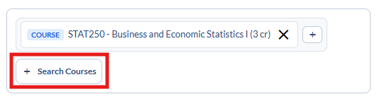
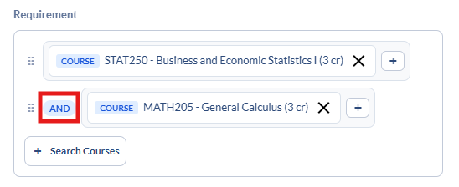
  - Courses will be AND’ed together when the Rule Condition is Complete All Of

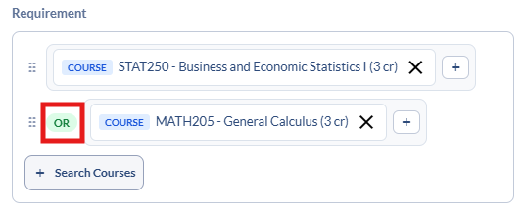
  - Courses will be OR’ed together when the Rule Condition is Complete Any Of

- To group courses together, click on the + symbol to the right of the course and then search for additional courses in the group within that box. Click on the white AND to change the grouping to an OR.
