Curriculum Plan PROCEDURE (NEW)
(Course picker)

Start proposal |
Click +New Proposal

Select Curriculum – New – Major v23.24
Curriculum – New – Minor v23.24
Curriculum – New – Certificate v23.24

Click Start Proposal
In Search box, Name = zTemplate
--may use wildcard *

Select catalog =
Source: Undergraduate programs: select 2023-2024 Undergraduate Catalog
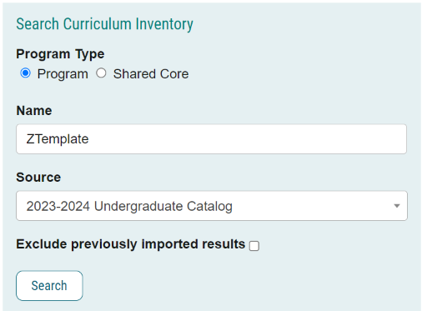

Click Search
Click
Click Build Proposal

OR

Select catalog =
For Graduate programs: select 2023-2024 Graduate Catalog
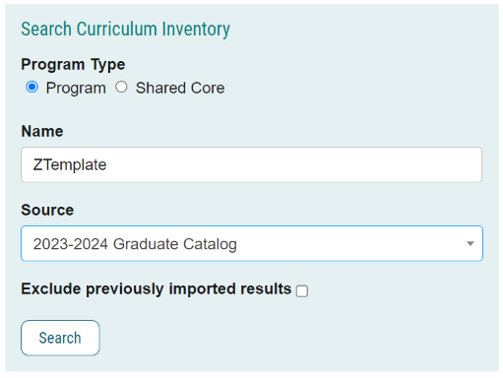
Click Search
Select for Undergraduate Templates:
- ZTemplate (BA) AS – only for use for College of Arts & Sciences Bachelor of Arts Majors
- ZTemplate (Bachelors)
- ZTemplate (BS) AS – only for use for College of Arts & Sciences Bachelor of Science Majors
- ZTemplate (Minor)
- ZTemplate (Undergraduate Certificate)
- Z Template Academic Degree Map

Select for Graduate Templates:
- ZTemplate (Accelerated)
- ZTemplate (Doctorate)
- ZTemplate (Graduate Certificate)
- ZTemplate (Masters)

Choose the template you are looking to launch and Click to Build the Proposal

Department |
Select the departmental owner of the program.
--If interdisciplinary, select the primary administrative owner.
--If “Kansas State University” is displayed, delete it and select the correct owner.
--Examples:
--Kinesiology (BS) | Accounting (BSBA) | English (BA)
--Agronomy (MS) | English (MA) | Chemistry (PHD) | Special Education (EDD
--Accelerated Finance (BS)/Personal Financial Planning (MS)

Program/Plan Name |
Replace “ZTemplate” with the name of the program
--Example: xxxx (BS)
Click Save All Changes

Curriculum Plan field: |
--three icons are available giving you viewing options:
1-View Curriculum Courses tab: displays all courses currently available in the program
2-View Curriculum Schema tab: displays all current cores within the program
3-Preview Curriculum button: pop-up window displays the current curriculum

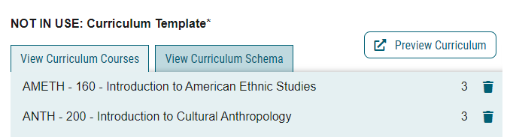

1-View Curriculum Courses tab: displays all courses currently available in the program |

--General Education/K-State Core courses are displayed by default
--Select/add ALL courses that will be used within the program
--suggested to add courses sorted by prefix for ease
--Once courses are added, assign to the appropriate core using the View Curriculum Schema module
--Courses deleted from cores should also be deleted here as well

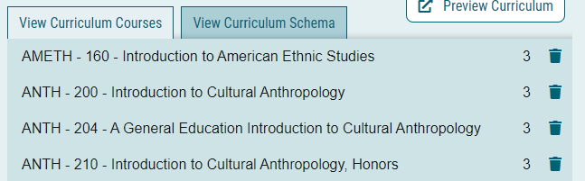

Import course (course currently in catalog)
In View Curriculum Courses, click Import Course
A new window will open: Import Data Into Your Proposal
Select [catalog]
--2023-2024 Undergraduate Catalog (for undergraduate programs)
--2023-2024 Graduate Catalog (for graduate and accelerated programs)
In Filter Courses, click Or add filter, click dropdown, and select Prefix
Type [prefix ](i.e. ENTOM)
Click Search Available Curriculum

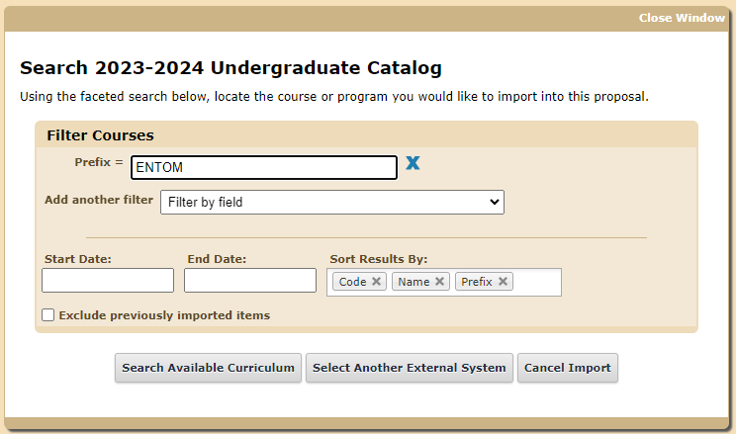

Search Results displays a list of courses
Select {courses}
--Scroll down or click Next to find courses
--Click on a course to select
--Courses turn YELLOW when selected
--Click again to de-select if one is mistakenly chosen
--multiple courses can be selected
Scroll to bottom to review Selected Courses.
Courses may be removed by hovering over the course and clicking the blue X to the right
Click Add Courses to Proposal
Click Save All Changes

Repeat to add all courses

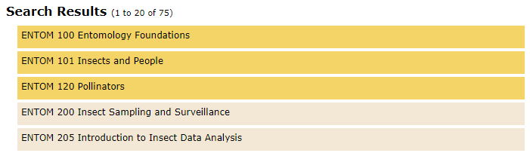

Add course (new course that is proposed but not currently in catalog)
Click Add Course
Enter Prefix
Enter Code: {course number}
Enter Name: use format = **NEW COURSE {title of course} (X credits)
Click Add Course
Click Save All Changes

Note: once the new course is approved and added to the catalog, and prior to importing this program into the catalog, this placeholder course must be replaced by the imported course

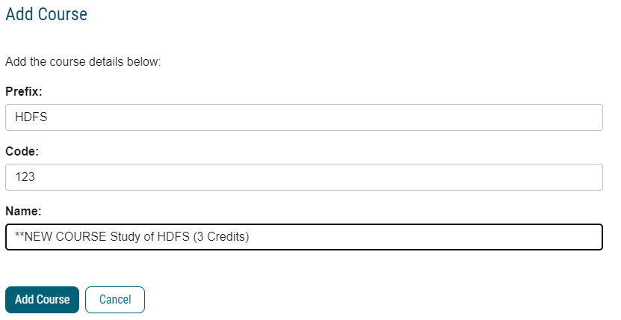

Delete course
Click Trash icon
Click Save All Changes

2-View Curriculum Schema tab: displays all current cores within the program. |

What it does:
--Click on the core/sub-core name once to expand
--This view allows you to:
--view/edit core title and core description (optional)
--view/edit courses associated with the core
--add courses (must first add the courses using “View Curriculum Courses”)
--delete courses (click Trash icon)
--move courses within core using drag/drop
--move courses between cores (using the Add Courses button)
--add custom text

Kansas State University Core
K-State Core requirements and course lists are automatically included in the template
No updates are required in this requirement
If desired, click down-arrow to expand requirement and view courses

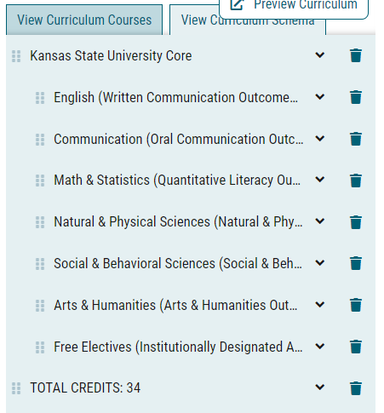

Title
Three Program Requirements (for college requirements) and three Programs (for Major Requirements) shells are provided in the initial template:
--Ex: “Title 1: X Credit Hours”
--adjust as necessary to fit your program
--Add “Required General Education Courses” shells??

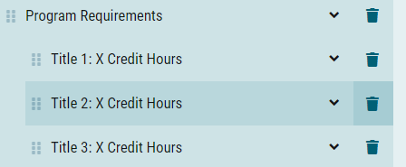

Click on a sub-requirement to expand the entry area
Replace “Title 1, Title 2, Title 3” with {name of requirement}
Replace “X” with {number of credit hours}
--Ex: Entomology Requirements: 11 Credits
Click Save All Changes

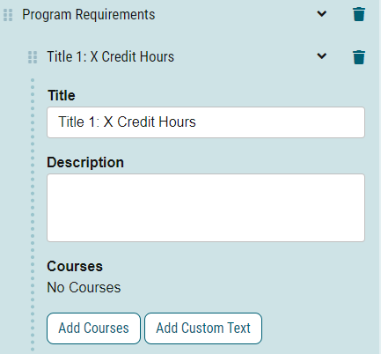

Description (OPTIONAL)
Enter instructions that pertains to whole requirement.
Examples:
“Select 4 credits from:”
“Select 2 courses from:”
“Select from:”
Click Save All Changes

Is this even needed if credits is in title and there are no further instructions?????
This description should be utilized if further explanation (beyond the title) of the nature of the grouping, or if there are additional requirements that coincide directly with this grouping of courses are desired.

Courses
--Add courses that have been added under the “View Curriculum Courses” tab
Click Add Courses
Select {courses}
--Courses turn blue when selected
--Click again to de-select if one is chosen mistakenly
Click Add Course

Courses added to the bottom of the core, and sorted by course number by default
To move a course, click and drag it to the desired location

Click Save All Changes

To group courses or include “and/or” situations
COMING SOON: Each Requirement template will include some blank, AND and OR and (GE) rows for use in your requirements
Delete those which are not needed
Add more, if needed
Drag and drop where needed to clarify the requirements

Click Add Custom Text

Name (required, will not display on the gateway) = Blank
Insert a blank line: Position = After
Click Add Text

Name = Or
Insert a blank line: Position = Before,
Rich text box = OR (in caps and bold)
Click Add Text

Name = And
Insert a blank line: Position = Before,
Rich text box = AND (in caps and bold)
Click Add Text

Name = Blank
Insert a blank line: Position = After, click Add Text

Click and drag text to the desired location(s) to clarify the meaning of the requirement

Click Save All Changes

Examples:
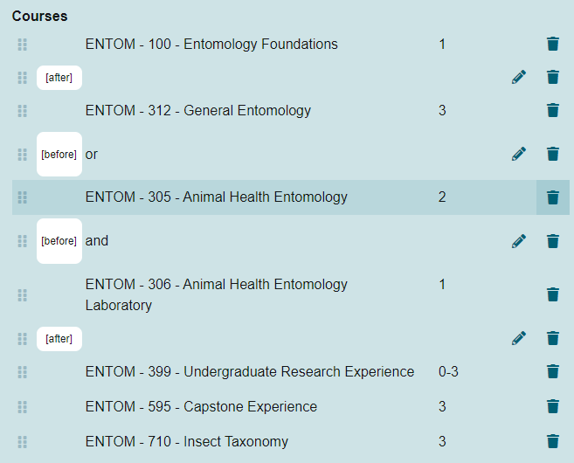

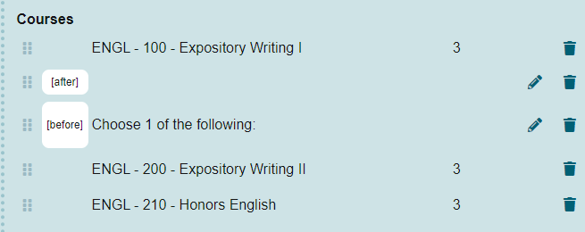

To Add Custom Text
Whether editing or adding courses within a core, you have the option to Add Custom Text.
Custom text is text that provides clarification for options between courses, etc.
You must add a course before you may add custom text
--if no courses are selected in this requirement,

Examples of custom text:
o “or” when able to choose between two or more courses,
o “Select one course from the following:” before a list of courses
o other text
o footnotes
o BIOCH***
o ENTOM 400 or above

Note: If custom text is used to only describe a single requirement, then the Requirement “Description” field can be used instead.

Click Add Custom Text

Name (required, will not display on the gateway) = {give it a name}
Insert a blank line: Position = After, click Add Text
Rich text box = {enter text here}
Click Add Text

Click and drag text to the desired location(s) to clarify the meaning of the requirement

Click Save All Changes

To Indent a Requirement
Click and drag text right/left to the desired location(s) to indent and clarify the meaning of the requirement
Click Save All Changes

Add a Core
If you need additional requirements than provided in the template:
• In View Curriculum Schema, click Add Core.
• You will see a new row added to the end of the list titled New Core.
• Click once on New Core and type in the title, and description (optional).
• You can then add courses to this core, as referenced above.
Drag and drop the new core to the desired location

Delete course
Also remember to delete from “View Curriculum courses” view

Delete Core
Delete any unused requirement shells, if needed

Click Delete Core from Proposal icon to right (trash can icon)
Click Delete Core
Click Save All Changes

3-Preview Curriculum button: pop-up window displays the current curriculum |
(catalog view)
--good place to ensure credits add up to 120
--This view does not allow editing; click View Curriculum Schema tab to edit

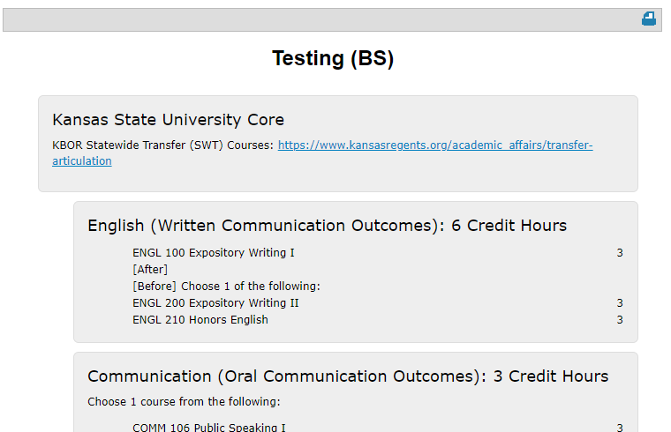

Show Curriculum Preview with Markup
--pop-up window displays the current curriculum in catalog view
--review for accuracy
--Make sure that ALL credit hours add up to the appropriate total (include all categories such as K-State Core Requirements, Program Requirements, Programs/Major Requirements)
--Once a proposal is launched, clicking the red pencil icon allows users to view mark-up reflecting changes in the curriculum

Example for CHANGE proposals:

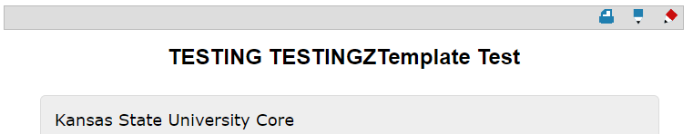
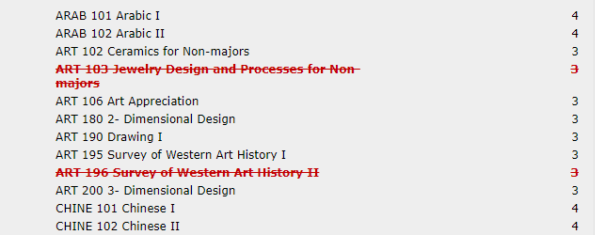

Status
Change “Active-Hidden” to “Active”

Launch proposal
Click the Launch and Validate Proposal icon

Submit “Academic Degree Map” proposal
REMEMBER: If you are creating a new bachelor’s program, as required by the new K-State Core general education, you must also submit a separate proposal in Curriculog to create the Academic Degree Map

Click +New Proposal
Select Curriculum – New – Major – Academic Degree Map
Click Start Proposal
In Search box, Name = zTemplate
--may use wildcard *
Select catalog =
For Undergraduate programs: select 2023-2024 Undergraduate Catalog
Click Search
Select ZTemplate Academic Degree Map
Click
Click Build Proposal

Use the “Academic Degree Map” section to select your degree map requirements
This section works similar to the “Curriculum Plan” section above

