Disposable Masks

- The disposable mask should fit snugly against the face
- When removing it DO NOT touch your eyes, nose, mouth or the inside of the mask
- Wash hands immediately after removal
- The disposable mask should be thrown away after every use or at the end of the work day
- Disposable masks are not PPE and will not prevent you from becoming infected
- Disposable masks are used to prevent asymptomatic carriers from spreading virus to others

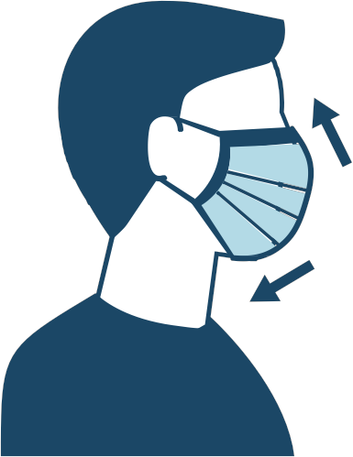

Disposable Masks

- The disposable mask should fit snugly against the face
- When removing it DO NOT touch your eyes, nose, mouth or the inside of the mask
- Wash hands immediately after removal
- The disposable mask should be thrown away after every use or at the end of the work day
- Disposable masks are not PPE and will not prevent you from becoming infected
- Disposable masks are used to prevent asymptomatic carriers from spreading virus to others

