Cloth Face Coverings

- The cloth face covering should fit snugly against the face
- When removing it DO NOT touch your eyes, nose, mouth or the inside of the cloth face covering
- Wash hands immediately after removal
- The cloth face covering should be washed after every use with soap and hot water
- Cloth face covering are not PPE and will not prevent you from becoming infected
- Cloth face covering are used to prevent asymptomatic carriers from spreading virus to others

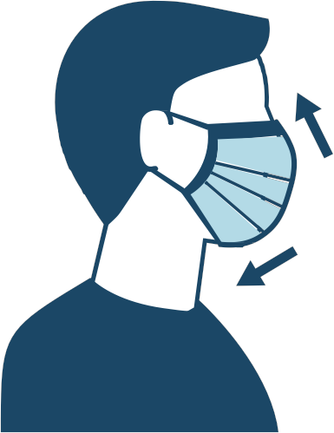

Cloth Face Coverings

- The cloth face covering should fit snugly against the face
- When removing it DO NOT touch your eyes, nose, mouth or the inside of the cloth face covering
- Wash hands immediately after removal
- The cloth face covering should be washed after every use with soap and hot water
- Cloth face covering are not PPE and will not prevent you from becoming infected
- Cloth face covering are used to prevent asymptomatic carriers from spreading virus to others

