Mood Management

Student Workbook

Adapted from Drexel University Counseling Center
Kansas State Counseling and Psychological Services
785-532-6927

Table of Contents

Welcome Page 3

Frequently Asked Questions Page 4

In Session Worksheets Page 5

Session 1: Introduction & Mindfulness Page 6

Introduction to Mindfulness Page 7

The “What” and “How” of Mindfulness Page 8

Mindfulness Exercises Pages 9-10

Session 1 Homework Assignment Page 11

Session 2: Emotion Regulation Page 12

Homework Review Page 13

Goals of Emotion Regulation Page 14

What Good Are Emotions? Page 15

Myths About Emotions Page 16

Model for Describing Emotions Page 17

Feelings Wheel Page 18

Emotion Regulation Skills Pages 19-21

Reducing Vulnerability to Negative Emotions Page 22

Session 2 Homework Assignment Page 23

Session 3: Distress Tolerance Page 24

Homework Review Page 25

Goals of Distress Tolerance Page 26

When to Use Distress Tolerance Skills Page 27

The Cost of Old Coping Strategies Page 28

Distress Tolerance Skills Pages 29-31

Planning to Use Your Plan Page 32

Distress Tolerance Practice Log Page 33

Resources Page 34

Welcome!

Welcome to Mood Management, a three-session workshop series intended to help increase your understanding of emotions and develop strategies to help you cope when your emotions become distressing and hard to tolerate. The goal is to provide you with skills to recognize and manage symptoms you may be experiencing. We hope you find it helpful.

Many people pursue therapy with the idea that the therapist will be able to “fix” them. While Mood Management is designed to provide specific tools to better manage overwhelming emotions, it is also designed to help you get a better idea of how to apply these strategies to your own situation. In order to get the most out of Mood Management, it is important to attend all 3 sessions since the material from each week builds on the previous week’s topic.

These skills are a form of “mental health hygiene.” At the outset, you may question why you need to practice these skills so often. Think of it like dental hygiene—you brush your teeth multiple times a day to prevent the buildup of plaque and ultimately to prevent cavities. Like brushing your teeth, daily skill practice can help you regulate your emotions both on a regular basis and when emotions become overwhelming. The more you practice and use these skills as part of your daily routine, the less tedious they will be.

Even if we brush our teeth meticulously, some of us still get cavities. There is a parallel to Mood Management skills here too, since change is not linear and you may encounter obstacles, setbacks, and/or difficulties while learning and integrating these skills into your life. Try your best not to get discouraged if this happens. You wouldn’t stop brushing your teeth if you found out you had a cavity!

Should you wish to focus more in depth on any of your mood-related concerns, you may debrief with a therapist following completion of the Mood Management workshop series to discuss options.

If at any time you notice active suicidal thoughts, please let your Mood Management leader know or contact the Counseling and Psychological Services at 785-532-6927.

Frequently Asked Questions (FAQ)

What is Mood Management?
A three-session workshop series that focuses on mindfulness, emotion regulation and distress tolerance. It is designed to help people who want to gain a deeper understanding of their emotions and develop more tools to manage emotional distress.

Why does the workshop use a three-session model?
Three sessions allows you sufficient time to learn the concepts with time to practice between sessions. Keeping it to three 50-minute sessions allows you to find time in your busy schedule to learn these skills.

What if I need more than 3 weeks to learn the model?
You are not alone. The skills are difficult and take time to build. If you need more resources, we encourage you to follow-up with your referring clinician.

What if I don’t feel comfortable in groups?
Many people feel a little anxious about participating in a group. This workshop is structured and curriculum-driven, like a class. You are not required to speak if you do not feel comfortable doing so. The facilitators respect each participant’s right to share only what they are comfortable sharing and never require you to share sensitive or private information.

What if I have an urgent need to see a counselor during the seminar?
Simply let the workshop leader or Counseling and Psychological Services front desk staff know and they will facilitate you getting the help you need.

Why do I have to do homework?
The focus of this workshop is on building skills to use when you feel emotionally distressed; in order to achieve that goal, regular practice is essential. You will not be required to provide your responses out loud at any time. However, it’s important to bring your responses with you each week as you may be asked to look back or elaborate on a prior assignment during the workshop.

What if I didn’t do my homework?
We encourage you to come to group regardless. If you forget your workbook, we can provide you a new one. We can also assist you in working on examples when the homework is reviewed.

IN SESSION WORKSHEETS

SESSION 1: Introduction & Mindfulness
Introduction: Workshop Series Goal Setting
General goal:
To increase your understanding of your emotions and develop strategies to help you cope when they become overwhelming.
Specific goals:
Behaviors to Decrease:
- Emptiness; carelessness; being out of touch with yourself and with others
- Being judgmental of yourself or others
- Loneliness or conflicts in relationships
- Difficulty with change; difficulty accepting reality
- Mood swings; extreme emotions; acting based solely on your mood
- Impulsivity; risky behaviors; using drinking or drugs to cope; addiction
- _____________________________________________________________
- _____________________________________________________________
- _____________________________________________________________
Skills to Increase:
- Mindfulness skills
- Emotion regulation skills
- Distress tolerance skills

Introduction to Mindfulness
Goals of Mindfulness Practice
- Reduce suffering, pain, tension and stress
- Increase happiness and contentment
- Increase control of your mind, memory, and focus
- Experience reality as it is
- _____________________________________________________________
Mindfulness Definitions
What is mindfulness?
Mindfulness is intentionally directing our awareness of thoughts, feelings and senses to the present moment. In mindfulness, this is done nonjudgmentally and without attachment to the present moment. In other words, we refrain from evaluating or judging the current moment (as good, bad, stupid, etc.) and accept our thoughts, feelings and senses just as they are. We also attend to the awareness of each new moment without clinging to the past or thinking into the future.
How do I learn to practice mindfulness?
Mindfulness skills can be practiced anytime, anywhere and while doing anything. Intentionally paying attention to the moment without judgment or attachment is all that is needed, but it can be harder than it sounds. We will learn the “what” and “how” of practicing mindfulness in more depth during today’s session.
Meditation is a form of practicing mindfulness for a set period of time. During mindfulness meditation, we find a comfortable position to stand, sit or lay in and focus the mind on our breath, sensations, thoughts and emotions. There are many ways to practice mindfulness meditation depending on what we focus on.
Contemplative prayer is a spiritual mindfulness practice.
Mindfulness movement includes yoga, martial arts, and dance. Other forms of movement, such as walking, can serve to practice mindfulness as well.
The “What” and “How” of Mindfulness
What:
- Observe: notice the sensations in your body, notice thoughts come into your mind and pass by like clouds in the sky, observe outside of yourself; when you notice your attention drifting, gently bring yourself back to the present moment
- Describe: focus on sensations to put words to your experience, label what you are observing, focus on stating facts as opposed to opinions or interpretations
- Participate: go with the flow, throw yourself completely into what you are doing or experiencing in the current moment, give your full attention
How:
- Nonjudgmentally: experience without evaluating as good or bad; acknowledge the difference between helpful and harmful or safe and dangerous, but don’t judge; if you find yourself judging, don’t judge your judging
- One-mindfully: pay attention to now, let go of distractions, concentrate and do one thing at a time
- Effectively: act skillfully, respectfully, with your goals in mind, and focus on what works (don’t let your emotions get in the way of being effective)

Journal Exercise – Focus on a Single Object:
Instructions: Use the “what” and “how” mindfulness skills to observe and describe an object.
___________________________________________________________________
___________________________________________________________________
___________________________________________________________________
___________________________________________________________________
___________________________________________________________________
___________________________________________________________________
___________________________________________________________________
Write about any reactions you had to the “Focus on a Single Object” exercise:
___________________________________________________________________
___________________________________________________________________
___________________________________________________________________
___________________________________________________________________
___________________________________________________________________
___________________________________________________________________

Mindful Moments Exercise:
Instructions: Take a look at some examples of ways you might try practicing the observe, describe and participate skills. Then, come up with 3 additional ways you might practice them yourself.
Observe
- Pay attention to your breathing, nothing else, just breathing in and out.
- Notice the sounds around you. What can you hear right now?
- Notice what you can feel (e.g. the feeling of your clothes, the air on your skin, your body’s contact with the floor or the chair you are sitting in).
- Fully immerse yourself when you take a bite while eating. What are the flavors, textures, temperature of what you are eating?
- _____________________________________________________________
- _____________________________________________________________

Describe
- Practice describing one of your belongings or an object you found in nature.
- Describe as you observe yourself breathing by repeating “I am inhaling, I am exhaling” while you breathe.
- Describe what a person has done or is doing right now. Be very specific and try to avoid judging, making assumptions, or commenting on things that are not truly observable in that moment.
- Describe your feelings and associated thoughts: “I feel X, and my thoughts are Y.”
- _____________________________________________________________
- _____________________________________________________________

Participate
- Dance to music.
- Throw yourself into fully listening to what another person is saying.
- Sing along to music you are listening to.
- While walking, focus only on walking.
- _____________________________________________________________
- _____________________________________________________________

Homework: Mindfulness Practice

Write about one situation each day that prompted you to practice mindfulness.

Day: | Situation (who, what, where, when): | Check off skills used: | Describe your experience using the skills: | Check if your practice contributed to the following:
Monday |  | - Observe  - Describe  - Participate  - Nonjudgmentally  - One-mindfully  - Effectively |  | - Reduced suffering  - Increased happiness  - Increased focus  - Increased living in the present  - Other:____________
Tuesday |  | - Observe  - Describe  - Participate  - Nonjudgmentally  - One-mindfully  - Effectively |  | - Reduced suffering  - Increased happiness  - Increased focus  - Increased living in the present  - Other:____________
Wednesday |  | - Observe  - Describe  - Participate  - Nonjudgmentally  - One-mindfully  - Effectively |  | - Reduced suffering  - Increased happiness  - Increased focus  - Increased living in the present  - Other:____________
Thursday |  | - Observe  - Describe  - Participate  - Nonjudgmentally  - One-mindfully  - Effectively |  | - Reduced suffering  - Increased happiness  - Increased focus  - Increased living in the present  - Other:____________
Friday |  | - Observe  - Describe  - Participate  - Nonjudgmentally  - One-mindfully  - Effectively |  | - Reduced suffering  - Increased happiness  - Increased focus  - Increased living in the present  - Other:____________
Saturday |  | - Observe  - Describe  - Participate  - Nonjudgmentally  - One-mindfully  - Effectively |  | - Reduced suffering  - Increased happiness  - Increased focus  - Increased living in the present  - Other:____________
Sunday |  | - Observe  - Describe  - Participate  - Nonjudgmentally  - One-mindfully  - Effectively |  | - Reduced suffering  - Increased happiness  - Increased focus  - Increased living in the present  - Other:____________

SESSION 2:
Emotion Regulation

Homework Review

If you practiced the homework, what strategies did you try? What did you observe? If you practiced these strategies more than once, what did you notice across practices?
___________________________________________________________________
___________________________________________________________________
___________________________________________________________________
___________________________________________________________________
___________________________________________________________________

If you did not practice the homework, what got in the way? If something got in the way, what could you do over the upcoming week to try to reduce this barrier?
___________________________________________________________________
___________________________________________________________________
___________________________________________________________________
___________________________________________________________________
___________________________________________________________________

Goals of Emotion Regulation

- Understand emotions and what they do for you
- Increase ability to identify (observe and describe) your emotions
- Stop unwanted emotions from starting in the first place
- Develop more understanding of unwanted emotions once they start
- Increase resilience and your ability to cope with strong emotions
- Increase positive emotions
- Reduce suffering when painful emotions overwhelm you
- Other:________________________________________________________

What Good Are Emotions?

EMOTIONS COMMUNICATE TO (AND INFLUENCE) OTHERS

- Facial expressions are a hard-wired part of emotions. Facial expressions communicate faster than words and may replace words.
- Our emotions are also communicated to others through language, voice tone, and body language.
- When it is important to communicate to others, or send them a message, it can be very hard for us to change our emotions.
- Whether we intend it or not, our communication of emotions influences others.

EMOTIONS ORGANIZE AND MOTIVATE ACTION

- Emotions motivate our behavior and prepare us for action. The action urge connected to specific emotions is often hard-wired.
- Emotions save time in getting us to act in important situations. This is especially useful when we don't have time to think everything through.
- Strong emotions help us overcome obstacles in our mind and in the environment.

EMOTIONS CAN BE SELF-VALIDATING

- Our emotional reactions to other people and to events can give us information about the situation. Emotions can be signals or alarms that something is happening.
- When this is carried to an extreme, emotions are treated as facts: "If I feel incompetent, I am." "If I get depressed when left alone, I shouldn't be left alone." "If I feel right about something, it is right." "If I'm afraid, it is threatening." "I love him, so he must be OK."

Myths About Emotions

1. There is a right way to feel in every situation.
CHALLENGE:________________________________________________________

2. Letting others know that I am feeling bad is admitting weakness.
CHALLENGE: ________________________________________________________

3. Negative feelings are bad and destructive.
CHALLENGE: ________________________________________________________

4. Being emotional means being out of control.
CHALLENGE: ________________________________________________________

5. Emotions can just happen for no reason.
CHALLENGE: ________________________________________________________

6. Some emotions are stupid.
CHALLENGE: ________________________________________________________

7. Painful emotions are a result of a bad attitude.
CHALLENGE: ________________________________________________________

8. If others don't approve of my feelings, I shouldn't feel the way I do. CHALLENGE: ________________________________________________________

9. Other people are the best judges of how I am feeling.
CHALLENGE: ________________________________________________________

10. Emotions should always be trusted.
CHALLENGE: ________________________________________________________

11.________________________________________________________________
CHALLENGE: ________________________________________________________

Model for Describing Emotions

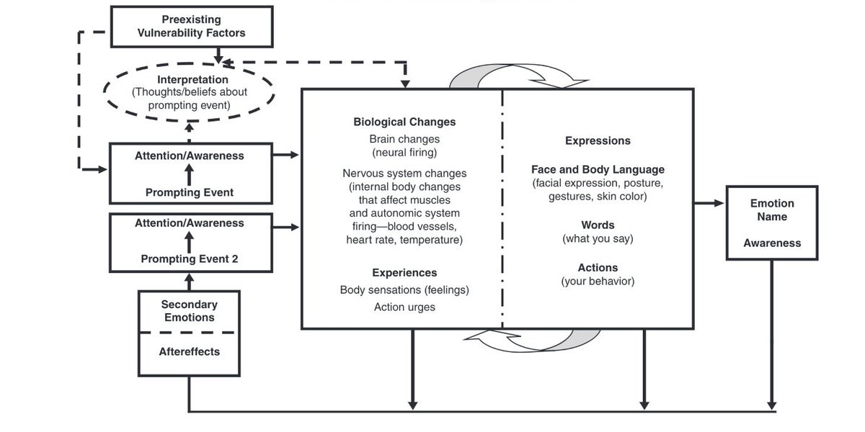

Instructions: Choose a current or recent situation and associated emotional reaction and fill out as much of this diagram as you can:

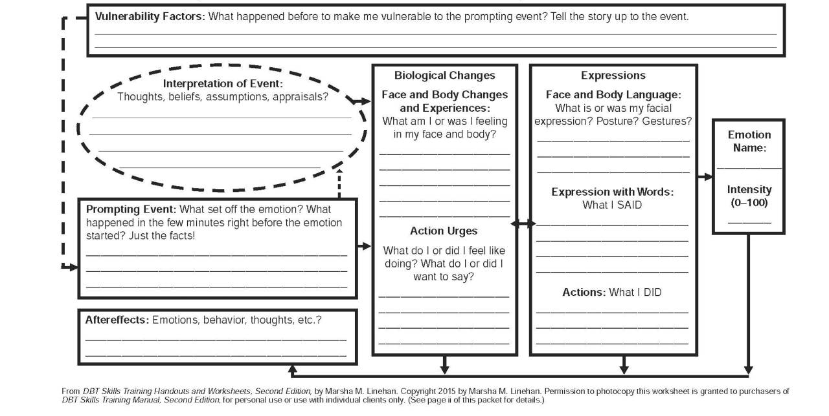

Feelings Wheel

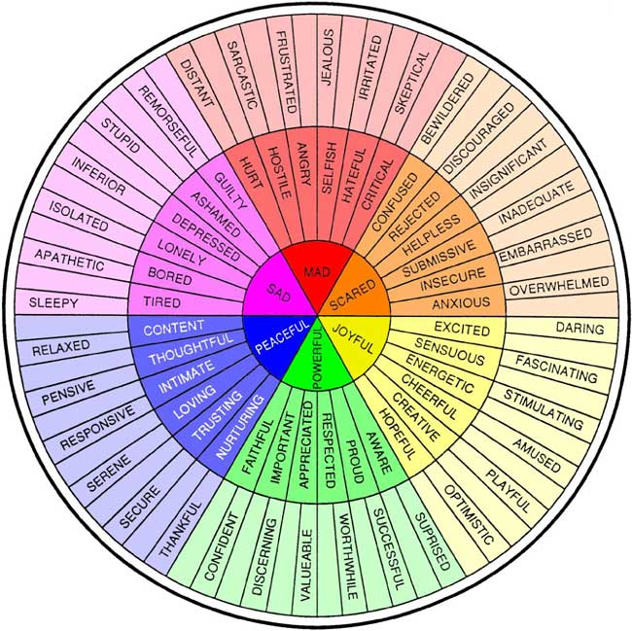

Emotion Regulation Skills: Check the Facts

To check the facts, ask yourself:

- What emotion do I want to change?
  - How intense is the emotion (1-10)?
- What was the prompting event?
  - How would I describe the prompting event using my senses?
  - Did I describe the prompting event without judgments or absolutes?
- Am I adding my own interpretations, beliefs, assumptions or thoughts to the facts?
  - What are other possible interpretations?
  - Am I looking at the event from all sides or points of view?
- Am I assuming a threat or catastrophe?
  - If so, what is the probability that it will occur?
  - If the threat/catastrophe did occur, how would I cope with it?
  - What other possible outcomes are there?
- Does my emotion and its intensity fit the facts?

Examples of Emotions That Fit the Facts

Fear
Anger
Disgust
Envy
Love
Sadness
Shame
Guilt

Emotion Regulation Skills: Opposite Action

When your emotion does not fit the facts OR when acting on your emotions is not effective, consider using the skill Opposite Action. Each emotion has an “action urge.” For example, when we are angry at someone we might want to verbally attack them; when we are fearful we might want to avoid the thing we are scared of. Opposite Action means choosing an action that is opposite to the action urge. Instead of attacking the person we are angry at, we might gently avoid the person. Instead of avoiding what we are afraid of, we might approach it or take action doing it.

Examples of Action Urges and Opposite Actions

Emotion | Situation | Action Urge | Opposite Action
Fear | Feeling nervous to participate in class discussion | Avoid; do not raise your hand | Take a chance! Raise your hand to participate.
Anger
Disgust
Envy
Sadness
Shame
Guilt

Emotion Regulation Skills: Problem Solving

When your emotion fits the facts and the situation is the problem, consider using the skill Problem Solving. Use the following steps:
- Identify your goal in solving the problem. What needs to happen or change? Is your goal realistic?
- Brainstorm as many solutions as you can think of. Do not evaluate your ideas at this step. Instead try to think of solutions nonjudgmentally, even if they aren’t feasible. You can also ask people you trust to help generate ideas.
- Choose a solution from your brainstorm that fits the goal and is likely to work. You may need to write out pros and cons if multiple solutions are viable.
- Act: try your solution.
- Evaluate the results. Did you achieve your goal? If not, you may choose to go back to step #3 to pick another solution to try.

Reducing Vulnerability to Negative Emotions

So far, the skills in Session 2 aim to help us regulate our emotions when we are already feeling/experiencing something that we wish to change. But what about preventative measures to help regulate our emotions?

Use the acronym PLEASE to reduce vulnerability to negative emotions:

take care of PhysicaL health
balance Eating
limit mood-Altering substances
balance Sleep
get Exercise

Take Care of PhysicaL Health | - Seek appropriate medical care  - Take medication as prescribed  - Practice safe sex
Balance Eating | - Practice mindful eating  - Pay attention to how different foods make you feel  - Seek nutritional support from professionals
Limit Mood-Altering Substances | - Limit alcohol consumption  - Limit marijuana use  - Limit other recreational drugs
Balance Sleep | - Get 7-9 hours of sleep per night  - Go to bed and wake up at the same time  - Get extra sleep when sick  - Avoid caffeine, nicotine and alcohol 4-6 hours before bed
Get Exercise | - Set reasonable exercise goals  - Schedule time to exercise throughout the week  - Seek out enjoyable exercise

Homework: Plan to Reduce Vulnerability to Negative Emotions
Instructions: List 3 strategies that you plan to engage in over the next week to help you reduce vulnerability to negative emotions. Be as specific as possible. For example, rather than writing, “Get adequate sleep,” write, “Go to sleep by 11:00 p.m. each night.” Your homework is both to create this list and to do your best to carry out your plan!

- ____________________________________________________________________________________________________________________________________________________________________________________________________________________________________________________
- ____________________________________________________________________________________________________________________________________________________________________________________________________________________________________________________
- ____________________________________________________________________________________________________________________________________________________________________________________________________________________________________________________

SESSION THREE:
Distress Tolerance

Homework Review

If you practiced the homework, what strategies did you try? What did you observe? If you practiced these strategies more than once, what did you notice across practices?
___________________________________________________________________
___________________________________________________________________
___________________________________________________________________
___________________________________________________________________
___________________________________________________________________

If you did not practice the homework, what got in the way? If something got in the way, what could you do over the upcoming week to try to reduce this barrier?
___________________________________________________________________
___________________________________________________________________
___________________________________________________________________
___________________________________________________________________
___________________________________________________________________

Goals of Distress Tolerance

- Survive painful events and crisis situations without making them worse
- Learn to tolerate distressing emotions when you cannot make things better
- Reduce suffering when painful emotions overwhelm you
- Develop coping strategies that do not have unwanted side effects or consequences (e.g. instead of drinking alcohol or self-harming to cope)
- Increase resilience and your ability to cope with strong emotions
- Other:________________________________________________________

When to Use Distress Tolerance Skills:
- You are in a crisis:
  - A stressful event occurs
  - You experience lots of strong emotions
  - You feel scatterbrained, have racing thoughts
  - You physically feel discomfort in your body
  - The crisis is short-term
  - You feel a sense of urgency (“I can’t stand it – it must be resolved now.”)
- When the crisis cannot be solved or cannot by solved yet
AND
- You are either not able to focus on changing how you feel or choosing not to change your emotions
AND
- The problems and the emotions are leading you to suffering/misery
- You want to act on your emotions but it will only make things worse

Distress Tolerance skills may not be appropriate for:
- Everyday problems
- Solving all your problems
- Making your life better in the long-term (since they are focused on helping you get some relief now)

The Cost of Old Coping Strategies
Coping Strategy | Possible Costs
Spending a lot of time thinking about past pain, mistakes, and problems | Missing what is happening in the present; regret; _______________________________
Worrying about potential future pain, mistakes and problems | Missing what is happening in the present; anxiety about the future; _____________________________________
Isolating yourself to avoid possible pain | Feeling lonely; missing out on support or experiences with friends/family; missing opportunities to make new connections; _____________________________________
Using substances (e.g. alcohol, drugs) to numb yourself | Addiction; spending money; academic/work problems; legal problems; relationship problems; health consequences; _____________________________________
Displacing painful feelings onto others | Damaging relationships; guilt; loneliness; legal consequences; _____________________________________
Engaging in self-harm behaviors (e.g. cutting, burning, hitting yourself) | Infection; scarring; shame; physical pain; _____________________________________
Engaging in unsafe sexual activity (e.g. unprotected sex, frequent sex with strangers, etc.) | STD risk; pregnancy risk; shame; _____________________________________ _____________________________________
Remaining in destructive relationships | Potential physical/verbal/emotional abuse; not getting your needs met; getting burnt out doing things for other people; _____________________________________
Engaging in disordered eating behaviors (e.g. overeating, restricting food, throwing up, etc.) | Dangerous weight gain/loss; health consequences; isolation from others during meals; _______________________________
Attempting suicide or engaging in other life-threatening behaviors | Possible death; hospitalization; medical consequences; disruption in academics/work; _____________________________________
Distress Tolerance Skills: STOP
The first step in coping with a crisis, stressful event or difficult emotion is to develop the ability to STOP:

S – Stop! Do not react. Your emotions may give you the urge to act without thinking but the goal is to stay in control.
T – Take a step back, take a break, breathe.
O – Observe what is going on inside and outside of you. What is the situation? What are your thoughts, sensations, and feelings? What is being said and done?
P – Proceed mindfully. Do your best to act with awareness. Consider your thoughts, sensations, feelings, the situation and others involved when deciding what to do. Think about your goals.

Distress Tolerance Skills: Distraction Strategies

Instructions: Check off all the distraction strategies that you are willing to try.
___ Engage in a hobby (specify:______________)
___Clean/organize
___Go to a coffee shop
___Write in a journal
___Surf the internet
___Do a puzzle
___Paint nails
___Call/text/visit a friend
___Go for a walk
___Go out for a meal
___Draw or paint
___Watch TV
___Wash dishes
___Cook your favorite food
___Make a collage
___Do homework
___Squeeze a stress ball
___Lift weights
___Go for a run
___Nature-watch
___Interact with animals
___Look at funny memes
___Write a poem, short story, or play
___Make list of 10 places you want to go
___Learn words from a new language
___Send a thank you letter/card/email
___Do a crossword or word search puzzle
___Go to an event (specify:______________)
___Play video games
___Play a sport
___Exercise
___Watch a sporting event
___Listen to music
___Take a gym class
___Go for a drive
___Go window shopping
___Do laundry
___Make something for someone else
___Do something for someone else
___Do volunteer work
___Read a book or magazine
___Watch a movie
___Make a video
___Listen to or watch a comedy routine
___Count/name the colors you see
___Take photographs
___Hold ice in your hand or to your face
___Call/text a crisis line
___Play a game on your phone
___Name all the sounds you can hear
___ Other:_____________
___ Other:_____________
___ Other:_____________

Distress Tolerance Skills: Relaxation Strategies

Instructions: Check off all the relaxation strategies that you are willing to try.

___Light a scented candle
___Burn incense
___Observe nature
___Look at an art/photography book
___Fix hair/nails/makeup
___Let ice melt in your mouth
___Touch something soft
___Take a bath
___Pet your dog/cat
___Soak your feet
___Sit in a comfortable chair
___Practice deep breathing
___Hug/squeeze a pillow
___Listen to upbeat music
___Pray/meditate
___Slowly suck on a hard candy
___Buy/pick a single beautiful flower
___Look up beautiful places online
___Blow bubbles
___Listen to a recording of nature sounds
___Lie in/smell the grass
___Make a collage of pleasing images
___Listen to soothing music
___Play an instrument
___Listen to a white noise machine
___Spray a pleasant fragrance
___Focus on sounds around you
___Slowly eat a popsicle
___Bake
___Treat yourself to a dessert
___Work on an art project
___Drink tea
___Get a massage
___Listen to a guided meditation
___Take a shower
___Put on a comfortable outfit
___Hug someone you care about
___Practice yoga or stretching
___ Other:_____________
___ Other:_____________
___ Other:_____________

Planning to Use Your Plan
Instructions: Write down three situations over the upcoming week when you anticipate it could be helpful to use your distraction and relaxation strategies.

- ____________________________________________________________________________________________________________________________________________________________________________________________________________________________________________________
- ____________________________________________________________________________________________________________________________________________________________________________________________________________________________________________________
- ____________________________________________________________________________________________________________________________________________________________________________________________________________________________________________________

Distress Tolerance Practice Log
Instructions: Rank your level of distress before and after using distraction and relaxation strategies (p. 30-31).
Distress
0 1 2 3 4 5 6 7 8 9 10
None Mild Moderate Strong Extreme

Date | Skills Used | Distress Before Using Skill | Distress After Using Skill

Resources
Counseling and Psychological Services-785-532-6927
Hotlines
National Suicide Prevention Hotline (24/7): 1-800-273-8255
Trans Lifeline (24/7): 1-877-565-8860
Trevor Project (24/7): 1-866-488-7386
Crisis Text Line (24/7): Text HOME to 741-741
Veterans Crisis Line (24/7): 1-800-273-8255 Press 1 or text 838-255

