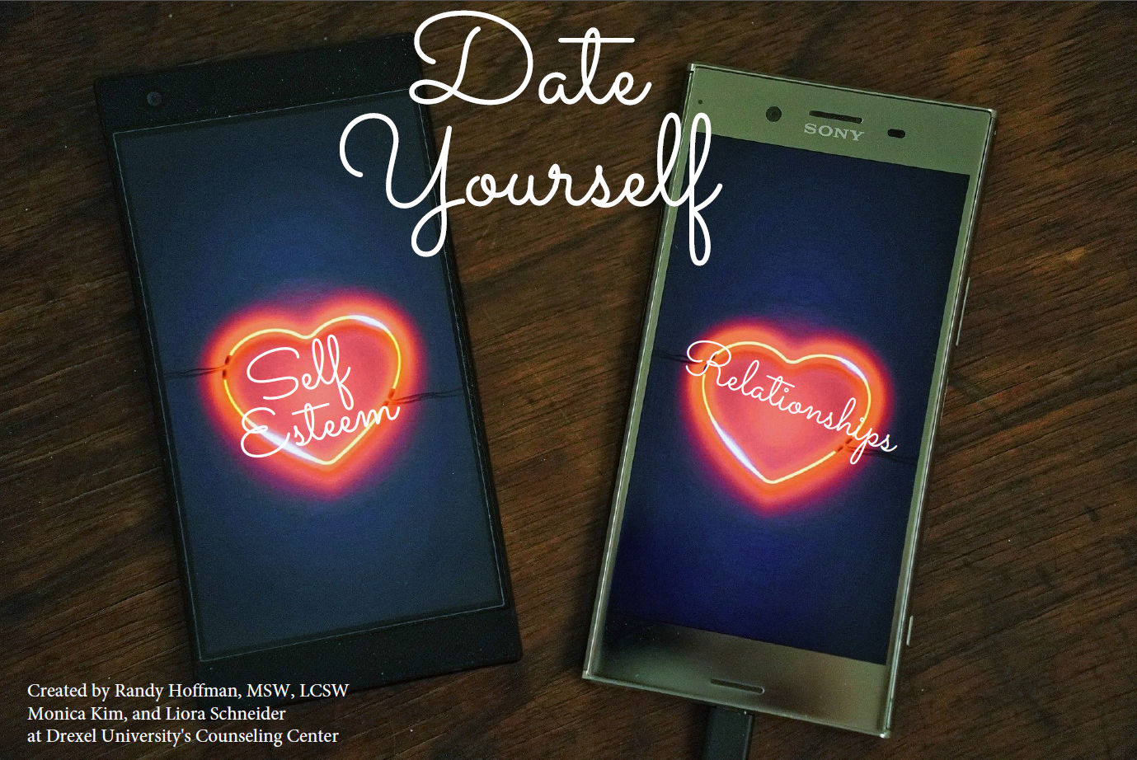

Adapted for Kansas State University Counseling and Psychological Services

INFORMED CONSENT – SKILLS WORKSHOP
Welcome to our three-week skills workshop! These workshops are designed for K-State students who have paid the privilege fees. In practical, day-to-day terms, these workshops are designed to give you the keys to getting and staying well. When you sign-up for one of the 3-week workshops, attendance at all three sessions will be important, as the lessons go in order and fit together as a whole. At the end of each workshop session we will ask you whether you want to sign up for the next session, and will schedule an appointment for you depending on your response. To gain maximum benefit from this workshop, you will need to attend three weekly, one hour sessions, then practice between sessions and apply the training you learn to your everyday life. The workshops will meet online and hosted by Counseling Services for 60 minutes, with the 3-week sequence repeating throughout the semester (no meetings on university holidays).
The workshops will be led by Counseling Services staff members who represent a variety of professionals and professionals-in training: doctoral and masters-level therapists, master’s students, and doctoral psychology interns.
The workshops are free of charge! However, if you no-show or cancel your appointment with less than 24hour notice, you will be charged $25. You are responsible for your bill. You may pay for charges at the time you incur them. Statements are available online by clicking on the Counseling Service Account link on our main webpage (www.k-state.edu/counseling). For overdue billing statements, we may utilize the local address you provided us or the last permanent address you provided to the University. Accounts reaching 60 days past due are filed with the University as delinquent, and a “hold” will be placed on your student account until payment is received. Accounts reaching 120 days past due may be sent to a collection agency if you have not contacted Counseling Services to set up a payment plan.
The focus of the workshops is on skill development, which is helpful in many areas of life. However, the workshops are not a form of or substitute for personal counseling. To become a client and receive counseling, please talk with our staff at the front desk.
We look forward to working with you and are confident it can be of great benefit to you.
Your signature indicates you have read, understood, and agreed to all of the information provided.
Printed Name: ________________________________ WID: ___________________________
Student Signature: _______________________________ Date: _________________________

Introduction to Workshop
Welcome to Date Yourself! Date Yourself is a fast paced, 3-session seminar focused on developing skills to understand concepts of self-esteem, its connections to attachment styles in relationships, and engaging in activities to improve your relationship with yourself and others.
The three workshops are divided into content that builds upon itself to assist students in addressing personal and interpersonal problems which are associated with negative self-perception. Personal and interpersonal problems include, but are not limited to, high self-criticism, difficulty self-appreciating or accepting compliments from others, feelings of inadequate/unattractive/flawed/inferior, difficulty speaking up/standing up for oneself, "people pleaser," difficulty making intimate relationships and unrealistic perfectionism.
By the end of this workshop, you will have a better understanding of the common areas where we 'hold ourselves back' in relating to both ourselves and others.
The activities in your workbook are for you and only you. We ask that you write your responses in the workbook because many of the in-session exercises build upon each other. You'll have some opportunity to participate out loud during this seminar, but please know that if you're uncomfortable you will not be required to do so.
This seminar provides a lot of information in a very short period of time. At times, you may feel somewhat overwhelmed by all of the information. That's okay! Remember, the workbook is yours to take with you and we strongly encourage you to review the material between sessions. The more you practice and reflect, the more you're going to get out of this. If you don't complete an activity or reflect in between sessions, please still come to the seminar.
Should you wish to focus more in depth on any of your self-esteem and/or relationship concerns, you may debrief with a therapist following completion of the workshop to discuss options.
If at any time you feel that you need additional support, please let your workshop leader know or contact the Counseling Center at 785-532-6927 or counsel@k-state.edu. Additionally, feel free to visit our website for more resources https://www.k-state.edu/counseling/

Confidentiality Reminder
Confidentiality is limited when there is risk of suicide or homicide, suspicion of abuse of a child, adult over 65, or dependent adult, or when there is a valid legal request for mental health records.
As this is a group setting, there is no way to guarantee confidentiality. However, our expectation is that no information about anyone in the group will be shared, including others' stories. We want to ensure that it feels safe to speak here.
Frequently Asked Questions (FAQ)
Why does the group use a 3-session model?
A three-session model allows you sufficient time to learn the concepts with time to practice between sessions. Keeping it to three 50-minute sessions allows you to find time in your busy schedule to learn these skills.
What if I need more than 3 weeks to learn and process all of this information?
You are not alone. The topics of discussion are deep and take time to explore. If you need more resources or would like to interpret these topics further, we encourage you to follow-up with your referring clinician.
What if I don't feel comfortable in groups?
Many people feel a little anxious about participating in a group. This group is structured and curriculum-driven, like a class. You are not required to speak if you do not feel comfortable doing so. The facilitators respect each participant's right to share only what they are comfortable sharing and never require you to share sensitive or potentially embarrassing information.
What if I have an urgent need to see a counselor during the seminar?
Simply let the facilitator or Counseling Services' front desk staff know, and they will facilitate you getting the help you need.
Why is it important to reflect between sessions?
The focus of this workshop is on building skills to build healthy and effective relationships with yourself and others; in order to achieve that goal, reflection is essential. You will not be required to provide your reflection responses at any time.
What if I did not reflect in between sessions?
We encourage you to come to the group regardless. If you forget your workbook, we can provide you with a new one. We can also assist you in working on examples when the homework is reviewed.

SESSION
ONE

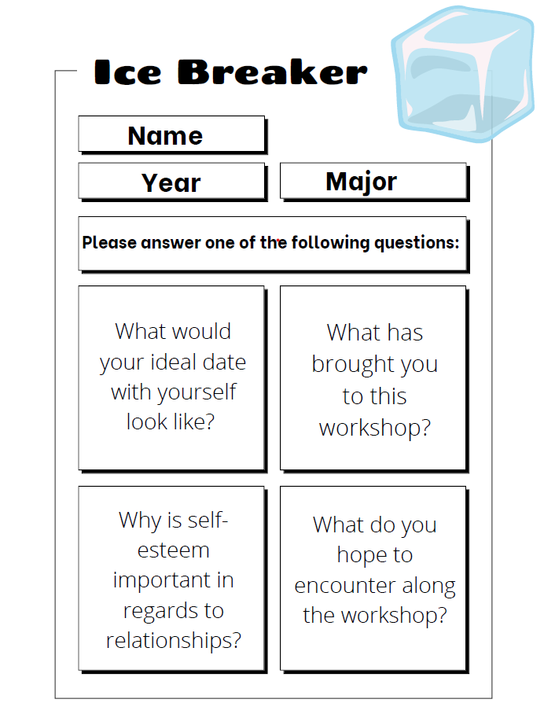
/'.self a'stëm/ noun
Self-esteem is the overall evaluation of the self, frequently associated with self-worth and self-image. Self-esteem may or may not reflect reality.
Other Definitions
- "Self-esteem is the ability to value one's self and to treat one's self with dignity, love, and respect." Virginia Satir
- "Your self-worth is determined by you. You don't have to depend on someone telling you who you are." Beyoncé
- "Self-esteem is the experience of being capable of managing life's challenges and being worthy of happiness." National Council for Self-Esteem
- "Self-esteem is the reputation we have with ourselves." Nathaniel Brandon
- "Knowing that I feel good because I am being diligent about taking care of myself mentally, physically, and emotionally creates self-esteem." Chrissy Metz
- "You yourself, as much as anybody in the entire universe deserve your love and affection." Buddha
- '^{I} l was always looking outside myself for strength and confidence, but it comes from within. It is there all the time." Anna Freud
- "It took me a long time not to judge myself through someone else's eyes." Sally Field
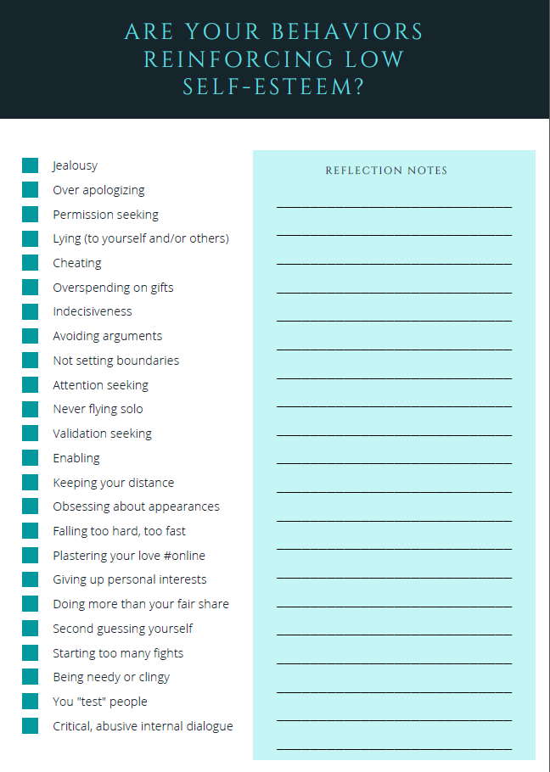
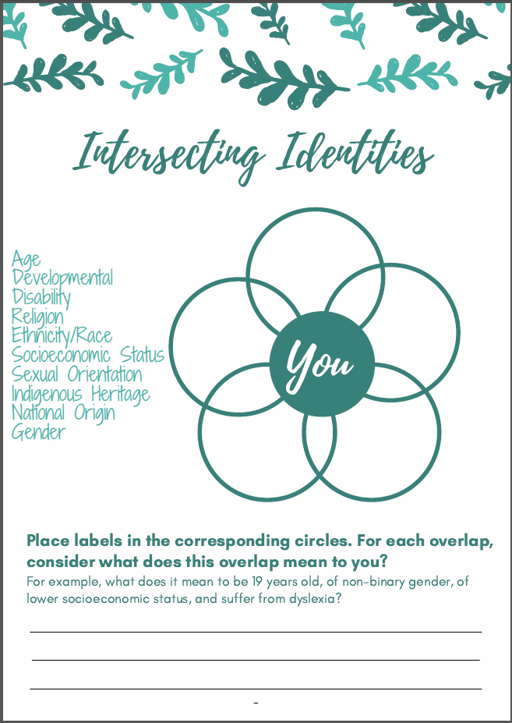

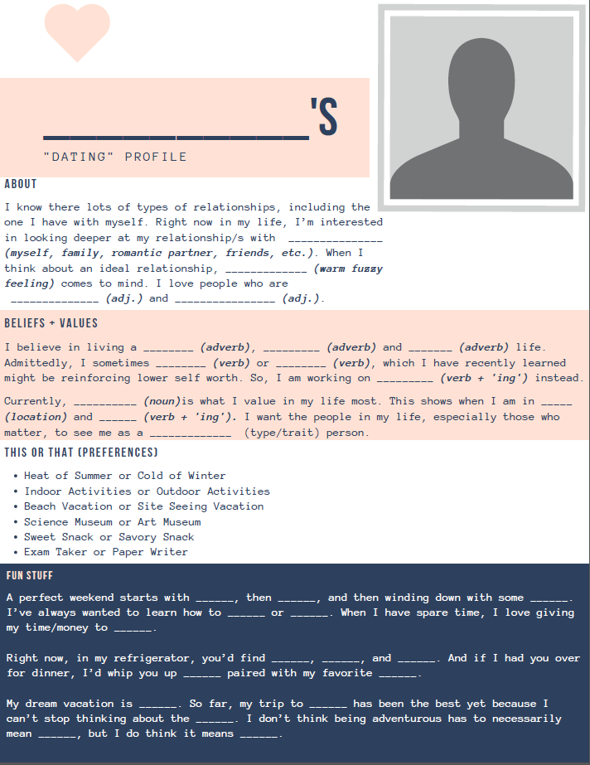

SESSION TWO

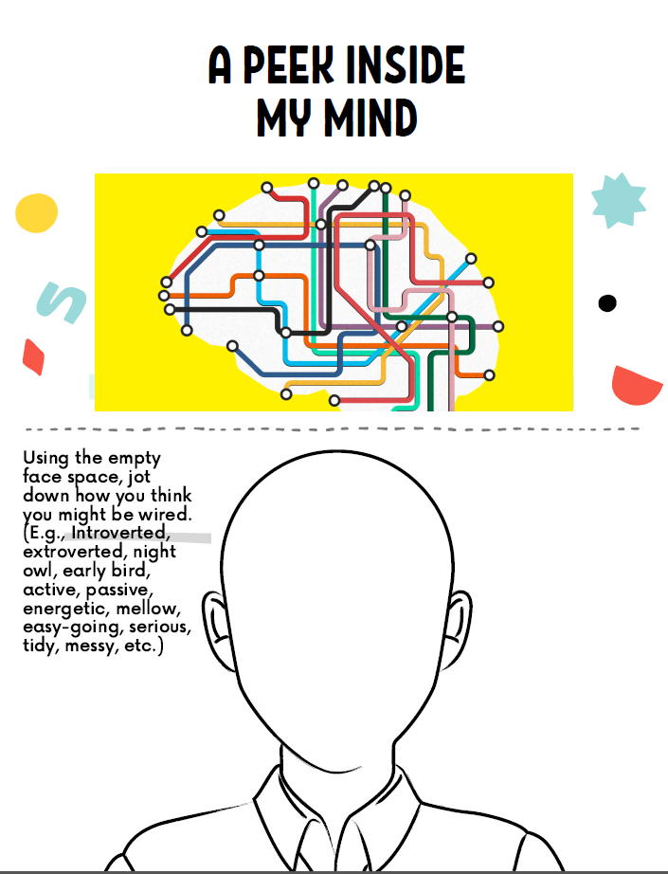

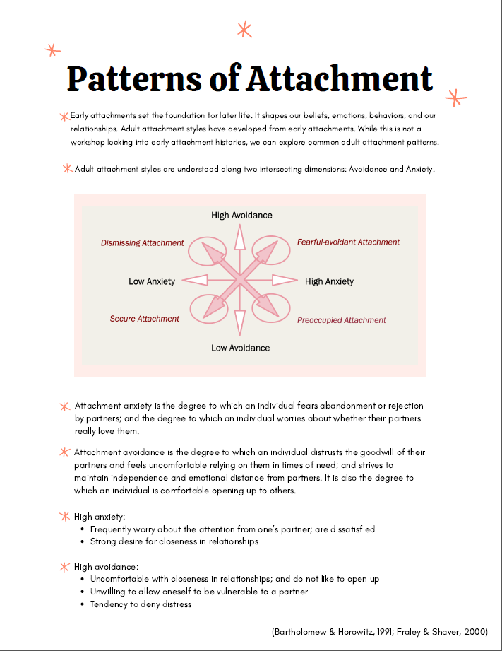

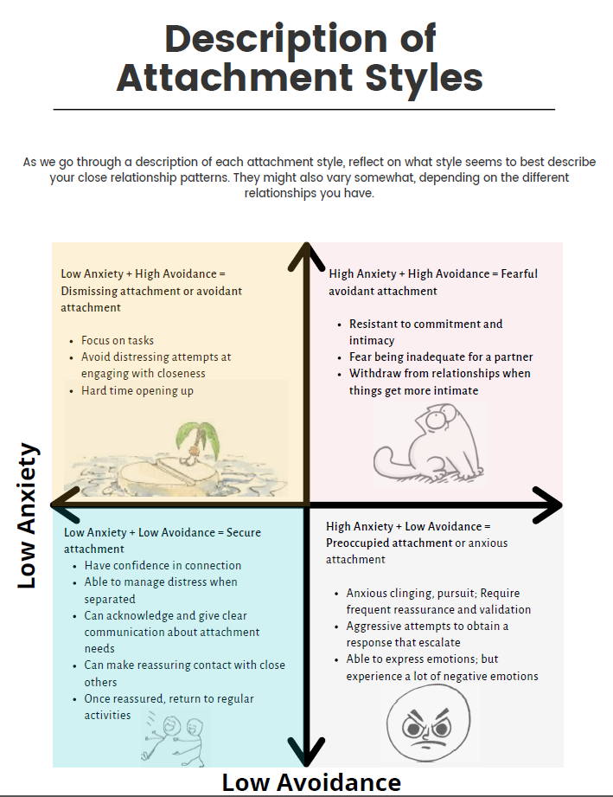

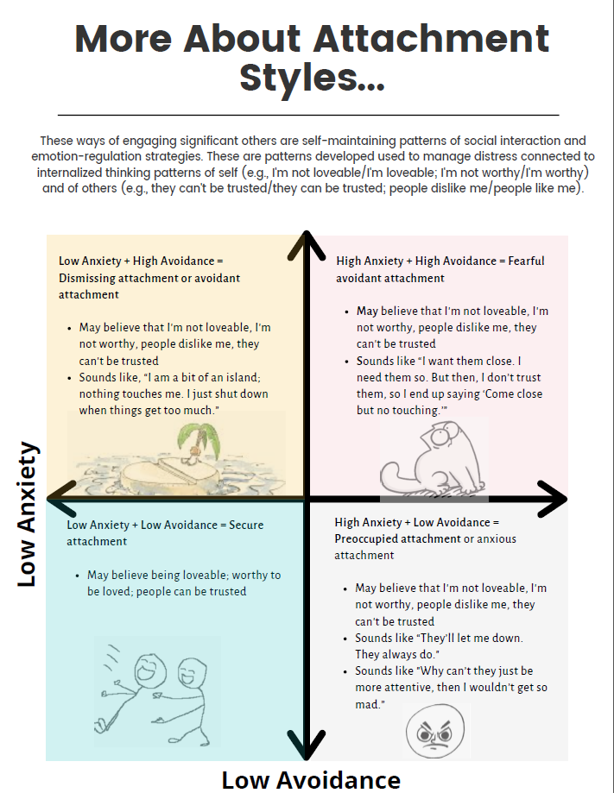

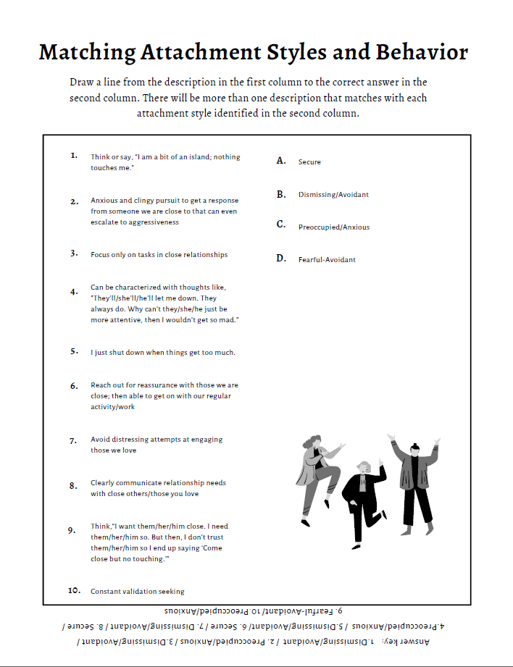

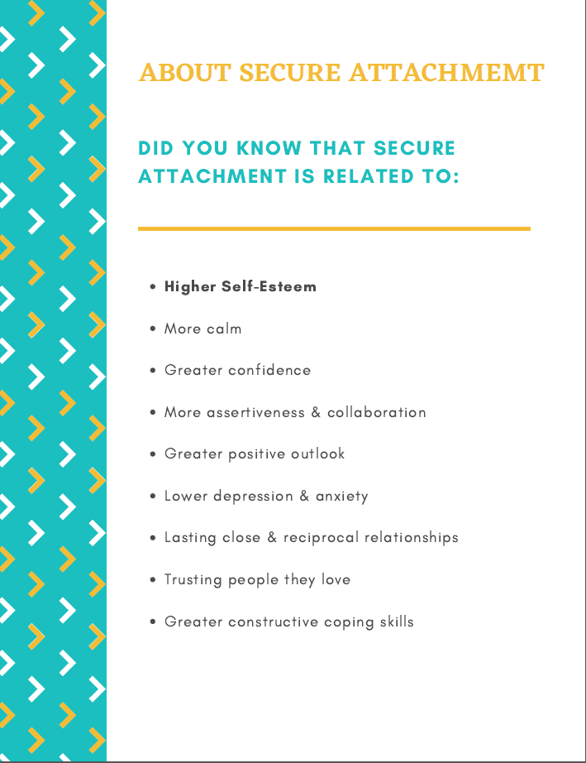

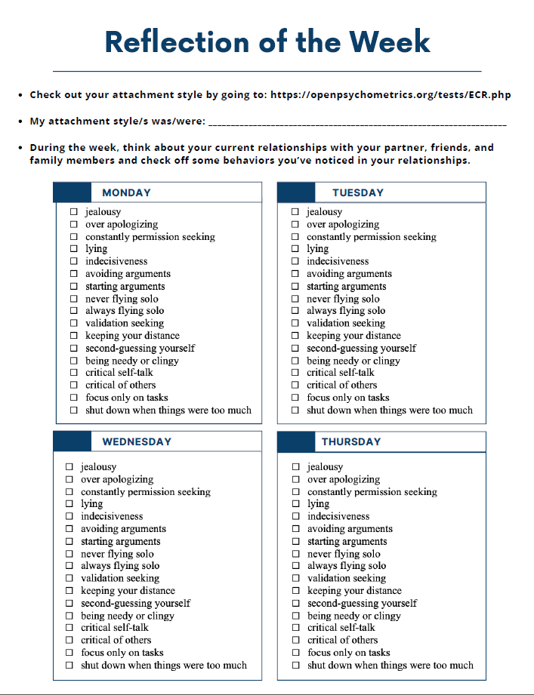

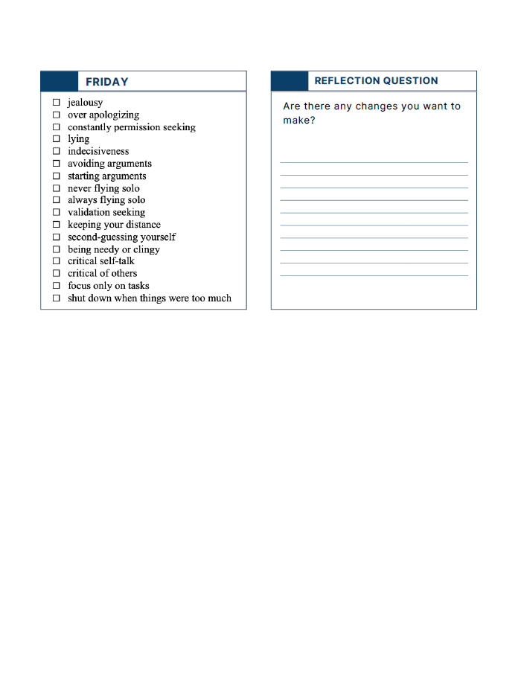

SESSION THREE

