B.R.I.D.G.E

Building Relationship Intimacy and DialoGue Effectiveness

Student Workbook

Adapted From Cal Poly Counseling Services
(785) 532-6927
counsel@k-state.edu

Table of Contents

Welcome Page 3
Frequently Asked Questions Page 4 Session Worksheets Page 5 Session 1: Understanding Relationships Page 6 Autonomy and Intimacy Page 7
What is a Healthy Relationship? Page 8 Values Compass Page 9 Common Values Pages 10-11
Blank Values Compass Page 12 Communication Inventory Page 13
Session 1 Homework Assignments Page 14 Reflection Worksheet Page 15 Session 2: Communication Skills Page 16 Communication Styles Page 17 Communication in Practice Page 18
Feelings Wheel Page 19
Communication Diagram Page 20 Communication Skills Page 21 Listening Skills Page 22
Barriers to Effective Communication Page 23
Correcting Barriers to Effective Communication Page 24
Session 2 Homework Assignments Page 25
My Communication and Listening Skills/My Communication Style Page 26
Session 3: Conflict, Managing Emotions, and Boundaries Page 27
Problematic and Non-Problematic Responses Page 27
Soft Emotions Versus Hard Emotions Page 28-29
Coping with Emotions Page 29-30
Conflict and Repair Page 30-32
My Boundaries Page 32 Power and Control Wheel Page 33
Appendix Pages 34-35

Welcome!

Welcome to B.R.I.D.G.E, Building Relationship Intimacy and Dialogue Effectiveness, a fast-paced, 3-session seminar intended to help increase your understanding and knowledge about how to build and maintain healthy, effective relationships. The goal is to provide you with some skills that build connection and intimacy in your relationships. We hope you find it helpful.

The seminar will provide you with life-long tools you can use in all of your important relationships whether with family, friends, colleagues, or romantic partners. By the end of this course, you will have received a lot of information and at times it may feel overwhelming. Remember that like any skill (e.g., learning to ride a bike), the skills you will learn in B.R.I.D.G.E take time and practice to master. At times, you may encounter obstacles and/or find it difficult to integrate these skills into your daily life. That’s okay, it’s how change works, and as with all change, it’s important to practice as much as you can, even after encountering setbacks.

These skills are a form of “mental health hygiene.” At the outset, it may seem tedious and you may question why you need to practice these skills so often. Think of it like dental hygiene—you brush your teeth multiple times a day to prevent the buildup of plaque and ultimately to prevent cavities. Similar to brushing your teeth, daily practice can help you move towards meaningful and lasting relationships. The more you practice and use these skills as part of your daily routine, the less tedious they may seem because they simply become a regular part of daily life.

Should you wish to focus more in depth on any of your relationship-related concerns, you may debrief with a therapist following completion of B.R.I.D.G.E to discuss options.

If at any time you feel that you need additional support, please let your B.R.I.D.G.E leader know or contact Counseling Services at (785) 532-6927. You may also find additional resources online at https://www.k-state.edu/counseling/

Frequently Asked Questions (FAQ)

What is B.R.I.D.G.E?
A fast-paced, three-session seminar designed to help people who struggle forming or maintaining meaningful, effective, and fulfilling relationships. The goal is to provide education on healthy and effective relationships and teach skills for fostering these types of relationships in your life.

Why does the group use a 3-session model?
Three sessions allows you sufficient time to learn the concepts with time to practice between sessions. Keeping it to three 50-minute sessions allows you to find time in your busy schedule to learn these skills.

What if I need more than 3 weeks to learn the model?
You are not alone. The skills are difficult and take time to build. If you need more resources, we encourage you to follow-up with your referring clinician.

What if I don’t feel comfortable in groups?
Many people feel a little anxious about participating in a group. This group is structured and curriculum-driven, like a class. You are not required to speak if you do not feel comfortable doing so. The facilitators respect each participant’s right to share only what they are comfortable sharing and never require you to share sensitive or potentially embarrassing information.

What if I have an urgent need to see a counselor during the seminar? Simply let the facilitator or Counseling Services’ front desk staff know, and they will facilitate you getting the help you need.

Why do I have to do homework?
The focus of this workshop is on building skills to build healthy and effective relationships; in order to achieve that goal, regular practice is essential. You will not be required to provide your responses at any time; however, it’s important to bring your responses as you may be asked to look back on or elaborate on a prior assignment during the workshop.

What if I didn’t do my homework?
We encourage you to come to group regardless. If you forget your workbook, we can provide you a new one. We can also assist you in working on examples when the homework is reviewed.

IN SESSION
WORKSHEETS SESSION 1:
Understanding Relationships

Autonomy and Intimacy
Autonomy= Independence Intimacy= Connectedness
1=Low 5=High
Levels of Intimacy and Autonomy Snapshot
Person | Intimacy | Autonomy
Parent/Guardian 1 | 1 2 3 4 5 | 1 2 3 4 5
Parent/Guardian 2 | 1 2 3 4 5 | 1 2 3 4 5
Sibling 1 | 1 2 3 4 5 | 1 2 3 4 5
Sibling 2 | 1 2 3 4 5 | 1 2 3 4 5
Friend | 1 2 3 4 5 | 1 2 3 4 5
Roommate | 1 2 3 4 5 | 1 2 3 4 5
Romantic Partner | 1 2 3 4 5 | 1 2 3 4 5
Coworker/  Classmate | 1 2 3 4 5 | 1 2 3 4 5

Ebb and Flow in my Relationship
Consider a relationship that you would like to focus on and reflect on the following questions:

What are the current autonomy and intimacy levels I am feeling?: ______________
__________________________________________________________________________________________ __________________________________________________________________________________________

How have the levels of intimacy and autonomy varied over time and experiences?:__________________________________________________________________________ __________________________________________________________________________________________
__________________________________________________________________________________________
__________________________________________________________________________________________ __________________________________________________________________________________________

Where would I like my intimacy and autonomy levels to be?:____________________
__________________________________________________________________________________________
__________________________________________________________________________________________
What is a Healthy Relationship?

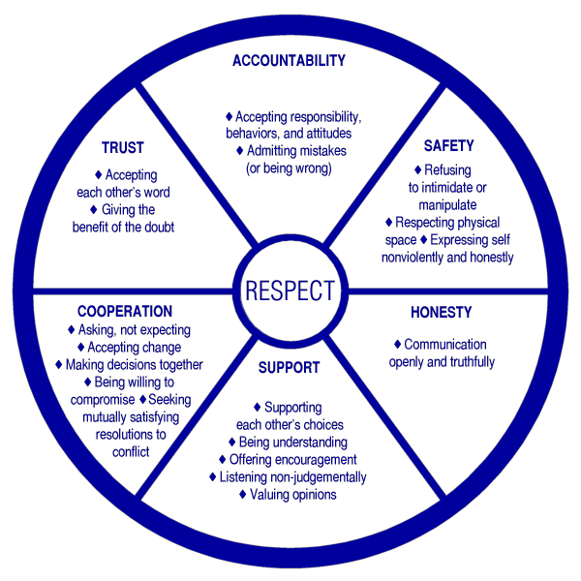

Values Compass
Values are what we find meaningful and important in order to live an authentic life. They are different for everybody, and can change over time. Values are different from goals. Put simply, goals can be ‘achieved’ whereas values are more like compass directions that we want to head in. For example, we might have the goal of getting to all your classes, which sits within the value of ‘being a good student.’
Some people value the domains below. Leaving aside any obstacles for the moment, think about what is important to you and what you think makes for a meaningful life that you could value.

Family
What kind of relationships do you want with your
family? What kind of parent/sibling/family
member do you want to be? What characteristics
are important in your family members?

Friendships/Social
What sort of friend do you want to be? How would you like to act towards your friends? What characteristics are important in your friends?

Community
What type of relationships in your community would you like to build (i.e., spiritual, neighbors)? What characteristics are important in your community members?

Romantic/Intimate
What kind of romantic or intimate partner do you want to be? What quality of relationship do you want to be a part of? What characteristics are important in your intimate or romantic partners?
Employment
What qualities do you want to bring as an employee? What kind of work relationships would you like to build? What characteristics are important in your coworkers?

Education/Training
What qualities do you want to bring as a student?
What kind of educational relationships would you
like to build? What characteristics are important in your classmates and instructors?

Common Values

- Acceptance: to be open to and accepting of myself, others, life, etc.
- Adventure: to actively seek, create, or explore novel experiences
- Assertiveness: to respectfully stand up for my rights and what I want
- Authenticity: to be authentic, genuine, real; to be true to myself
- Beauty: to appreciate, create, nurture or cultivate beauty in myself, others, the environment, etc.
- Caring: to be caring towards myself, others, the environment, etc.
- Challenge: to keep challenging myself to grow, learn, improve
- Compassion: to act with kindness towards those who are suffering
- Connection: to engage fully in what I am doing and be present with others
10.Contribution: to help or make a positive difference to others or myself
11.Conformity: to be respectful and obedient of rules and obligations
12.Cooperation: to be cooperative and collaborative with others
13.Courage: to be brave; to persist in the face of fear or difficulty
14.Creativity: to be creative or innovative
15.Curiosity: to be open-minded and interested; to explore and discover
16. Encouragement: to encourage behavior that I value in others or myself 17. Equality: to treat others as equal to myself, and vice-versa
- Excitement: to seek, create, and engage in activities that are stimulating or thrilling
- Fairness: to be fair to others or myself
- Fitness: to maintain, improve, and look after my physical and mental health and wellbeing
- Flexibility: to adjust and adapt readily to changing circumstances
- Freedom: to choose how I live and behave, or help others do likewise
- Friendliness: to be friendly, companionable, or agreeable towards others
- Forgiveness: to be forgiving towards others or myself
- Fun: to be fun loving; to seek, create, and engage in fun-filled activities
- Generosity: to be generous, sharing and giving, to others or myself
- Gratitude: to be appreciative of myself, others and life
- Honesty: to be honest, truthful, and sincere with others and myself
- Humor: to see and appreciate the humorous side of life
- Humility: to be humble or modest; to let my achievements speak for themselves
- Industry: to be industrious, hard-working, dedicated
- Independence: to be self-supportive and choose my own way of doing things
- Intimacy: to open up, reveal, and share myself -- emotionally or physically
– in my close relationships
- Justice: to uphold justice and fairness for myself and others
- Kindness: to be compassionate, considerate, nurturing or caring towards myself and others
- Love: to act lovingly or affectionately towards myself and others
- Mindfulness: to be open to and curious about my present, here-and-now experience
- Order: to be orderly and organized
- Open-mindedness: to think things through, see things from other’s points of view, and weigh evidence fairly
- Patience: to remain calm during difficult times
- Persistence: to continue resolutely, despite problems or difficulties
- Pleasure: to create and give pleasure to others or myself
- Power: the ability to direct or influence the behavior of others, such as taking charge, leading, organizing
- Reciprocity: to build relationships with a balance of giving and taking 45. Respect: to be polite, considerate and show myself and others positive regard
- Responsibility: to be responsible and accountable for my actions
- Romance: to be romantic; to display and express love or strong affection for another person
- Safety: to secure, protect, or ensure the wellbeing of others or myself
- Self-awareness: to be aware of my own thoughts, feelings and actions
- Self-care: to look after my health and wellbeing and get my needs met 51. Self-development: to keep growing, advancing or improving in knowledge, skills, character, or life experience.
- Self-control: to act in accordance with my own ideals
- Sensuality: to create, explore and enjoy experiences that stimulate my senses
- Sexuality: to explore or express my sexuality
- Spirituality: to connect with things bigger than myself
- Skillfulness: to continually practice and improve my skills, and apply myself fully when using them
- Supportiveness: to be helpful, encouraging, and available to others or myself
- Trust: to be trustworthy; to be loyal, faithful, sincere, and reliable

Blank Values Compass
For each of these domains, write a quick summary of your values or list of your values, such as, “humor, support, to be a good friend to people who need me, and to enjoy my time with the people I love” (friendships).
Rate each domain for how important it is to you from 0-10 (0=not important)

Family

Passive,

Education/Training

Friendships/Social

Employment

Romantic/Intimate

Community

Communication Inventory

The following questions are to help you begin to explore your communication strengths and areas of growth. To help you reflect on questions 1 and 2, think about your communication as it relates to: the people with whom you communicate, your physical and emotional state, time of day, and the type of communication as starting points.

- When do you communicate well? (i.e., when I’ve had time to think, in the mornings)
__________________________________________________________________________________________
__________________________________________________________________________________________ __________________________________________________________________________________________
__________________________________________________________________________________________

- When do you communicate poorly? (i.e., when tired, with my family)
__________________________________________________________________________________________
__________________________________________________________________________________________
__________________________________________________________________________________________
__________________________________________________________________________________________

To help you reflect on questions 3 and 4, think about: your tone of voice, level of speaking, body language, and behaviors surrounding your language as starting points.

- What does your good communication look like? (i.e., calm tone, I listen)
__________________________________________________________________________________________
__________________________________________________________________________________________
__________________________________________________________________________________________
__________________________________________________________________________________________

- What does your poor communication look like? (i.e., the silent treatment, slamming doors, etc.)
__________________________________________________________________________________________
__________________________________________________________________________________________
__________________________________________________________________________________________
__________________________________________________________________________________________

Session 1 Homework Assignments

Homework 1: Finish Values Compass on page 12

Homework 2: Finish Communication Inventory on page 13

Homework 3: Self-Reflection worksheet on page 15

Self-Reflection Worksheet

Your task this week is to be a curious scientist about yourself and your relationships. If you can, make notes each day. What did you notice this week about:

The levels of intimacy and autonomy in your relationships?
__________________________________________________________________________________________
__________________________________________________________________________________________
__________________________________________________________________________________________
__________________________________________________________________________________________
__________________________________________________________________________________________

What your boundaries look like in your relationships?
__________________________________________________________________________________________
__________________________________________________________________________________________
__________________________________________________________________________________________ __________________________________________________________________________________________
__________________________________________________________________________________________

How and if you are working towards your values system?
__________________________________________________________________________________________
__________________________________________________________________________________________
__________________________________________________________________________________________
__________________________________________________________________________________________
__________________________________________________________________________________________

What your communication looks like in your relationships?
__________________________________________________________________________________________
__________________________________________________________________________________________
_______________________________________________________________________________________

SESSION 2:
Communication
Skills

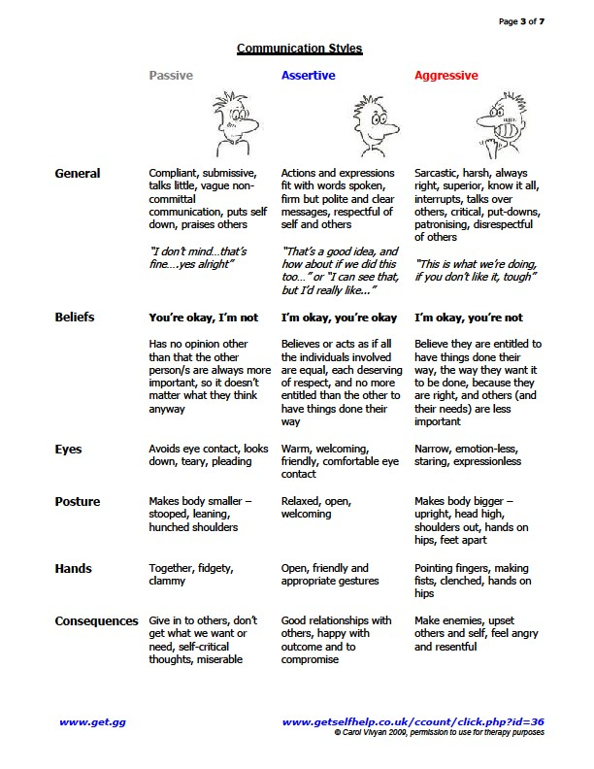

Communication In Practice
Example: Sally is unhappy with James because he told a secret that Sally told James in confidence.

Passive Response:  Sally doesn’t say anything. When James mentions what he said to Sally, she thinks to herself, “That’s okay, he didn’t  mean anything by  it.” | Aggressive Response:  Sally find James in the UU and yells at him, saying “You’re the worst friend! What is wrong with you?!” When James attempts to respond, Sally yells over him. | Passive/Aggressive Response:  Sally doesn’t confront James. She is sarcastic with James for a week after the event but denies that anything is wrong when he asks her. | Assertive Response:  Sally talks with James in private, saying in a calm  voice, “I was hurt and angry when you told your friends about my secret. It feels like it is hard to trust you now.”

Considering the following questions, what might your reactions be?
- If you were in Sally’s place, how would you feel if you responded as Sally does above?
- If you were in James’ place, how would you feel if Sally addressed you in this way?

Practice
Tip: Before responding, consider what your wants and needs are in each situation:

Your Partner: “I know you have plans for the weekend, but I really need you to watch the kids. I have friends coming to town , and we made plans.”
Assertive Response:______________________________________________________________________________________________________________________________________________________________________________________________________

Situation: You’ve just received your food at a restaurant, and it was prepared incorrectly. Your sandwich seems to have extra mayo, instead of no mayo.

Your Response: ______________________________________________________________________________________________________________________________________________________________________________________________________
___________________________________________________________________________________________________

Your Friend: “Hey, can I borrow some money? I want to buy these shoes, but I left my wallet at home. I’ll pay you back soon, I swear. It won’t be like last time.”

Your Response: ______________________________________________________________________________________________________________________________________________________________________________________________________
___________________________________________________________________________________________________

Situation: Your neighbor is having a party, one of many that occur each week. The parties are very loud and wake you up multiple times a week.

Your Response: ______________________________________________________________________________________________________________________________________________________________________________________________________
___________________________________________________________________________________________________

Provided by Therapistaid.com
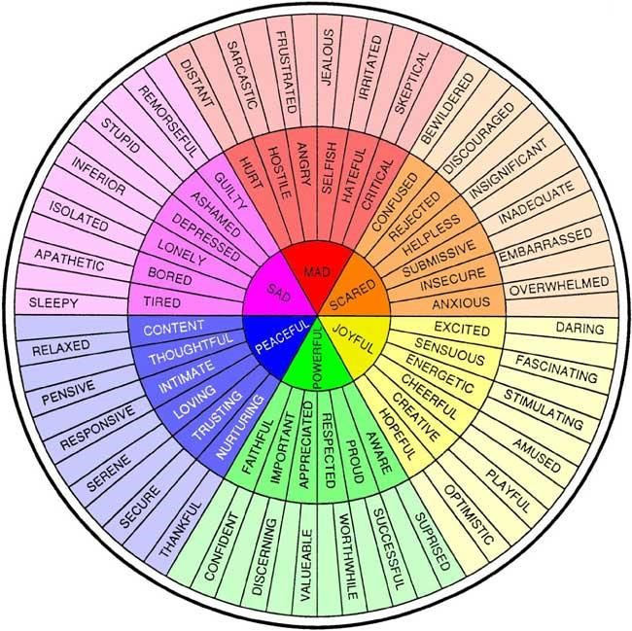

Feelings Wheel

Communication Diagram

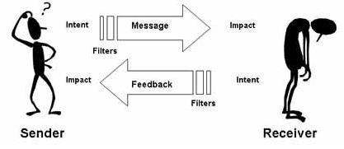

- Communication is a process that includes both a Sender and Receiver
- The Sender gives a MESSAGE to the Receiver
- Then, the Receiver has FEEDBACK for the Sender
- The Sender and Receiver both have FILTERS that affect BOTH the message and the feedback
- The message and feedback have an IMPACT on both the Sender and Receiver
- Misunderstandings can happen at any part of the process

Communication Skills

- Respect yourself- your needs, wants and rights are as important as anyone else’s. It’s fine to express what you want being mindful of the rights of others.

- Express thoughts and feelings calmly-Giving the silent treatment, yelling, threatening, shaming, are all great examples of what not to do. Take responsibility for your emotions and express them in a calm and factual manner. Try starting sentences with, “I feel…”

- Plan what you are going to say- know your wants and needs and how you can express them, before entering into a conversation. Come up with specific sentences and words you can use.

- Say “no” when you need to- You can’t make everyone happy all the time. When you need to say “no”, do so clearly without lying about the reasons. Offer to help find another solution.

Provided by Therapistaid.com

Listening Skills

- Check In. Check in with yourself. Notice if now is a time when you can commit to listening. If not, gently ask for a rain check to continue the discussion at another time.
- Prepare. Prior to listening, put other things out of your mind and focus on staying present.
- Stop Talking. Don’t interrupt, talk over, or complete someone’s sentences.
- Delivery. Pay attention to how someone is communicating (i.e., tone, volume), as it can provide useful information about emotions.
- Empathize. Attempt to see the person’s perspective and keep an open mind.
- Enhancers. Use your nonverbals to show you are listening. Smile, nod, or use “uh huh” while the other person is talking.
- Focus. Don’t pay attention to other tasks, interests, etc. Focus on the speaker’s words.
- Be Patient. Don’t jump in to speak the second that there is a pause. Wait until you know the person is done speaking (it’s okay to ask in a gentle way!)
- Nonverbals. Attend to gestures, facial expressions, and other nonverbals, which are important cues in communication.
- Avoid judgement. People communicate in different ways. Focus on the communicator’s meaning, instead of rejecting the message based on how it is said or the person who said it.
- Label words. Make a mental image of what you are being
told (this helps you remember it later).
- Reflect. Paraphrase or reflect what you heard to make sure you got it right.

Barriers to Effective Communication

- Mind Reading. Assuming you know what someone else means, often before they complete their statement.
- Physical: Objects or distractions get in the way.
- Rehearsing. Focusing on what you will say next (instead of listening).
- Non-verbals: When your words and nonverbal signals are inconsistent.
- Distraction/Daydreaming. Focusing on things outside the conversation.
- Judging. Making judgements about what is being said or about the speaker.
- Filtering. Selective listening. Hearing what you want to and ignoring the rest.
- Sparring. Listening just so you can disagree.
- Derailing. Changing the subject or making jokes, especially when uncomfortable with the topic.
- Misperceptions: Misunderstanding what someone is saying when they speak.
- Culture/Language: Different beliefs about experiences, relating, and what is “right” or “wrong” in communication.
- Superficial: Having a hard time accessing experiences beyond surface level.
- Advising. Wanting to “fix” or offer needless advice.
- Placating. Too quickly agreeing, sometimes as a way to make the other person stop talking.
- Dumping: Purging concerns without space for the other person to communicate.
- Being Right. Focusing on proving that you are not wrong, often times without taking into consideration the other person’s feelings or experience.
- Boredom. Either due to the topic or because you’ve been listening for prolonged periods. 18. Heightened Emotions. It can be challenging to attend to a conversation when you’re emotionally activated
(positively or negatively).
Correcting Barriers to Effective Communication

One of the first steps for correcting these barriers is to engage in self-reflection and notice when you may be doing them. Additionally, the following are helpful tools:

  - Mind Reading. Allow someone to finish their statement before speaking.
  - Physical: Try to have face-to-face conversations. Put distractions away. Gently ask to have the conversation at another time if you cannot avoid the distractions.
  - Rehearsing. Practice focusing on the communicator’s words and paraphrase what is said.
  - Non-verbals: Pay attention to your actions as well as your words. Self check-in about your emotional state. Remember culture impacts the meaning of many non-verbals.
  - Distraction/Daydreaming. Self checkin to see if now is a good time to talk. If not, ask to speak later. If you cannot delay, practice visualizing the words in your head.
  - Judging. Attempt to suspend judgement, checking in with where the judgment comes from. Focus on your disagreement with the message, not judgement of the person.
  - Filtering. Highlight to yourself the items that you may typically ignore.
  - Sparring. Attempt to understand the person’s message
  - Derailing. Respond on-point to what was said, or avoid making commentary and use enhancers if you are unable.
  - Misperceptions: Ask for clarification or clarify what you meant.

  - Culture/Language: Take steps to understand cultural differences. Ask for clarification when it seems that there might be a difference. Avoid judgement—there is no one “right” way to communicate.
  - Superficial: Self-Reflection: check in with how you’re feeling, what you think, and if you want to share those with the other person.
  - Advising. Try to refrain from giving advice until asked. Step back and be supportive. Let them know you are there if needed.
  - Placating. Too quickly agreeing, sometimes as a way to make the other person stop talking.
  - Dumping: If you are dumping, notice about how much time/space you have taken up. Set goals to scale back. If you’re receiving, set boundaries where you can (i.e., set a time limit).
  - Being Right. Focus on the other person’s feelings or experience. You may disagree about something, but everyone’s feelings are valid.
  - Boredom. Self check-in to see if now is a good time to talk. If not, ask to speak later. If you can’t delay, practice visualizing the person’s words in your head.
- Heightened Emotions. Let the other person know that right now is not a good time but you are happy to talk later. Find ways to care for your emotions to prevent them from negatively affecting communication.

Session 2 Homework Assignments

Homework 1: Practice one communication and listening skill over the next week. Practice trouble shooting one barrier to communication and barrier to listening this week.

Homework 2: Reflect on your communication style and the factors that influence it. Write your reactions on page 26.
My Communication and Listening Skills
The listening skill I plan to practice ________________________________________________

The barrier to listening I plan to work on __________________________________________

How I plan to work on it _____________________________________________________________
__________________________________________________________________________________________ __________________________________________________________________________________________

The communication skill I plan to practice _______________________________________

The barrier to communication I plan to work on __________________________________

How I plan to work on it _____________________________________________________________ __________________________________________________________________________________________ __________________________________________________________________________________________

My Communication Style

Be a curious observer for a second week, this time paying attention to the style of communication that you tend to use (i.e., assertive, aggressive) and what factors influence your style of communication.

The style of communication I noticed myself using most this week (i.e., passive, assertive, etc.): ______________________________________________________________ __________________________________________________________________________________________
__________________________________________________________________________________________ __________________________________________________________________________________________

Things that I noticed influence my style of communication: ______________________

SESSION 3:
Conflict,

Managing Emotions, and Boundaries

Problematic and Non-Problematic Responses

Problematic responses- the Four Horsemen:

Criticism: “You talked about yourself all through dinner and didn’t ask me anything about my day. How can you treat me this way? What kind of selfcentered person are you?”

Defensiveness: “What are you picking on me for? I didn’t do anything wrong. What about all the good things I do? I never get any appreciation.”

Contempt: “It’s not that I could care less, it’s that I couldn’t care less. At least get that right.”

Stonewalling: Looking away and no longer taking part in the conversation.

Non-problematic response- a Complaint:

Complaint: “I’m upset that you talked about yourself all through dinner and you didn’t ask me anything about my day. That hurts my feelings.”

Which problematic responses do you use? How does it impact the intimacy in your relationship? How does it impact conflict in your relationship?
__________________________________________________________________________________________
__________________________________________________________________________________________
__________________________________________________________________________________________
__________________________________________________________________________________________
__________________________________________________________________________________________

Which problematic responses does your partner use? How do these responses make you feel about yourself and the relationship?
__________________________________________________________________________________________
__________________________________________________________________________________________
__________________________________________________________________________________________
__________________________________________________________________________________________
__________________________________________________________________________________________

Soft Emotions Versus Hard Emotions

The expression of certain types of emotions is key in building intimacy, coming together around a problem, and preventing polarization.

Soft emotions:
- Includes vulnerability, sadness, fear, doubt, uncertainty, danger and disappointment
- Generate empathy from partner
- Lead to closeness
- Enhance the security of the attachment and repair ruptures to the attachment

Hard emotions:
- Includes anger, hostility, resentment, power and control around a conflict
- Imply blame and dominance
- Escalate conflict

Which soft or hard emotions are you more likely to express? How does the expression of each impact your partners and relationships? How are you impacted when each type is expressed to you?
__________________________________________________________________________________________
__________________________________________________________________________________________
__________________________________________________________________________________________
__________________________________________________________________________________________
__________________________________________________________________________________________
__________________________________________________________________________________________
__________________________________________________________________________________________
__________________________________________________________________________________________
__________________________________________________________________________________________
__________________________________________________________________________________________ __________________________________________________________________________________________

Coping with Emotions

- Activities: Find something you enjoy doing. It can be anything from hiking to watching TV to going shopping.
- Contributing: Find something nice to do for someone.
- Sensations: Pay attention to your surroundings using all five senses (sight, hearing, smell, taste, touch).
- Relaxation: Get a massage, take a bath, or find something else that
helps you reduce
physical tension.
- Distractions: Find something to take your attention for 10 minutes, with a plan to return to the problem.

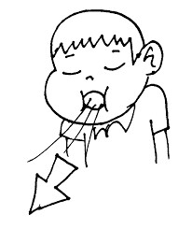
- Deep Breathing: Take 10 slow, deep, breaths. Count to 4 on the in and out breath.
- Mindfulness: Practice a short mindfulness exercise. You can find them easily on YouTube or
apps like mindfulness coach.
- Opposite Emotions: Read, watch, or listen to things that evoke the opposite emotion from what you’re experiencing.
- Time-Out: When overwhelmed with emotions, take a tenminute break and come back.

Conflict and Repair

Generates Conflict | Repairs Conflict
Change Agenda: trying to increase or decrease the frequency of your partner’s behavior | Acceptance: changing your own emotional reaction to or perceptions of your partner’s unwanted behavior
Seeing problems as a power struggle, change efforts and conflict | Seeing problems as opportunities for vulnerability, connection, and intimacy
Problem is YOU | Problem is IT; externalize the problem and be specific about what is upsetting.  Remember that you care about this person.
Emotionally enmeshed with problem | Intellectual analysis of problem
Use of coercive behaviors and Four Horsemen (criticism, defensiveness, contempt, stonewalling) | Express problem as complaint, focusing specifically on your feelings and reactions to specific behaviors or events
Express hard emotions: anger, hostility, resentment, power and control around a conflict | Express soft emotions: vulnerability, sadness, fear, doubt, uncertainty, danger, and disappointment
React with a negative response | Use positive affect to de-escalate conflict: agreement, approval, humor, assent, laughter, positive physical contact, smiling
Gridlock over perpetual problems | Open dialogue about perpetual problems. Accept incomplete resolution. Avoid preoccupation with past disappointments.
Refusing compromise or partner influence | Be agreeable! Search for a common ground. (This doesn’t mean just going along with what someone says to keep the peace.)
Polarization | Support and soothe one another; express your appreciation; gratitude for differences
Emotional reactivity; strong Fight or Flight response | Time outs, relaxation and mindfulness exercises; individual therapy and additional workshops. Choose a good time to talk when you are calmer

My Boundaries

Boundaries are the rules or limits that we set for ourselves. An important part of building and maintaining relationships is identifying our limits. For the relationships listed below, take a moment to consider your personal limits related to physical touch, personal space, and emotions. If a relationship does not apply to you, consider how you might want a relationship of that type to look.

Parents/Guardians:___________________________________________________________________
__________________________________________________________________________________________
__________________________________________________________________________________________

Siblings:________________________________________________________________________________
__________________________________________________________________________________________
__________________________________________________________________________________________

Romantic Partners: ___________________________________________________________________
__________________________________________________________________________________________
__________________________________________________________________________________________

Roommates:___________________________________________________________________________
__________________________________________________________________________________________
__________________________________________________________________________________________

Classmates:____________________________________________________________________________
__________________________________________________________________________________________
__________________________________________________________________________________________

Professors:_____________________________________________________________________________
__________________________________________________________________________________________
__________________________________________________________________________________________

Friends:________________________________________________________________________________
__________________________________________________________________________________________
__________________________________________________________________________________________

Power and Control Wheel

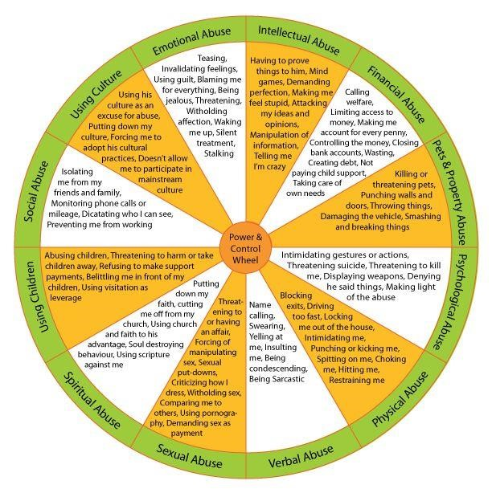

APPENDIX
Evaluating My Relationships

These questions are not designed to tell you what is right or wrong, good or bad in a relationship but to help you think about and explore how you function in relation to another in terms of connection/disconnection and what feels best to you for each specific relationship.

Think of a significant relationship in your life now or recently (a friend, roommate, parent, romantic partner, etc.):

- How much time do you spend with the other person?

- How easy is it to express and pursue your own interests, activities, and opinions?

- How easy is it to share your personal needs and concerns?

- How easy is it to disagree?

- How available and dependable is the other person?

- How acceptable is it to have time for yourself or other friendships?

- How authentic are you in the relationship?

- How much respect for privacy is there?

- How much affection and appreciation is expressed?

- Was the relationship ever different than it is now?

- What would you like to see change?

- Is there something stressful happening right now that could be impacting the way you interact?

- Are there problems from the past that were never resolved and are now resurfacing?

