Kansas State University (K-State) is committed to performing animal facilitated research in a humane and compliant manner. The K-State Institutional Animal Care and Use Committee (IACUC) is empowered to “review, and, if warranted, investigate concerns involving the care and use of animals resulting from public complaints, or reports of noncompliance from laboratory or research facility employees or personnel.” If you have questions or concerns about animal care and use at K-State, please contact one of the individuals listed below, a member of the IACUC, or submit via the “Report a Concern” link on the K-State IACUC website. If you prefer to remain anonymous, you are not required to give your name.
- Dr. Jason Grady – Attending Veterinarian, jgrady@ksu.edu (785-477-1405)
- Dr. Sally Olson – IACUC Chair, solson@ksu.edu (785-410-7513)
- Dr. Brad Woods – Associate Vice President for Research, brwoods@k-state.edu (785-532-2318)

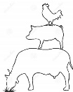

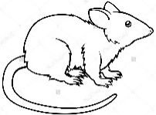

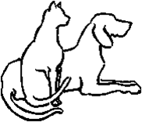
In accordance with the Animal Welfare Act [9 CFR, Part 2, Subpart C 2.32 (c) (4)] No facility
employee, committee member, or laboratory personnel shall be discriminated against or be subject to any reprisal for reporting violations of any regulation or standards under the Act.

Revised 06/25/2026

